AnalyseTS Stock Watchlist Report

Run: 2026-08-03 16:09:23
Digest source: ChatGPT (web)

Market Digest

* **Today:** The overall mood was bullish with **5 stocks up** and **5 stocks down**. The biggest gain was **GOOGL +6.73%** at **$356.13**, while the biggest drop was **AAPL -7.35%** at **$308.91**.
* **Sectors:** Technology was mixed, with **GOOGL +6.73%** and Microsoft offset by **AAPL -7.35%**, while Semiconductors lagged because both tracked names finished lower. Data Analytics, Entertainment/Electronics, and the ETF category all held up with modest gains.
* **Standouts:** **GOOGL +6.73%** was the strongest positive move, finishing **3.71 percentage points** ahead of the next-best performer, **MSFT +3.02%**.
* **Dollar moves:** The largest dollar gain was **GOOGL +6.73%** (+$22.47), while the largest dollar loss was **MU -5.90%** (-$51.63), showing the biggest dollar decline came from a different stock than the biggest percentage drop.
* **Quiet names:** **PLTR +0.65%** and **VOO +0.71%** were the steadiest names, with the smallest percentage moves in the watchlist.
* **Data quality:** Valid data was returned for **10 out of 10** stocks. No stocks were excluded.

This is monitoring information only and is not financial advice.

Price Summary

SYMBOL PRICE CHG% $CHG
AAPL 308.91 -7.35% -24.52
MSFT 464.72 3.02% 13.62
NVDA 200.75 2.93% 5.71
GOOGL 356.13 6.73% 22.47
AMD 476.15 -1.9% -9.24
TTWO 242.92 -1.82% -4.51
PLTR 123.06 0.65% 0.8
SONY 23.26 2.15% 0.49
MU 823.03 -5.9% -51.63
VOO 686.65 0.71% 4.86

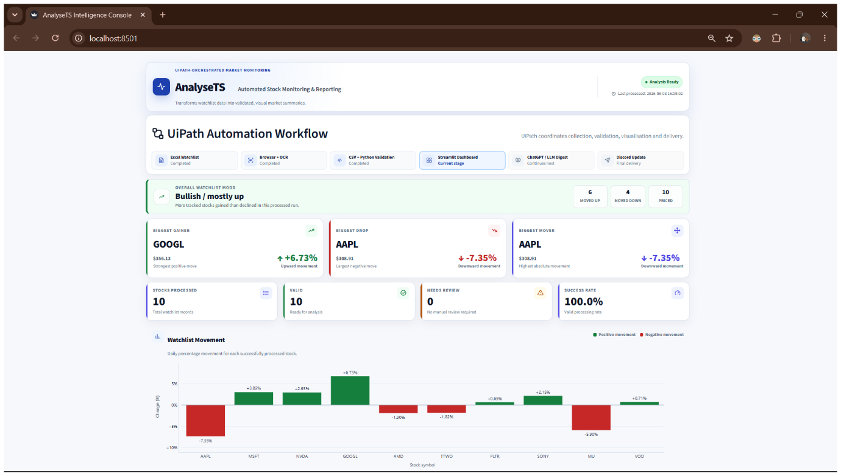
Run Statistics
Stocks processed: 10
OCR failures: 0

Data processed at: 2026-08-03 16:09:02.
Total stocks processed: 10.
Stocks with valid data: 10.
Stocks needing review: 0.
Biggest gainer: GOOGL at 6.73 percent.
Biggest drop: AAPL at -7.35 percent.
Biggest mover by absolute movement: AAPL at 7.35 percent.
Overall watchlist mood: Bullish / mostly up.

This report is monitoring information only and is not financial advice.

