实验5—适配器模式和桥接模式实验
实验目的：加深对适配器模式和桥接设计模式原理的理解
实验环境：C#.Net/VC++.Net或MyEclipse(Java)等
演示内容：算法适配
现有一个接口DataOperation定义了排序方法Sort(int[])和查找方法search(int[],int)，已知类QuickSort的quickSort(int[])方法实现了快速排序，类BinarySearch的binarySearch(int[],int)方法实现了二分查找算法，现使用适配器模式设计一个系统，在不修改源码的情况下将类QuickSort和类BinarySearch的方法适配到DataOperation接口中。绘制类图并编程实现。
⑴实验过程：
- 、构建实现场景，画出UML类图

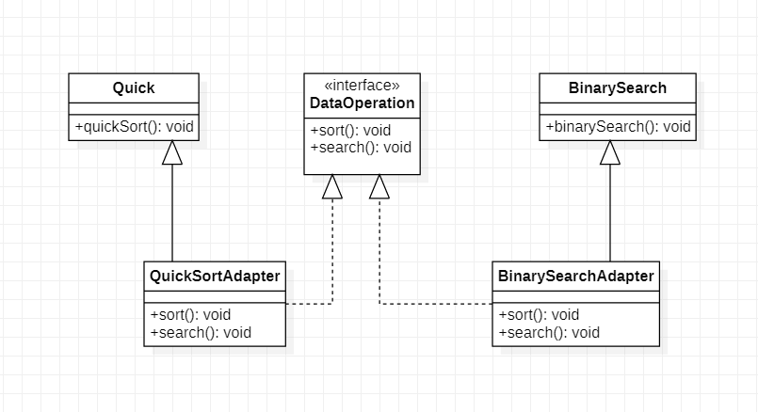

- 、实现代码,见演示源码
Config7_1.xml
<?xml version="1.0" encoding="UTF-8"?>
<config>

<!-- <clssName>designPattern.experiment7_1.code.QuickSortAdapter</clssName> -->
<clssName>designPattern.experiment7_1.code.BinarySearchAdapter</clssName>

</config>

DataOperation.java
package designPattern.experiment7_1.code;

public interface DataOperation {
public void sort();
public void search();

}

QuickSort.java
package designPattern.experiment7_1.code;

public class QuickSort {
public void quickSort() {
System.out.println("快速排序");
}

}

QuickSortAdapter.java
package designPattern.experiment7_1.code;

public class QuickSortAdapter extends QuickSort implements DataOperation {
public void sort() {
System.out.println("QuickSort类的方法适配到DataOperation接口");
super.quickSort();

}

public void search() {

}

}
Client.java
package designPattern.experiment7_1.code;

public class Client {

public static void main(String[] args) {
// TODO Auto-generated method stub
DataOperation dataOperation = (DataOperation)XMLUtil.getBean();
dataOperation.sort();
dataOperation.search();
}

}

BinarySearch.java
package designPattern.experiment7_1.code;

public class BinarySearch {
public void binarySearch() {
System.out.println("二分查找");
}

}

BinarySearchAdapter.java
package designPattern.experiment7_1.code;

public class BinarySearchAdapter extends BinarySearch implements DataOperation {
public void sort() {

}

public void search() {
System.out.println("Binary类的方法适配到DataOperation接口");
super.binarySearch();

}
}

XMLUtil.java
package designPattern.experiment7_1.code;

import javax.xml.parsers.*;
import org.w3c.dom.*;
import org.xml.sax.SAXException;
import java.io.*;
public class XMLUtil
{
//该方法用于从XML配置文件中提取具体类类名，并返回一个实例对象
public static Object getBean()
{
try
{
//创建文档对象
DocumentBuilderFactory dFactory = DocumentBuilderFactory.newInstance();
DocumentBuilder builder = dFactory.newDocumentBuilder();
Document doc;
doc = builder.parse(new File("config7_1.xml"));

//获取包含类名的文本节点
NodeList nl = doc.getElementsByTagName("clssName");
//System.out.println(nl.item(0));
Node classNode=nl.item(0).getFirstChild();
String cName=classNode.getNodeValue();

//System.out.println(cName);

//通过类名生成实例对象并将其返回
Class c=Class.forName(cName);
Object obj=c.newInstance();
// Class<?> clazz=Class.forName(cName);
// Object obj=(AbstractLogFactory) clazz.newInstance(); return obj;
}
catch(Exception e)
{
e.printStackTrace();
return null;
}
}
}
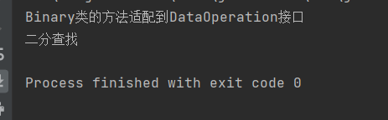

实验内容（一）：
修改实例仿生机器人，使得机器人可以像鸟一样叫，并像狗一样的跑，请绘制类图并编程实现。
⑴实验过程：
- 、构建实现场景，画出UML类图
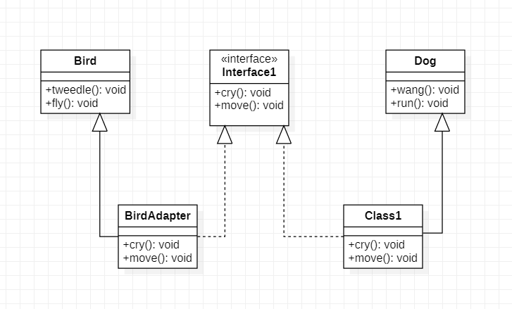

- 、实现代码
Robot.java
package designPattern.experiments7_2.code;

public interface Robot {
public void cry();
public void move();

}

Bird.java
package designPattern.experiments7_2.code;

public class Bird {
public void tweedle()
{
System.out.println("像鸟一样叫！");
}

public void fly()
{
System.out.println("像鸟一样飞！");
}

}

BirdAdapter.java
package designPattern.experiments7_2.code;

public class BirdAdapter extends Bird implements Robot {
public void cry()
{
System.out.print("机器人模仿：");
super.tweedle();
}

public void move()
{
System.out.print("机器人模仿：");
super.fly();
}
}

Dog.java
package designPattern.experiments7_2.code;

public class Dog {
public void wang()
{
System.out.println("像狗一样叫！");
}

public void run()
{
System.out.println("像狗一样跑！");
}

}
DogAdapter.java
package designPattern.experiments7_2.code;

public class DogAdapter extends Dog implements Robot {
public void cry()
{
System.out.print("机器人模仿：");
super.wang();
}

public void move()
{
System.out.print("机器人模仿：");
super.run();
}

}

XMLUtil.java
package designPattern.experiments7_2.code;

import javax.xml.parsers.*;
import org.w3c.dom.*;
import org.xml.sax.SAXException;
import java.io.*;
public class XMLUtil
{
//该方法用于从XML配置文件中提取具体类类名，并返回一个实例对象
public static Object getBean()
{
try
{
//创建文档对象
DocumentBuilderFactory dFactory = DocumentBuilderFactory.newInstance();
DocumentBuilder builder = dFactory.newDocumentBuilder();
Document doc;
doc = builder.parse(new File("config7_2.xml"));

//获取包含类名的文本节点
NodeList nl = doc.getElementsByTagName("clssName");
//System.out.println(nl.item(0));
Node classNode=nl.item(0).getFirstChild();
String cName=classNode.getNodeValue();

//System.out.println(cName);

//通过类名生成实例对象并将其返回
Class c=Class.forName(cName);
Object obj=c.newInstance();
// Class<?> clazz=Class.forName(cName);
// Object obj=(AbstractLogFactory) clazz.newInstance();

return obj;
}
catch(Exception e)
{
e.printStackTrace();
return null;
}
}
}

Client.java
package designPattern.experiments7_2.code;

public class Client {

public static void main(String[] args) {
// TODO Auto-generated method stub
// Robot robot = (Robot)XMLUtil.getBean();
// robot.cry();
Robot robot1 = (Robot)XMLUtil.getBean();
robot1.move();

}

}

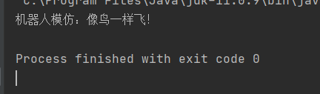

⑵实验讨论（效果分析）:

实验内容（二）：
如果系统中某对象有三个维度，如某日志记录器既可以支持不同的操作系统，还可以支持多种编程语言，并且可以使用不同的输出方式。请使用桥接模式设计该系统。

⑴实验过程：
- 构建实现场景，画出UML类图

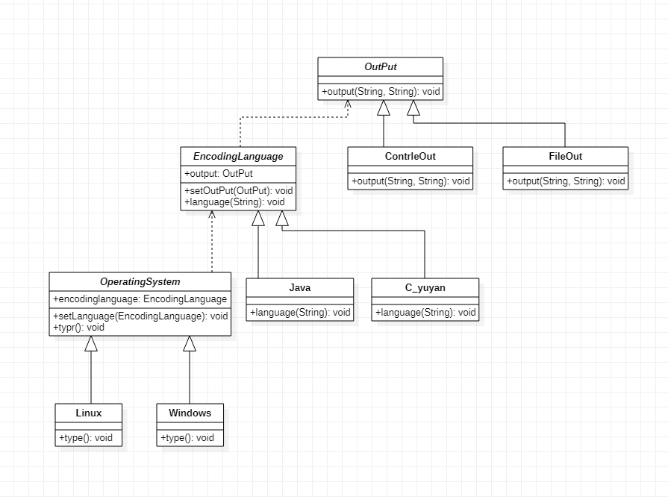

- 实现代码

OperatingSystem.java
package designPattern.experriments7_3.code;

public abstract class OperatingSystem {
EncodingLanguage encodinglanguage;
public void setlanguage(EncodingLanguage lang)
{
this.encodinglanguage=lang;
}
public abstract void type();

}

Windows.java
package designPattern.experriments7_3.code;

public class Windows extends OperatingSystem {
public void type() {
// TODO Auto-generated method stub
String system="windows系统";
this.encodinglanguage.language(system);
//System.out.println("正在使用Windows系统！");
}

}

Linux.java

package designPattern.experriments7_3.code;

public class Linux extends OperatingSystem {
public void type() {
// TODO Auto-generated method stub
String system="Linux系统";
this.encodinglanguage.language(system);
//System.out.println("正在是用Linux系统！");
}

}

EncodingLanguage.java
package designPattern.experriments7_3.code;

//定义抽象编程语言类
public abstract class EncodingLanguage {
OutPut output;
public void setOuPut(OutPut out)
{
this.output=out;
}
public abstract void language(String system);
}

Java.java
package designPattern.experriments7_3.code;

public class Java extends EncodingLanguage {
public void language(String system) {
// TODO Auto-generated method stub
String language="Java语言\n";
this.output.output(system,language);
//System.out.println("java编程！\n");
}

}
C_yuyan.java
package designPattern.experriments7_3.code;

public class C_yuyan extends EncodingLanguage {
public void language(String system) {
// TODO Auto-generated method stub
String language="c语言";
this.output.output(system, language);
//System.out.println("C语言编程！\n");
}

}

OutPut.java
package designPattern.experriments7_3.code;

public abstract class OutPut {
public abstract void output(String system,String language);

}

FileOut.java
package designPattern.experriments7_3.code;

public class FileOut extends OutPut {
public void output(String system, String language) {
// TODO Auto-generated method stub
String means="File方式输出";
System.out.println("在"+system+"用"+language+"以"+means);
}

}

ContrleOut.java
package designPattern.experriments7_3.code;

public class ContrleOut extends OutPut {
public void output(String system, String language) {
// TODO Auto-generated method stub
String means="控制台方式";
System.out.println("在"+system+"用"+language+"以"+means);
}

}

XmlUtil.java
package designPattern.experriments7_3.code;
import java.io.File;
import javax.xml.parsers.*;
import org.w3c.dom.*;

public class XmlUtil {
//配置文件读取处理类
public static Object getBean(String args)
{

try{
//创建一个文档对象
DocumentBuilderFactory dFactory=DocumentBuilderFactory.newInstance();
DocumentBuilder builder=dFactory.newDocumentBuilder();

Document doc=builder.parse(new File("config7_3.xml"));

//获取包含类名的文本节点
NodeList n1=doc.getElementsByTagName("classname");
Node classnode = null;
String className=null;

if(args.equals("OutPut"))
{
classnode=n1.item(0).getFirstChild();
}else if(args.equals("OperatingSystem"))
{
classnode=n1.item(1).getFirstChild();
}else if(args.equals("EncodingLanguage"))
{
classnode=n1.item(2).getFirstChild();
}
className=classnode.getNodeValue();

//通过类名生成实例对象并将其返回
Class c=Class.forName(className);
Object obj=c.newInstance();
return obj;
}catch(Exception e)
{
e.getStackTrace();
return null;
}

}

}

Client.java
package designPattern.experriments7_3.code;

public class Client {

public static void main(String[] args) {
// TODO Auto-generated method stub
// TODO Auto-generated method stub
OutPut output=null;
EncodingLanguage language=null;
//System.out.println(language);
OperatingSystem system=null;
if(output==null && language==null && system==null)
{
output=(OutPut)XmlUtil.getBean("OutPut");
language=(EncodingLanguage)XmlUtil.getBean("EncodingLanguage");
//System.out.println(language);
system=(OperatingSystem)XmlUtil.getBean("OperatingSystem");

//System.out.println(output);
//System.out.println(language);
//System.out.println(system);
}
system.setlanguage(language);
//System.out.println(language);
language.setOuPut(output);
system.type();

}

}

截图：
