实验3—抽象工厂方法、建造者设计与原型设计模式
实验目的：加深对抽象工厂方法设计模式及创建型设计模式原理的理解
实验环境：C#.Net/VC++.Net或MyEclipse(Java)等
实验内容：
某单据管理系统中要求实现对采购、销售、库存的单据管理，系统的采购类的单据中有如采购单、收货单、应付帐单、付款单和退货单等，现使用抽象工厂方法设计模式设计该系统。
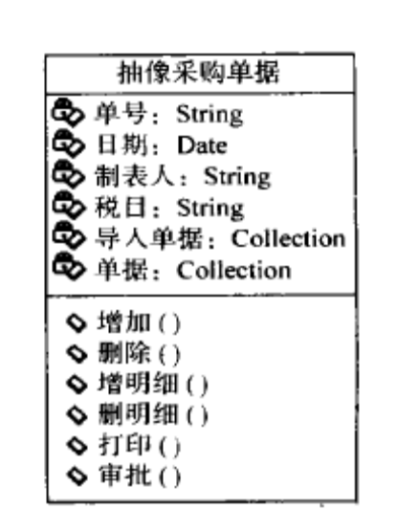

实验过程：
1、构建实现场景，给出需求中的问题描述
2、画出UML类图
3、实现代码

实验讨论（效果分析）:
- 单据的本质就是资金的“收入”与“支出”，所以分为收入与支出两个工厂来生产单据。
采购(Purchase)：采购单（支出）、退货单（收入）
销售（Sale）：销售单（收入）、退款单（支出）
库存(Stock)：入库单（支出）、出库单（收入）

画出UML类图:

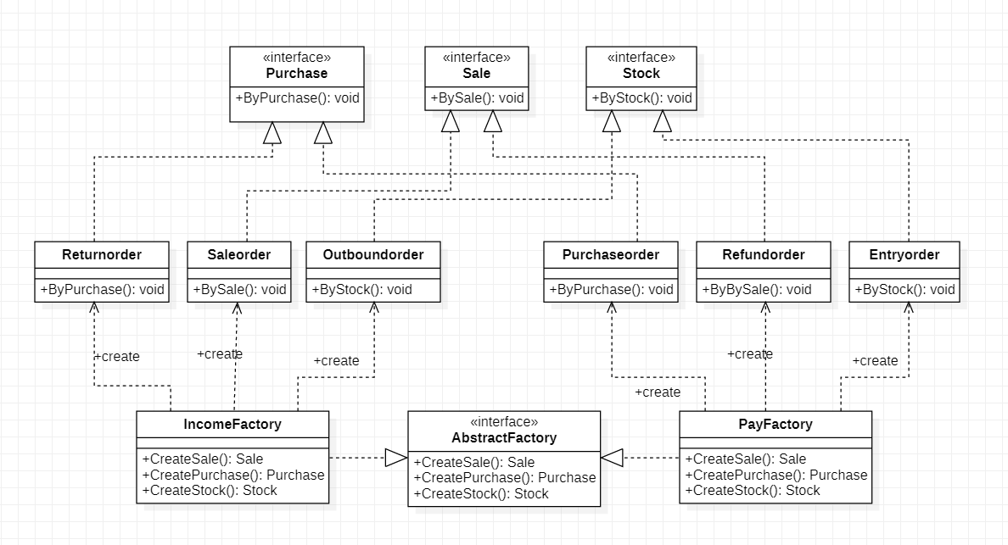

AbstractFactory.java
package text5;

public interface AbstractFactory {

public Sale CreateSale();
public Purchase CreatePurchase();
public Stock CreateStock();
}

IncomeFactory.java
package text5;

public class IncomeFactory implements AbstractFactory{

public Sale CreateSale() {

System.out.println("收入工厂生产销售单");
return new Saleorder();
}
public Purchase CreatePurchase() {
System.out.println("收入工厂生产退货单");
return new Returnorder();

}
public Stock CreateStock() {
System.out.println("收入工厂生产出库单");
return new Outboundorder();

}
}

PayFactory.java
package text5;

public class PayFactory implements AbstractFactory{

public Sale CreateSale() {
System.out.println("支出工厂生产退款单");
return new Refundorder();
}
public Purchase CreatePurchase() {
System.out.println("支出工厂生产采购单");
return new Purchaseorder();

}
public Stock CreateStock() {
System.out.println("支出工厂生产入库单");
return new Entryorder();
}
}

Sale.java

package text5;

public interface Sale {
public void BySale();

}

Saleorder.java
package text5;

public class Saleorder implements Sale {

public void BySale() {
System.out.println("这是销售部门的单子");
}
}

Refundorder.java
package text5;

public class Refundorder implements Sale{
public void BySale() {
System.out.println("这是销售部门的单子");
}

}

Stock.java
package text5;

public interface Stock {
public void ByStock();

}

Outboundorder.java
package text5;

public class Outboundorder implements Stock{
public void ByStock() {
System.out.println("这是库存部门的单子");
}

}

Entryorder.java
package text5;

public class Entryorder implements Stock{
public void ByStock() {
System.out.println("我是库存部门的单子！");
}

}

Returnorder.java
package text5;

public class Returnorder implements Purchase{
public void ByPurchase() {
System.out.println("我是采购部门的单子！");
}

}

Purchase.java
package text5;

public interface Purchase {

public void ByPurchase();
}

Purchaseorder.java
package text5;

public class Purchaseorder implements Purchase{
public void ByPurchase() {
System.out.println("我是采购部门的单子");
}

}

XMLUtil.java
package text5;
import javax.xml.parsers.*;
import org.w3c.dom.*;
import org.xml.sax.SAXException;
import java.io.*;
public class XMLUtil {

public static Object getBean() {
try {
DocumentBuilderFactory dFactory = DocumentBuilderFactory.newInstance();
DocumentBuilder builder = dFactory.newDocumentBuilder();
Document doc;
doc = builder.parse(new File("config.xml"));

NodeList n1 = doc.getElementsByTagName("className");
Node classNode = n1.item(0).getFirstChild();
String cName = classNode.getNodeValue();

Class<?> c = Class.forName(cName);
Object obj = c.newInstance();
return obj;
}catch(Exception e){
e.printStackTrace();
return null;

}
}
}

Client.java
package text5;

public class Client {
public static void main(String args[]) {
try {
Sale sale;
Purchase purchase;
Stock stock;

AbstractFactory abstractFactory;
abstractFactory = (AbstractFactory) XMLUtil.getBean();
sale = abstractFactory.CreateSale();
sale.BySale();
purchase = abstractFactory.CreatePurchase();
purchase.ByPurchase();
stock = abstractFactory.CreateStock();
stock.ByStock();

} catch (Exception e) {
e.printStackTrace();
}
}
}

config.xml
<?xml version="1.0" encoding="UTF-8"?>
<config>
<className>design5.PayFactory</className>

</config>
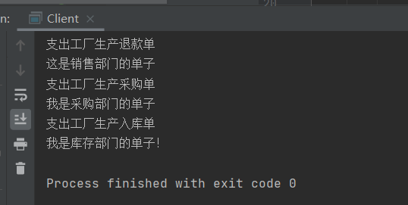

建造者
实验目的：加深对建造者设计模式\原型设计及创建型设计模式原理的理解
实验环境：C#.Net/VC++.Net或MyEclipse(Java)等
实验内容（一）：
某软件公司欲开发一个音频与视频播放软件，为了给用户使用提供方便，该播放软件提供了多种界面显示模式，如完整模式、精简模式、记忆模式、网络模式等。在不同的显示模式下主界面的组成元素有所差异，如在完整模式下将显示菜单、播放列表、主窗口、控制条等；在精简模式下只显示主窗口和控制条，而在记忆模式下将显示主窗口、控制条、收藏列表等。现要求使用建造者设计模式设计该软件。

实验过程：
- 画出UML类图
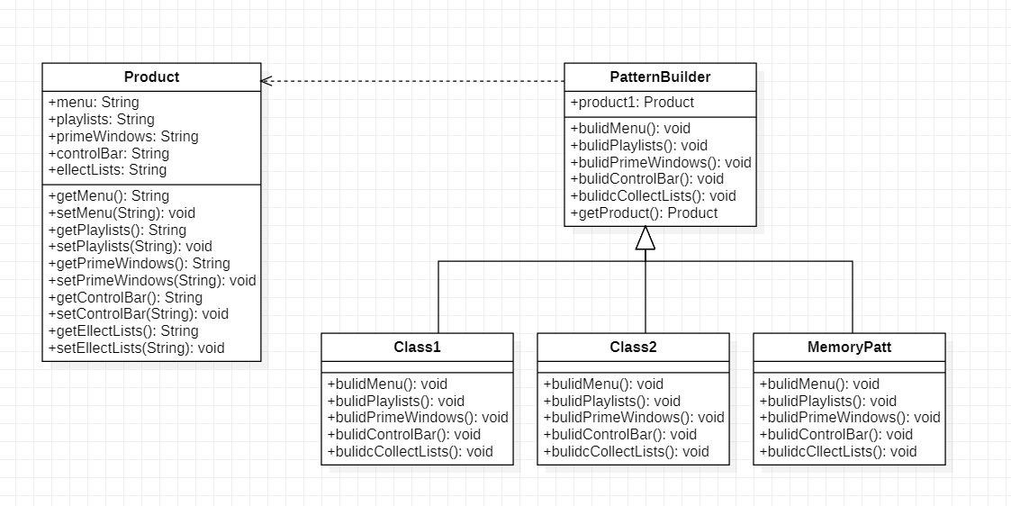

- 实现代码
Product.java

package designPattern.experiment6_1.code;

public class product {
private String menu;
private String playlists;
private String primeWindows;
private String controlBar;
private String ellectLists;
public String getMenu() {
return menu;
}
public void setMenu(String menu) {
this.menu = menu;
}
public String getPlaylists() {
return playlists;
}
public void setPlaylists(String playlists) {
this.playlists = playlists;
}
public String getPrimeWindows() {
return primeWindows;
}
public void setPrimeWindows(String primeWindows) {
this.primeWindows = primeWindows;
}
public String getControlBar() {
return controlBar;
}
public void setControlBar(String controlBar) {
this.controlBar = controlBar;
}
public String getEllectLists() {
return ellectLists;
}
public void setEllectLists(String ellectLists) {
this.ellectLists = ellectLists;
}

}

PatternBuilder.java

package designPattern.experiment6_1.code;

public abstract class PatternBuilder {
protected product product1 = new product();

public abstract void bulidMenu();

public abstract void bulidPlaylists();

public abstract void bulidPrimeWindows();

public abstract void bulidControlBar();

public abstract void bulidcCollectLists();

public product getProduct(){
return product1;
}

}

FullPatternBuilder.java
package designPattern.experiment6_1.code;

public class FullPatternBuilder extends PatternBuilder{
//完整模式下将显示菜单、播放列表、主窗口、控制条

public void bulidMenu() {
product1.setMenu("菜单");
}

public void bulidPlaylists() {
product1.setPlaylists("播放列表");
}

public void bulidPrimeWindows() {
product1.setPrimeWindows("主窗口");
}

public void bulidControlBar() {
product1.setControlBar(" ");

}

public void bulidcCollectLists() {
product1.setEllectLists("");
}

}

MemoryPatternBuilder.java

package designPattern.experiment6_1.code;

public class MemoryPatternBuilder extends PatternBuilder {
/// 记忆模式下将显示主窗口、控制条、收藏列表
public void bulidMenu() {
product1.setMenu(" ");

}

public void bulidPlaylists() {
product1.setPlaylists(" ");
}

public void bulidPrimeWindows() {
product1.setPrimeWindows("主窗口");
}

public void bulidControlBar() {
product1.setControlBar("控制条");
}

public void bulidcCollectLists() {
product1.setEllectLists("收藏列表");
}

}

SpfPatternBuilder.java

package designPattern.experiment6_1.code;

public class SpfPatternBuilder extends PatternBuilder {
///在精简模式下只显示主窗口和控制条
public void bulidMenu() {
product1.setMenu(" ");
}

public void bulidPlaylists() {
product1.setPlaylists(" ");
}

public void bulidPrimeWindows() {
product1.setPrimeWindows("主窗口");
}

public void bulidControlBar() {
product1.setControlBar("控制条");
}

public void bulidcCollectLists() {
product1.setEllectLists("");
}

}

RedRum.java
package designPattern.experiment6_1.code;

public class RedRum {
private PatternBuilder patternBuilder;
public void setPatternBulider(PatternBuilder patternBuilder) {
this.patternBuilder = patternBuilder;
}

public product construct() {
patternBuilder.bulidMenu();
patternBuilder.bulidPrimeWindows();
patternBuilder.bulidPlaylists();
patternBuilder.bulidControlBar();
patternBuilder.bulidcCollectLists();
return patternBuilder.getProduct();
}
}

Client.java
package designPattern.experiment6_1.code;

public class Client {

public static void main(String[] args) {
// TODO Auto-generated method stub
PatternBuilder pBuilder = (PatternBuilder)XMLUtil.getBean();
RedRum redRum = new RedRum();
redRum.setPatternBulider(pBuilder);
product product1 = redRum.construct();

// System.out.println("完整模式下将显示菜单、播放列表、主窗口、控制条");
// System.out.println("精简模式下只显示主窗口和控制条");
System.out.println("忆模式下将显示主窗口、控制条、收藏列表");
System.out.println(product1.getControlBar());
System.out.println(product1.getEllectLists());
System.out.println(product1.getMenu());
System.out.println(product1.getPrimeWindows());
System.out.println(product1.getPlaylists());
}

}

XMLUtil.java
package designPattern.experiment6_1.code;

import javax.xml.parsers.*;
import org.w3c.dom.*;
import org.xml.sax.SAXException;
import java.io.*;
public class XMLUtil
{
//该方法用于从XML配置文件中提取具体类类名，并返回一个实例对象
public static Object getBean()
{
try
{
//创建文档对象
DocumentBuilderFactory dFactory = DocumentBuilderFactory.newInstance();
DocumentBuilder builder = dFactory.newDocumentBuilder();
Document doc;
doc = builder.parse(new File("config6_1.xml"));

//获取包含类名的文本节点
NodeList nl = doc.getElementsByTagName("clssName");
//System.out.println(nl.item(0));
Node classNode=nl.item(0).getFirstChild();
String cName=classNode.getNodeValue();

//System.out.println(cName);

//通过类名生成实例对象并将其返回
Class c=Class.forName(cName);
Object obj=c.newInstance();
// Class<?> clazz=Class.forName(cName);
// Object obj=(AbstractLogFactory) clazz.newInstance();

return obj;
}
catch(Exception e)
{
e.printStackTrace();
return null;
}
}
}

config6_1.xml
<?xml version="1.0" encoding="UTF-8"?>
<config>

<!-- <clssName>designPattern.experiment6_1.code.FullPatternBuilder</clssName> -->
<!-- <clssName>designPattern.experiment6_1.code.SpfPatternBuilder</clssName> -->
<clssName>designPattern.experiment6_1.code.MemoryPatternBuilder</clssName>

</config>

运行结果截图：
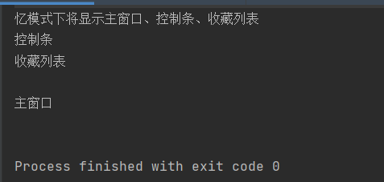

原型设计模式
实验内容（三）：
某数据处理软件要增加一个图表复制功能，在图表对象中包含一个数据集对象，用于封闭待显示的数据，可以通过界面的“复制”按钮将该图表复制一份，复制后可以得到新的图表对象，用户可以修改新图表的编号、颜色和数据。现要求使用原型设计模式设计该软件。

实验过程：
- 画出UML类图
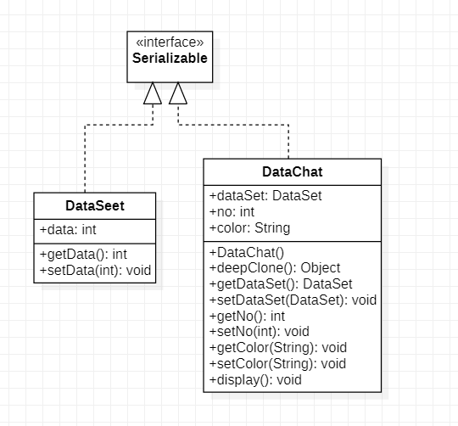
2、实现代码
DataSet.java
package designPattern.experiments6_2.code;

import java.io.Serializable;

public class DataSet implements Serializable {
private int data;

public int getData() {
return data;
}

public void setData(int data) {
this.data = data;
}
}

DataChat.java

package designPattern.experiments6_2.code;
import java.io.*;

public class DataChat implements Serializable{
private DataSet dataSet = null;
private int no;
private String color;
public DataChat() {
this.dataSet = new DataSet();
}

public Object deepClone() throws IOException, ClassNotFoundException, OptionalDataException
{
//将对象写入流中
ByteArrayOutputStream bao=new ByteArrayOutputStream();
ObjectOutputStream oos=new ObjectOutputStream(bao);
oos.writeObject(this);

//将对象从流中取出
ByteArrayInputStream bis=new ByteArrayInputStream(bao.toByteArray());
ObjectInputStream ois=new ObjectInputStream(bis);
return(ois.readObject());
}

public DataSet getDataSet() {
return dataSet;
}

public void setDataSet(DataSet dataSet) {
this.dataSet = dataSet;
}

public int getNo() {
return no;
}

public void setNo(int no) {
this.no = no;
}

public String getColor() {
return color;
}

public void setColor(String color) {
this.color = color;
}

public void display()
{
System.out.println("查看图表 --->图表编号为: "+this.getNo()+" 数据为: "+this.getDataSet().getData()+" 颜色:"+this.getColor());
}

}

Client.java
package designPattern.experiments6_2.code;

public class client {

public static void main(String[] args) {
// TODO Auto-generated method stub
DataChat dataChat = new DataChat();
//初始化图表的编号、颜色和数据
dataChat.getDataSet().setData(1111);
dataChat.setColor("black");
dataChat.setNo(12301);
dataChat.display();

DataChat copyDataChat = null;
try {
copyDataChat = (DataChat)dataChat.deepClone();

} catch (Exception e) {
// TODO: handle exception
e.printStackTrace();
}
/* copyDataChat.display();*/
System.out.println("用户修改新图表的编号、颜色和数据");
copyDataChat.getDataSet().setData(2222);
copyDataChat.setNo(10086);
copyDataChat.setColor("green");
copyDataChat.display();
}

}

运行结果截图：

