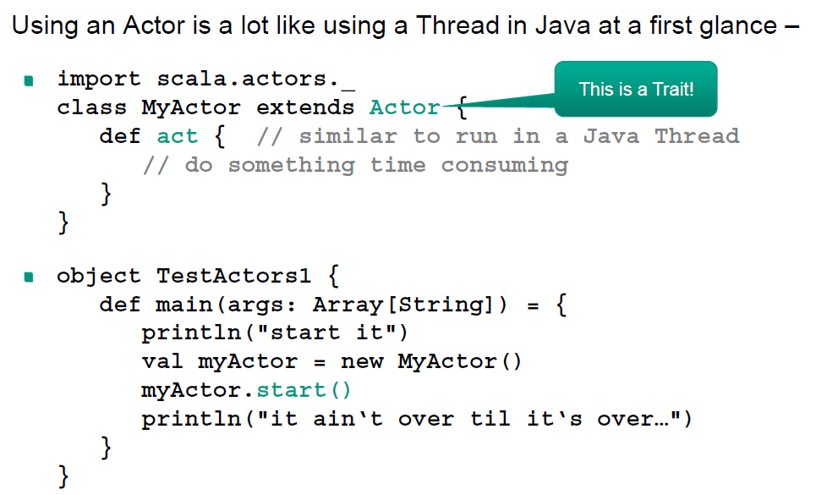
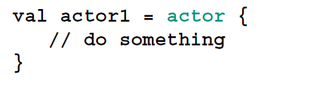
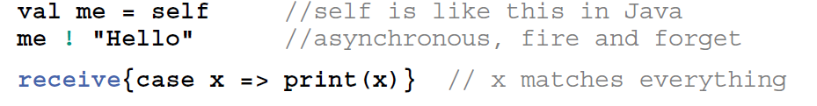
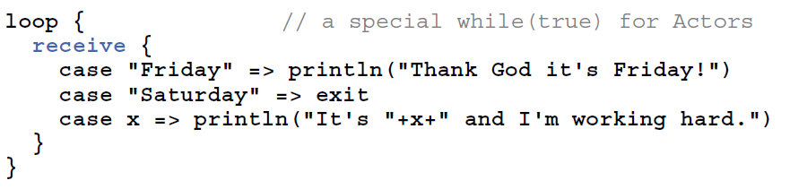
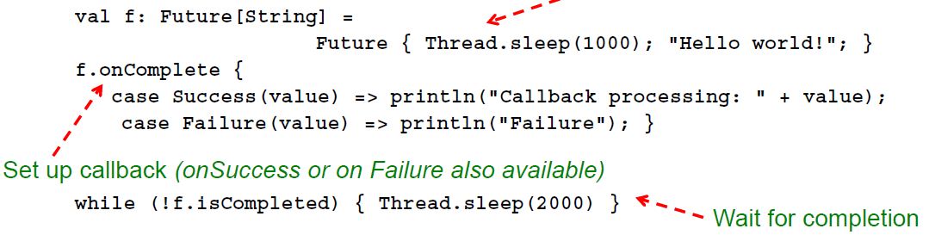
Scala CheetSheet
Message passing in actors:
receiver ! message
Futures

