X10: Cheat Sheet
Allgemein:
X10 knows classes, interfaces, structs, functions as first-class objects (functional).
Computation is performed in multiple places which contains data and that can be operated remotely: Distribution ↔ Places; Concurrency ↔ Activities
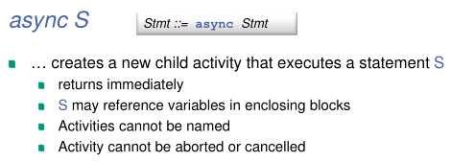
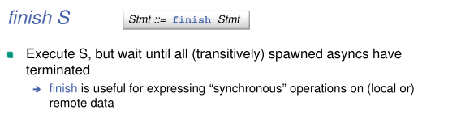

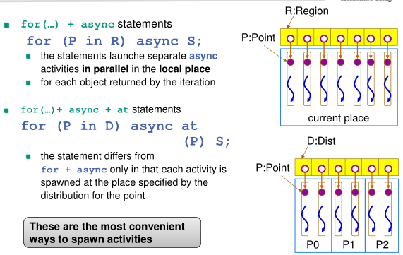
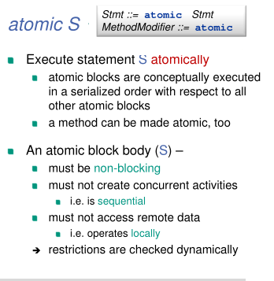

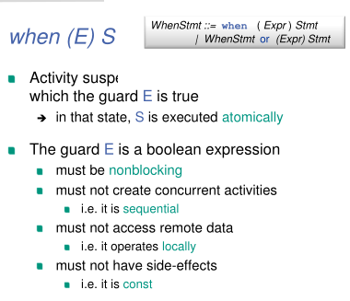
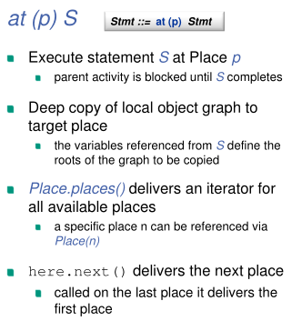

Distributed Object Model: DistArrays:
