Project Design Document

1. Design Intent
- What experience are you trying to create? We want to create a sense of unexpected life. When someone walks past a pile of what looks like scrap electronics, we want them to feel surprised when it wakes up, tracks their presence, and reacts to their noises. It should feel curious rather than robotic.
- Who is it for? This is built for gallery visitors, makers, and anyone interested in kinetic art and sustainability.
- If solving a problem, what problem does it solve? It tackles the narrative around e-waste. Instead of throwing away old electronics and broken hardware, this project proves that discarded materials can be repurposed into engaging, interactive installations. It challenges the idea that technology needs to be brand new to be valuable.

2. Inspiration & References
- Existing products / ideas: We looked heavily at Disney animatronics, industrial scrap metal sculptures, and pop-culture robots like Wall-E and Five Nights at Freddy’s.
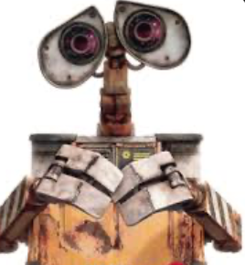

- Images / links: Reference boards included exposed gearboxes, vintage camera lenses (for the eyes), and cable-managed wire bundles that look like mechanical muscles.
- What did you learn from them? We learned that lifelike movement is all about sequencing. If a robot moves all its parts at the exact same time, it looks like a machine. If the eyes open first, look around, and then the head turns toward a sound, it suddenly feels like a living creature making decisions.

3. User Journey
- Step-by-step experience: A person enters a quiet room. In the corner sits a small, motionless robot. As the person steps closer, crossing an invisible threshold, the machine wakes up. Its mechanical eyelids click open, and the eyes dart to the left and right, scanning the room. The person, startled, says "Hello?" or snaps their fingers. The moment the sound hits the air, the robot's head snaps toward the noise, and a green pulse of light illuminates its chassis. After a few moments of silence and stillness, the robot closes its eyes and goes back to sleep, waiting for the next visitor.

4. Success Criteria
Functional: The motion sensor must trigger the wake sequence reliably within half a second of a person approaching. The sound sensor must successfully interrupt the eye-scanning loop to trigger the head movement.
User experience: The mechanical movements need to feel smooth and intentional. The interaction should evoke a sense of curiosity and playfulness from the user.
Reliability: The power delivery must be stable. Moving five motors at once draws a lot of current, so the system must run continuously without the microcontroller browning out or resetting.

5. System Overview
High-level explanation: At its core, the system uses a microcontroller to read environmental data (motion and audio) and translates that data into physical movement and light.
What are the main parts? The "brain" is an ESP32 development board. The "senses" are a PIR motion sensor and a digital sound sensor. The "muscles" are five micro servo motors controlling the eyelids, eyeballs, and neck. Finally, a NeoPixel LED strip provides visual feedback.

6. High-Level Block Diagram
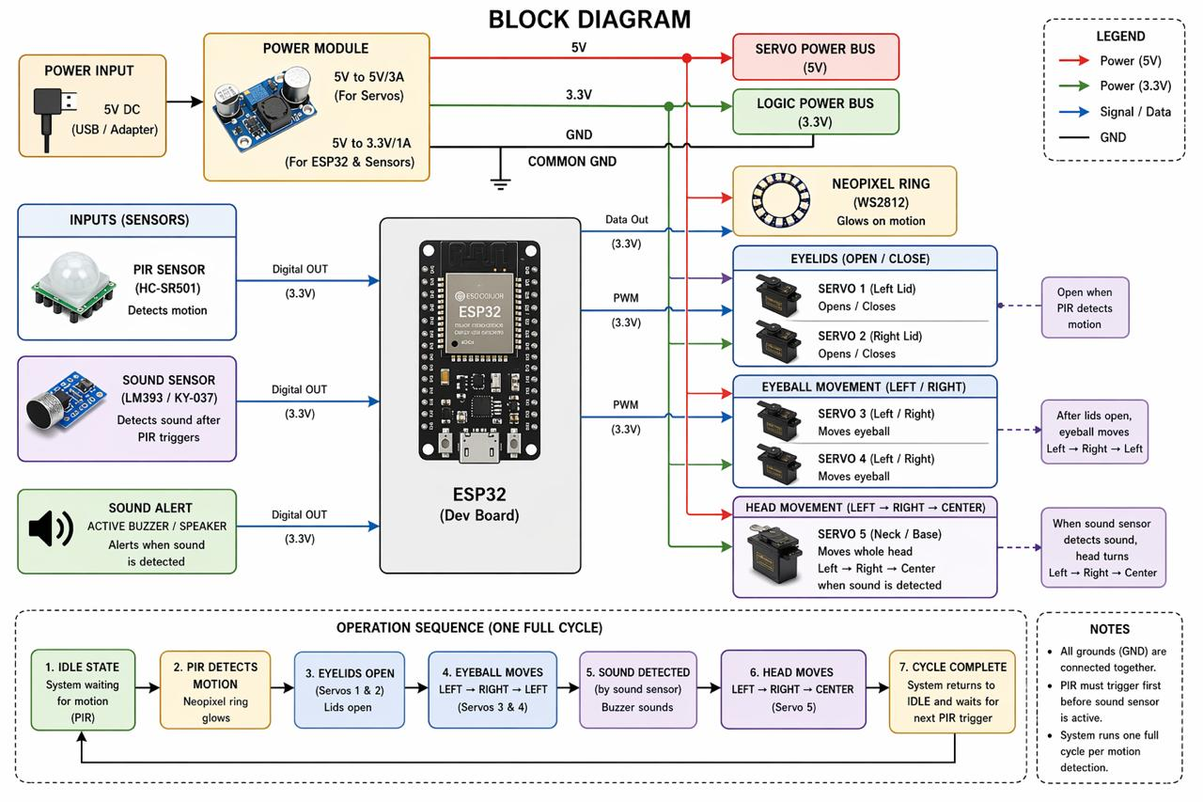

7. Input / Output Mapping

Input | Process | Output
PIR Sensor: Detects thermal infrared shifts (human movement) in front of the robot. | ESP32 interrupts idle state, resets the system timer, and triggers the primary "Wake" function. | Eyelid Servos: Rotate to 102° (Open). Eyeball Servos: Begin horizontal scanning sequence.
Sound Sensor: Captures a sudden decibel spike (claps, voices, or footsteps). | The controller checks if the system is currently "Active." If true, it initiates the head-turning subroutine. | Head Servo: Snaps to the left/right position. NeoPixels: Trigger a high-intensity green pulse pattern.
PIR Signal (LOW): No infrared motion detected for a continuous duration. | Software calculates the time delta. If no motion is logged for >60 seconds, it shuts down active processes. | NeoPixels: Power down. All Servos:Return to default "Rest" angles (Lids closed, Head centered).

8. Sketches & Concepts
- 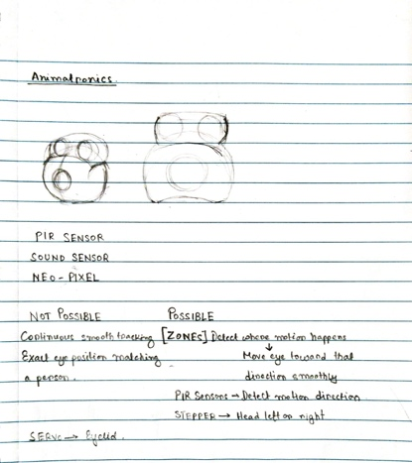 s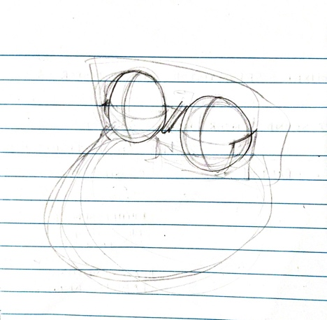 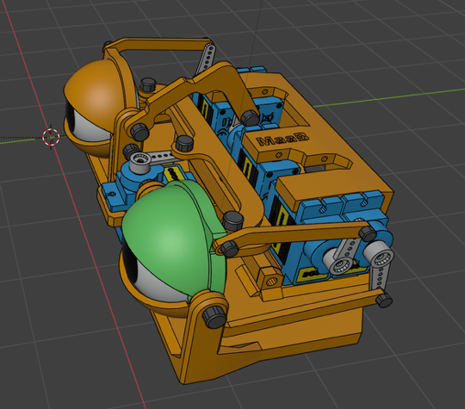

9. Final System Architecture (Labelled)
- Power Hub: 5V / 3A External Power Supply -> Feeds power to all Servos, NeoPixels, and the ESP32 VIN pin. Common ground shared across all components.
- Brain: ESP32 Development Board
- Inputs:
  - Pin 35 <- PIR Motion Sensor (Signal out)
  - Pin 34 <- Sound Sensor (Digital out)
- Outputs:
  - Pin 25 -> Left Eye Servo (PWM)
  - Pin 13 -> Right Eye Servo (PWM)
  - Pin 14 -> Left Eyelid Servo (PWM)
  - Pin 4 -> Right Eyelid Servo (PWM)
  - Pin 33 -> Head Rotation Servo (PWM)
  - Pin 12 -> NeoPixel LED Strip (Data line)
- 