分类问题

1. **（traditional machine learning）传统机器学习方法**
   1. **LR**

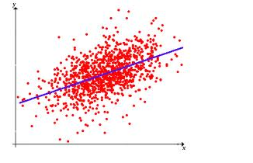

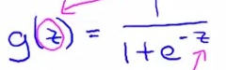

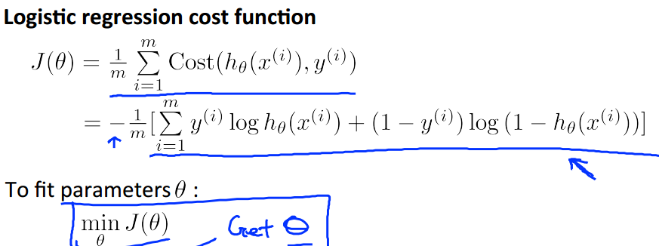

**1.2 SVM**

**Svm is to find a hyperplane to make the dataset far away from the hyperplane.** 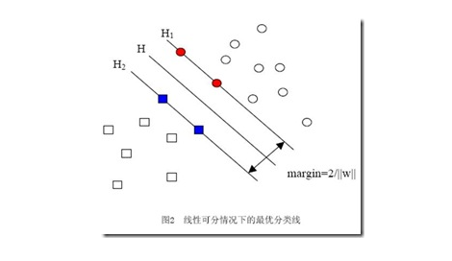

1. **（****neural****network****）神经网络方法**

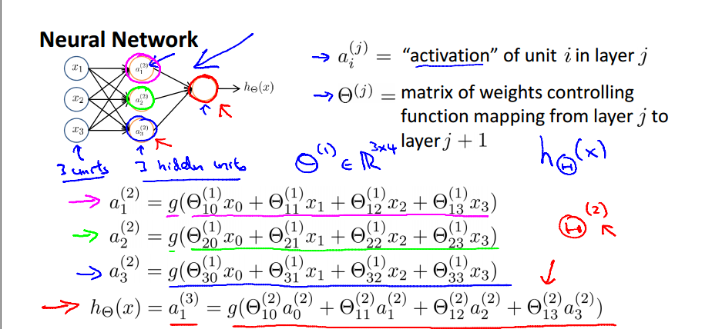

1. **（deep learning）深度学习方法**

**3.1 MLP**

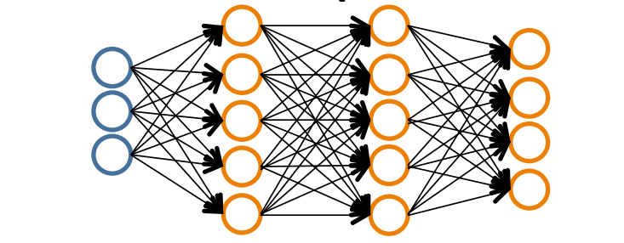

**3.2 CNN**

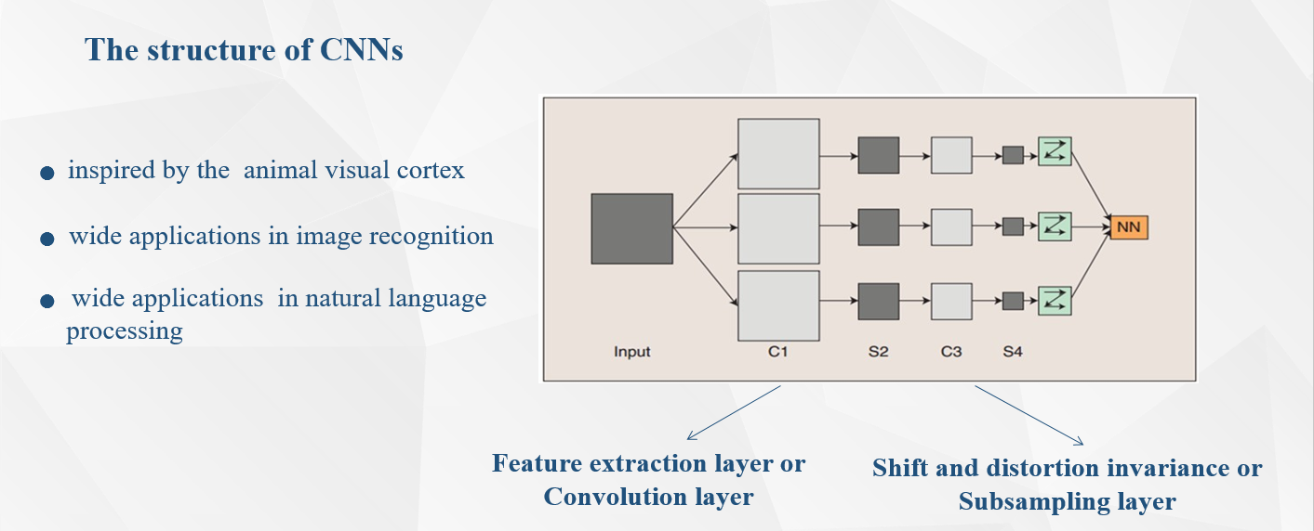

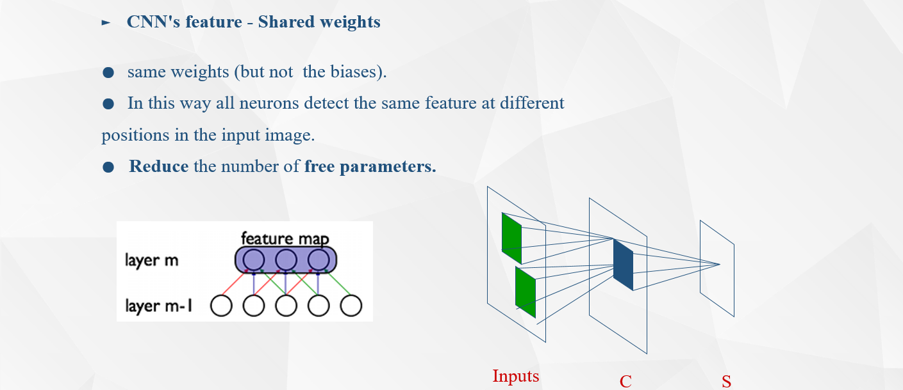

**3.3 LSTM**

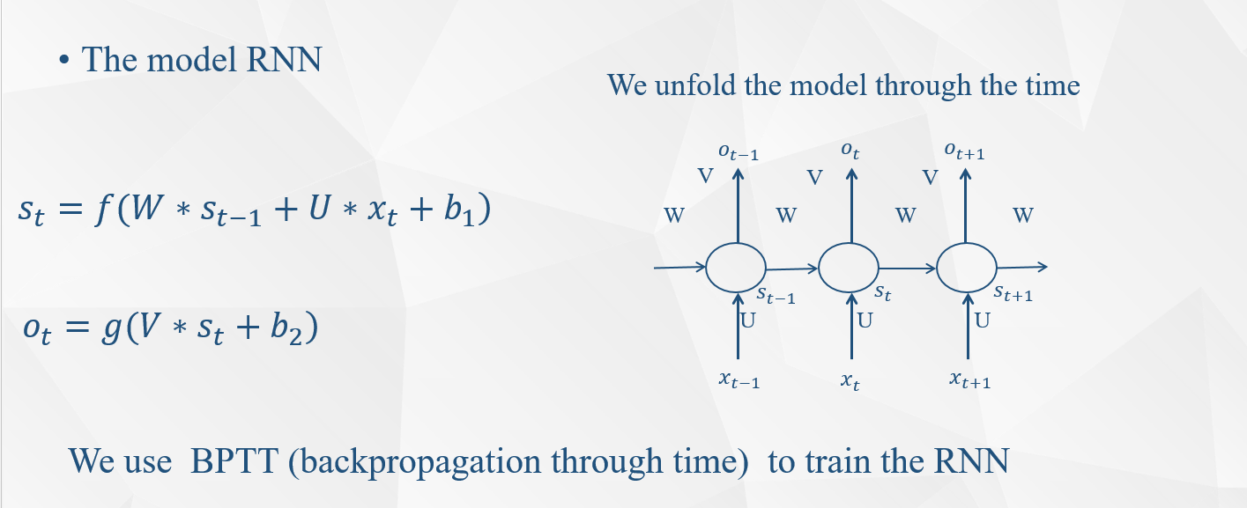

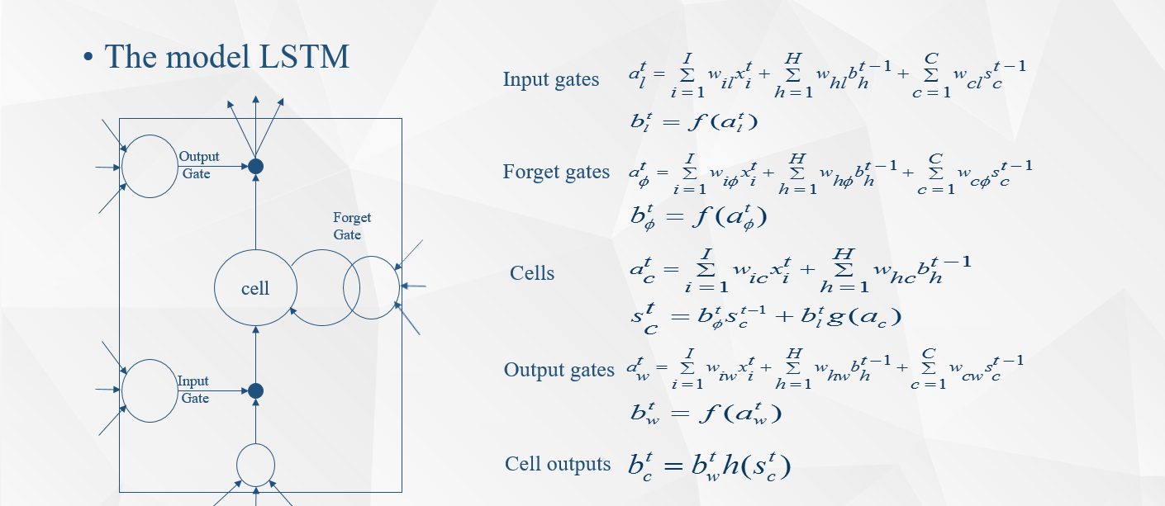

1. 降维
   1. PCA

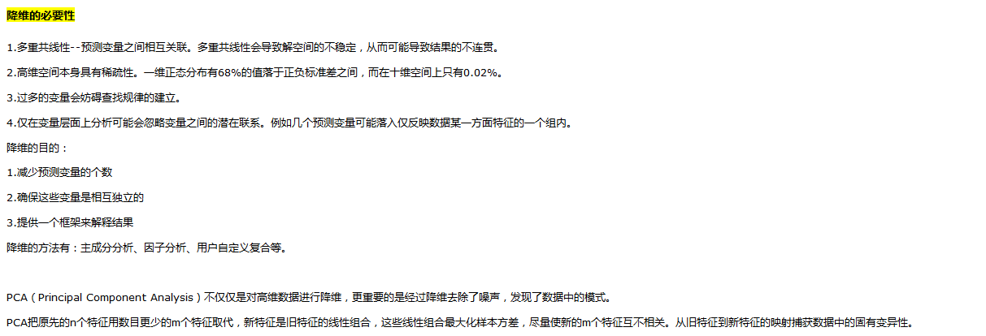

* 1. DA

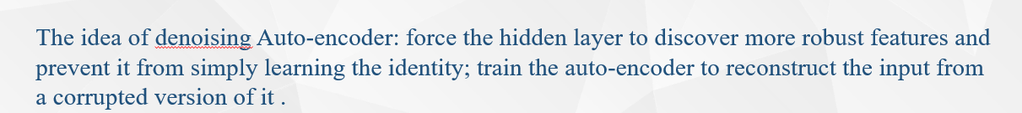

* 1. Step-wise regression

