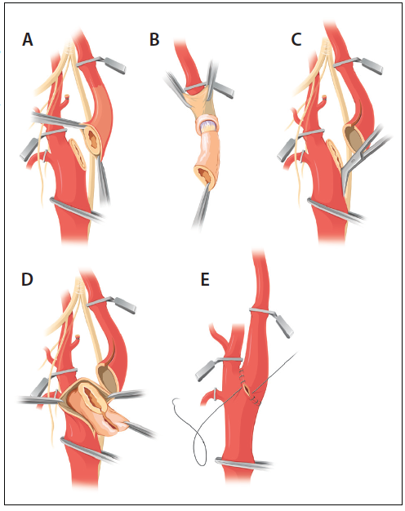

*By [Timothy M. Sullivan](https://evtoday.com/search?q=timothy+m.+sullivan)*