# **PART 1**

**use world;**

**-- Task 1 : Retrive the country name from code given('USA','GBR','ARE')**

**select Name from country where Code in ('USA','GBR','ARE');**

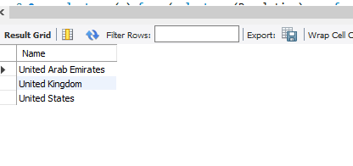

**-- Task 2 : Create a query that retrieves a single value of the sum of continental populations**

**select avg(y) from (select sum(Population)as y from country group by Continent) as x;**

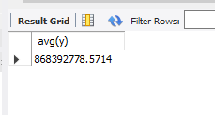

**-- Task 3 : Create query that retrieves the list of countries from the contient Europw where french is spoken**

**select Name from country where Code in (select CountryCode from countrylanguage where Language='French') and Continent='Europe';**

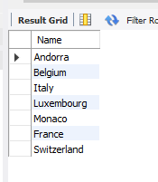

**-- Task 4 : Create a query that retrieves noncountry from each continent which has the highest population**

**create view t as**

**select Continent,max(Population) as Population from country group by Continent;**

**select * from t;**

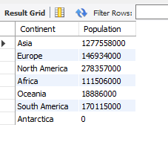

**select t.Continent,t.Population,Name from t**

**inner join country**

**using(Population)**

**where Population!=0;**

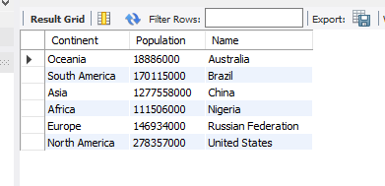

# **Part 2**

**-- Task 1 : Find film id and existing number of copies of movies Brotherhood Blanket and Soup Wisdom**

**Use sakila;**

**-- Using subquery**

**select film_id,title,(select count(inventory_id) from inventory where film.film_id=inventory.film_id ) as No_of_Copies**

**from film where title in ('Brotherhood Blanket','Soup Wisdom');**

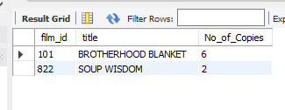

**-- Using join**

**select count(inventory_id) as No_of_copies,film_id,title from inventory**

**inner join film using(film_id)**

**where title in ('Brotherhood Blanket','Soup Wisdom')**

**group by film_id;**

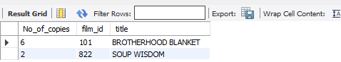

**-- Task 2 : The inventory has many movies in stock. Display the total number of each genere**

**select name,count(inventory_id) as Number_of_movies from category**

**inner join film_category using(category_id)**

**inner join film using (film_id)**

**inner join inventory using (film_id)**

**group by name;**

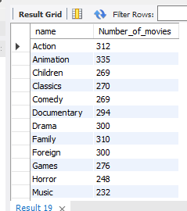

**-- Task 3 : Find top 3 actors who have highest replacement cost**

**select distinct(replacement_cost) from film**

**order by 1 desc**

**limit 3;**

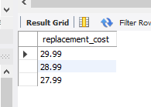

**select actor_id,first_name,last_name,replacement_cost from actor**

**inner join film_actor using(actor_id)**

**inner join film using(film_id)**

**where replacement_cost in (29.99,28.99,27.99)**

**order by 4 desc**

**;**

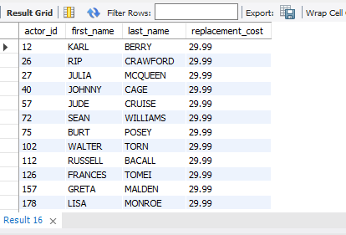

**-- Task 4 : The board wants to know the total sales of each movie type like incidents,political issues,mystery, fiction or culture**

**create view movie_special_cat as**

**select film_id, title, description,**

**case**

**when description like '%Epic%' then 'culture'**

**when description like '%India%' then 'culture'**

**when description like '%monastery%' then 'culture'**

**when description like '%Sahara Desert%' then 'culture'**

**when description like '%sumo%' then 'culture'**

**when description like '%music%' then 'culture'**

**when description like '%sports%' then 'culture'**

**when description like '%Feminist%' then 'political'**

**when description like '%Emotional%' then 'fiction'**

**when description like '%Astronaut%' then 'fiction'**

**when description like '%Discover%' then 'mystery'**

**when description like '%thrilling%' then 'mystery'**

**when description like '%Robot%' then 'fiction'**

**when description like '%reflection%' then 'fiction'**

**when description like '%documentary%' then 'fiction'**

**when description like '%shark tank%' then 'fiction'**

**when description like '%Robot%' then 'fiction'**

**when description like '%Psychologist%' then 'fiction'**

**when description like '%scientist%' then 'fiction'**

**when description like '%Conquer%' then 'fiction'**

**when description like '%technology%' then 'fiction'**

**when description like '%defeat%' then 'fiction'**

**when description like '% space station%' then 'fiction'**

**when description like '%technical%' then 'fiction'**

**when description like '%Drama%' then 'fiction'**

**when description like '%thril%' then 'mystery'**

**when description like '%Escape%' then 'mystery'**

**when description like '%Frisbee %' then 'mystery'**

**when description like '%secret Agent%' then 'mystery'**

**when description like '%Ancient%' then 'culture'**

**else 'NULL' end as movie_type**

**from film;**

**select movie_type,sum(amount) as Total_sales from movie_special_cat**

**inner join inventory using(film_id)**

**inner join rental using(inventory_id)**

**inner join payment using (rental_id)**

**group by movie_type;**

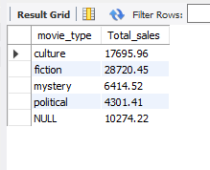

**-- Task 5 : Find list of top 10 generes and their gross revenue in descending order and present it virtually and also save it for future reference**

**select name,sum(amount) from category**

**inner join film_category using(category_id)**

**inner join film using (film_id)**

**inner join inventory using(film_id)**

**inner join rental using (inventory_id)**

**inner join payment using(rental_id)**

**group by name**

**order by 2 desc**

**limit 10**

**into outfile 'C:\\ProgramData\\MySQL\\MySQL Server 8.0\\Uploads\\Sakila.csv'**

**fields terminated by ','**

**lines terminated by '\n';**

