AI-ASSISTED CODING
ASSIGNMENT-11.1
Bandam Akarsh
2303A53018
B-46

Task Description #1 – Stack Implementation
Task: Use AI to generate a Stack class with push, pop, peek, and is_empty
methods.
Sample Input Code:
class Stack:
pass
Expected Output:
• A functional stack implementation with all required methods and
docstrings.
Prompt:
#Generate a functional Python Stack class that implements push, pop, peek, and is_empty methods using a list internally, include clear docstrings for each method, handle empty stack errors properly, and show a short example of how to use the class.

Code:
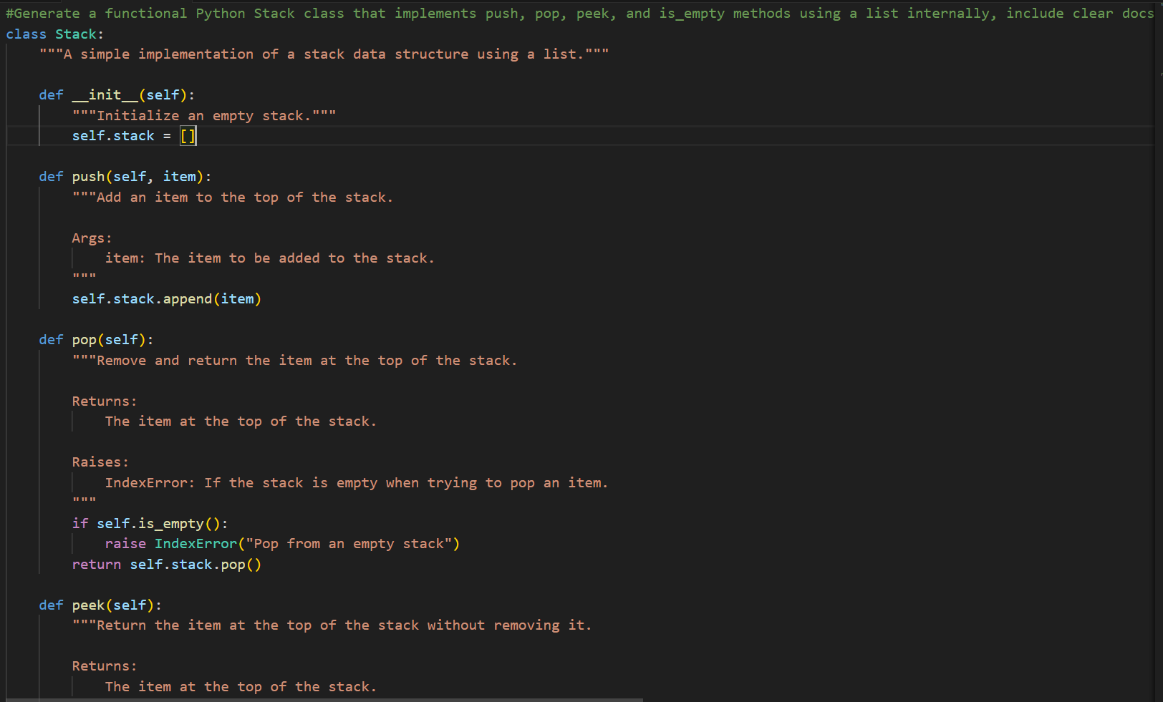
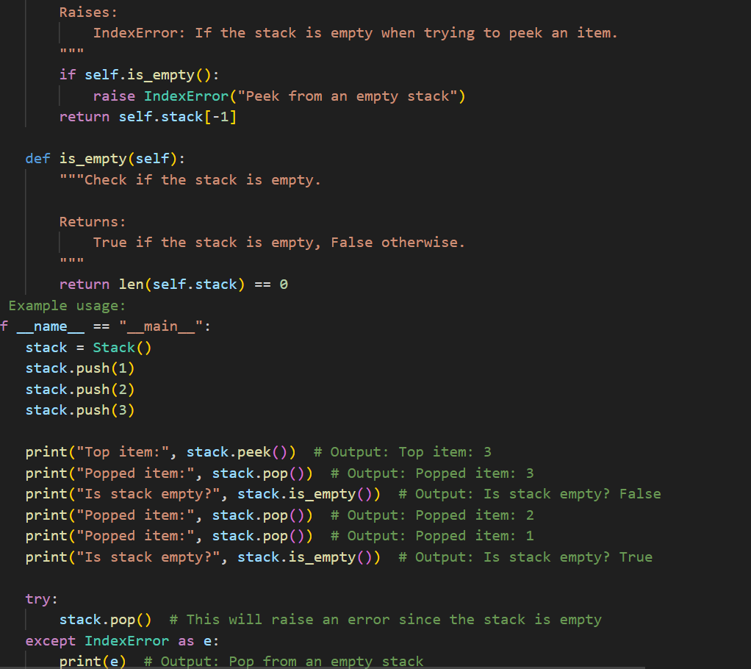
Output:
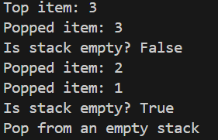
Explanation:
This program implements a Stack using Python list.
A stack works on the LIFO principle (Last In First Out).
That means the last element added will be removed first.
Class Stack
We create a class named Stack to define all stack operations.
A list called _items is used to store the elements.
init Method
This method initializes an empty stack by creating an empty list.
push()
This method adds an element to the top of the stack using append().
pop()
This method removes the top element using pop().
If the stack is empty, it shows an error.
peek()
This method shows the top element without removing it.
is_empty()
This method checks whether the stack is empty or not.
It returns True if empty, otherwise False
Task Description #2 – Queue Implementation
Task: Use AI to implement a Queue using Python lists.
Sample Input Code:
class Queue:
pass
Expected Output:
• FIFO-based queue class with enqueue, dequeue, peek, and size
methods.
Prompt:
Generate a Python Queue class using a list that follows FIFO order and includes enqueue, dequeue, peek, and size methods, with short docstrings and a small example of usage.

Code:
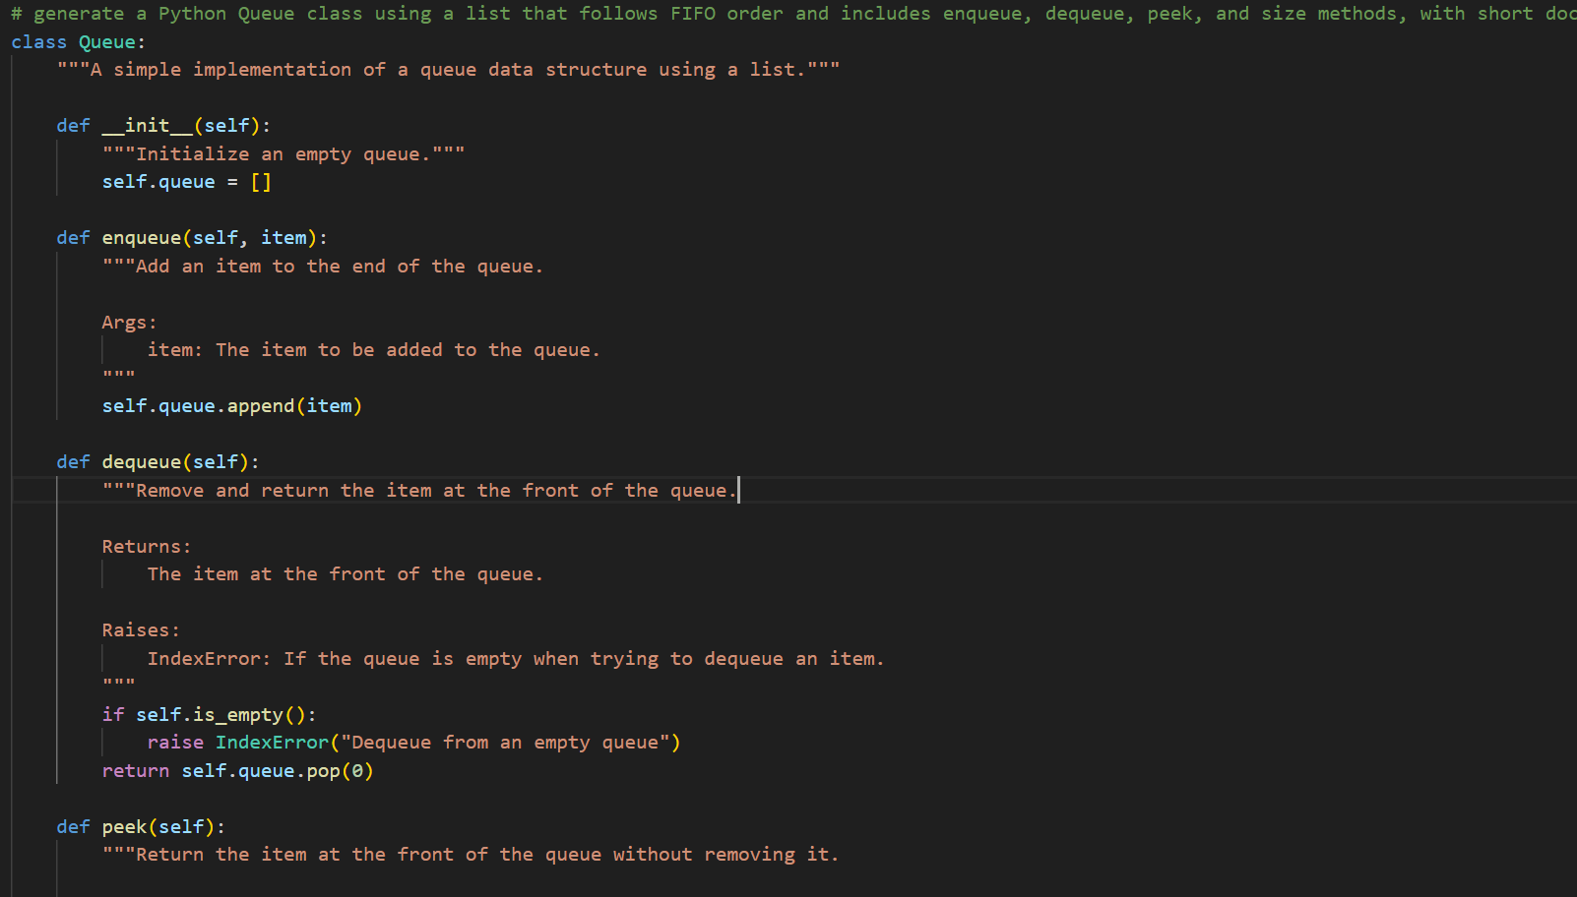
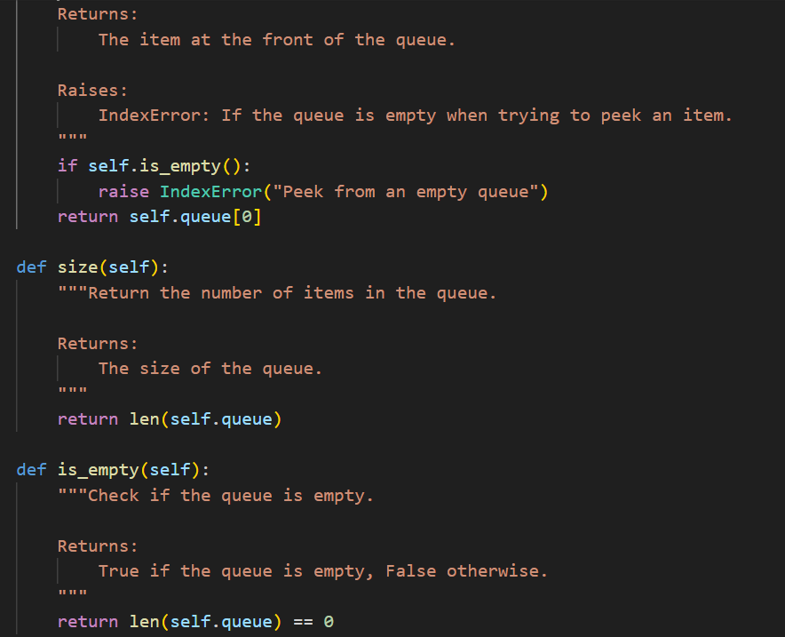
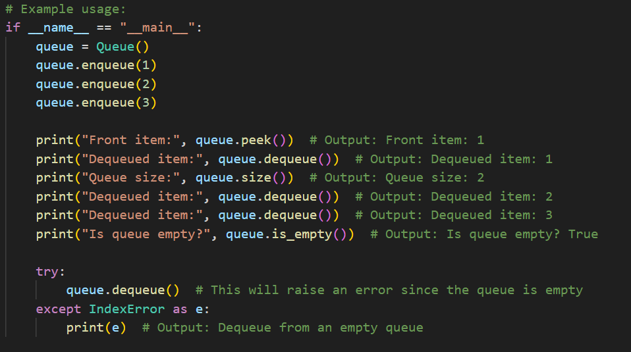
Output:
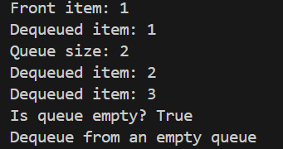

EXPLANATION:
- A queue is a data structure that follows FIFO (First In, First Out) order.
- Elements are added at the rear (enqueue) and removed from the front (dequeue).
- It is used in real-life situations like waiting lines, scheduling tasks, and data processing.

Task Description #3 – Linked List
Task: Use AI to generate a Singly Linked List with insert and display
methods.
Sample Input Code:
class Node:
pass
class LinkedList:
pass
Expected Output:
• A working linked list implementation with clear method
documentation.

Prompt:
#Generate a Python implementation of a singly linked list using a Node class and a LinkedList class, with insert and display methods, and include clear docstrings explaining each method. And small example usage

Code:
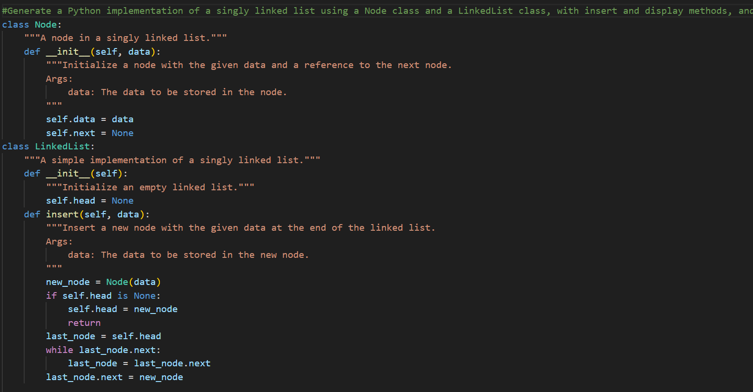
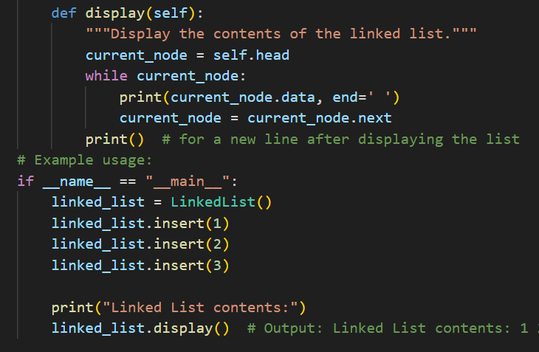
Output:
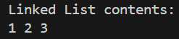
Explanation:
This program implements a Singly Linked List using Python classes.
Each node contains data and a reference to the next node.
The insert() method adds nodes at the end of the list.
The insert_at_beginning() method adds nodes at the start.
The display() method traverses and prints all elements in the linked list.

Task Description #4 – Binary Search Tree (BST)
Task: Use AI to create a BST with insert and in-order traversal methods.
Sample Input Code:
class BST:
pass
Expected Output:
• BST implementation with recursive insert and traversal methods.

Prompt:
#generate a python code for a binary tree with insert and inorder traversal methods, including clear docstrings for each method and a small example of usage.

Code:
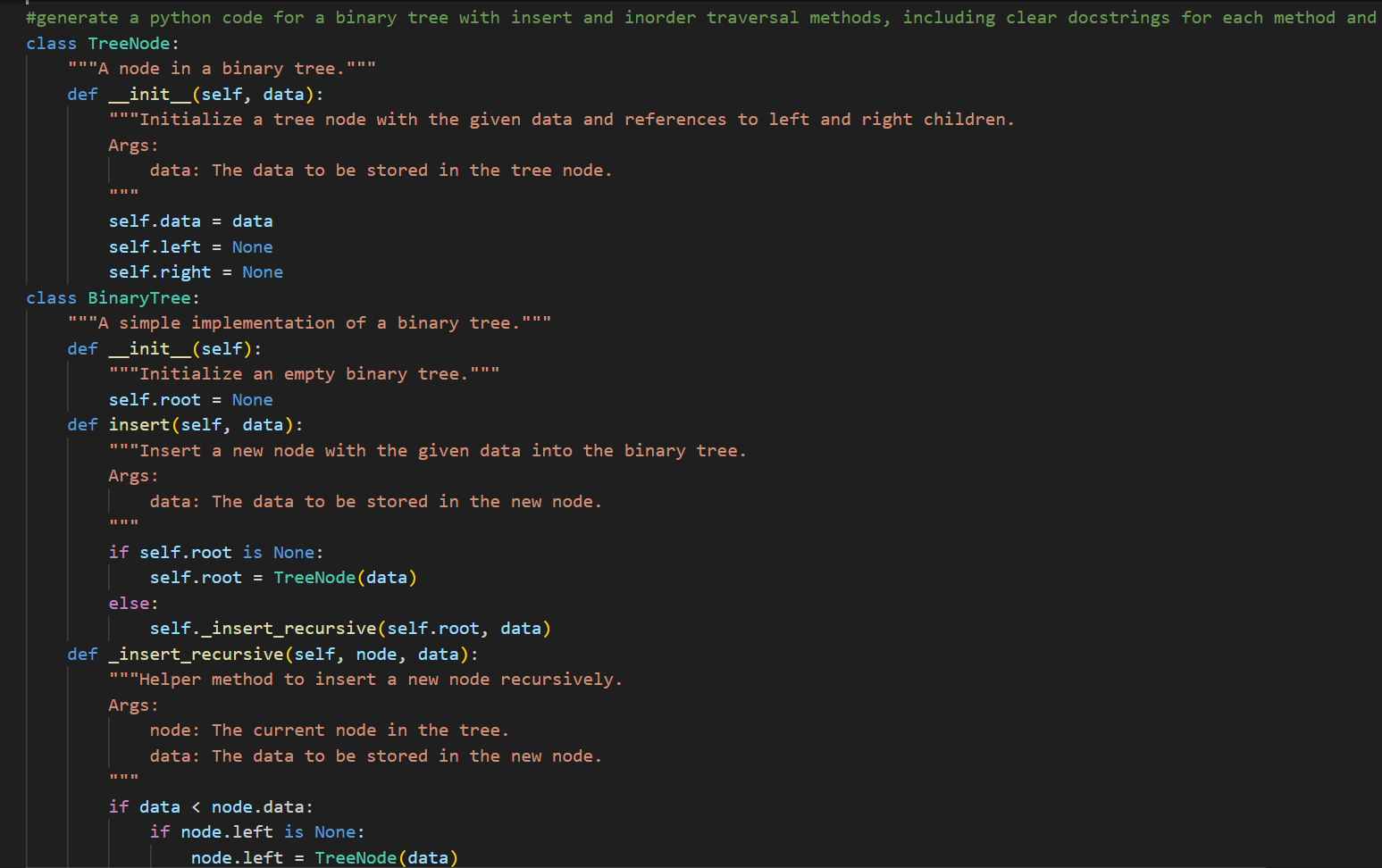
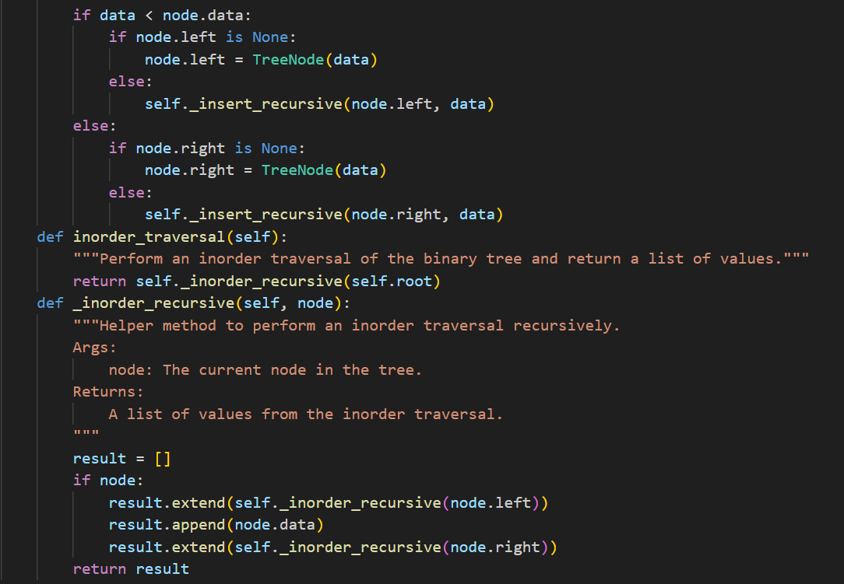
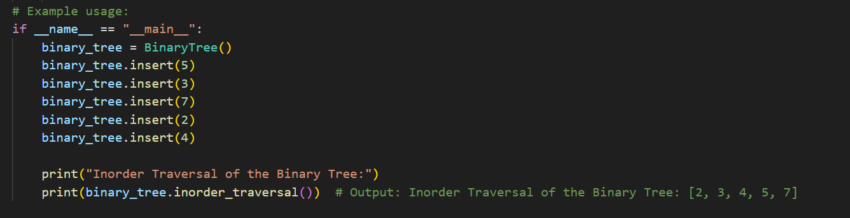
Output:
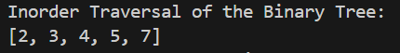

Explanation:
This program implements a Binary Search Tree (BST) using Python classes.
Each node stores a value and references to left and right children.
The insert() method adds elements in correct position using recursion.
Smaller values go to the left and larger values go to the right.
The inorder_traversal() method visits nodes in sorted order (Left → Root → Right).

Task Description #5 – Hash Table
Task: Use AI to implement a hash table with basic insert, search, and
delete methods.
Sample Input Code:
class HashTable:
pass
Expected Output:
• Collision handling using chaining, with well-commented methods.

Prompt: #generate a Python implementation of a hash table using separate chaining for collision resolution, with methods for inserting key-value pairs, retrieving values by key, and deleting key-value pairs, including clear docstrings for each method and a small example of usage.

Code:
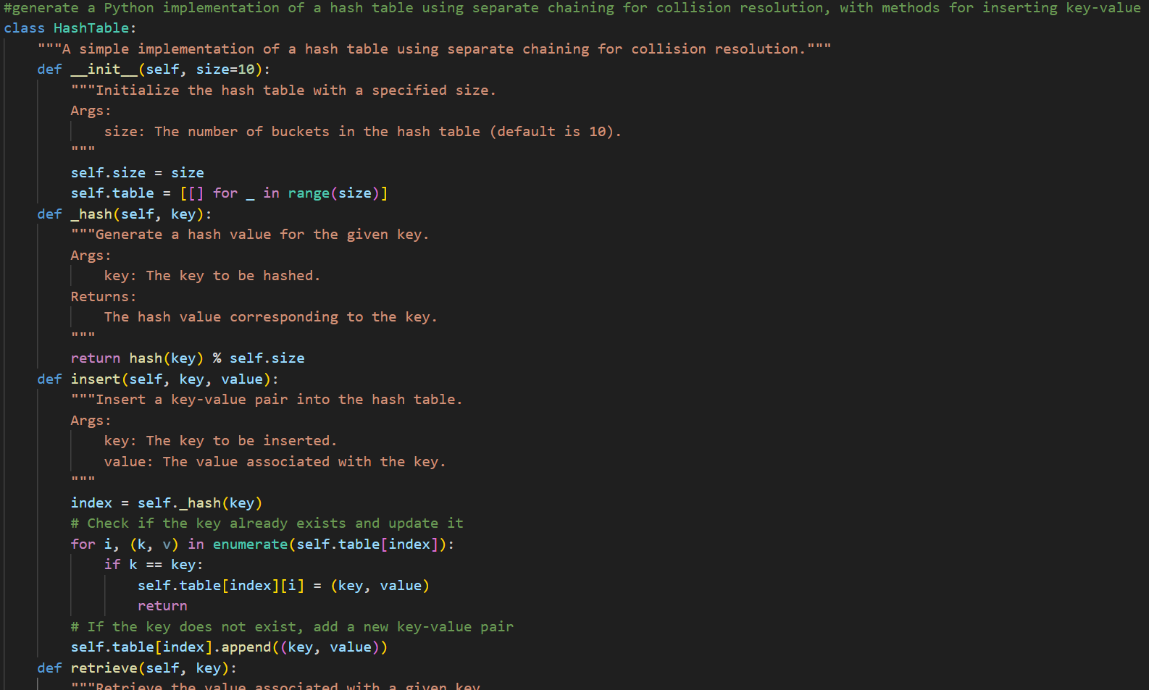
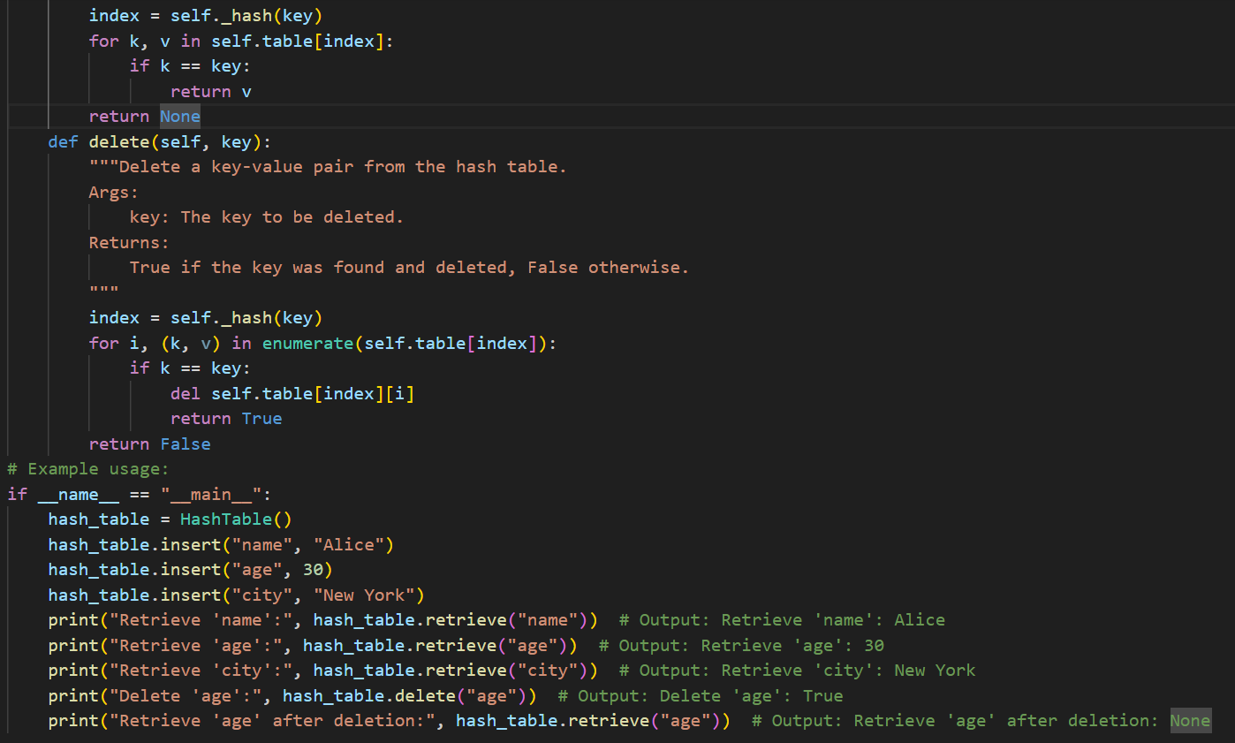
Output:
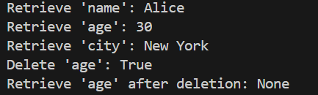

Explanation:
- A hash table is a data structure that stores data as key–value pairs.
- It uses a hash function to quickly find the index where data is stored.
- Hash tables allow fast searching, insertion, and deletion of data.

Task Description #6 – Graph Representation
Task: Use AI to implement a graph using an adjacency list.
Sample Input Code:
class Graph:
pass
Expected Output:
• Graph with methods to add vertices, add edges, and display
connections.

Prompt:
#generate a Python Graph class using an adjacency list with methods to add vertices, add edges, and display the graph connections, including brief docstrings and an example.

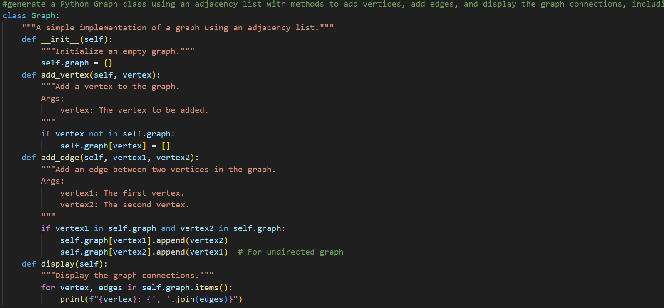
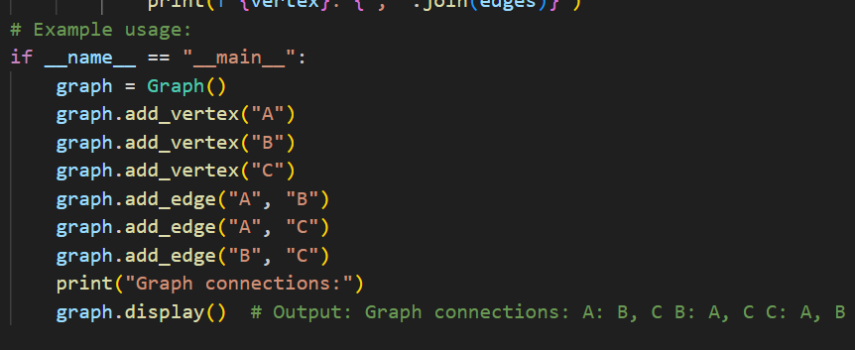
Output:
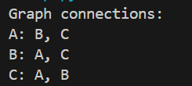

Explanation:
- A graph representation shows how vertices (nodes) and edges (connections) are stored in a computer.
- An adjacency list stores each vertex and a list of the vertices connected to it.
- This method is memory-efficient and makes it easy to add and view connections between nodes.

Task Description #7 – Priority Queue
Task: Use AI to implement a priority queue using Python’s heapq
module.
Sample Input Code:
class PriorityQueue:
pass
Expected Output:
• Implementation with enqueue (priority), dequeue (highest priority),
and display methods.

Prompt:#generate a Python PriorityQueue class using the heapq module with enqueue (with priority), dequeue (highest priority), and display methods, including brief docstrings and a simple example.
Code:
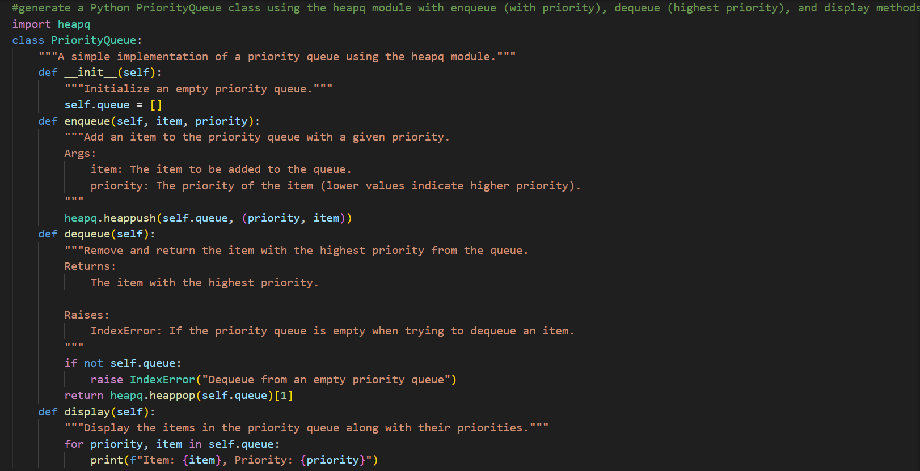
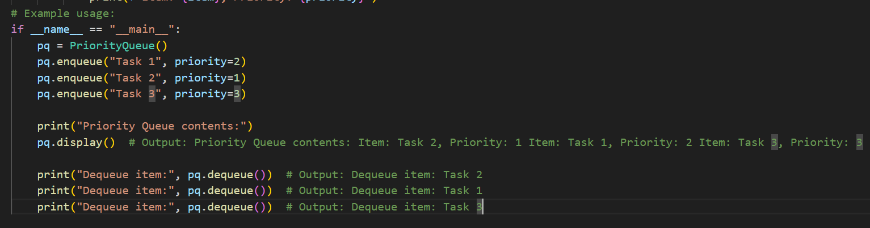
Output:
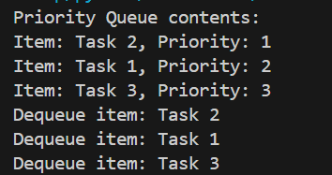
- Explanation: A priority queue is a data structure where each element has a priority value.
- Elements with higher priority are removed first, not just by order of arrival.
- It is commonly implemented using a heap to allow fast insertion and removal.
Task Description #8 – Deque
Task: Use AI to implement a double-ended queue using
collections.deque.
Sample Input Code:
class DequeDS:
pass
Expected Output:
• Insert and remove from both ends with docstrings.

Prompt:
#generate a python deque class using collections.deque with methods for adding to both ends, removing from both ends, and displaying the contents, including brief docstrings and an example.
Code:
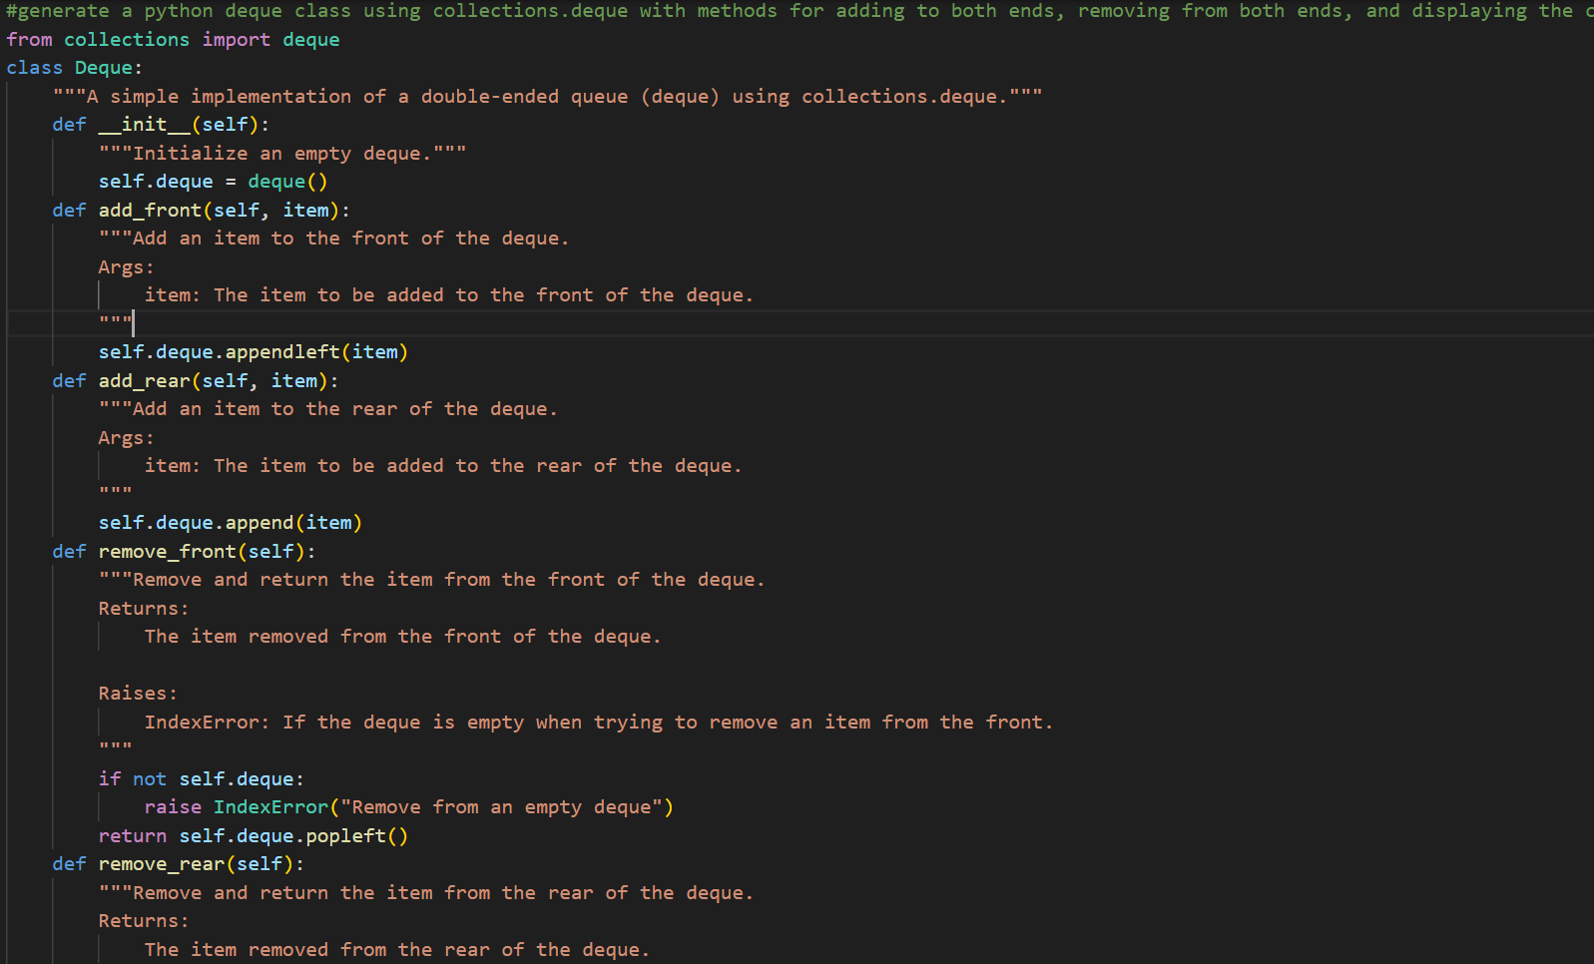
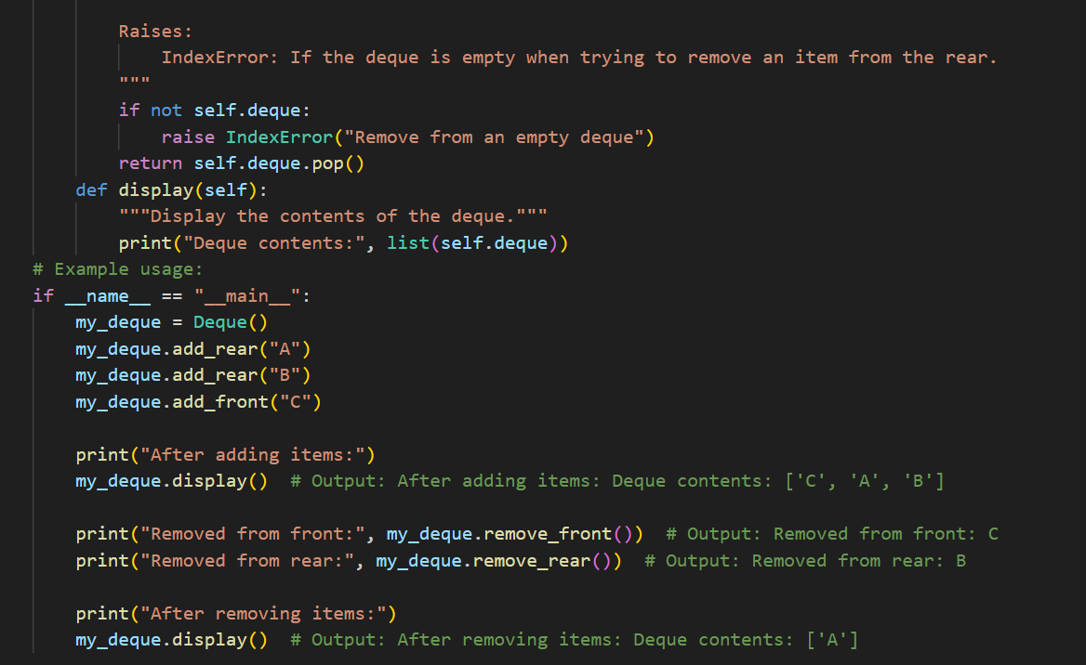
Output:
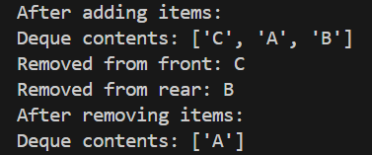
Explanation:
- A deque (double-ended queue) is a data structure that allows adding and removing elements from both the front and rear.
- It is flexible and faster than lists for operations at both ends.
- In Python, it is efficiently implemented using collections.deque.

Task Description #9 Real-Time Application Challenge – Choose the
Right Data Structure
Scenario:
Your college wants to develop a Campus Resource Management System
that handles:
1. Student Attendance Tracking – Daily log of students
entering/exiting the campus.
2. Event Registration System – Manage participants in events with
quick search and removal.
3. Library Book Borrowing – Keep track of available books and their
due dates.
4. Bus Scheduling System – Maintain bus routes and stop
connections.
5. Cafeteria Order Queue – Serve students in the order they arrive.
Student Task:
• For each feature, select the most appropriate data structure from
the list below:
o Stack
o Queue
o Priority Queue
o Linked List
o Binary Search Tree (BST)
o Graph
o Hash Table
o Deque
• Justify your choice in 2–3 sentences per feature.
• Implement one selected feature as a working Python program with
AI-assisted code generation.
Expected Output:
• A table mapping feature → chosen data structure → justification.
• A functional Python program implementing the chosen feature

PROMPT:
#For a campus resource management scenario, create a table that maps each feature to the most suitable data structure with a 2–3 sentence justification, and generate a working Python program implementing one chosen feature with clear comments and docstrings.

CODE:
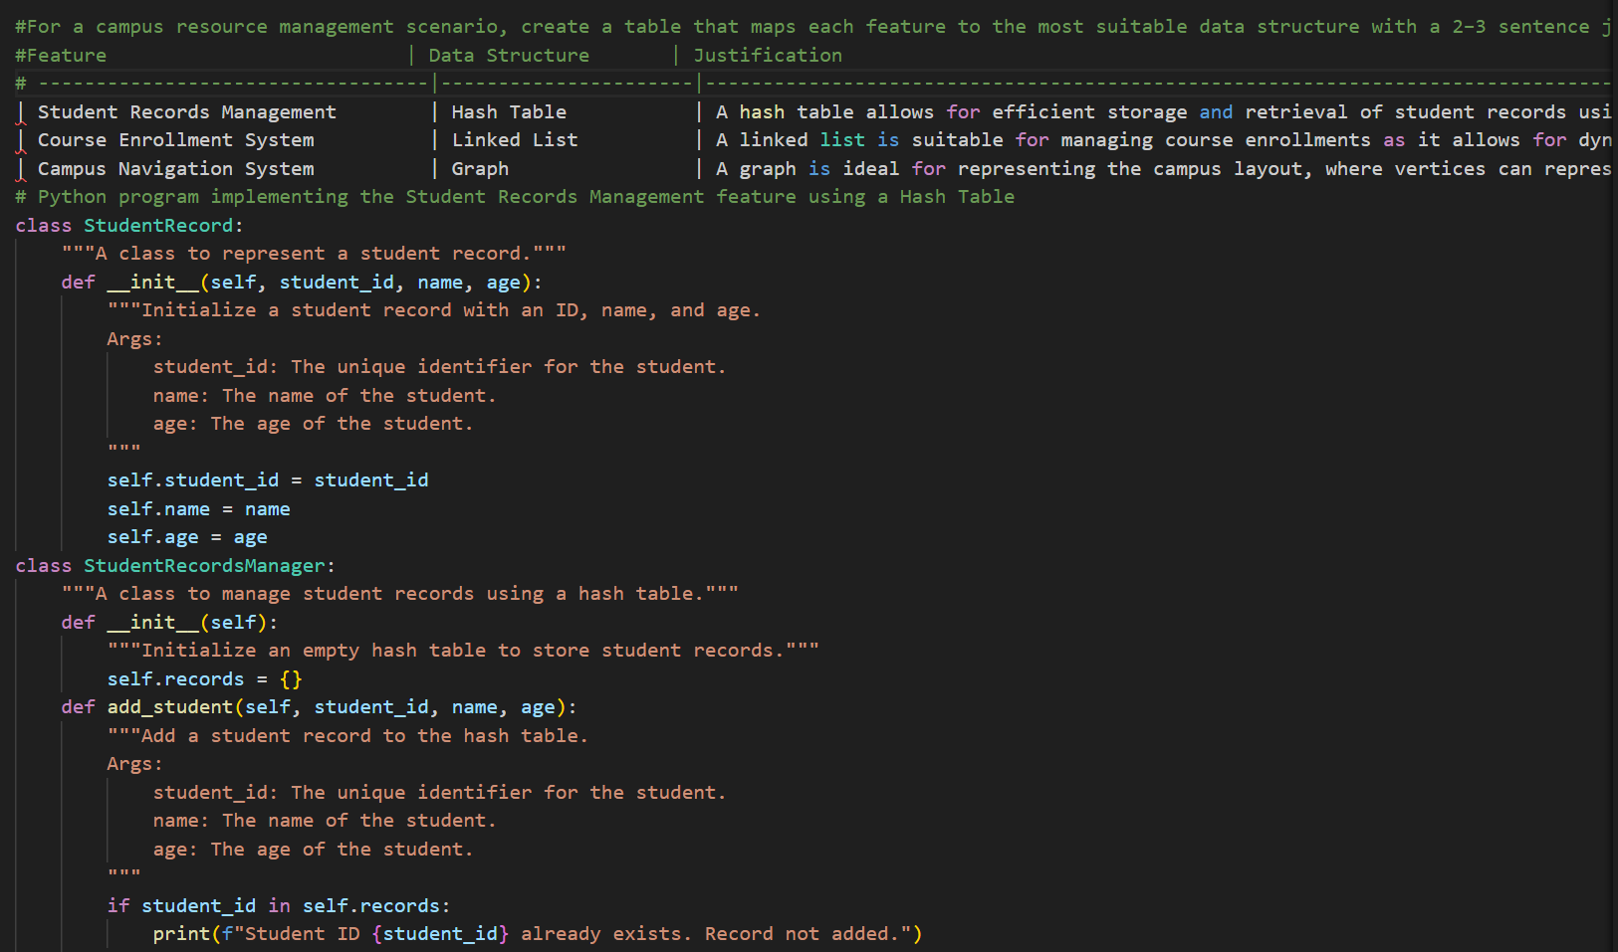

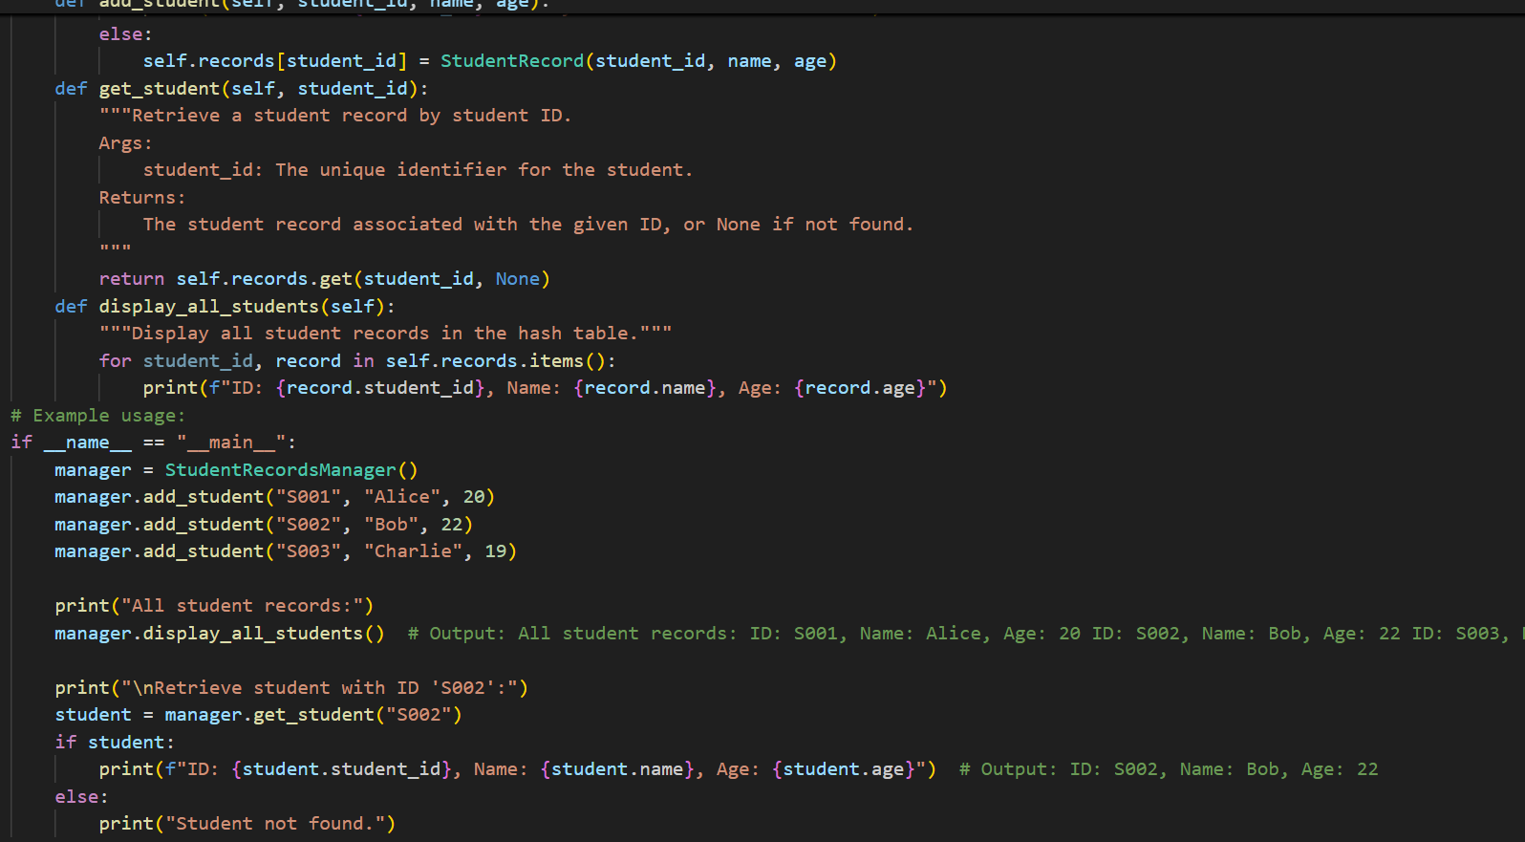
OUTPUT:
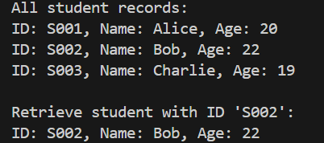

EXPLANATION:
- The prompt asks the AI to analyze a real-world scenario and match each feature with a suitable data structure.
- It requires justification so the reasons for choosing each structure are clear.
- It also tells the AI to generate a working Python program for one feature with proper comments and documentation.

Task Description #10: Smart E-Commerce Platform – Data Structure
Challenge
An e-commerce company wants to build a Smart Online Shopping System
with:
1. Shopping Cart Management – Add and remove products
dynamically.
2. Order Processing System – Orders processed in the order they are
placed.
3. Top-Selling Products Tracker – Products ranked by sales count.
4. Product Search Engine – Fast lookup of products using product ID.
5. Delivery Route Planning – Connect warehouses and delivery
locations.
Student Task:
• For each feature, select the most appropriate data structure from
the list below:
o Stack
o Queue
o Priority Queue
o Linked List
o Binary Search Tree (BST)
o Graph
o Hash Table
o Deque
• Justify your choice in 2–3 sentences per feature.
• Implement one selected feature as a working Python program with
AI-assisted code generation.
Expected Output:
• A table mapping feature → chosen data structure → justification.
• A functional Python program implementing the chosen feature
with comments and docstrings.

Prompt:
#For a smart e-commerce platform scenario, create a table mapping each feature to the most suitable data structure with a 2–3 sentence justification, and generate a working Python program implementing one selected feature with clear comments and docstrings

Code:
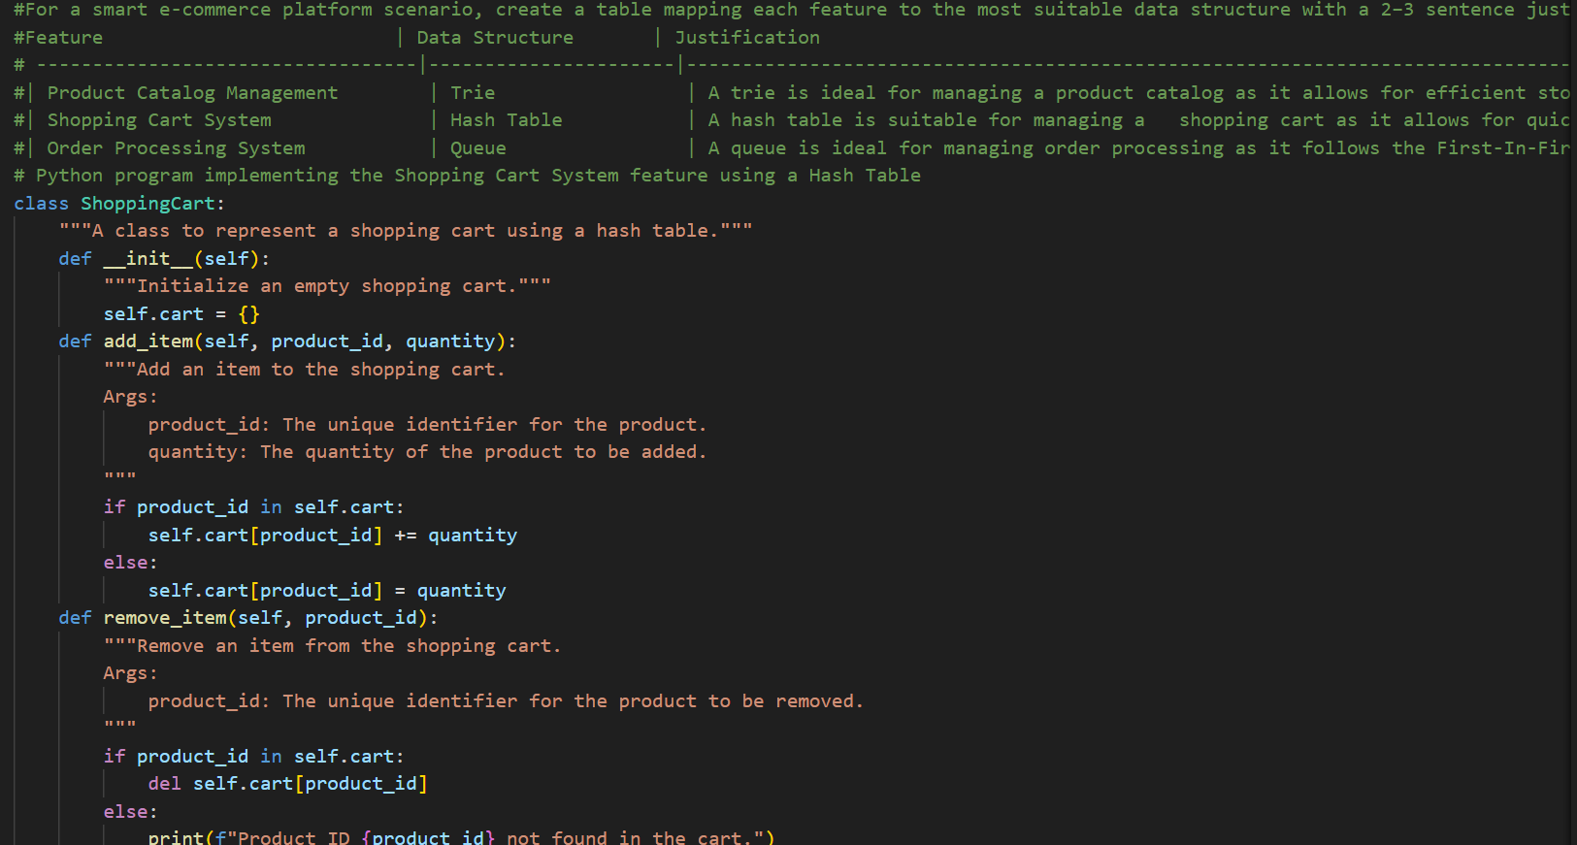
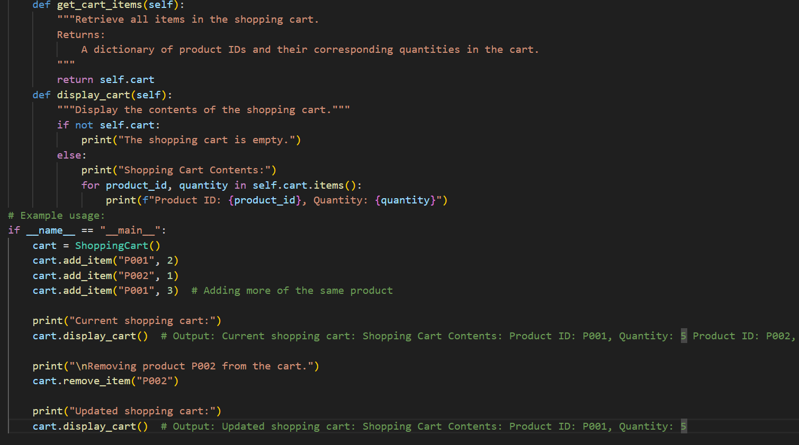

Output:
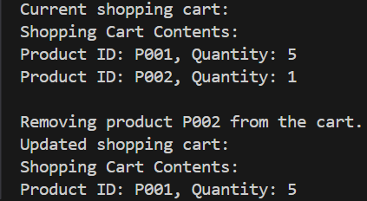

Explanation:
- The prompt tells the AI to study the e-commerce features and pick suitable data structures.
- It asks for short explanations to justify each choice.
- It also requires a Python program that implements one feature with proper comments and documentation.

