AI-ASSISTED CODING
ASSIGNMENT-12.3

Bandam Akarsh
2303A53018

B-46
Task 1: Sorting Student Records for Placement Drive
Scenario
SR University’s Training and Placement Cell needs to shortlist candidates
efficiently during campus placements. Student records must be sorted by
CGPA in descending order.
Tasks
1. Use GitHub Copilot to generate a program that stores student records
(Name, Roll Number, CGPA).
2. Implement the following sorting algorithms using AI assistance:
o Quick Sort
o Merge Sort
3. Measure and compare runtime performance for large datasets.
4. Write a function to display the top 10 students based on CGPA.
Expected Outcome
• Correctly sorted student records.
• Performance comparison between Quick Sort and Merge Sort.
• Clear output of top-performing students.

Prompt:
#Generate a Python program to manage student placement records (name, roll number, CGPA), implement Quick Sort and Merge Sort to sort students by CGPA in descending order, compare their runtime performance on large datasets, and display the top 10 students with clear output and comments.

Code:
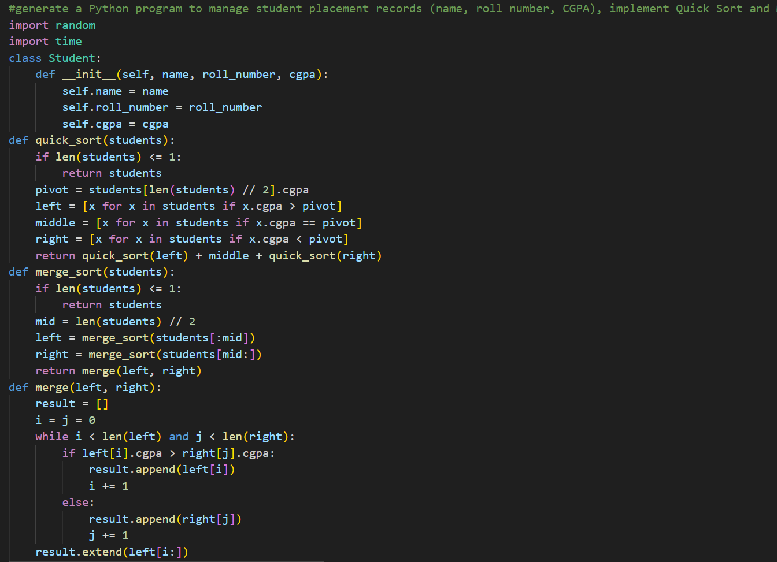

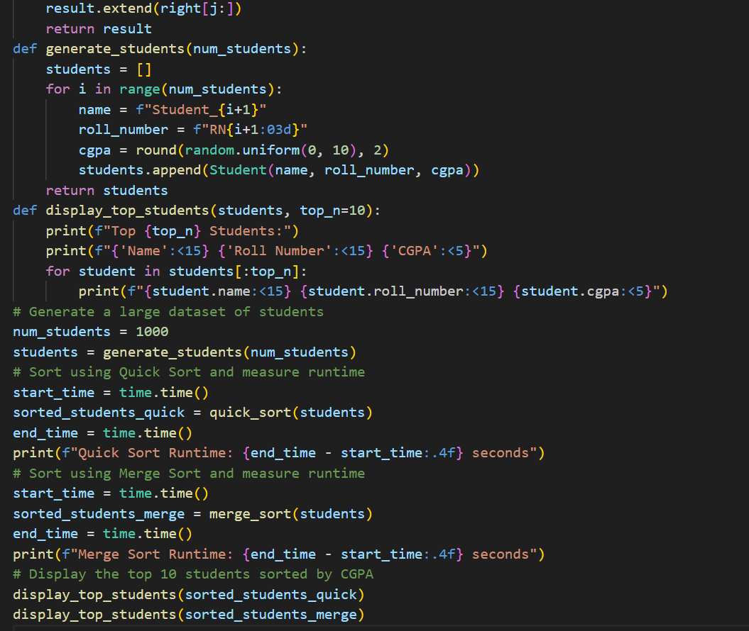
Output:
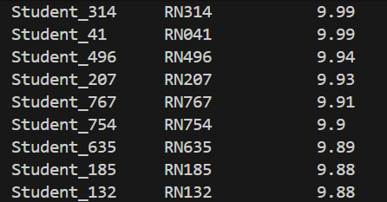

Explanation:
- The prompt asks the AI to create a program for managing student records for placements.
- It requires implementing Quick Sort and Merge Sort and comparing their performance.
- It also tells the AI to show the top 10 students with clear and organized output.

Task 2: Implementing Bubble Sort with AI Comments
• Task: Write a Python implementation of Bubble Sort.
• Instructions:
• Students implement Bubble Sort normally.
• Ask AI to generate inline comments explaining key logic (like
swapping, passes, and termination).
• Request AI to provide time complexity analysis.
• Expected Output:
• A Bubble Sort implementation with AI-generated explanatory
comments and complexity analysis.

PROMPT:
#Generate a Python implementation of Bubble Sort with clear inline comments explaining the swapping process, passes, and termination condition, and include a brief time complexity analysis

CODE:
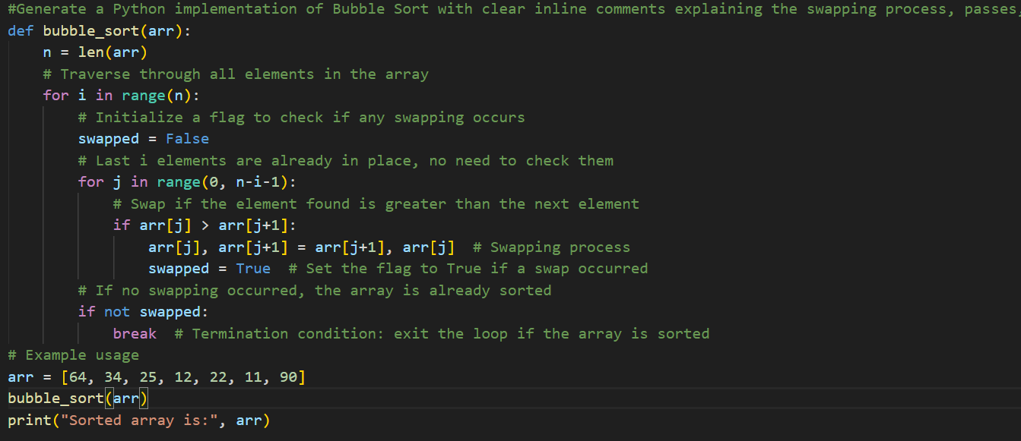

OUTPUT:

EXPLANATION:

# Time complexity analysis:
The worst-case and average-case time complexity of Bubble Sort is O(n^2) because
it requires two nested loops to compare each element with every other element.
The best-case time complexity is O(n) when the array is already sorted, as it only requires one pass to check that the array is sorted without performing any swaps.

Task 3: Quick Sort and Merge Sort Comparison
• Task: Implement Quick Sort and Merge Sort using recursion.
• Instructions:
• Provide AI with partially completed functions for recursion.
• Ask AI to complete the missing logic and add docstrings.
• Compare both algorithms on random, sorted, and reverse-sorted
lists.
• Expected Output:
• Working Quick Sort and Merge Sort implementations.
• AI-generated explanation of average, best, and worst-case
complexities.

PROMPT:
#Complete the recursive Python implementations of Quick Sort and Merge Sort by filling in the missing logic, add clear docstrings, compare their performance on random, sorted, and reverse-sorted lists, and explain their average, best, and worst-case time complexities.

CODE:

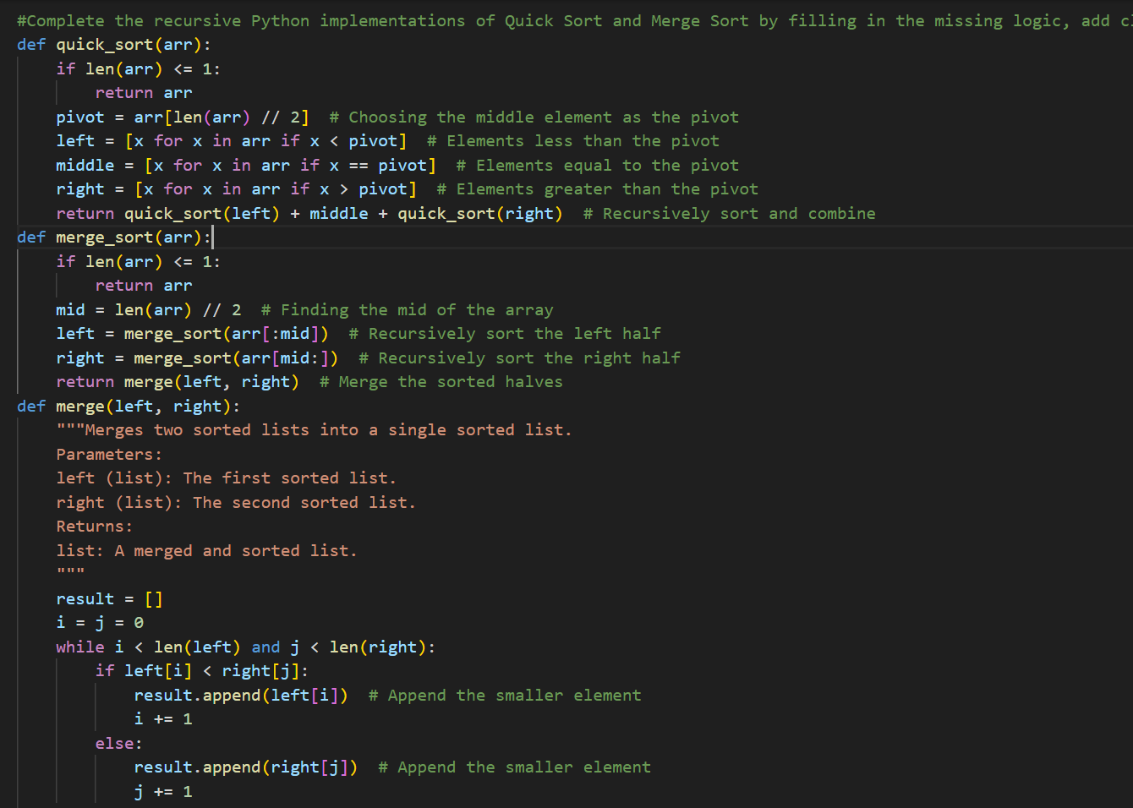

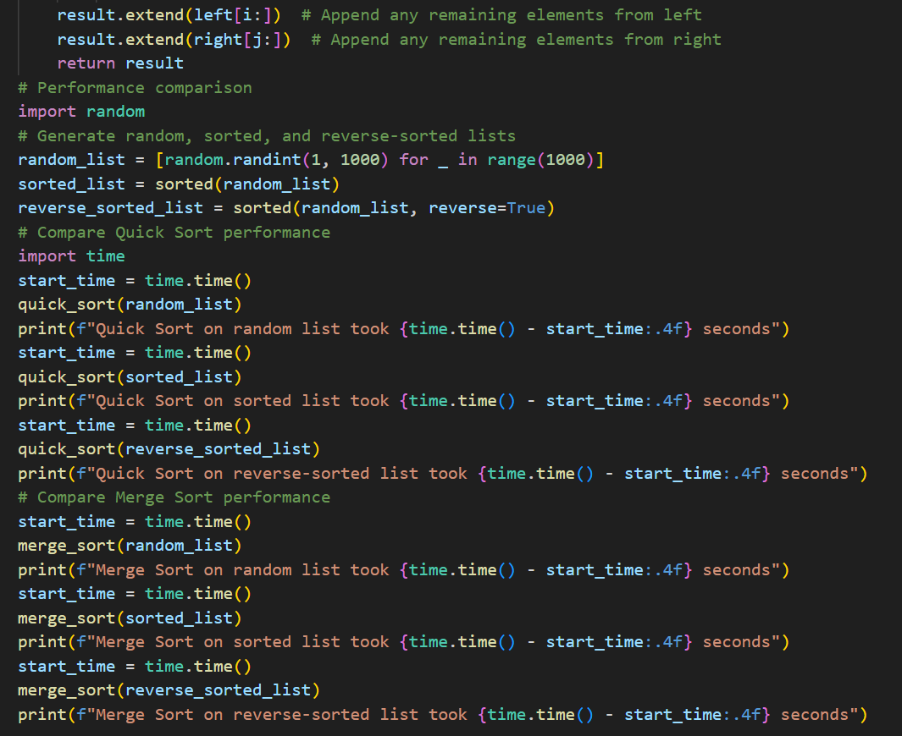
OUTPUT:

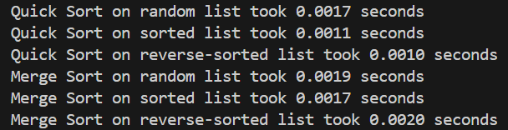

EXPLANATION:
QUICK SORT-
Sorts an array using the Quick Sort algorithm.
Parameters:
arr (list): The list of elements to be sorted.

Returns:
list: A new sorted list in ascending order.

Time Complexity:
- Average Case: O(n log n)
- Best Case: O(n log n)
- Worst Case: O(n^2) (when the smallest or largest element is always chosen as the pivot)
MERGESORT:
Sorts an array using the Merge Sort algorithm.
Parameters:
arr (list): The list of elements to be sorted.
Returns:
list: A new sorted list in ascending order.
Time Complexity:
- Average Case: O(n log n)
- Best Case: O(n log n)
- Worst Case: O(n log n) (Merge Sort always divides the array into halves)

Task 4 (Real-Time Application – Inventory Management System)
Scenario: A retail store’s inventory system contains thousands of products,
each with attributes like product ID, name, price, and stock quantity. Store staff
need to:
1. Quickly search for a product by ID or name.
2. Sort products by price or quantity for stock analysis.
Task:
• Use AI to suggest the most efficient search and sort algorithms for this
use case.
• Implement the recommended algorithms in Python.
• Justify the choice based on dataset size, update frequency, and
performance requirements.
Expected Output:
• A table mapping operation → recommended algorithm → justification.
• Working Python functions for searching and sorting the inventory.

PROMPT:
#For a retail inventory management system, recommend efficient search and sorting algorithms for each operation, present them in a table with justifications based on dataset size and performance needs, and generate working Python functions to implement the chosen algorithms with comments.

CODE:
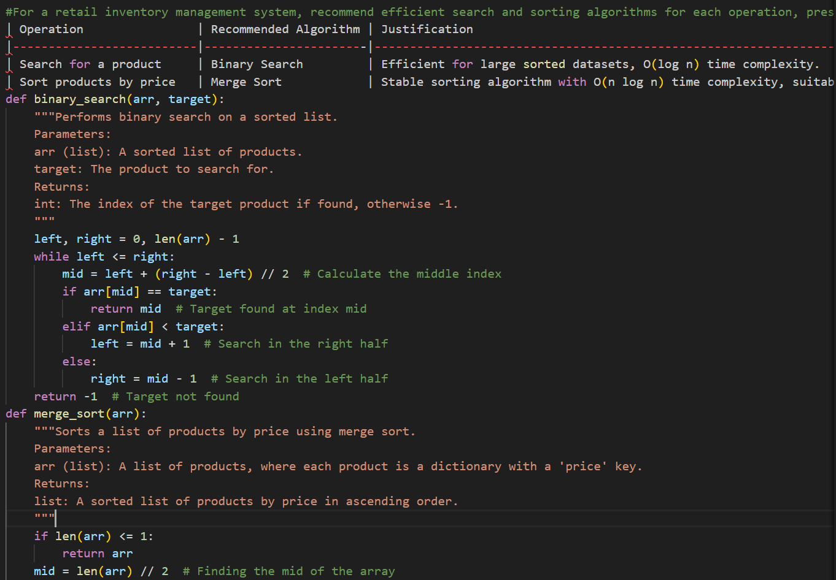
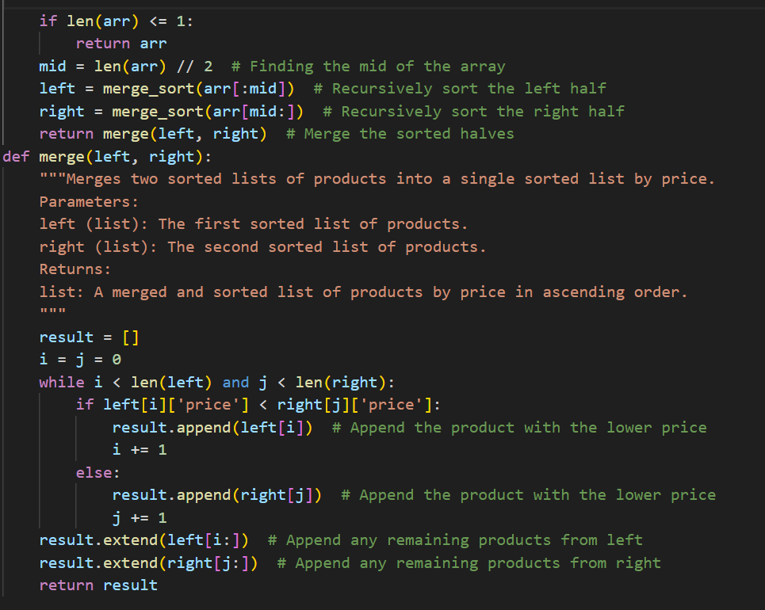

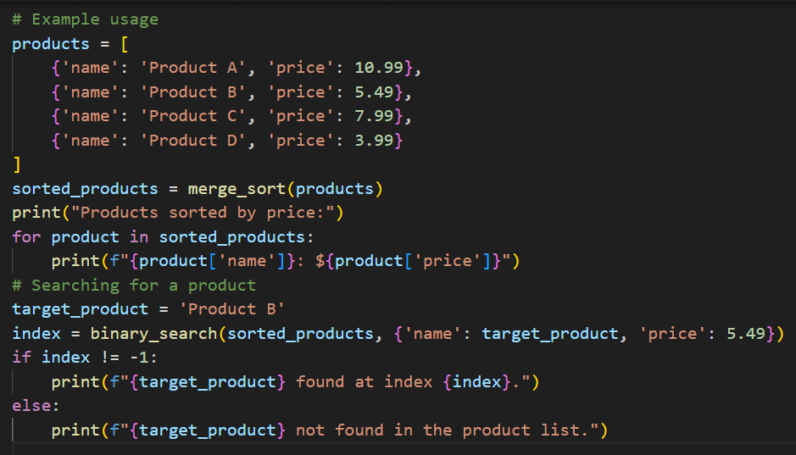

OUTPUT:
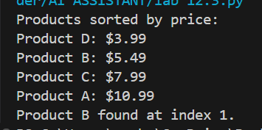

EXPLANATION:
- The prompt asks the AI to choose suitable search and sorting algorithms for an inventory system.
- It requires reasons (justification) for each choice based on performance needs.
- It also tells the AI to write working Python functions that implement those algorithms.

Task 5: Real-Time Stock Data Sorting & Searching
Scenario:
An AI-powered FinTech Lab at SR University is building a tool for analyzing
stock price movements. The requirement is to quickly sort stocks by daily
gain/loss and search for specific stock symbols efficiently.
• Use GitHub Copilot to fetch or simulate stock price data (Stock
Symbol, Opening Price, Closing Price).
• Implement sorting algorithms to rank stocks by percentage change.
• Implement a search function that retrieves stock data instantly when a
stock symbol is entered.
• Optimize sorting with Heap Sort and searching with Hash Maps.
• Compare performance with standard library functions (sorted(), dict
lookups) and analyze trade-offs

PROMPT:
#generate a Python program that simulates stock data (symbol, opening and closing price), sorts stocks by percentage change using Heap Sort, searches stocks efficiently using a hash map, compares performance with built-in sorted() and dictionary lookups, and includes clear comments and analysis of trade-offs.”

CODE:
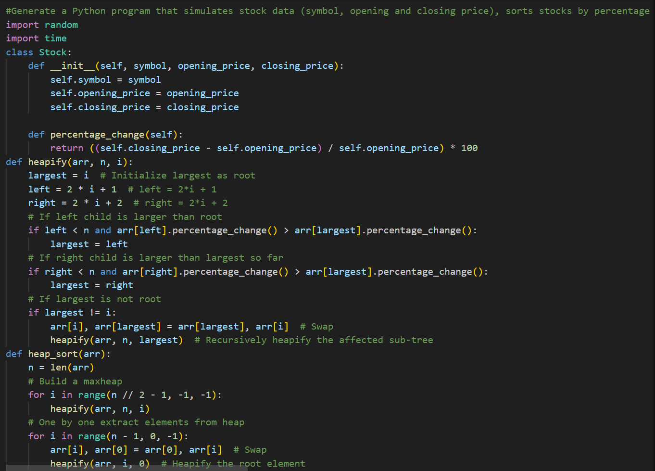
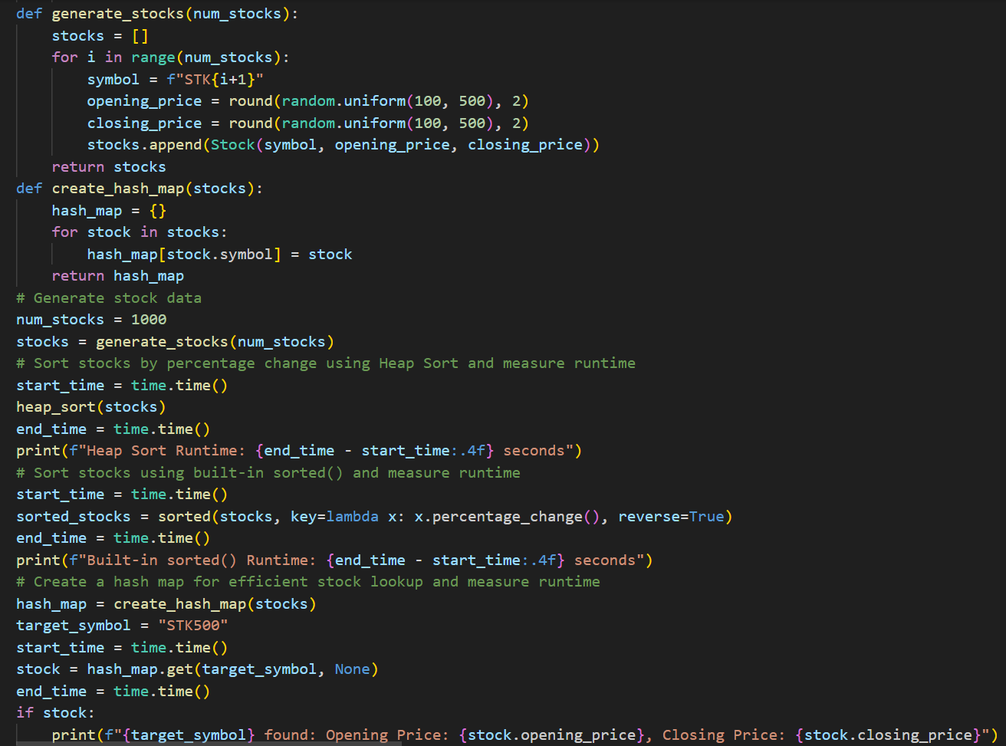
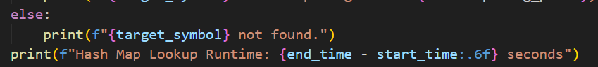

OUTPUT:
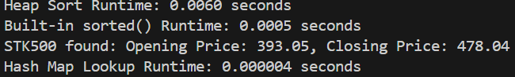

EXPLANATION:
- The prompt asks the AI to create a program that simulates and analyzes stock data.
- It requires using Heap Sort for sorting and hash maps for fast searching.
- It also tells the AI to compare performance with built-in functions and explain the trade-offs.

