CS4650-Final Project--
Count Available Parking lot
Team numbers:
Li Xu 14228745
Tianzheng Huang
Implementation language：Matlab
Datasets we are going to use: Pictures from Google Map

Idea:
It is useful to count the number of parking sets of a location like school, supermarket and parking space around stadium. Nowadays, the most useful technology to statistic the parking sets is arranging a sensor at the entrance of the parking location. It is costly for we need buy and maintain machines and not intelligent enough, for some cars are getting out of the parking sets and it shows it is on the parking until it pass through the exit of the location after 3 minutes.
I randomly look through the Google map recently. I find the map is clear enough to check a parking sets through the pictures from the satellites. So I wonder if it is possible to check the number of parking sets of a location by the pictures of Google Maps.

Design:
Method we refer to the former assignment:
We use the edge detection technology(sobel filter) to check some remarkable edges.We will fill in the edges with white color (grayscale = 255) by a threshold value about 20 from the Sobel filter. This value is effective to check most of obvious boundary of two different colors objects. It can also detect the parking lines’ outline as it shows in the following pictures. Then, we can use the CCL algorithm to count the size of objects in binary images.
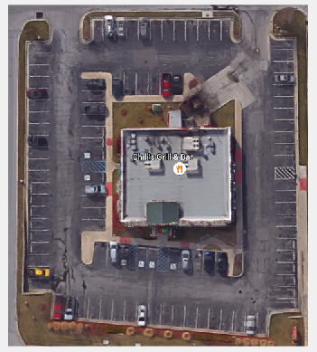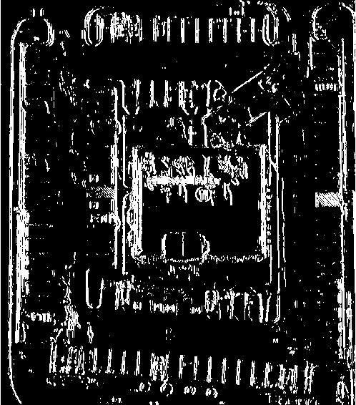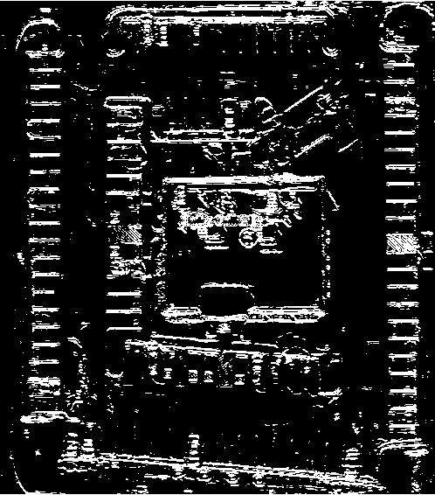
Source image Gx filter Gy filter

Method we create to detect only parking lines:
①. Remove noise
We analysis this picture and the parking lines is about the 3-5 pixels wide and 30 high. So most line’s size equals to 90-150. So we consider the components whose size is larger than 200 or less than 20 as noise and remove it.
②．Detect figure of the parking lines
We go through the labeled array of image. We will find the the start and end of one label as a components when go through the image. We record the two key points of the components in a 1D arraylist.
start

End
1 | 2 | 3 | 4 | 5 | 6 | 7 | 8 | 9 | 10
start/end | null | start/end | null | null | null | start/end | null | null | start/end

With value means is a label to component which is not noise.
Null means labels not use, union to another or eliminated as noise.

△x = xstart - xend △y= ystart-yend
If min(△x , △y) equals to 3-7 and max(△x , △y) equals to 25-35 means it is a parking line. It looks like a rectangle stripe.
This time only mark these component.

③.Count the parking lots

1
3

7

Like this one it only has 15 parking lots, but 20 lines.
In the image, we can find label in arraylist sequence which symbols a parking line.
The center point of a parking line is near to ((xstart + xend)/2,(ystart + yend)/2)start. Now we go from the center point of parking lines to a vertical direction up and down(left and right if the line is vertical to the image).
It is about 3 times width of the parking space than parking lines. In the example, it is 15 pixels.
1 | 2 | 3 | 4 | 5 | 6 | 7 | 8 | 9 | 10
isline | null | isline | null | null | null | isline | null | null | isline

So we go 15 pixels up, find the next pixels, if the it is white(255), find the new labels of this pixels, turn it isn’tline, then count plus one.
Then from this line, go the same direction and check next line in the same way.
If no line, means end. Then back to the source line, check in the same way to a inverse direction until no return.
Go on going through the arraylist, fine a isline one and do the same way until go to the end of the line.
The return values is about the parking lots in reality.
But actually errors exist. Only a approximate value at present.

Comments from instructors.：
Proposal is OK. The technique however, the way its described will not work that effectively. You can attempt it but it may need something more sophisticated

