FOREST RUNNER – BAMBOO GROOVES
A course project report submitted in partial fulfilment of the requirement
of
GAME MECHANICS, DESIGN AND DEVELOPMENT
by
B.PRANEETH (2303A51711)

Under the guidance of
Dr.Vijay Chandra Jadala
Asst. Professor, Department of CS & AI


SR University, Warangal
APRIL-2026
INDEX :
1. Introduction
2. Objectives of the Project
3. Game Overview
4. Game Design
5. Game Mechanics
6. Game Controls
7. Technical Implementation
8. Testing
9. Game flow
10. Future Enhancements
11.Conclusion

ABSTRACT :
Endless Forest Runner – Bamboo Grooves is an endless runner game developed using the Unity game engine and C# programming language as part of the course Game Mechanics and Design Development. The game is set in a visually engaging bamboo forest environment, where players control a character running through an endless path while avoiding obstacles, collecting coins and gems, and achieving the highest possible score.
The game incorporates various interactive mechanics, including three-lane movement, jumping, sliding, collision detection, collectible items, power-ups, and progressive difficulty. Players can select from multiple characters and use special abilities such as Coin Magnet, Bamboo Shield, Double Coins, and Jade Dash to enhance their gameplay experience. The game also features a scoring system, missions, rewards, pause functionality, and a revive system to make the gameplay more engaging and challenging.
The primary objective of this project is to apply fundamental game design principles and game mechanics to develop an interactive and entertaining gaming experience. It demonstrates the practical implementation of player controls, game physics, collision handling, procedural environment generation, user interaction, and game state management.
Through this project, practical knowledge of game development, Unity tools, C# scripting, gameplay design, and interactive system implementation is demonstrated. Overall, Bamboo Grooves provides an engaging endless runner experience while showcasing the application of game mechanics and design concepts in a real-world game development project.

OBJECTIVES:
The main objectives of the Bamboo Grooves are:
- To develop an engaging endless runner game using Unity and C#.
- To implement basic game mechanics such as jumping, sliding, and lane switching.
- To design an interactive bamboo forest environment.
- To implement obstacles, collectibles, and power-ups to enhance gameplay.
- To create a scoring system and progressive difficulty levels.
- To improve practical knowledge of game design, player interaction, and game development.
GAME OVERVIEW:
Bamboo Grooves is a 3D endless runner game developed using Unity and C#. The game takes place in a beautiful bamboo forest where the player continuously runs along a path, avoiding obstacles and collecting coins and gems.
Players can switch between three lanes, jump over obstacles, and slide underneath barriers to survive as long as possible. The game also features multiple selectable characters, special power-ups, a scoring system, and increasing difficulty as the game progresses.
The main goal is to achieve the highest score by covering the maximum distance while avoiding obstacles and collecting rewards.

GAME DESIGN :
The game Bamboo Grooves is designed with a 3D bamboo forest theme, providing an immersive and engaging environment. The design focuses on simple controls, attractive visuals, and interactive gameplay.
The main elements of the game design include:
1. Environment Design: A green bamboo forest environment with a continuous running path and natural surroundings.
2. Character Design: The game provides four selectable characters: Kai, Mei, Master Lin, and Shadow.
3. Obstacle Design: Different obstacles are placed along the running path to challenge the player's movement and reflexes.
4. Collectibles Design: Coins and jade gems are placed throughout the environment for players to collect and earn rewards.
5. User Interface Design: The game includes menus, character selection, score display, pause options, and game-over screens.
6. Audio and Visual Design: Sound effects, animations, and visual effects are used to make the gameplay more interactive and enjoyable.
GAME MECHANICS:
The game Bamboo Grooves includes several gameplay mechanics that make the player experience interactive and challenging.
- Lane Switching: Players can move between three lanes to avoid obstacles and collect rewards.
- Jumping: Allows players to jump over obstacles placed on the running path.
- Sliding: Players can slide underneath barriers to avoid collisions.
- Obstacle Detection: Collision detection identifies when the player hits an obstacle and triggers the game-over condition.
- Coin Collection: Players collect coins during the run to increase their rewards.
- Power-ups: The game includes four power-ups:
  - Coin Magnet – Attracts nearby coins.
  - Bamboo Shield – Protects against collisions.
  - Double Coins – Doubles coin rewards.
  - Jade Dash – Provides a temporary speed boost and protection.
- Scoring System: The score increases based on the distance travelled and rewards collected.
- Difficulty Progression: The running speed increases over time, making the game progressively challenging.
- Revive System: Players can revive their character after a collision by spending coins and continue the game.

GAME CONTROLS:
The game Bamboo Grooves provides simple and easy-to-use controls to allow players to interact with the game.

Action | Control
Move Left | A / Left Arrow
Move Right | D / Right Arrow
Jump | - W / Up Arrow / Space
Slide | - S / Down Arrow
Pause Game | - P / Escape
Restart Game | - R
Mute Audio | - M
The game also supports swipe-based controls for touch and mouse input, allowing players to perform movements by swiping in different directions.

TECHNICAL IMPLEMENTATION :
The game Bamboo Grooves is developed using the Unity game engine and C# programming language. The project uses different scripts to manage gameplay, player movement, environment generation, input handling, and audio.
The main scripts used are:
GameManager.cs: Manages game states, scoring, missions, power-ups, and rewards.
PlayerController.cs: Handles player movement, lane switching, jumping, sliding, and character selection.
GameInput.cs: Handles keyboard, mouse, and touch-based inputs.
WorldGenerator.cs: Generates the endless forest environment, obstacles, and collectibles.
Art.cs: Creates procedural visual elements, including bamboo, trees, and other environment objects.
ProcAudio.cs: Manages sound effects, background music, and audio settings.
The game also uses Unity's PlayerPrefs system to save player progress, including coins, high scores, selected characters, and other settings.
TESTING :
The game Bamboo Grooves was tested to ensure that all major gameplay features work correctly and provide a smooth gaming experience.
The following functionalities were tested:
Test Case | Expected Result
Player Movement | Player moves between three lanes.
Jumping | Player jumps successfully.
Sliding | Player slides under obstacles.
Coin Collection | Coins are collected and the count increases.
Power-ups | Power-ups activate their respective abilities.
Collision Detection | Collision with obstacles triggers the game-over state.
Pause and Resume | Gameplay pauses and resumes correctly.
Restart | Game restarts successfully.
Scoring | Score updates based on gameplay progress.
GAME FLOW :
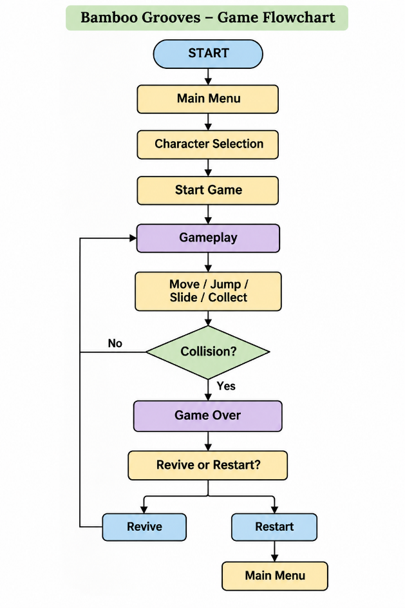
FUTURE ENHANCEMENT :
The following features can be added to Bamboo Grooves to improve the gaming experience:
- New Characters: Introduce more playable characters with unique abilities.
- Multiple Environments: Add new locations such as mountains, temples, and forests.
- Multiplayer Mode: Allow players to compete with friends.
- Leaderboards: Display high scores and rankings.
- New Obstacles: Introduce more challenging obstacles and gameplay elements.
- Additional Power-ups: Add new special abilities and rewards.
- Mobile Support: Optimize the game for Android and iOS devices.
- Missions and Achievements: Include more challenges and rewards to keep players engaged.
CONCLUSION :
The Bamboo Grooves project successfully demonstrates the development of an interactive 3D endless runner game using Unity and C#. The project incorporates various game mechanics such as lane switching, jumping, sliding, obstacle avoidance, coin collection, and power-ups.
Through this project, practical knowledge of game design, player interaction, scripting, collision detection, and environment generation was gained. Overall, the project helped in understanding the fundamentals of game mechanics and design while creating an engaging gaming experience.



