**Observation:**

|  |  |  |  |  |
| --- | --- | --- | --- | --- |
| **Experiment Number** | **Model** | **Parameters** | **Result** | **Decision + Explanation** |
| **1** | **Conv3D** | **Image_height=200**  **Image_width=200** | **Throws Generator error** |  |
| **2** | **Conv3D** | **Image_height=84**  **Image_width=84**  **Filter_size=8**  **Number of layers=1**  **batchNormization=False**  **Dropout=False** | **Accuracy:**  **Training and validation 0.21** | **Increase filter size** |
| **3** | **Conv3D** | **Image_height=84**  **Image_width=84**  **Filter_size=64**  **Number of layers=1**  **BatchNormization=False**  **Dropout=False** | **Resource Exhaust error** | **increase layers and minimize filter size of initial layers** |
| **4** | **Conv3D** | **Image_height=84**  **Image_width=84**  **Number of layers=2**  **Filter_size_layer1=64**  **Filter_size_layer2=128**  **Without maxpooling**  **batchNormization=False**  **Dropout=False** | **Resource Exhaust error** | **increase layers and minimize filter size of initial layers.**  **Adding Maxpooling and dropout to reduce parameters** |
| **5** | **Conv3D** | **Image_height=84**  **Image_width=84**  **Number of layers=3**  **Filter_size_layer1=64**  **Filter_size_layer2=128**  **Filter_size_layer3=256**  **batchNormization=False**  **Dropout=False**  **Epochs =10** | **Accuracy**  **Train:0.5**  **Val:0.4** | **Increase number of epochs to 50** |
| **6** | **Conv3D** | **Image_height=84**  **Image_width=84**  **Number of layers=4**  **Filter_size_layer1=64**  **Filter_size_layer2=128**  **Filter_size_layer3=256**  **Filter_size_layer4=256**  **batchNormization=False**  **Dropout=False**  **Epochs =20** | **Accuracy**  **Early stop**  **Train:0.67**  **Val:0.61** | **Adding BatchNormalization** |
| **7** | **Conv3D** | **Image_height=84**  **Image_width=84**  **Number of layers=4**  **Filter_size_layer1=64**  **Filter_size_layer2=128**  **Filter_size_layer3=256**  **Filter_size_layer4=256**  **batchNormization=True**  **Dropout=False**  **Epochs =50** | **Accuracy**  **Train:0.98**  **Val:0.72** | **Model Overfits** |
| **8** | **Conv3D** | **Image_height=84**  **Image_width=84**  **Number of layers=4**  **Filter_size_layer1=64**  **Filter_size_layer2=128**  **Filter_size_layer3=256**  **Filter_size_layer4=256**  **batchNormization=True**  **Dropout=True**  **Epochs =40** | **Accuracy**  **Early Stop**  **Train:0.83**  **Val:0.77** | **Good model till now on early stop** |
| **9** | **CNN pretrained model(VGG16)+GRU** | **Image_height=84**  **Image_width=84**  **Number of Epochs =25** | **Resource Exhaust error** | **Reduced image size** |
| **10** | **CNN pertained model(VGG16)+GRU** | **Image_height=75**  **Image_width=75**  **Number of Epochs =25** | **Accuracy**  **Train:0.3**  **Val:0.3** | **Going with CNN+RNN** |
| **11** | **CNN+RNN** | **Image_height=100**  **Image_width=100**  **Filter_size1=8**  **Filter_size2=16**  **Filter_size3=64**  **Dropout=True**  **BatchNormalization=True**  **GRU=128**  **Number of Epochs =30** | **At epoch 16 received accuracy as 91 and val accuracy as 74.** | **Continued with the more epochs** |
| **12** | **CNN+RNN** | **Image_height=100**  **Image_width=100**  **Filter_size1=8**  **Filter_size2=16**  **Filter_size3=64**  **Dropout=True**  **BatchNormalization=True**  **GRU=128**  **Number of Epochs =30** | **At epoch 29 received accuracy as 97 and val accuracy as 71.** | **Model overfits and**  **On early stop accuracy is low** |
| **Final Model** | **CNN+RNN** | **Image_height=100**  **Image_width=100**  **Filter_size1=8**  **Filter_size2=16**  **Filter_size3=64**  **Dropout=True**  **BatchNormalization=True**  **GRU=128**  **Number of Epochs =30** | **Since the model overfits with increase in epochs, but the model at epoch 16 is decent enough.**  **Train:91**  **Val:74** | **Best model with good train_accuracy as 91 and val_accuracy as 74.** |
| **Final Model** | **Conv3D** | **Image_height=84**  **Image_width=84**  **Number of layers=4**  **Filter_size_layer1=64**  **Filter_size_layer2=128**  **Filter_size_layer3=256**  **Filter_size_layer4=256**  **batchNormization=True**  **Dropout=True** | **Train:0.83**  **Val:0.77** | **Best model with good train_accuracy and val_accuracy.** |

**Conv3D:**

Best Conv3D model achieved with the following parameters Image_height=84, Image_width=84, Number of layers=3, Filter_size_layer1=64, Filter_size_layer2=128, Filter_size_layer3=256,Filter_size_layer4=256,BatchNormization=True, Dropout=True.

categorical_accuracy: 0.83 - val_categorical_accuracy: 0.77

**Attaching the google drive link for Conv3D model H5 file:**

<https://drive.google.com/file/d/1wCO2s2epLtMmHZlfgt9rHPaDw9M1RjhY/view?usp=sharing>

**CNN+RNN:**

Best CNN+RNN model achieved with the following parameters Image_height=84, Image_width=84, Number of layers=3, Filter_size_layer1=8, Filter_size_layer2=16, Filter_size_layer3=64, BatchNormization=True, Dropout=True, GRU=128 .

categorical_accuracy: 0.91 - val_categorical_accuracy: 0.77

**Graphs for CNN+RNN model:**

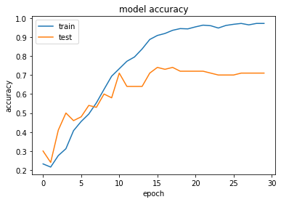

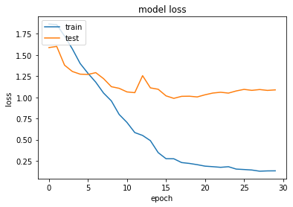

We observed that the model tends to overfit with increase in number of epochs, so early stop is a good option. And we received a good model by early stop at epoch number 16 with categorical_accuracy as 0.91, val_categorical_accuracy as 0.77.