3 Increasing Loads

Development Environment

* Apache JMeter 5.1.1 Version

Steps:

1 Increasing the load

2 Demonstrating an example of increasing the load

3 Pushing the code to GitHub repositories

**Step 1:** Increasing the load

* Open JMeter.
* Right click on TestPlan.
* Click on Thread(Users)->Concurrency Thread Group.

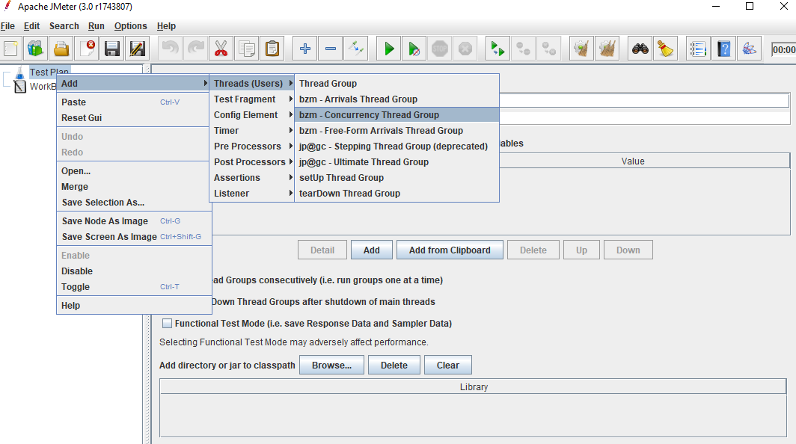

**Step 1.3.2:** Demonstrating an example of increasing the load

* + Minimum ramp up of 5 (increasing the load by step count)

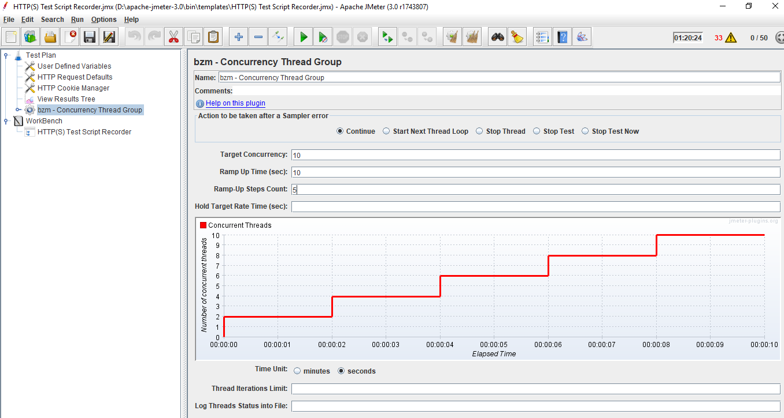

* + Maximum ramp up of 10 (increasing the load by step count)

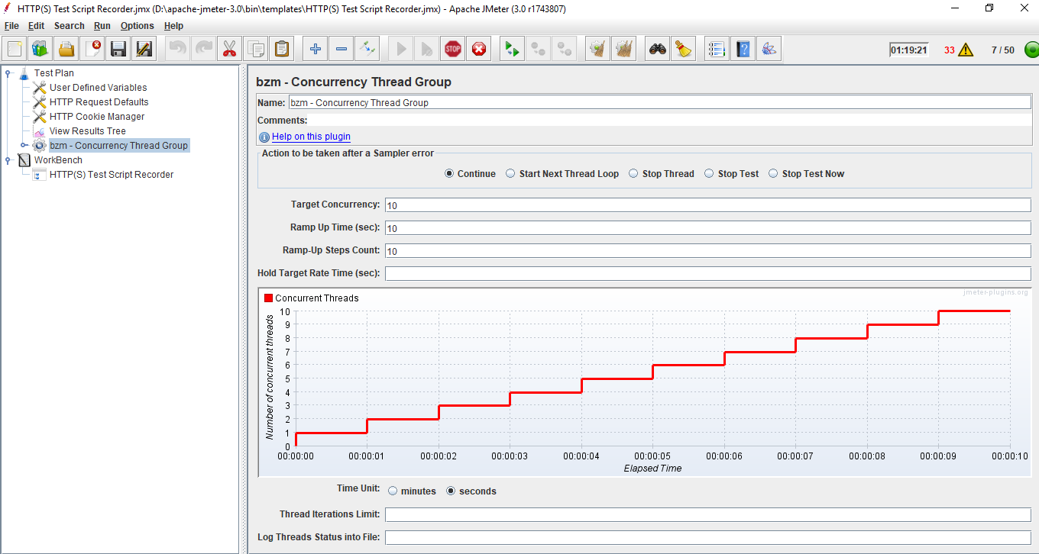

**Step .3:** Pushing the code to your GitHub repositories

Open your command prompt and navigate to the folder where you have created your files.

cd <folder path>

Initialize your repository using the following command:

git init

Add all the files to your git repository using the following command:

git add . 

Commit the changes using the following command:

git commit . -m “Changes have been committed.”

Push the files to the folder you initially created using the following command:

git push -u origin master