11 OS Process, Debug, and Test Action Sampler - Script

This section will guide you:

* To understand the OS Process
* To debug
* To use Test Action Sampler - Script

**Development Environment:**

* Apache JMeter 5.1.1 Version

This guide has three sub-sections, namely:

1.11.1 Creating an OS process in JMeter

1.11.2 Debugging in JMeter and testing action sampler

1.11.3 Pushing the code to your GitHub repositories

**Steps 1.11.1:** Creatingan OS process in JMeter

* Open JMeter.
* Right click on Test Plan.
* Click on Thread(Users)->Thread Group.

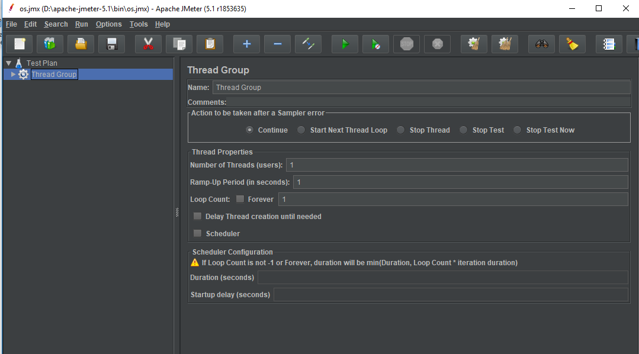

* Right click on the thread group.
* Go to Add -> Sampler -> OS process sampler.

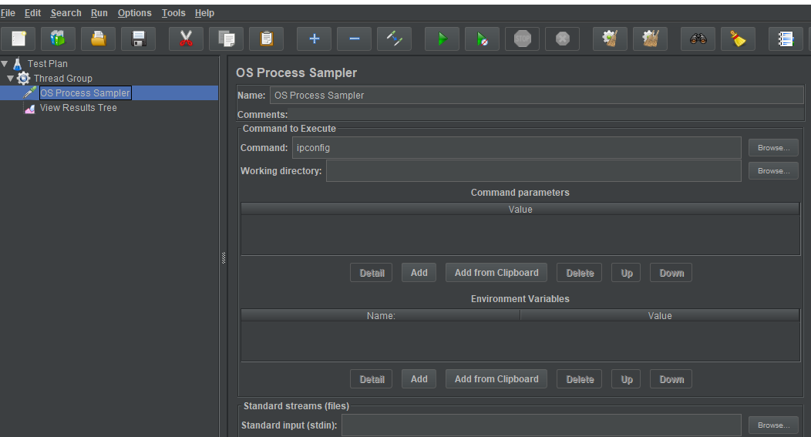

* Right click on the thread group.
* Go to Add -> Listener -> View results tree.

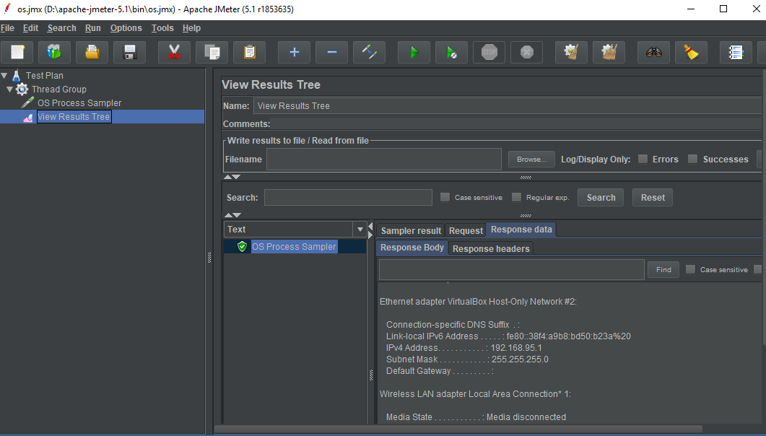

* Run the result tree.



**Steps 1.11.2:** Debugging in JMeter and testing the action sampler

* Right click on Test Plan.
* Click on Thread(Users) -> Thread Group.
* Right click on thread group -> Add -> samplers -> HTTP Request -> Enter Server name ‘lifecharger.org.’

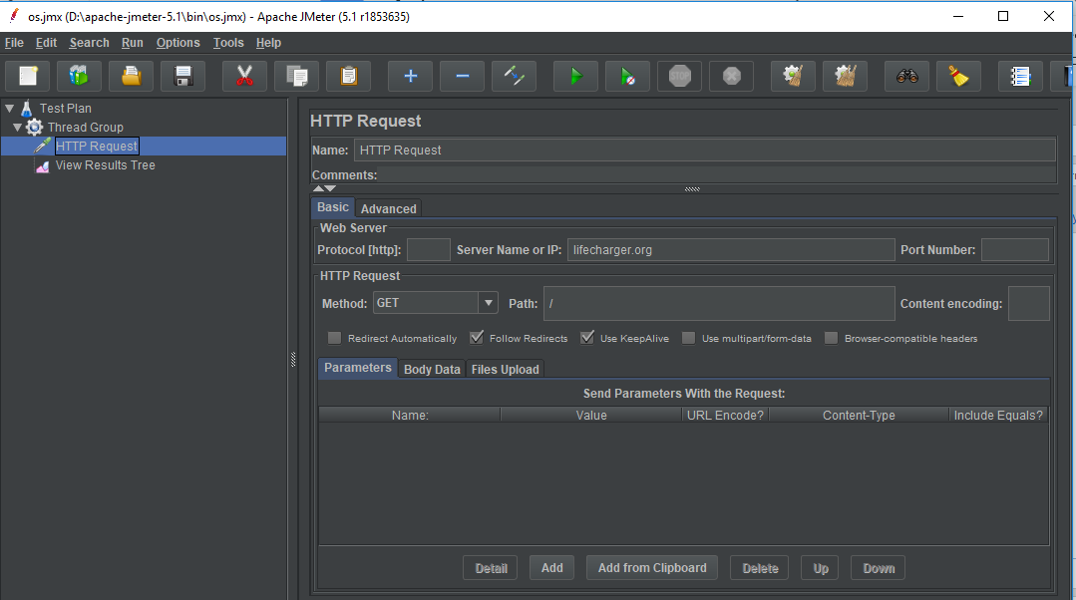

* Run the result tree.

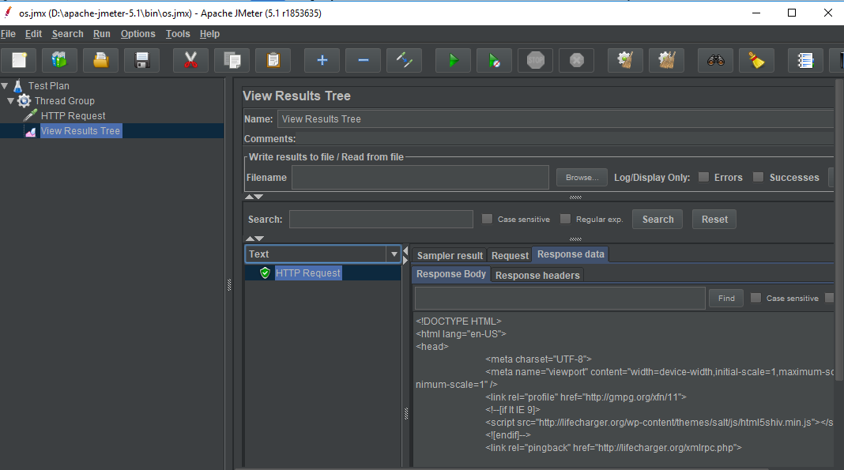

* Click on the drop down button and debug particular elements like HTML/CSS file depending on your requirement.

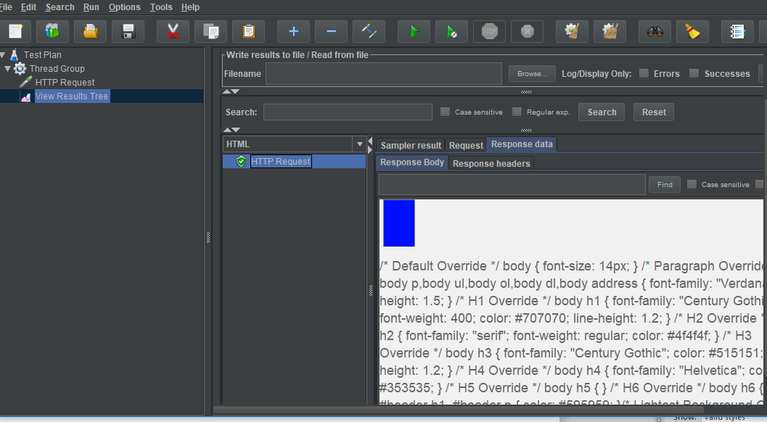

* The text action sampler will have multiple thread groups in the Test Plan. The second **Thread Group** should start execution only a few seconds after the 1st **Thread Group** gets started.
* Right click on Test Plan.
* Click on Thread(Users) -> Add two Thread Groups.

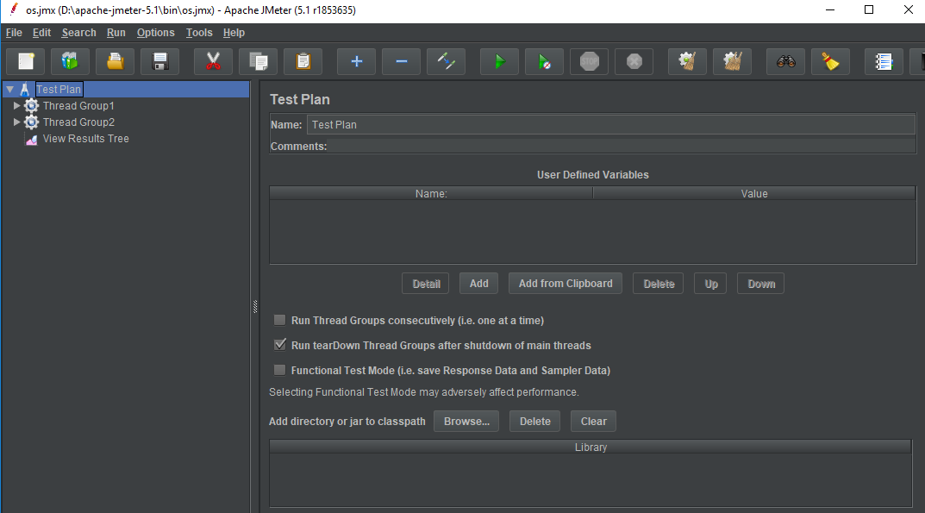

* Right click on the thread group.
* Go to Add -> Samplers -> Add two HTTP Request -> Thread 1.
* Now, enter the server name as ‘lifecharger.org.’

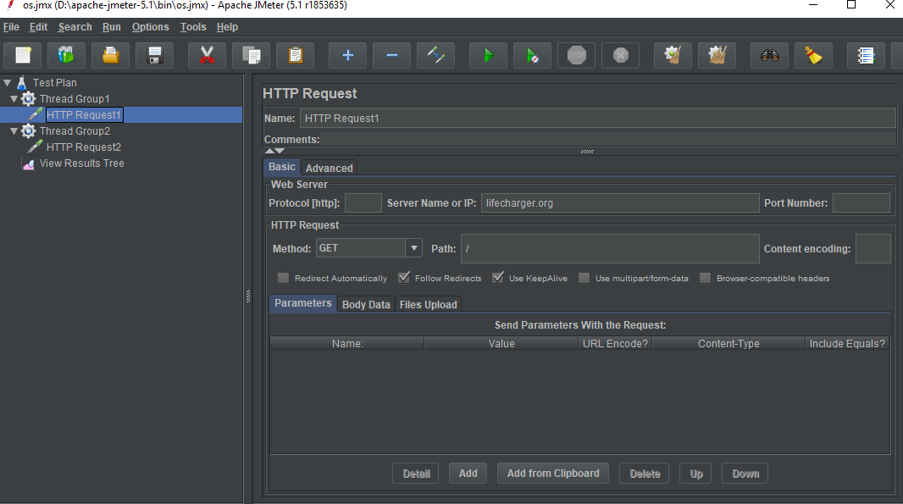

* Thread 2 -> Enter Server name ‘www.facebook.com.’

Note: This can be achieved by ramp_up delay between the two threads.

* Right click on the thread group.
* Go to Add -> Listener -> View Results Tree.
* Run the result tree.

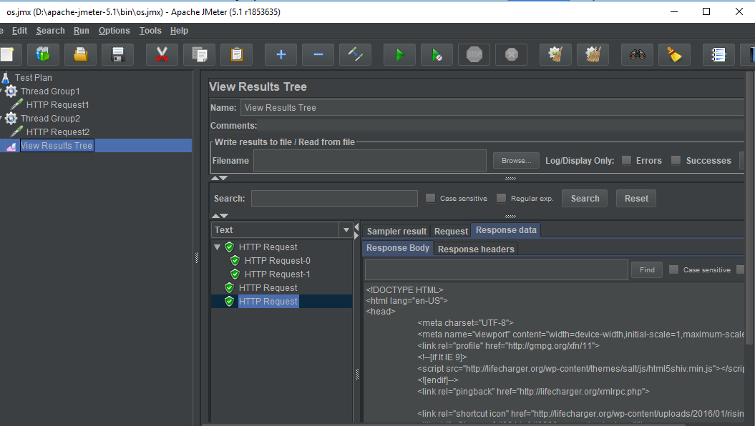

**Steps 1.11.3:** Pushing the code to GitHub repositories

Open your command prompt and navigate to the folder where you have created your files.

cd <folder path>

Initialize your repository using the following command:

git init

Add all the files to your git repository using the following command:

git add . 

Commit the changes using the following command:

git commit . -m “Changes have been committed.”

Push the files to the folder you initially created using the following command:

git push -u origin master