14 Workspaces



This section will guide you to understand:

* How to create workspace
* How to manage workspace

**Development Environment:**

* Postman Tool
* Endpoint URL

This guide has three subsections, namely:

2.14.1 Creating a workspace

2.14.2 Pushing the code to GitHub repositories

**Step 2.14.1:** Creating a workspace

* Open Postman
* Go to the top of the page of Postman
* Click on the arrow mark
* Click on Create

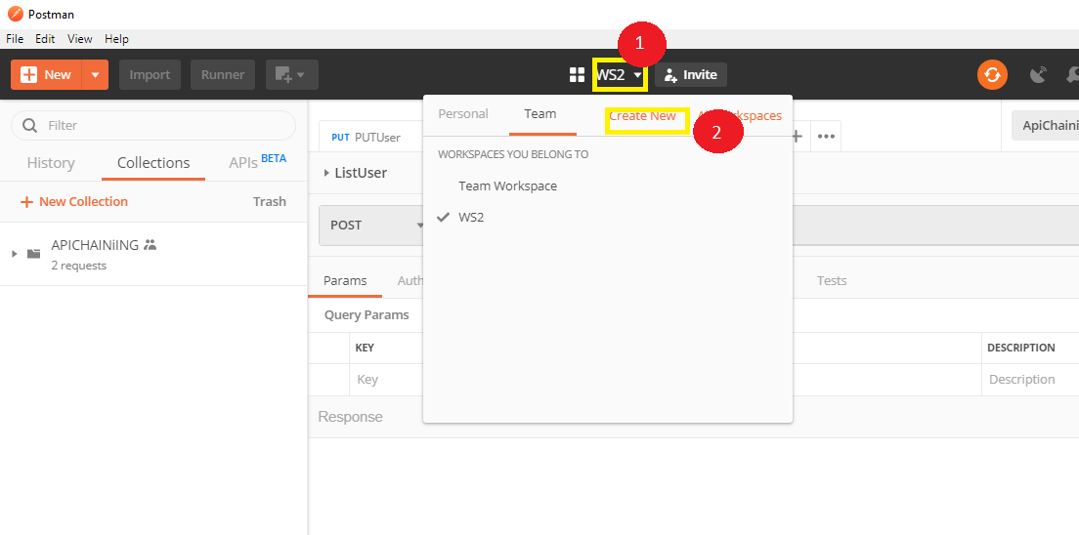

* Manage Workspace

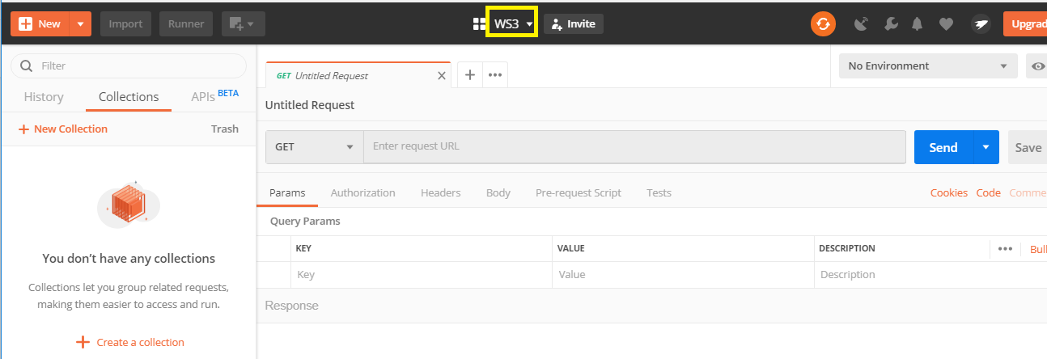

**Step 2.14.2:** Pushing the code to GitHub repositories

Open your command prompt and navigate to the folder where you have created your files

cd <folder path>

Initialize your repository using the following command:

git init

Add all the files to your git repository using the following command:

git add . 

Commit the changes using the following command:

git commit . -m “Changes have been committed.”

Push the files to the folder you initially created using the following command:

git push -u origin master