16 API Documentation

This section will guide you to understand:

* How to create API documentation

**Development Environment**

* Postman
* Endpoint url

This guide has three subsections, namely:

2.16.1 Creating a Collection

2.16.2 Creating API documentation

2.16.3 Pushing the code to GitHub repositories

**Step 2.16.1:** Creating a Collection

* Open Postman
* Go to New
* Click on Collection

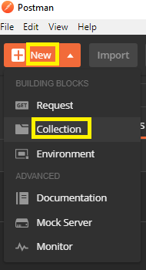

**Step 2.16.2:** Creating API documentation

* Go to New
* Click on API Documentation

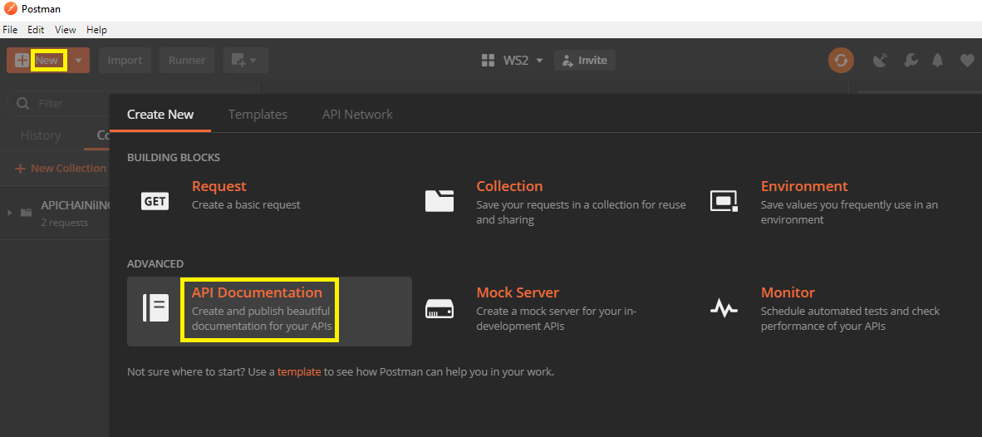

* Set your HTTP request as Get request
* Give request url as: <https://reqres.in/api/users?page=2>

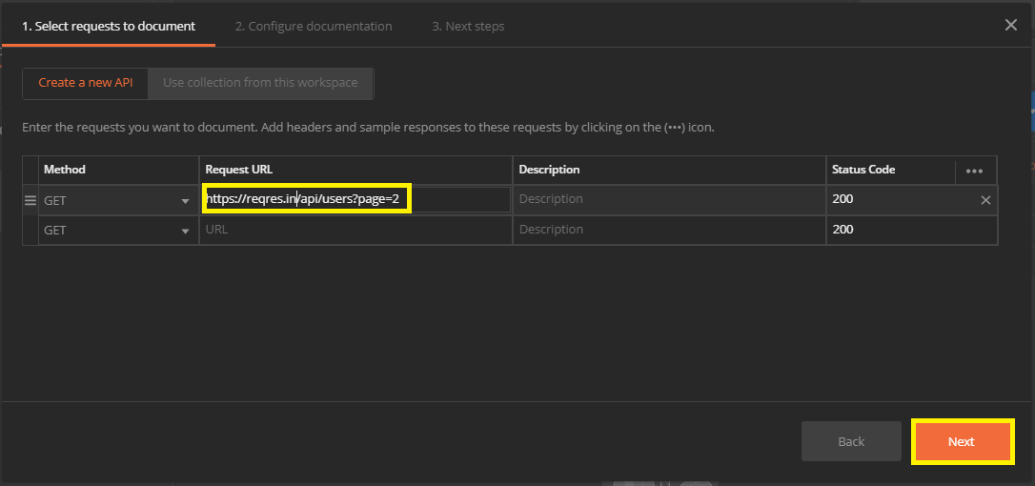

* Set a name
* Click on Create

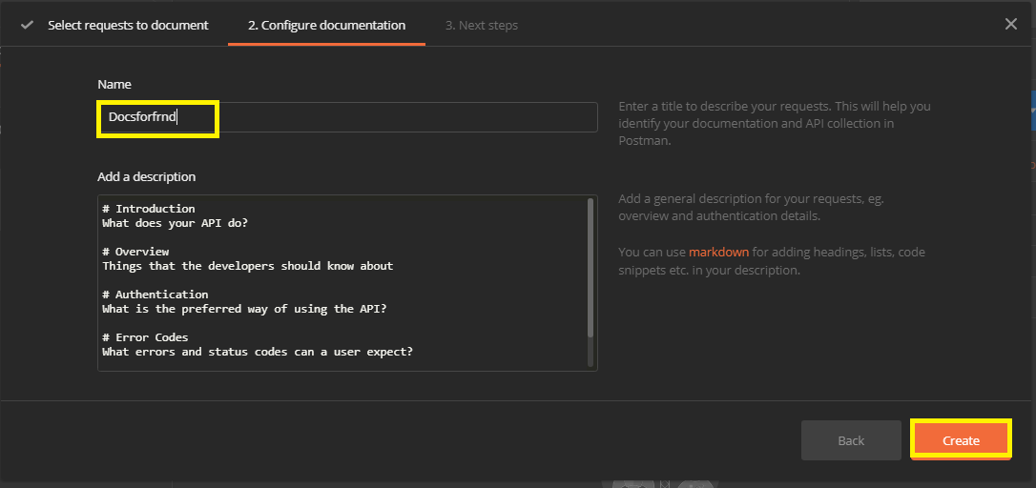

**Step 2.16.3:** Pushing the code to GitHub repositories

Open your command prompt and navigate to the folder where you have created your files

cd <folder path>

Initialize your repository using the following command:

git init

Add all the files to your git repository using the following command:

git add . 

Commit the changes using the following command:

git commit . -m “Changes have been committed.”

Push the files to the folder you initially created using the following command:

git push -u origin master