18 Run Collection Remotely with URL



This section will guide you to understand:

* How to get collection URL
* How to run the collection URL remotely

**Development Environment:**

* Postman
* Collection
* Endpoint URL

This guide has five subsections, namely:

* + 1. Creating a collection
    2. Creating a new request
    3. Getting the Collection URL
    4. Running the Collection URL remotely
    5. Pushing the code to GitHub repositories

**Step 2.18.1:** Creating a collection

* Open Postman
* Click on **New** option
* Select Collection

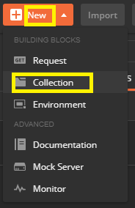

**Step 2.18.2:** Creating a New Request

* Go to New
* Select Request

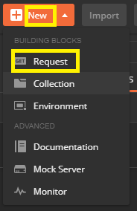

**Step 2.18.3:** Getting the Collection URL

* Go to Collection
* Click on the arrow mark next to Collection
* Click Share

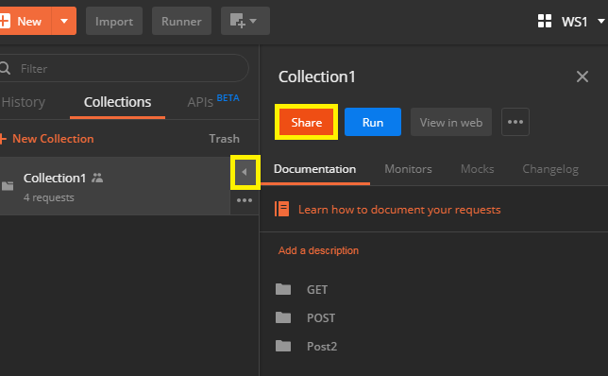

* Click on Get link
* Copy that link

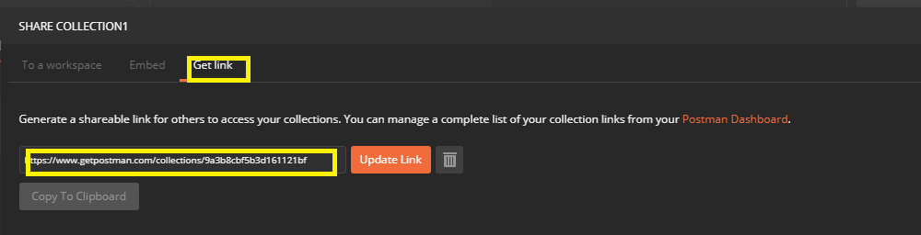

**Step 2.18.4:** Running the collection URL remotely

* Type the collection URL
* Install Newman:

*npm -g install newman*

* Run that URL remotely using:

*newman run* [*https://www.getpostman.com/collections/9a3b8cbf5b3d161121bf*](https://www.getpostman.com/collections/9a3b8cbf5b3d161121bf)

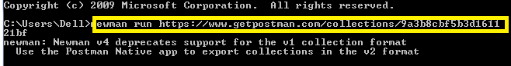

**Step 2.18.5:** Pushing the code to GitHub repositories

Open your command prompt and navigate to the folder where you have created your files

cd <folder path>

Initialize your repository using the following command:

git init

Add all the files to your git repository using the following command:

git add . 

Commit the changes using the following command:

git commit . -m “Changes have been committed.”

Push the files to the folder you initially created using the following command:

git push -u origin master