12 Test Scripts



This section will guide you to understand:

* How to write test scripts
* How to check the response of scripts

**Development Environment**

* Postman Tool
* Endpoint URL

This guide has four subsections, namely:

2.12.1 Writing a script using snippet

2.12.2 Running the script and checking Response

2.12.3 Pushing the code to your GitHub repositories

**Steps 2.12.1:** Writing a script using snippet

* Create a new Request.

<https://reqres.in/api/users/2>

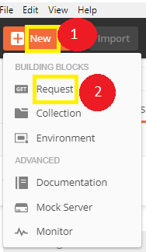

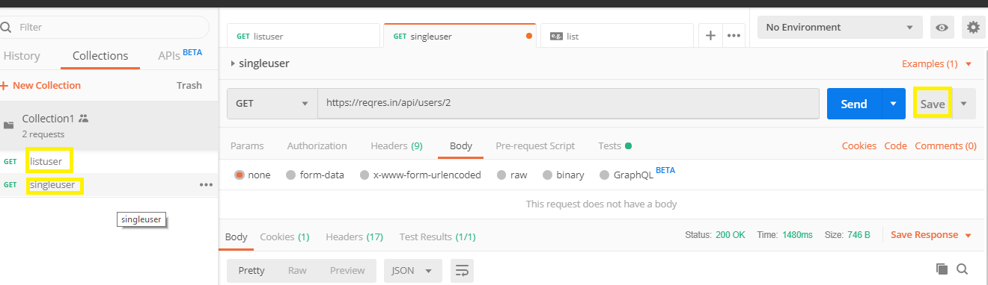

* Switch to the tests tab. On the right side are snippet codes.
* From the snippets section, click on "Status code: Code is 200."

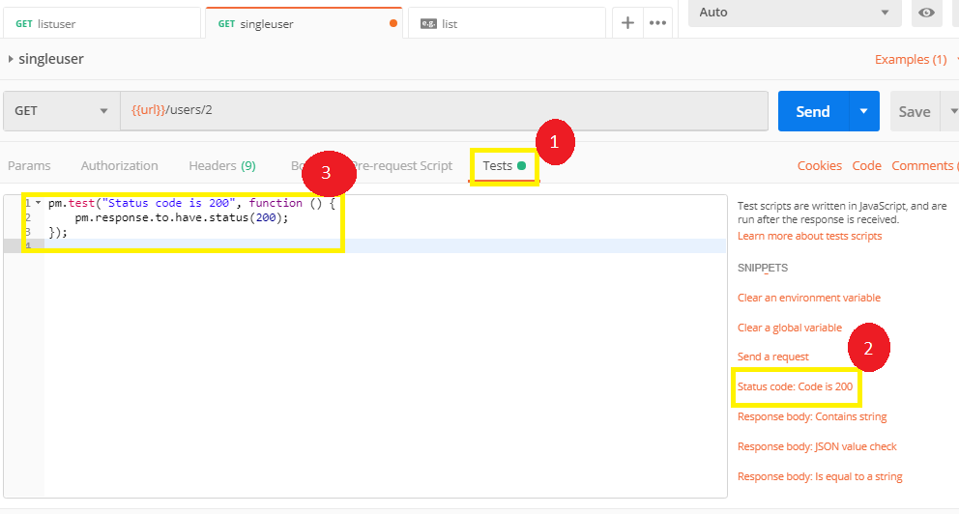

* Now click Send. The test result should now be displayed.

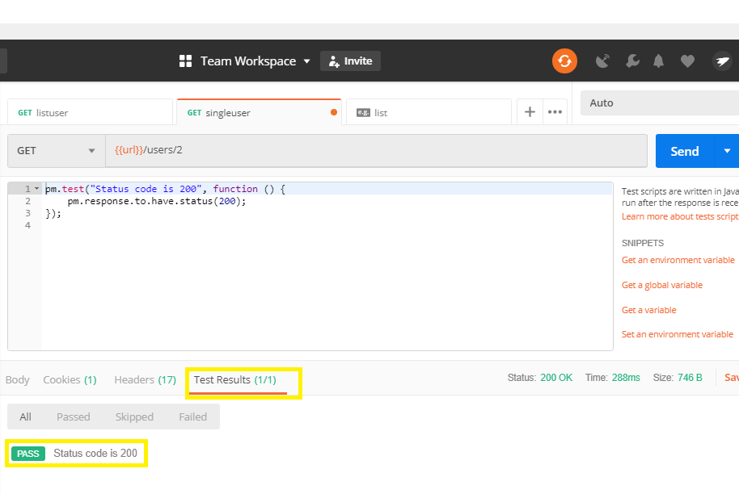

**Steps 2.12.2:** Running the script and checking Response

* Go back to the Test tab and let's add another Test. This time we will compare the expected result to the actual result.
* From the snippets section, click on "Response time less than 200ms.”
* Click Send. There should now be two passed test results for your request.

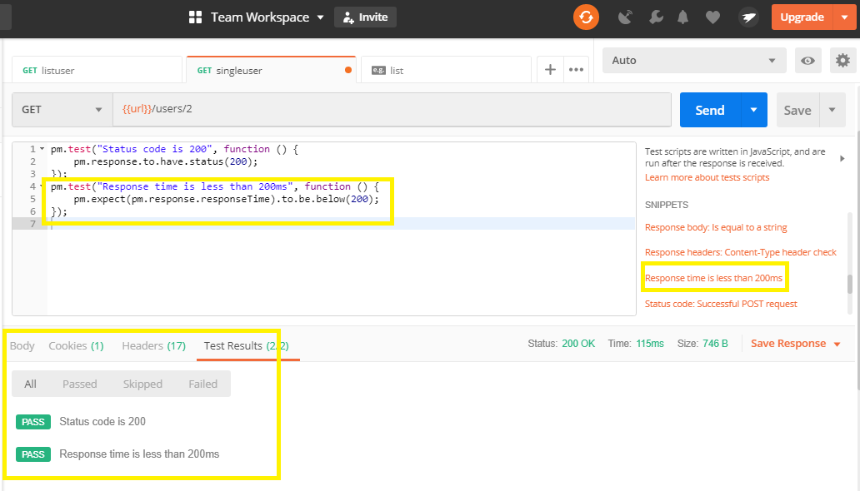

**Steps 2.12.3:** Pushing the code to your GitHub repositories

Open your command prompt and navigate to the folder where you have created your files

cd <folder path>

Initialize your repository using the following command:

git init

Add all the files to your git repository using the following command:

git add . 

Commit the changes using the following command:

git commit . -m “Changes have been committed.”

Push the files to the folder you initially created using the following command:

git push -u origin master