7 Create a Collection



This section will guide you to understand:

* How to create a Collection
* How to use Collection
* Response Run

**Development Environment:**

* Postman Tool
* Collection
* Endpoint URL

This guide has six subsections, namely:

2.7.1 Creating a Collection

2.7.2 Adding the desired name

2.7.3 Adding a new request in Collection

2.7.4 Running that Collection

2.7.5 Checking the output

2.7.6 Pushing the code to GitHub repositories

**Steps 2.7.1:** Creating a Collection

* Click on the NEW button
* Then you get a pop up like below:

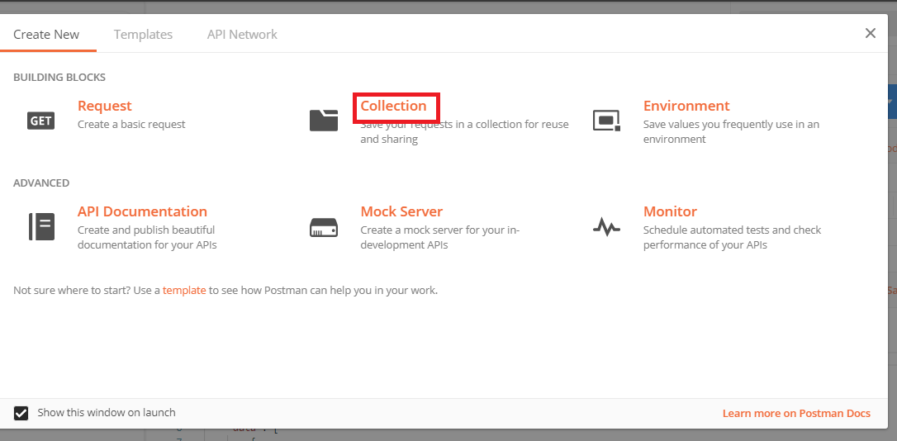

**Steps 2.7.2:** Inputting the Desired name

* Click on the Collection button
* Then you can pass your desire name
* Click the Create button

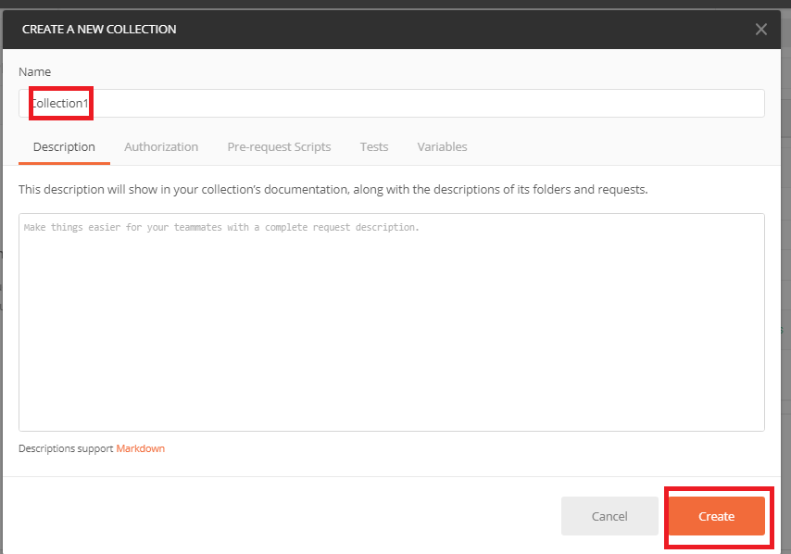

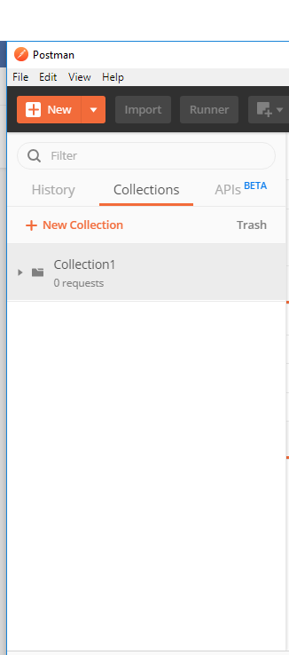

**Steps 2.7.3:** Adding a new request in Collection

* Click on New
* Give a name

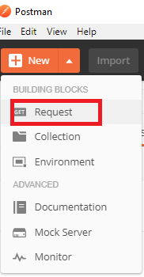

* Pass sample url (https://reqres.in/api/users?page=2)
* Save it

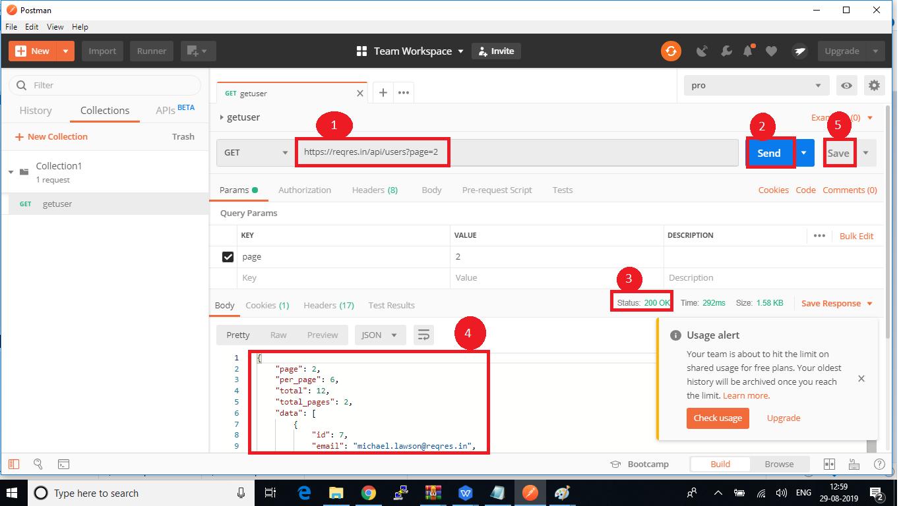

**Steps 2.7.4:** Running the Collection

* Go to the Collection option
* Click on Arrow
* Click on Run

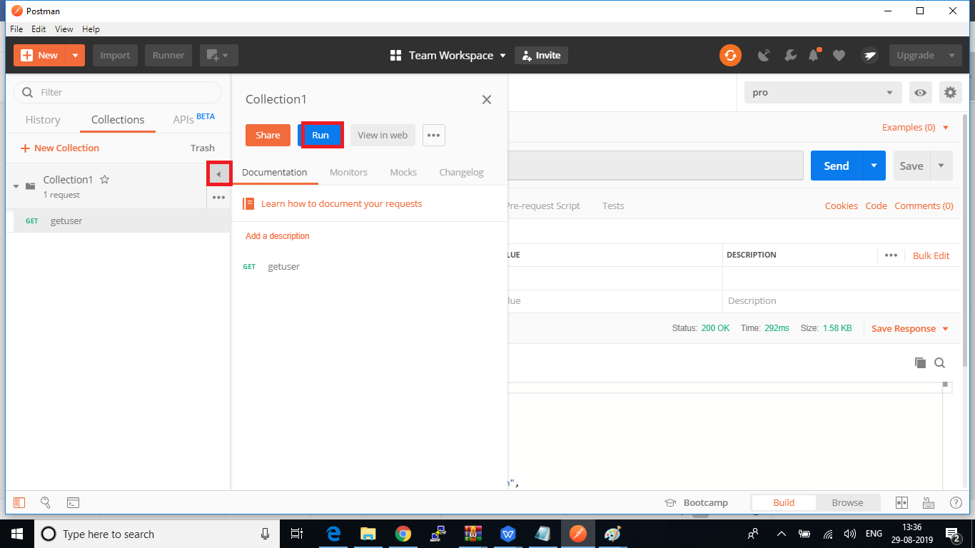

* After that, you will get a new console
* Click on Run Collection1

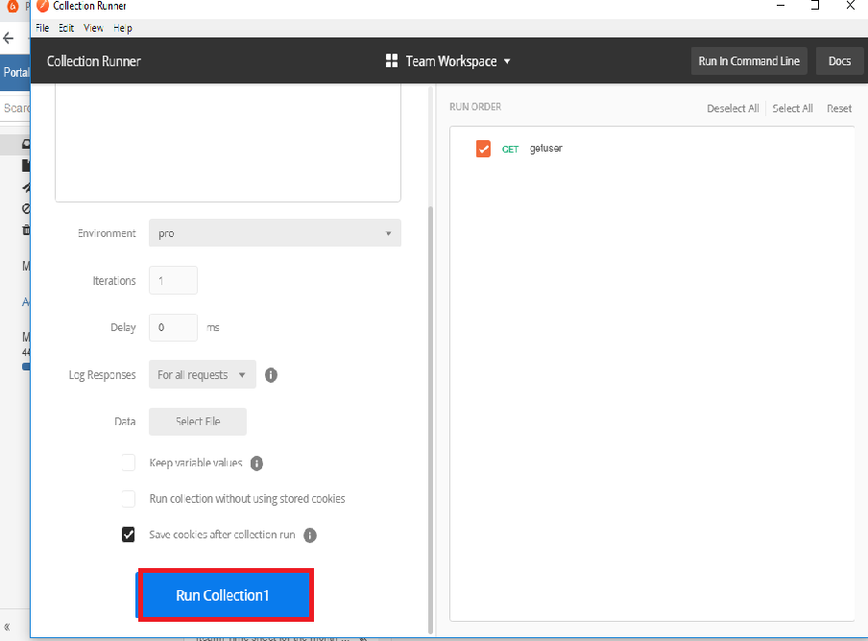

**Steps 2.7.5:** Checking the Output

* The output will look like:

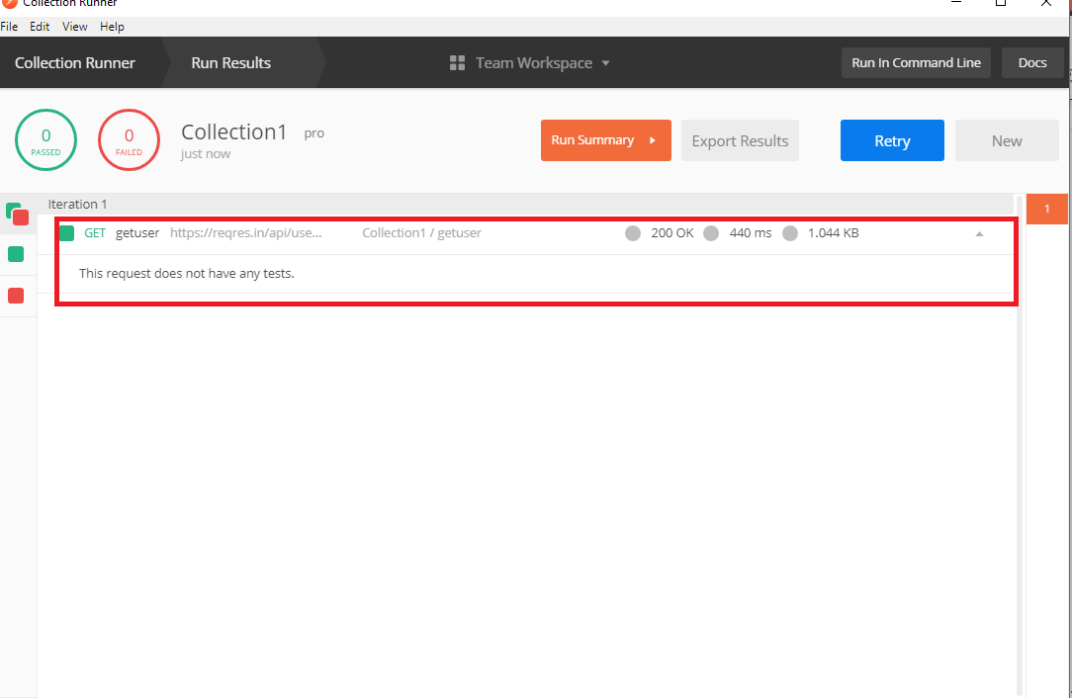

**Step 2.7.6:** Pushing the code to your GitHub repositories

Open your command prompt and navigate to the folder where you have created your files

cd <folder path>

Initialize your repository using the following command:

git init

Add all the files to your git repository using the following command:

git add . 

Commit the changes using the following command:

git commit . -m “Changes have been committed.”

Push the files to the folder you initially created using the following command:

git push -u origin master