5. Test Interfaces and Default Methods

Steps:

* + 1. Writing a code to demonstrate interfaces and default methods
    2. Writing a code to demonstrate Test Factory
    3. Pushing the code to GitHub repositories

**Step 4.5.1:** Writing a code to demonstrate interfaces and default methods:

This section will guide you to write code with the annotations given below:

* Test
* RepeatedTest
* ParameterizedTest
* TestFactory
* TestTemplate
* BeforeEach
* AfterEach
* BeforeAll
* AfterAll

**Step 4.5.2:** Writing a code to demonstrate TestFactory

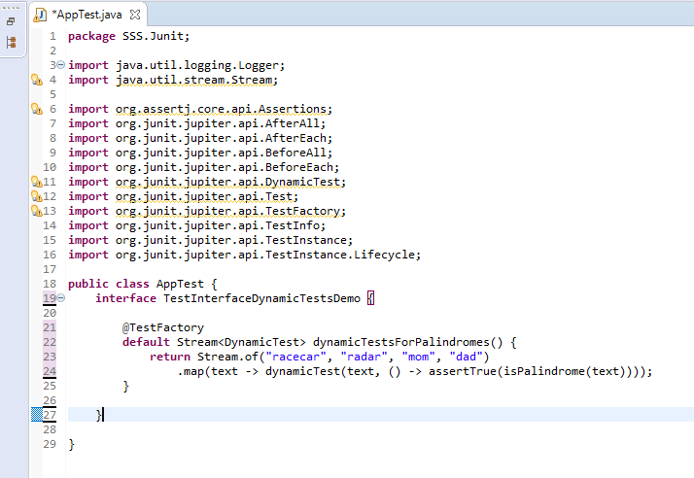

**Step 4.5.3:** Pushing the code to GitHub repositories:

Open your command prompt and navigate to the folder where you have created your files:

cd <folder path>

Initialize your repository using the following command:

git init

Add all the files to your git repository using the following command:

git add . 

Commit the changes using the following command:

git commit . -m “Changes have been committed.”

Push the files to the folder you initially created using the following command:

git push -u origin master