4. Assumptions



This section will guide you:

* To import the Junit assumptions and its types

Steps:

* + 1. Importing a Junit Assumption
    2. Writing a code to demonstrate the types of Assumptions
    3. Pushing the code to GitHub repositories

**Steps 4.4.1:** Importing a Junit Assumption

* JUnit Assumptions class provides a useful collection of assumption methods. To import them in our test class, write the commands given below.

import static org.junit.jupiter.api.Assumptions.*;

import static org.junit.Assume.assumeTrue;

**Steps 4.4.2:** Writing a code to demonstrate the types of Assumptions

* assumeTrue()

We can use assumeTrue() to skip the test if the input number is negative. Below is the updated code:

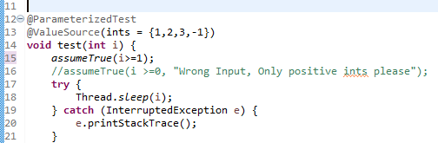

* JUnit will skip when the input number is negative. When we run the test, we will get the following output:

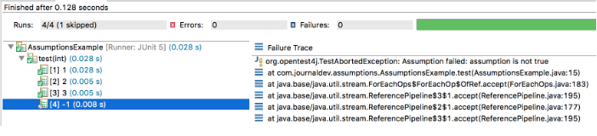

* assumeFalse()

assumeFalse() validates the given assumption to false and if the assumption is false then the test proceeds, otherwise, the test execution is aborted. It works just opposite to assumeTrue().

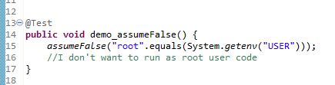

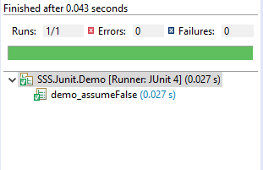

* assumingThat()

This method executes the supplied Executable if the assumption is valid. If the assumption is invalid, this method does nothing. We can use this for logging or notifications when our assumptions are valid.

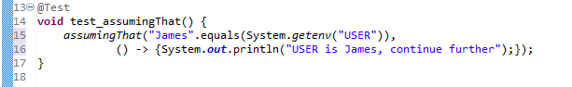

**Step 4.4.3:** Pushing the code to GitHub repositories:

Open your command prompt and navigate to the folder where you have created your files:

cd <folder path>

Initialize your repository using the following command:

git init

Add all the files to your git repository using the following command:

git add . 

Commit the changes using the following command:

git commit . -m “Changes have been committed.”

Push the files to the folder you initially created using the following command:

git push -u origin master