Transaction Management

This guide has three subsections, namely:

1. Writing a program to perform JDBC transaction management using Auto-Commit Mode.
2. Writing a program to perform JDBC transaction management by disabling setAutoCommit().
3. Pushing the code to your GitHub repositories.

**Step 3.6.1:** Writing a program to perform JDBC transaction management using Auto-Commit Mode.

* By default, when we create a database connection, it runs in **auto-commit** mode. It means that whenever we execute a query, the commit is fired automatically. So, every SQL query we fire is a transaction and if we are running DML or DDL queries, the changes are getting saved in the database after every SQL statement is executed .
* Sometimes we want a group of SQL queries to be part of a transaction, so that we can commit them when all the queries run successfully. If we get any exception, we have a choice to rollback all the queries executed as part of the transaction.
* Let’s understand with a simple example where we want to utilize JDBC transaction management support for data integrity. Let’s say we have “transaction_management” database and employee information saved in two tables. Example: I am using MySQL database.
* Create two tables ‘employee’ and ‘address’ in ‘transaction_management’ database using the credentials below:

**CREATE** **TABLE** transaction_management.employee (

empId int(11) unsigned NOT NULL,

name varchar(20) DEFAULT NULL,

**PRIMARY** **KEY** (`empId`)) ENGINE=InnoDB DEFAULT CHARSET=utf8;

**CREATE** **TABLE** transaction_management.address (

empId int(11) unsigned NOT NULL,

address varchar(20) DEFAULT NULL,

city varchar(5) DEFAULT NULL,

country varchar(20) DEFAULT NULL,

**PRIMARY** **KEY** (`empId`)) ENGINE=InnoDB DEFAULT CHARSET=utf8;

* Open Eclipse
* Create Java Project. Ex: JDBCTransaction
* Download “mysql-connector-java-5.1.18.jar”
* Add External jar “mysql-connector-java-5.1.18.jar” into the project

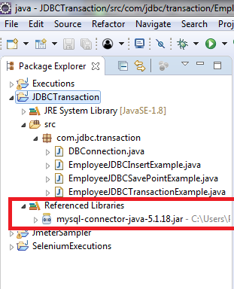

* + - Create a class called “DBConnection.java” and give the database credentials as below:
      * **DB_URL:** jdbc:mysql://localhost:3307/transaction_management
      * **DB_DRIVER_CLASS:** com.mysql.jdbc.Driver
      * **DB_USERNAME:** The username of database (here: **root)**
      * **DB_PASSWORD:** Password for the username (here: **root)**

package com.jdbc.**transaction**;

import java.sql.Connection;

import java.sql.DriverManager;

import java.sql.SQLException;

public class DBConnection {

public final static **String** DB_DRIVER_CLASS =

"com.mysql.jdbc.Driver";

public final static **String** DB_URL =

"jdbc:mysql://localhost:3307/transaction_management";

public final static **String** DB_USERNAME = "root";

public final static **String** DB_PASSWORD = "root";

public static Connection getConnection() throws

ClassNotFoundException, SQLException {

Connection con = null;

// **load** the Driver Class

Class.forName(DB_DRIVER_CLASS);

// **create** the connection **now**

con = DriverManager.getConnection(DB_URL,

DB_USERNAME, DB_PASSWORD);

System.out.println("DB Connection created

successfully");

return con;

}

}

* DBConnection is the class used by other classes for MYSQL database connection.
* Create another class called “EmployeeJDBCInsertExample.java”

**package** com.jdbc.transaction;

**import** java.sql.Connection;

**import** java.sql.PreparedStatement;

**import** java.sql.SQLException;

**public** **class** EmployeeJDBCInsertExample {

**public** **static** **final** **String** INSERT_EMPLOYEE_QUERY =

"insert into Employee (empId, name) values (?,?)";

**public** **static** **final** **String** INSERT_ADDRESS_QUERY = "insert into

Address (empId, address, city, country) values (?,?,?,?)";

**public** **static** void main(**String**[] args) {

**Connection** con = **null**;

**try** {

con = DBConnection.getConnection();

insertEmployeeData(con, 1, "Pankaj");

insertAddressData

(con, 1, "Albany Dr", "San Jose", "USA");

} **catch** (**SQLException** | **ClassNotFoundException** e) {

e.printStackTrace();

} **finally** {

**try** {

**if** (con != **null**)

con.close();

} **catch** (**SQLException** e) {

e.printStackTrace();

}

}

}

**public** **static** void insertAddressData(**Connection** con, int id,

**String** address, **String** city, **String** country) **throws** **SQLException** {

**PreparedStatement** stmt =

con.prepareStatement(INSERT_ADDRESS_QUERY);

stmt.setInt(1, id);

stmt.setString(2, address);

stmt.setString(3, city);

stmt.setString(4, country);

stmt.executeUpdate();

**System**.out.println("Address Data inserted successfully

for ID=" + id);

stmt.close();

}

**public** **static** void insertEmployeeData(**Connection** con, int id,

**String** name) **throws** **SQLException** {

**PreparedStatement** stmt =

con.prepareStatement(INSERT_EMPLOYEE_QUERY);

stmt.setInt(1, id);

stmt.setString(2, name);

stmt.executeUpdate();

**System**.out.println("Employee Data inserted

successfully for ID=" + id);

stmt.close();

}

}

* By running the “EmployeeJDBCInsertExample.java” program, we will get the following output:

DB Connection created successfully

Employee Data inserted successfully **for** ID=1

com.mysql.jdbc.MysqlDataTruncation: Data truncation: Data too

**long** **for** column 'city' at row 1

at com.mysql.jdbc.MysqlIO.checkErrorPacket(MysqlIO.java:2939)

at com.mysql.jdbc.MysqlIO.sendCommand(MysqlIO.java:1623)

at com.mysql.jdbc.MysqlIO.sqlQueryDirect(MysqlIO.java:1715)

at com.mysql.jdbc.Connection.execSQL(Connection.java:3249)

at com.mysql.jdbc.PreparedStatement.executeInternal

(PreparedStatement.java:1268)

at com.mysql.jdbc.PreparedStatement.executeUpdate

(PreparedStatement.java:1541)

at com.mysql.jdbc.PreparedStatement.executeUpdate

(PreparedStatement.java:1455)

at com.mysql.jdbc.PreparedStatement.executeUpdate

(PreparedStatement.java:1440)

at com.journaldev.jdbc.transaction.EmployeeJDBCInsertExample.

insertAddressData(EmployeeJDBCInsertExample.java:45)

at com.journaldev.jdbc.transaction.EmployeeJDBCInsertExample.

**main**(EmployeeJDBCInsertExample.java:23)

* As you can see, SQLException is only raised when we are trying to insert data into the address table, because the value is bigger than the size of the column.
* If you look at the content in the employee and address tables, you will notice that data is present only in the employee table.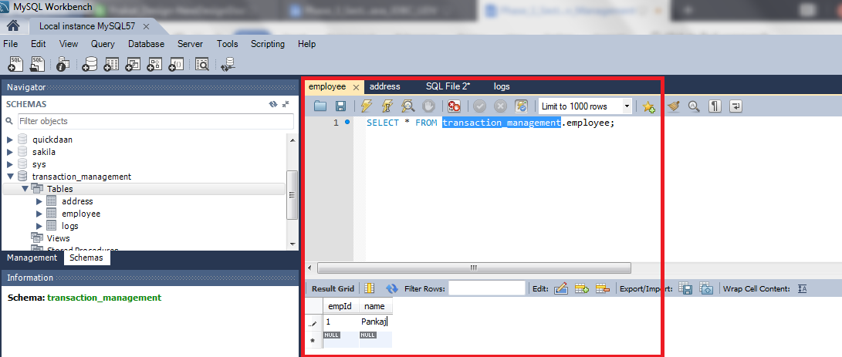

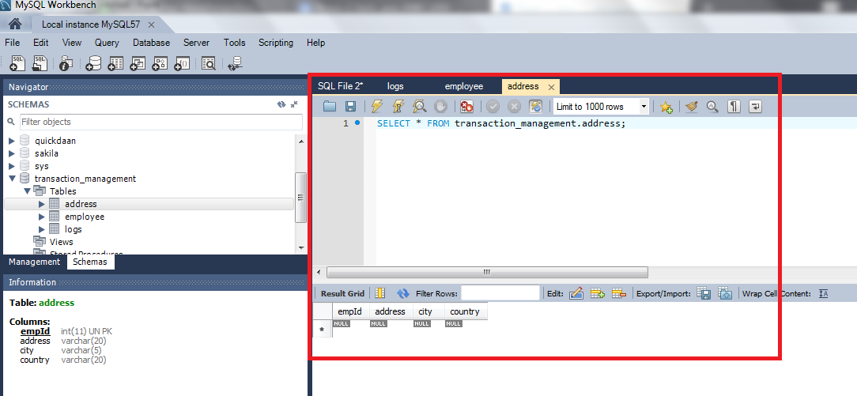

* By running the program again, it will try to insert employee information into the employee table again and will throw the below exception.

com.mysql.jdbc.exceptions.MySQLIntegrityConstraintViolationExceptio

n: Duplicate entry '1' **for** key 'PRIMARY'

at com.mysql.jdbc.SQLError.createSQLException

(SQLError.java:931)

at com.mysql.jdbc.MysqlIO.checkErrorPacket(MysqlIO.java:2941)

at com.mysql.jdbc.MysqlIO.sendCommand(MysqlIO.java:1623)

at com.mysql.jdbc.MysqlIO.sqlQueryDirect(MysqlIO.java:1715)

at com.mysql.jdbc.Connection.execSQL(Connection.java:3249)

at com.mysql.jdbc.PreparedStatement.executeInternal

(PreparedStatement.java:1268)

at com.mysql.jdbc.PreparedStatement.executeUpdate

(PreparedStatement.java:1541)

at com.mysql.jdbc.PreparedStatement.executeUpdate

(PreparedStatement.java:1455)

at com.mysql.jdbc.PreparedStatement.executeUpdate

(PreparedStatement.java:1440)

at com.journaldev.jdbc.transaction.EmployeeJDBCInsertExample.

insertEmployeeData(EmployeeJDBCInsertExample.java:57)

at com.journaldev.jdbc.transaction.EmployeeJDBCInsertExample.

**main**(EmployeeJDBCInsertExample.java:21)

* Now, there is no way we can save the data in the address table for the Employee. Since this program leads to data integrity issues, we need transaction management to insert data into both the tables successfully or rollback everything if any exception arises.

**Step 3.6.2:** Writing a program to perform JDBC transaction management by disabling setAutoCommit().

* JDBC API provides the method setAutoCommit() through which we can disable the auto commit feature of the connection (should disable when it’s required because the transaction will not be committed unless we call the commit() method on connection).
* Let’s write another program where we will use JDBC transaction management feature to make sure data integrity is not violated.

**package** com.jdbc.transaction;

**import** java.sql.Connection;

**import** java.sql.SQLException;

**public** **class** EmployeeJDBCTransactionExample {

**public** **static** void main(**String**[] args) {

**Connection** con = **null**;

**try** {

con = DBConnection.getConnection();

//set auto commit to false

con.setAutoCommit(**false**);

EmployeeJDBCInsertExample.insertEmployee

Data(con, 1, "Pankaj");

EmployeeJDBCInsertExample.insertAddress

Data(con, 1, "Albany Dr", "San Jose", "USA");

//now commit transaction

con.commit();

} **catch** (**SQLException** e) {

e.printStackTrace();

**try** {

con.rollback();

**System**.out.println("JDBC

Transaction rolled back successfully");

} **catch** (**SQLException** e1) {

**System**.out.println("SQLException in

rollback"+e.getMessage());

}

} **catch** (**ClassNotFoundException** e) {

e.printStackTrace();

} **finally** {

**try** {

**if** (con != **null**)

con.close();

} **catch** (**SQLException** e) {

e.printStackTrace();

}

}

}

}

* Please make sure you remove the earlier inserted data from both the tables before running this program. By running this program, you will get the following output:

DB Connection created successfully

Employee Data inserted successfully **for** ID=1

com.mysql.jdbc.MysqlDataTruncation: Data truncation: Data too **long**

**for** column 'city' at row 1

at com.mysql.jdbc.MysqlIO.checkErrorPacket(MysqlIO.java:2939)

at com.mysql.jdbc.MysqlIO.sendCommand(MysqlIO.java:1623)

at com.mysql.jdbc.MysqlIO.sqlQueryDirect(MysqlIO.java:1715)

at com.mysql.jdbc.Connection.execSQL(Connection.java:3249)

at com.mysql.jdbc.PreparedStatement.executeInternal

(PreparedStatement.java:1268)

at com.mysql.jdbc.PreparedStatement.executeUpdate

(PreparedStatement.java:1541)

at com.mysql.jdbc.PreparedStatement.executeUpdate

(PreparedStatement.java:1455)

at com.mysql.jdbc.PreparedStatement.executeUpdate

(PreparedStatement.java:1440)

at com.journaldev.jdbc.transaction.EmployeeJDBCInsertExample.

insertAddressData(EmployeeJDBCInsertExample.java:45)

at com.journaldev.jdbc.transaction.EmployeeJDBCTransaction

Example.**main**(EmployeeJDBCTransactionExample.java:19)

JDBC Transaction rolled back successfully

* If you look into the database tables, you will notice that data is not inserted into both employee and address table.

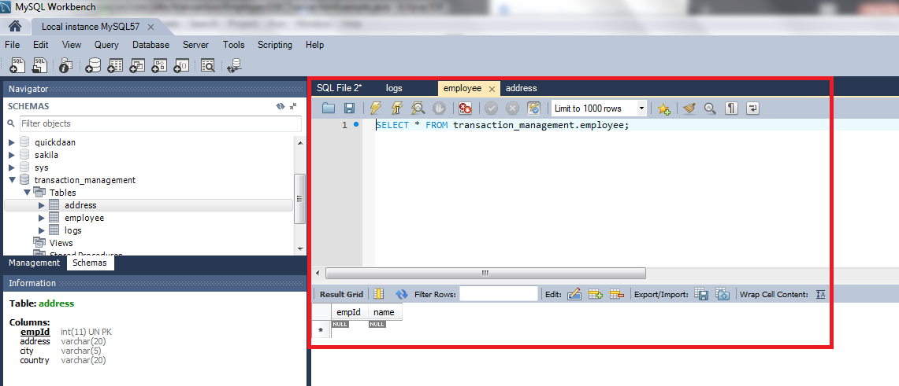



* Now we can change the city value, (here changed “San Jose” to “san” since city column size is 5) so that it can fit in the column and rerun the program to insert data into both the tables.

DB Connection created successfully

Employee Data inserted successfully **for** ID=1

Address Data inserted successfully **for** ID=1

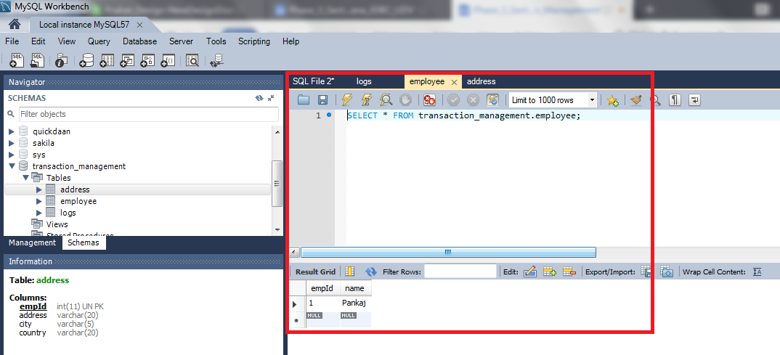

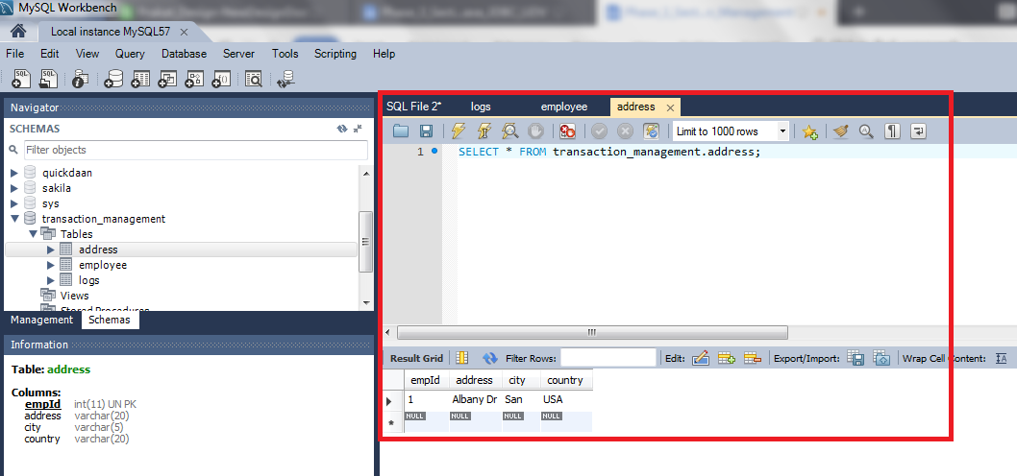

* Notice that connection is committed only when both the inserts are executed successfully. If any of them throws an exception, we are rolling back the complete transaction.

**Step 3.6.3:** Pushing the code to your GitHub repositories

Open your command prompt and navigate to the folder where you have created your files

cd <folder path>

Initialize your repository using the following command:

git init

Add all the files to your git repository using the following command:

git add . 

Commit the changes using the following command:

git commit . -m “Changes have been committed.”

Push the files to the folder you initially created using the following command:

git push -u origin master