INTERNSHIP WEEK 1
Data Cleaning and Preliminary Analysis with R
Titanic Passenger Survival Dataset

Data Analytics Internship — Week 1 Submission
Intern Name: Amulya
Internship Domain: Data Analytics
Week: 1 | Task: Data Cleaning & Preliminary Analysis
Tools: R, RStudio, ggplot2, dplyr
Dataset: Titanic Passenger Survival Dataset

Internship Objective
This Week 1 internship task demonstrates a practical data-analytics workflow in R. The work covers dataset selection, data-quality assessment, missing-value treatment, outlier handling, categorical encoding, standardization, exploratory analysis, and professional documentation. The objective is to transform a raw public dataset into a clean, analysis-ready dataset and communicate the findings clearly.

Internship Deliverables
- Data profiling and quality assessment using R.
- Missing-value analysis and justified preprocessing.
- Outlier detection, categorical encoding, and standardization.
- Descriptive statistics, correlations, and visual exploratory analysis.
- Reproducible R code and an analysis-ready CSV.
- Professional documentation suitable for an internship submission.

1. Dataset Overview
The Titanic passenger dataset contains demographic, travel and ticket information for 891 passengers. The target variable, Survived, records whether each passenger survived (1) or did not survive (0). The dataset is suitable for introductory data cleaning because it contains numerical and categorical variables, missing values, and strongly skewed variables such as Fare.
The dataset used here is the standard Kaggle Titanic training dataset. Kaggle describes the training data as containing 891 passengers and provides the data dictionary for variables such as Survived, Pclass, Sex, Age, SibSp, Parch, Fare, Cabin and Embarked.
Dataset source: https://www.kaggle.com/c/titanic/data

Dataset Dimensions and Variables
Rows: 891 | Columns: 12
Variable | Type | Meaning
PassengerId | Numerical | Unique passenger identifier
Survived | Binary | Target: 0 = did not survive, 1 = survived
Pclass | Categorical/ordinal | Passenger class: 1, 2, 3
Name | Text | Passenger name
Sex | Categorical | Female or male
Age | Numerical | Passenger age in years
SibSp | Numerical | Siblings/spouses aboard
Parch | Numerical | Parents/children aboard
Ticket | Text | Ticket number
Fare | Numerical | Passenger fare
Cabin | Categorical/text | Cabin identifier
Embarked | Categorical | Port: C, Q, or S

2. Initial Data Inspection
The first stage is to understand the structure, data types, dimensions, and missingness before modifying any observations. In R, str(), summary(), head(), dim(), and is.na() provide a compact initial audit.
R code — loading and inspecting the data
titanic <- read.csv("titanic_raw.csv", stringsAsFactors = FALSE)
dim(titanic)
str(titanic)
head(titanic)
summary(titanic)
Expected key output:
[1] 891 12
Missing-value counts:
Age = 177
Cabin = 687
Embarked = 2
All other columns = 0

Initial Missing-Value Audit
Column | Missing Values | Percentage
Age | 177 | 19.87%
Cabin | 687 | 77.10%
Embarked | 2 | 0.22%

3. Data Cleaning Process
Cleaning decisions were based on the amount of missingness, the variable's analytical value, and the risk of introducing unnecessary assumptions. The goal is not to make the data artificially perfect, but to make it consistent and suitable for preliminary analysis.
Variable | Problem | Action | Rationale
Age | 177 missing (19.87%) | Median imputation | Robust to skew and preserves all rows.
Embarked | 2 missing (0.22%) | Mode imputation: S | Only two values are missing; S is the most frequent category.
Cabin | 687 missing (77.10%) | Exclude from preliminary feature set | Very high missingness makes naive imputation unreliable.
Name / Ticket | High-cardinality text | Exclude from numerical analysis | Identifiers/text are not directly useful for the requested preliminary analysis.
PassengerId | Unique identifier | Retain only as an ID | It identifies rows but should not be treated as a predictive numeric measurement.

3.1 Missing-Value Handling
Age is imputed using the median (28.0 years). Median imputation is preferable to the mean here because age is not perfectly symmetric and the median is less sensitive to extreme observations. Embarked is imputed with the mode, S. Cabin is not imputed because approximately 77% of its values are missing; inventing cabin labels would create substantial uncertainty.
R code — missing-value treatment
titanic_clean <- titanic %>%
mutate(
Age = ifelse(is.na(Age), median(Age, na.rm = TRUE), Age),
Embarked = ifelse(is.na(Embarked), "S", Embarked)
)

3.2 Outlier Detection
Outliers were identified with the 1.5 × IQR rule. This is particularly relevant for Fare, where a small number of very high fares can dominate averages and correlations. Instead of deleting passengers, IQR capping was used so that the observations remain in the dataset while the influence of extreme values is reduced.
Variable | Q1 | Q3 | Lower Bound | Upper Bound | Outliers
Age | 20.125 | 38.000 | -6.688 | 64.812 | 11
Fare | 7.910 | 31.000 | -26.724 | 65.634 | 116
SibSp | 0.000 | 1.000 | -1.500 | 2.500 | 46
Parch | 0.000 | 0.000 | 0.000 | 0.000 | 213
R code — IQR detection and capping
iqr_bounds <- function(x) {
q1 <- quantile(x, 0.25, na.rm = TRUE)
q3 <- quantile(x, 0.75, na.rm = TRUE)
iqr <- q3 - q1
c(lower = q1 - 1.5*iqr, upper = q3 + 1.5*iqr)
}
cap_iqr <- function(x) {
b <- iqr_bounds(x)
pmin(pmax(x, b["lower"]), b["upper"])
}
titanic_clean$Fare <- cap_iqr(titanic_clean$Fare)

3.3 Categorical Encoding
Sex is encoded as female = 0 and male = 1. Embarked is converted to binary indicator variables Embarked_Q and Embarked_S, with Cherbourg represented by the all-zero baseline. One-hot/dummy encoding avoids imposing a false numerical ordering on port categories.
R code — categorical encoding
titanic_clean$Sex_Encoded <- ifelse(titanic_clean$Sex == "female", 0, 1)
titanic_clean$Embarked_Q <- ifelse(titanic_clean$Embarked == "Q", 1, 0)
titanic_clean$Embarked_S <- ifelse(titanic_clean$Embarked == "S", 1, 0)

3.4 Normalization / Standardization
Z-score standardization was applied to Age, Fare, SibSp and Parch after cleaning. Standardization places variables on a comparable scale with mean approximately 0 and standard deviation approximately 1. This is useful for many downstream statistical and machine-learning methods, although it is not required for every model.
R code — z-score standardization
titanic_clean$Age_Z <- as.numeric(scale(titanic_clean$Age))
titanic_clean$Fare_Z <- as.numeric(scale(titanic_clean$Fare))
titanic_clean$SibSp_Z <- as.numeric(scale(titanic_clean$SibSp))
titanic_clean$Parch_Z <- as.numeric(scale(titanic_clean$Parch))

4. Exploratory / Preliminary Analysis

4.1 Descriptive Statistics
Variable | Count | Mean | SD | Min | Median | Max
Survived | 891 | 0.384 | 0.487 | 0.000 | 0.000 | 1.000
Pclass | 891 | 2.309 | 0.836 | 1.000 | 3.000 | 3.000
Age | 714 | 29.699 | 14.526 | 0.420 | 28.000 | 80.000
SibSp | 891 | 0.523 | 1.103 | 0.000 | 0.000 | 8.000
Parch | 891 | 0.382 | 0.806 | 0.000 | 0.000 | 6.000
Fare | 891 | 32.204 | 49.693 | 0.000 | 14.454 | 512.329
R code — summary statistics
summary(titanic)
summary(titanic[c("Age", "Fare", "SibSp", "Parch")])

4.2 Survival Rate
Overall survival rate: 38.38% of passengers.
R code — overall survival
survival_rate <- mean(titanic$Survived) * 100
print(survival_rate)

4.3 Survival by Sex
Sex | Survival Rate
female | 74.20%
male | 18.89%
A strong difference is visible between the two sex categories. Female passengers had a survival rate of 74.20%, while male passengers had a rate of 18.89%. This is an association in this dataset, not proof that sex itself caused the outcome.
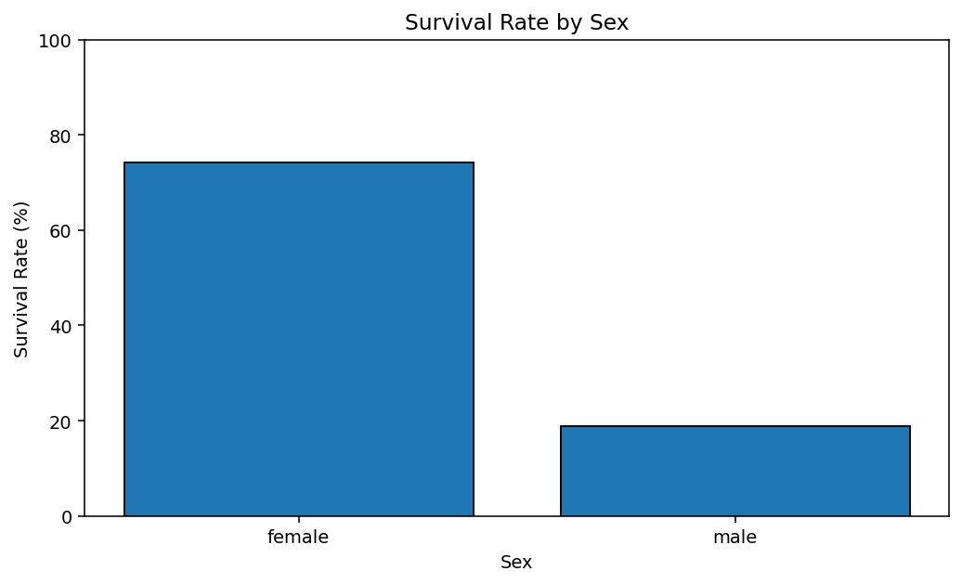

4.4 Survival by Passenger Class
Passenger Class | Survival Rate
1 | 62.96%
2 | 47.28%
3 | 24.24%
Survival also varies substantially by passenger class. First-class passengers had the highest observed survival rate (62.96%), followed by second class (47.28%) and third class (24.24%).
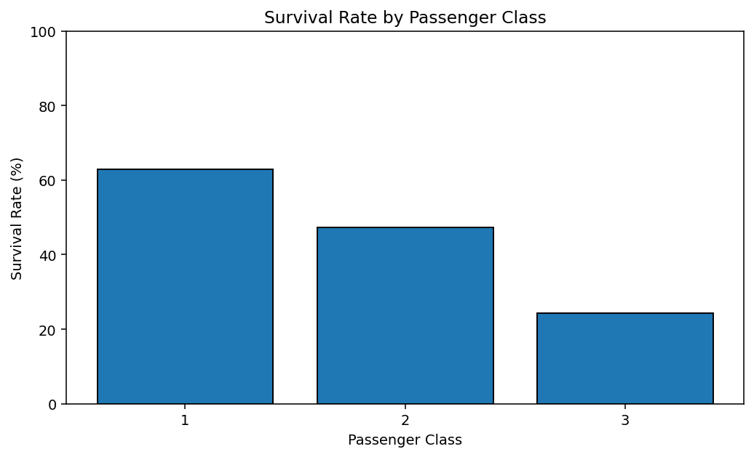

4.5 Numerical Distributions
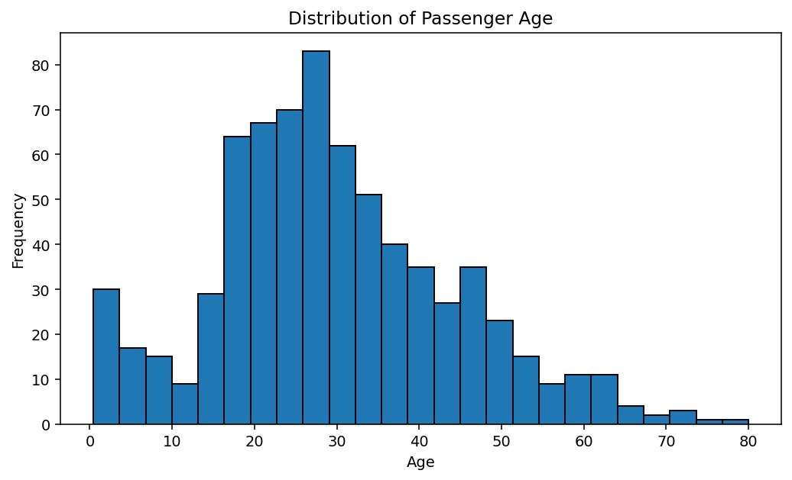
Age is concentrated around young and middle adulthood, with children also represented. The original age distribution contains missing observations, which were handled before standardization.
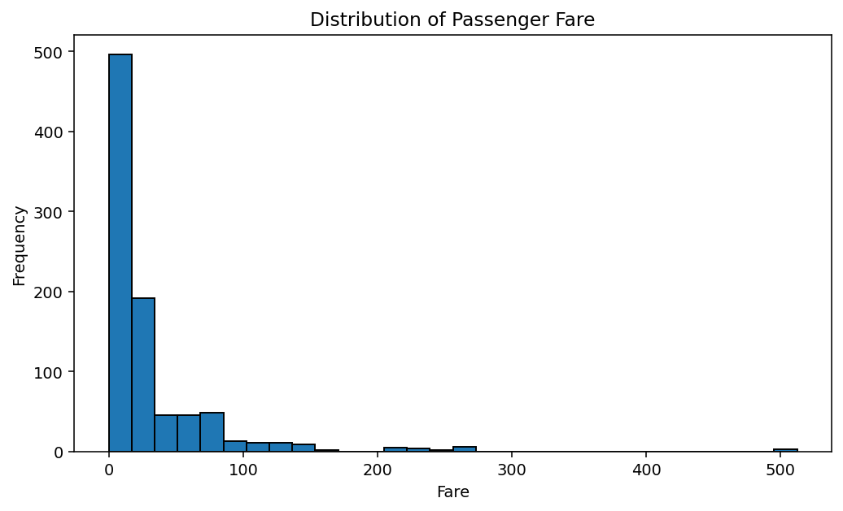
Fare is strongly right-skewed: most passengers paid relatively low fares, while a small number paid substantially more. This explains why Fare deserves explicit outlier treatment.

4.6 Correlation Analysis
 | Survived | Pclass | Age | SibSp | Parch | Fare
Survived | 1.000 | -0.338 | -0.077 | -0.035 | 0.082 | 0.257
Pclass | -0.338 | 1.000 | -0.369 | 0.083 | 0.018 | -0.549
Age | -0.077 | -0.369 | 1.000 | -0.308 | -0.189 | 0.096
SibSp | -0.035 | 0.083 | -0.308 | 1.000 | 0.415 | 0.160
Parch | 0.082 | 0.018 | -0.189 | 0.415 | 1.000 | 0.216
Fare | 0.257 | -0.549 | 0.096 | 0.160 | 0.216 | 1.000
The correlation matrix is a preliminary association check. Correlation measures linear association and should not be interpreted as causation. Because some variables are ordinal or binary, the values should be interpreted cautiously.
R code — correlation matrix
cor_matrix <- cor(
titanic[c("Survived","Pclass","Age","SibSp","Parch","Fare")],
use = "complete.obs"
)
round(cor_matrix, 3)

5. Key Initial Insights
- The dataset contains 891 passenger records and 12 original variables.
- Age has 177 missing values (19.87%), while Cabin has 687 missing values (77.10%).
- Overall survival was 38.38%.
- Female survival (74.20%) was much higher than male survival (18.89%) in the sample.
- First-class survival (62.96%) was higher than second-class (47.28%) and third-class (24.24%).
- Fare is strongly right-skewed and contains high-end observations that can affect descriptive statistics and correlations.
- After cleaning, categorical variables can be represented numerically and selected continuous variables can be standardized for downstream analysis.

Important Analytical Caution
These are descriptive findings, not causal conclusions. For example, the higher survival rate among first-class passengers does not by itself establish that class caused survival. Passenger class, sex, age, family structure, access to lifeboats, and other factors may be interrelated. A later predictive or inferential analysis would need a more rigorous model.

6. Cleaning Outcome
The final analysis-ready file retains all 891 rows. Missing Age and Embarked values are filled, Cabin/Name/Ticket are excluded from the compact feature set, categorical variables are encoded, and selected numerical variables are standardized.
Aspect | Before | After | Treatment
Rows | 891 | 891 | Rows retained; no listwise deletion
Missing Age | 177 | 0 | Median imputation
Missing Embarked | 2 | 0 | Mode imputation
Cabin | 687 | Excluded | Too much missingness for naive imputation
Sex | Text | Encoded | Female=0, Male=1
Embarked | Text | Dummy variables | Q and S indicators; C baseline
Scaled variables | 0 | 4 | Age, Fare, SibSp, Parch z-scores

7. Reproducibility and Files
The accompanying R script contains the complete workflow in executable R syntax. The cleaned CSV contains the analysis-ready data produced by the documented preprocessing.
- week1_titanic_analysis.R
- titanic_raw.csv
- titanic_cleaned.csv

How to Run in RStudio
- Place the raw CSV and the R script in the same working directory.
- Open week1_titanic_analysis.R in RStudio.
- Install/load ggplot2 and dplyr if they are not already installed.
- Run the script from top to bottom.
- Compare the console output and plots with the evidence included in this report.
- The script writes titanic_cleaned.csv to the working directory.

Internship Skills Demonstrated
- Data ingestion and initial profiling
- Missing-value handling and imputation
- IQR-based outlier detection and treatment
- Categorical variable encoding
- Numerical standardization
- Descriptive and correlation analysis
- Data visualization and insight communication
- Reproducible R workflow

8. Conclusion
This Week 1 analysis established a complete data-cleaning and preliminary-analysis workflow in R. The Titanic dataset was inspected for structure and missingness, missing values were handled using defensible simple imputation, extreme numerical observations were identified with the IQR rule and capped, categorical variables were encoded, and selected numerical variables were standardized. Descriptive statistics, survival-rate comparisons, distributions, and correlations were then examined. The resulting dataset is more consistent and suitable for subsequent exploratory or predictive modelling.

Appendix A — Console-Style Output Evidence
dim(titanic)
[1] 891 12
colSums(is.na(titanic))
PassengerId Survived Pclass Name Sex Age
0 0 0 0 177
SibSp Parch Ticket Fare Cabin Embarked
0 0 0 0 687 2
mean(titanic$Survived) * 100
[1] 38.38
survival_by_sex
female 74.20%
male 18.89%
survival_by_class
class 1 62.96%
class 2 47.28%
class 3 24.24%

