IBM Cloud Managed Services

Instructions Guide – Health Check Scripts for Linux & AIX

Author:

Adyantha T S (Adyantha Ts/India/IBM)

Owner:

Madhu Sudhan K N (Madhusudhan K Ningaiah/India/IBM)

1. Document history
   1. Document location

Paper copies are valid only on the day they are printed. Contact the author of this document for any feedback or queries.

* 1. Revision history

|  |  |  |
| --- | --- | --- |
| Revision number | Revision date | Summary of changes |
| 1.0 | 22/08/2017 | First draft |
| 1.1 | 14/09/2017 | Added details on configurable parameters and limitations of the script |

* 1. Approvals

To update this document, you need to get an approval from the people listed in the table. Use the Inspection Tool review for getting approvals.

|  |  |
| --- | --- |
| Name | Notes ID |
| Madhu Sudhan K N | Madhusudhan K Ningaiah/India/IBM |

* 1. Distribution

This document is available in the Cloud Managed Services (CMS) document repository.

* 1. Authors

|  |  |
| --- | --- |
| Name | Notes ID |
| Adyantha T S | Adyantha Ts/India/IBM |
|  |  |

* 1. Contributors

|  |  |
| --- | --- |
| Name | Notes ID |
| Reymond Peo Nevis | Reymond N Peo/India/IBM |
| Madhu Sudhan K N | Madhusudhan K Ningaiah/India/IBM |

Contents

1. Document history 2

1.1 Document location 2

1.2 Revision history 2

1.3 Approvals 2

1.4 Distribution 2

1.5 Authors 2

1.6 Contributors 2

2. About this document 4

3. Description 5

4. Features 7

5. Prerequisites 8

6. Configurable Parameters 9

7. Usage 10

8. Limitations 12

Appendix A: Health Check Parameters 13

List of Parameters for Linux: 13

List of Parameters for AIX: 13

1. About this document

This document provides instructions to use/execute the script to generate OS health check report for n number of servers across Linux and AIX platforms.

1. Description

This script can be used to generate "OS health check report" for n number of servers

* can be used for LINUX/AIX
* can be executed for a site with multiple customers (eg. RTP site & WHR, WH1 and WH2 customers)
* can be executed for customers across multiple sites (eg. Z4G customer in all sites)
* can be used to get details of servers irrespective of site/customers by inputting file containing host names
* can be used to get details of all parameters or only few (custom). User will be prompted to choose parameters (screen shot attached below)

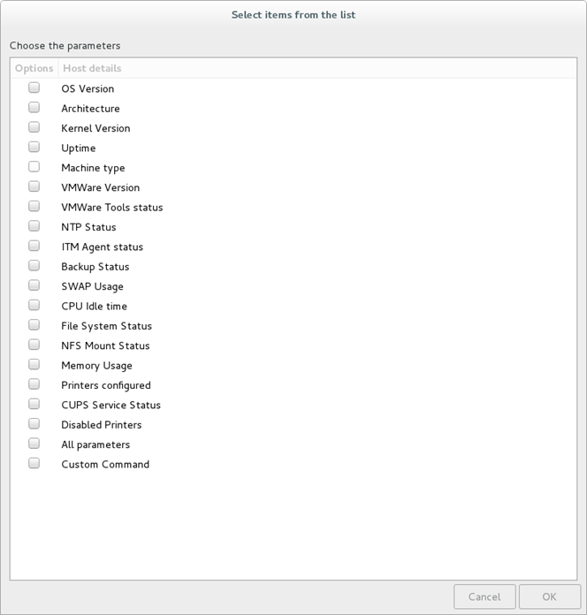

* can be used to execute a custom command (eg. uname -a) for n number of servers and get the output in csv/xls report.

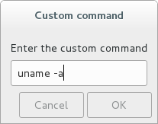

1. Features

* **Auto tunneling** is implemented i.e. user don't need to connect to SASGUI. Scenarios like connecting to one tunnel in SASGUI needs disconnection of other tunnel is taken care. script connects to multiple tunnels as well.
* **Parallel processing** is implemented. Multiple SSH processes (threads) will run in parallel which helps in generating the report in less time. Number of threads can be configured. Default value is 100.
* **Summary details** in report. Once details are collected for all servers, script will prepare a xls report with new sheet (summary) and put details of servers having issues. Also full details will be available in another sheet. (sample summary
* If a server takes too long to get the details because of commands etc, the script will terminate that task and continue with next server. Terminated server details will be printed in terminal as well as in the report, so that necessary action can be taken. Deafult time out is set to 3 minutes. This can be configured.
* If ctrl+c is pressed during execution of the script. report will be prepared with server details till that point.
* If ibmadmin is unable to connect to a server, osadmin will be used for getting the details. If osadmin is also unable to connect, report will have connection failure details.

1. Prerequisites

* Connect to Forticlient SSL VPN
* Make sure, necessary execution permissions are provided for scripts.
* If you need summary details (in xls) for the servers you're executing, install **Perl packages** - Text::CSV & Spreadsheet::WriteExcel. If these packages are not present, only CSV report will be generated.

1. Configurable Parameters

## Max no of servers processed at a time. Higher the number, faster the execution. Please make sure nproc is set properly if configuring with value > 200

threads=100

## If a server takes too much time or gets hung while executing any command, how long to wait before proceeding with next set of servers can be specified here (in seconds)

time_out=180

## Keep monitoring the process every 5 seconds until time out (above value) is reached.

sleep_time=5

1. Usage

**bash health_check.sh**

-P [Platform - LINUX/AIX] Mandatory

-T [Health Check Type - FULL for all parameters/CUSTOM to choose any] Mandatory

-S [Site Code] Optional

-C [Customer codes - comma separated] Optional

-I [servers file containing hostnames] Optional

-h help

**Examples:**

1. bash health_check.sh -P LINUX -T FULL -S ABN

Above usage will generate full health check report for all Linux servers of ABN site .

Sample screen shot is attached below:



1. bash health_check.sh -P aix -T CUSTOM -S abn

Above usage will prompt the user to choose the parameters & generate custom health check report for all AIX servers of ABN site

Sample screen shot is attached below:

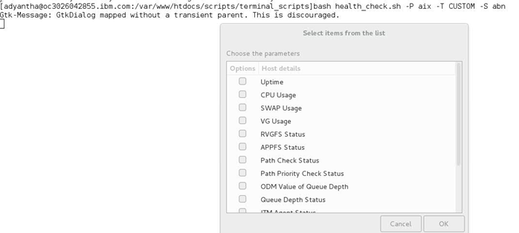

1. bash health_check.sh -P AIX -T FULL -C Z4G

Above usage will generate full health check report for all AIX servers of Z4G customer across all sites.

1. bash health_check.sh -P Linux -T FULL -S ABN -C AB3, Q71, Q91

Above usage will generate full health check report for Linux servers of AB3, Q71 &Q91 customers in ABN site.

1. bash health_check.sh -P Linux -T CUSTOM -S EHN, MOP -C Z4G

Above usage will prompt the user to choose the parameters & generate custom health check report for all Linux servers of Z4G customer in ABN & RTP sites.

1. bash health_check.sh -P Linux -T CUSTOM -I servers_file

Above usage will prompt the user to choose the parameters & generate custom health check report for all Linux servers present in the servers_file (list of host names)

1. bash health_check.sh -P AIX -T FULL -I servers_file

Above usage will generate full health check report for all AIX servers present in the servers_file (list of host names)

1. Limitations

* Even if the script needs to be executed for a single server, it must be added into an input file and then needs to be executed.
* If details need to be retrieved for a specific POD of a site, script will not help. i.e. Script can be executed only at site-customer level. One option is to put host names of specific POD into an input file and execute which is tedious.

1. Health Check Parameters

List of Parameters for Linux:

* OS Version
* Architecture
* Kernel Version
* Uptime
* Machine type
* VMWare Version
* VMWare Tools status
* NTP Status
* ITM Agent status
* Backup Status
* SWAP Usage
* CPU Idle time
* File System Status
* NFS Mount Status
* Memory Usage
* Printers configured
* CUPS Service Status
* Disabled Printers
* Custom Command

List of Parameters for AIX:

* Uptime
* CPU Usage
* SWAP Usage
* VG Usage
* RVGFS Status
* APPFS Status
* Path Check Status
* Path Priority Check Status
* ODM Value of Queue Depth
* Queue Depth Status
* ITM Agent Status
* GPFS Status
* HACMP Status
* Custom Command