Construction Site Safety Classification Using Convolutional Neural Networks
Detecting Safe vs. Unsafe PPE Compliance from Construction Site Images
Phase 2 – Proposal and Code Implementation
[Your Name] | [Course Name] | [Date]

1. Project Title
Construction Site Safety Classification Using Convolutional Neural Networks: Detecting Safe vs. Unsafe PPE Compliance from Construction Site Images.

2. Background and Motivation
Construction remains one of the most hazardous industries worldwide, with a large share of workplace injuries and fatalities linked to non-compliance with Personal Protective Equipment (PPE) requirements, such as failing to wear a hard hat or a high-visibility safety vest. Manual safety inspection is labor-intensive, inconsistent, and cannot scale to the number of workers and cameras present on a large site. Recent advances in deep learning, and Convolutional Neural Networks (CNNs) in particular, have made it possible to automatically analyze images and video streams to flag safety violations in near real time.
This project is motivated by the practical need for an automated, camera-based safety monitoring tool that can classify a construction site image as "safe" (worker properly equipped with PPE) or "unsafe" (worker missing required PPE or in a visibly hazardous situation), supporting site supervisors in enforcing safety compliance and reducing preventable accidents.

3. Problem Statement
Given an image captured on or around a construction site, the goal is to automatically determine whether the depicted scene/worker complies with basic safety standards ("Safe") or represents a safety violation ("Unsafe"). This is framed as a binary image classification problem. The challenge lies in the high visual variability of construction environments — differences in lighting, camera angle, occlusion, worker pose, and site clutter — which makes it difficult for simple rule-based or color-based heuristics to reliably detect PPE compliance. A CNN-based approach is proposed to learn discriminative visual features directly from the data.

4. Selected Dataset and Dataset Link
Dataset: Construction Site Safety Dataset for PPE Compliance Classification (Kaggle).
Link: https://www.kaggle.com/datasets/ (search: "Construction Site Safety Dataset for PPE Compliance Classification") — replace with the exact dataset URL used in the Kaggle notebook.

5. Dataset Description
Property | Description
Number of images | ≈ 1,010 images in total (test split alone: 200 images — 100 safe, 100 unsafe)
Number of classes | 2 classes (binary classification): Safe, Unsafe
Image type | RGB color photographs of construction sites and workers (JPEG/PNG), variable resolution, resized to 224 × 224 for the model
Class distribution | Balanced between the two classes in the test set (100 / 100); training set is likewise curated to be close to balanced
Data source | Images sourced from public online construction-safety photo collections and manually labeled as safe or unsafe based on PPE compliance

Below is a sample of labeled images from the dataset, illustrating the visual variability (indoor/outdoor scenes, close-ups of PPE, varying lighting) and the two target classes:
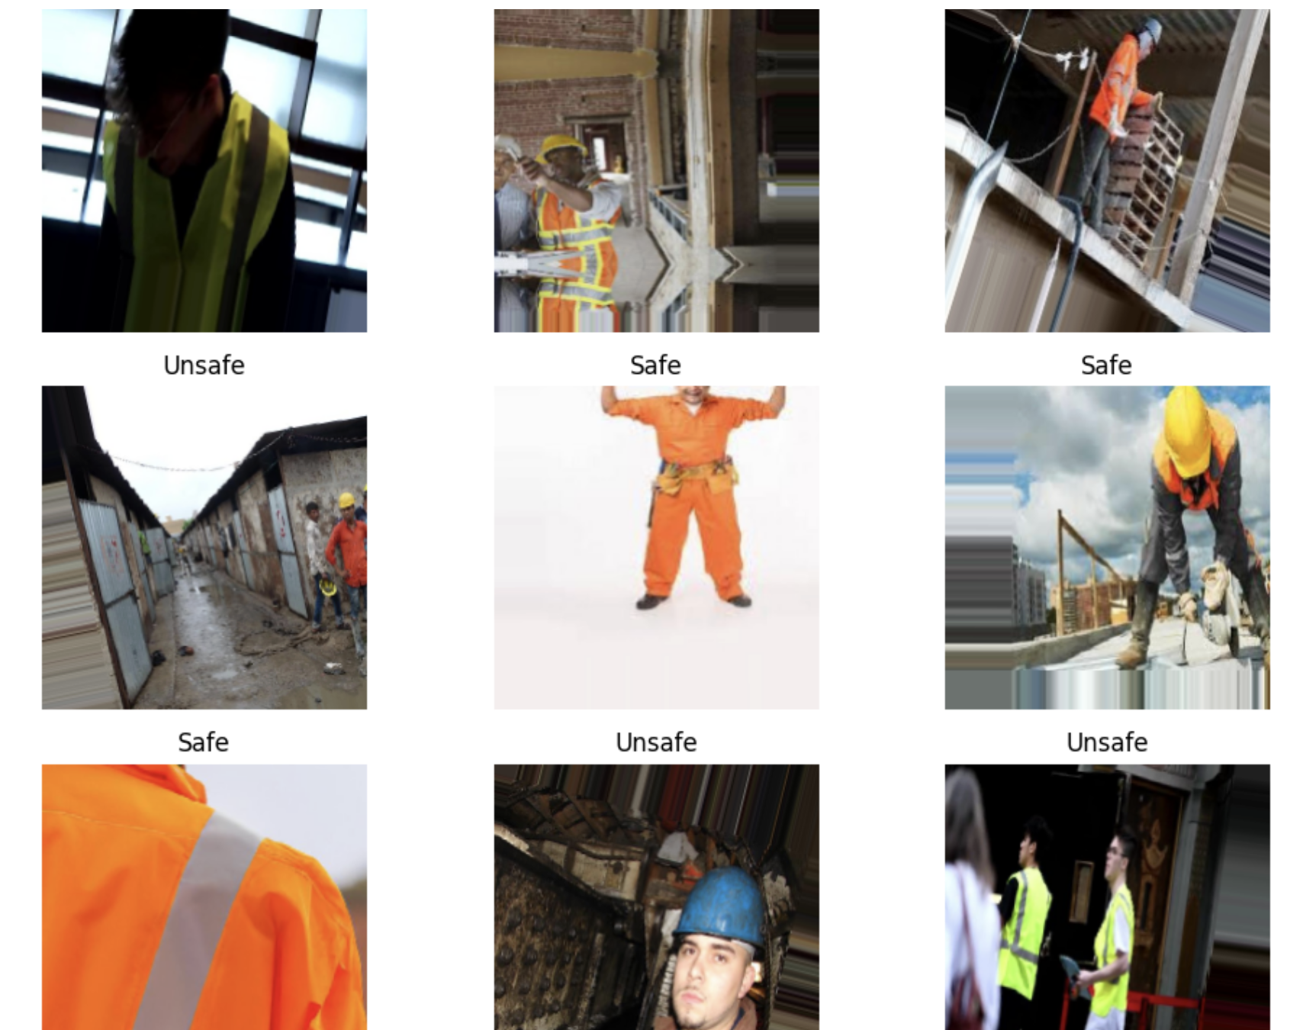
Figure 1. Sample images from the dataset with their ground-truth Safe / Unsafe labels.

6. Research Questions
- Can a CNN trained from scratch reliably distinguish safe from unsafe construction site conditions based on PPE visibility alone?
- How does a custom-built CNN compare against a pretrained transfer-learning model (e.g., MobileNetV2 / VGG16 / ResNet50) in terms of accuracy and generalization on this dataset?
- Which types of images (e.g., cluttered backgrounds, partial occlusion, poor lighting) are most frequently misclassified, and what does this reveal about the model's limitations?
- Does data augmentation and regularization (dropout) meaningfully reduce overfitting given the relatively small dataset size?

7. Expected Results
The custom CNN is expected to achieve moderate accuracy (roughly 65–75%) given the limited dataset size and the visual complexity of real-world construction scenes, as reflected in preliminary results (69% test accuracy). The transfer-learning model is expected to outperform the custom CNN, since pretrained ImageNet features should transfer well to distinguishing high-visibility vests, hard hats, and safe postures. Confusion matrices are expected to show that most errors occur on ambiguous images (e.g., partial PPE visibility, distant or occluded workers) rather than on clearly safe or clearly unsafe scenes.

8. Proposed Methodology

8.1 Data Pipeline
- Load images from the labeled Safe/Unsafe folders.
- Resize all images to a fixed input size (224 × 224 × 3).
- Normalize pixel values to the [0, 1] range.
- Split data into training, validation, and test sets.
- Apply data augmentation on the training set (random rotation, horizontal flip, zoom, brightness shift) to improve generalization and reduce overfitting.

8.2 Modeling
- Build and train a custom CNN from scratch as the baseline model.
- Fine-tune a pretrained transfer-learning model (e.g., MobileNetV2 or VGG16 with a custom classification head) for comparison.
- Train both models with early stopping / learning-rate scheduling and monitor training vs. validation curves for overfitting.

8.3 Evaluation
- Evaluate both models on the held-out test set.
- Compare performance using accuracy, precision, recall, F1-score, and the confusion matrix.
- Perform qualitative error analysis on misclassified images.

9. CNN Model Design
The custom CNN follows a standard convolution → pooling stack of increasing depth, followed by a fully connected classification head with dropout regularization. The architecture (as implemented) is summarized below:
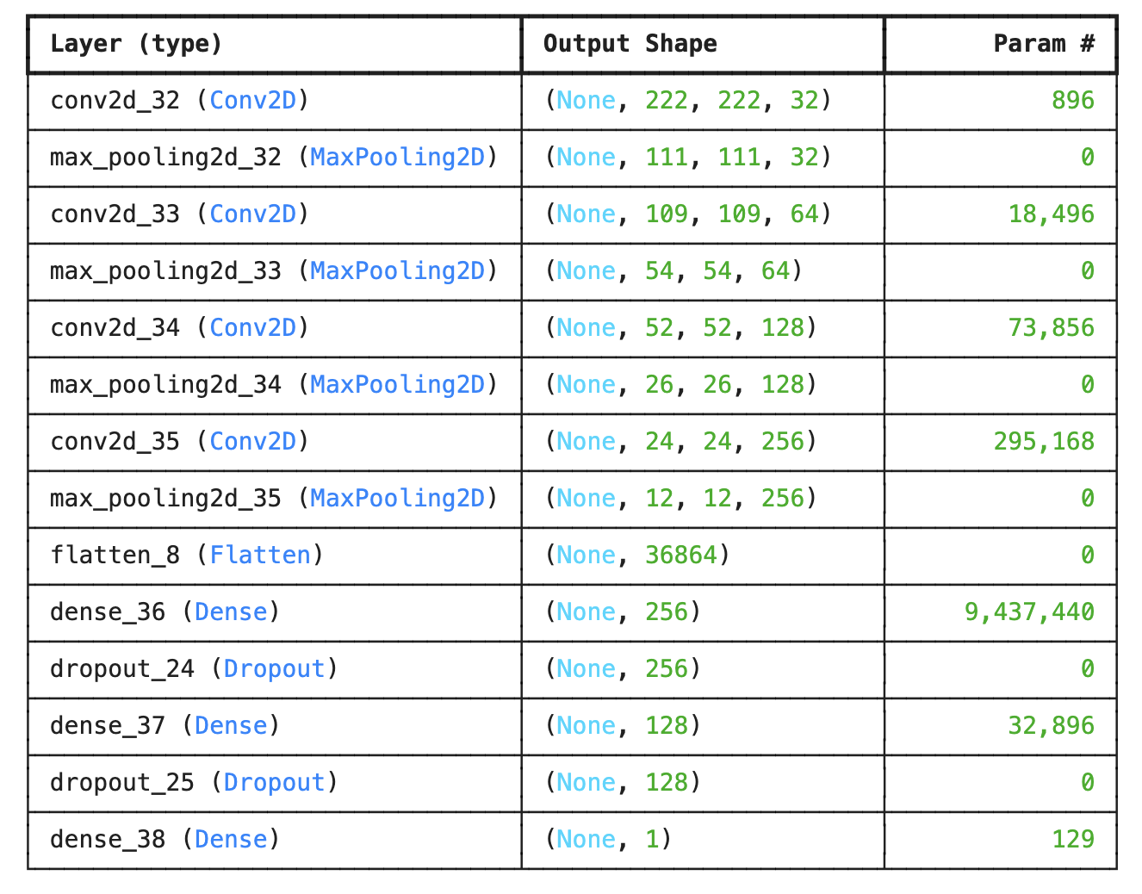
Figure 2. Custom CNN architecture summary (4 convolutional blocks + dense classification head, ≈ 9.86M parameters).
Design rationale:
- Four Conv2D + MaxPooling2D blocks (32 → 64 → 128 → 256 filters) progressively extract low-level (edges, colors) to high-level (PPE shapes, vest patterns) features while reducing spatial dimensions.
- A Flatten layer feeds into two Dense layers (256 and 128 units) with Dropout (after each) to reduce overfitting given the limited dataset size.
- A final Dense(1) layer with sigmoid activation outputs the probability of the "unsafe" class for binary classification.
- The model is compiled with binary cross-entropy loss and the Adam optimizer, trained for 20 epochs with batch-wise validation tracking.

10. Transfer Learning Models
To answer the research question on how a custom CNN compares to transfer learning, a pretrained model — MobileNetV2 (or alternatively VGG16 / ResNet50), pretrained on ImageNet — will be used as a fixed or fine-tuned feature extractor. Its convolutional base will be attached to a new classification head (GlobalAveragePooling2D → Dense → Dropout → Dense(1, sigmoid)) and trained on the same train/validation/test split, using the same augmentation pipeline, to allow a fair, direct comparison against the custom CNN described in Section 9.

11. Evaluation Metrics
- Accuracy — overall proportion of correctly classified images.
- Precision, Recall, and F1-score — per class (safe / unsafe), to account for the cost asymmetry of missing an unsafe scene.
- Confusion Matrix — to visualize the distribution of correct classifications vs. false positives/negatives.
- Training/Validation Accuracy and Loss curves — to monitor convergence and detect overfitting.
- (Optional/stretch) ROC curve and AUC, and Grad-CAM visualizations to interpret which image regions drive the model's predictions.

12. Expected Figures and Tables
The following figures and tables are produced by the current implementation and will be included/expanded in the final report:

12.1 Training Progress (Custom CNN)
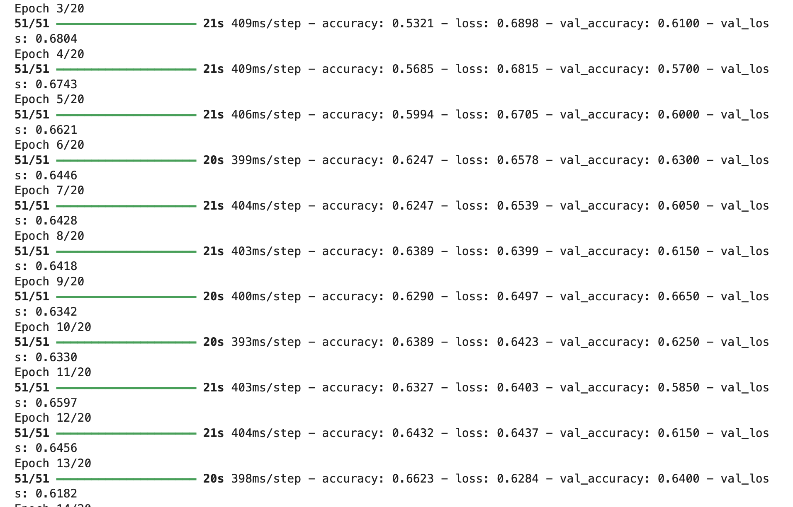
Figure 3. Training log excerpt showing per-epoch accuracy and loss for the custom CNN.
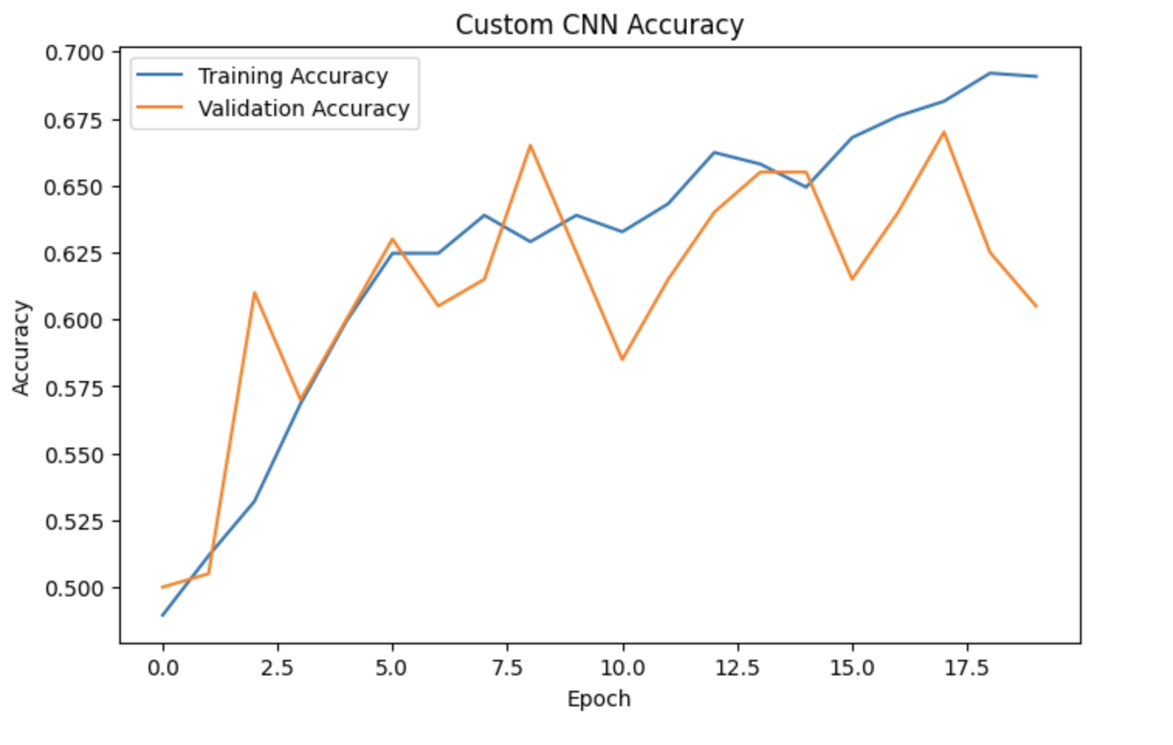
Figure 4. Training vs. validation accuracy across 20 epochs.
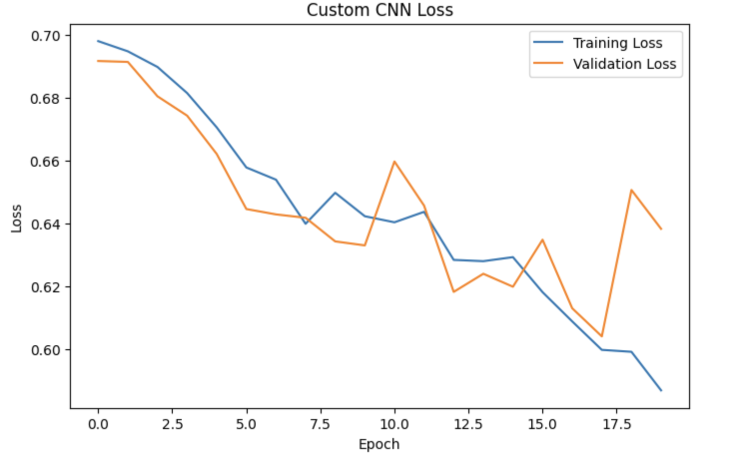
Figure 5. Training vs. validation loss across 20 epochs.

12.2 Test Set Evaluation (Custom CNN)
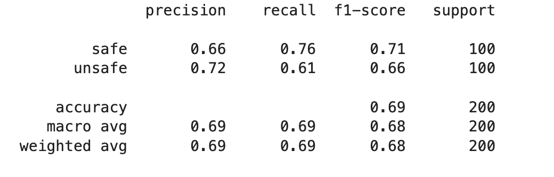
Figure 6. Classification report on the test set (200 images: 100 safe, 100 unsafe).
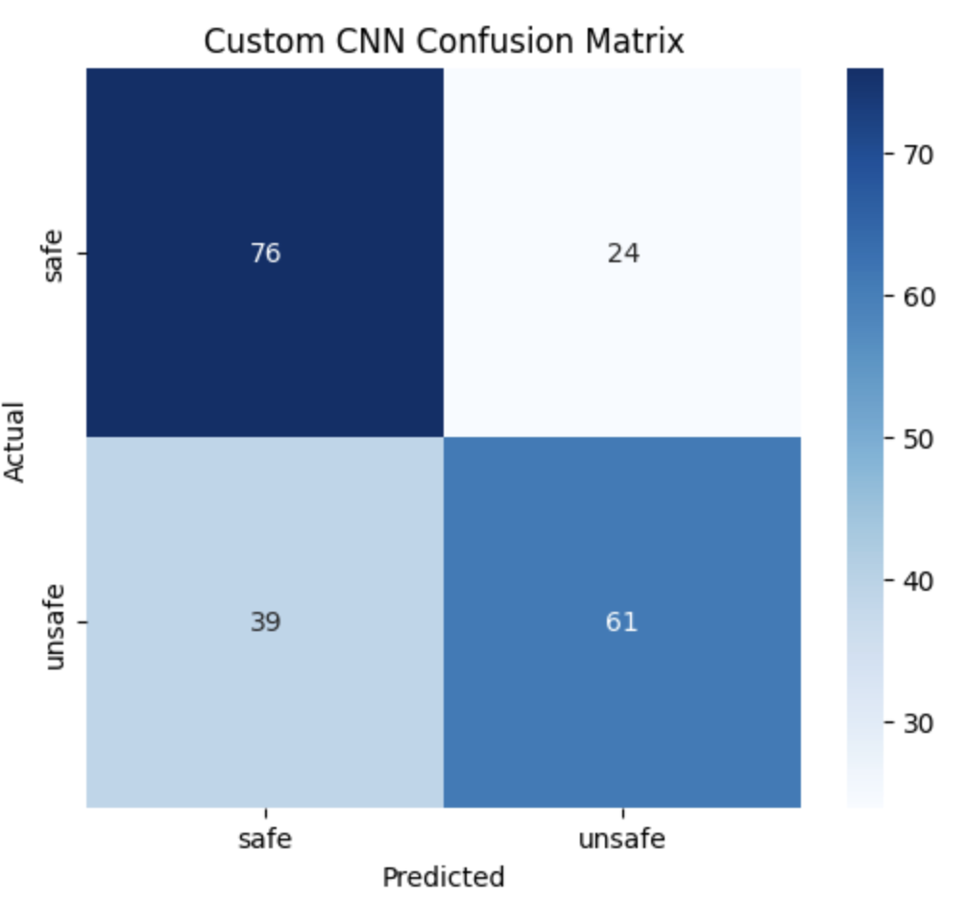
Figure 7. Confusion matrix for the custom CNN on the test set (overall accuracy ≈ 69%).

12.3 Planned Additional Outputs
- Accuracy/loss curves and confusion matrix for the transfer-learning model, presented side-by-side with Figures 4–7 for direct comparison.
- A model comparison table (Custom CNN vs. Transfer Learning) summarizing accuracy, precision, recall, F1-score, and training time.
- Grad-CAM heatmaps on a sample of correctly and incorrectly classified images, to visualize which regions of the image the model attends to.
- A short qualitative error-analysis section discussing common misclassification patterns.

Interim Results Summary
The custom CNN summarized in Sections 9 and 12 was trained for 20 epochs and evaluated on a held-out test set of 200 images (100 safe, 100 unsafe). It achieved 69% overall test accuracy, with the confusion matrix showing 76/100 safe images and 61/100 unsafe images correctly classified. Precision and recall are reasonably balanced between classes (safe: precision 0.66, recall 0.76; unsafe: precision 0.72, recall 0.61), and the accuracy/loss curves (Figures 4–5) show validation performance tracking training performance without a wide train–validation gap, with the fluctuation in validation accuracy typical of a modestly sized dataset. These results establish a baseline against which the transfer-learning model (Section 10) will be compared in the next stage of the project.

