# 踩过的坑

Demo位置：D:\ideaproject\moco\result\resultData

1、通过settings.json启动moco时启动命令为

java -jar moco-runner-<version>-standalone.jar start -p 12306 -g settings.json

本机启动命令：java -jar moco-runner-1.1.0-standalone.jar start -p 9999 -g settings.json

守护进程启动：nohup java -jar moco-runner-1.1.0-standalone.jar start -p 9999 -g settings.json &

2、通过settings.json配置启动时各json文件设置为

Settings.json :

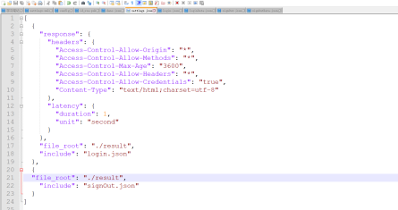

[

{

"response": {

"headers": {

"Access-Control-Allow-Origin": "*",

"Access-Control-Allow-Methods": "*",

"Access-Control-Max-Age": "3600",

"Access-Control-Allow-Headers": "*",

"Access-Control-Allow-Credentials": "true",

"Content-Type": "text/html;charset=utf-8"

},

"latency": {

"duration": 1,

"unit": "second"

}

},

"file_root": "./result",

"include": "login.json"

},

{

"file_root": "./result",

"include": "signOut.json"

}

]

login.json :

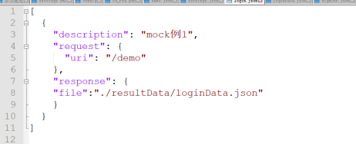

[

{

"description": "mock例1",

"request": {

"uri": "/demo"

},

"response": {

"file":"./resultData/loginData.json"

}

}

]

loginData.json : 内容为请求返回的json数据

signOut.json ：

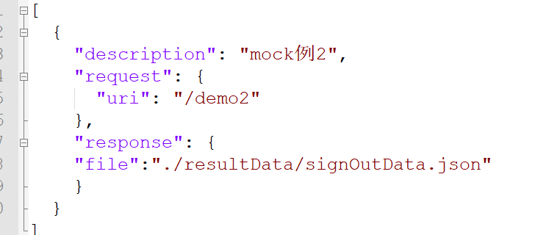

[

{

"description": "mock例2",

"request": {

"uri": "/demo2"

},

"response": {

"file":"./resultData/signOutData.json"

}

}

]

signOutData.json ：内容为返回的json数据

3、moco设置带cookie请求配置，及postman如何带cookie请求

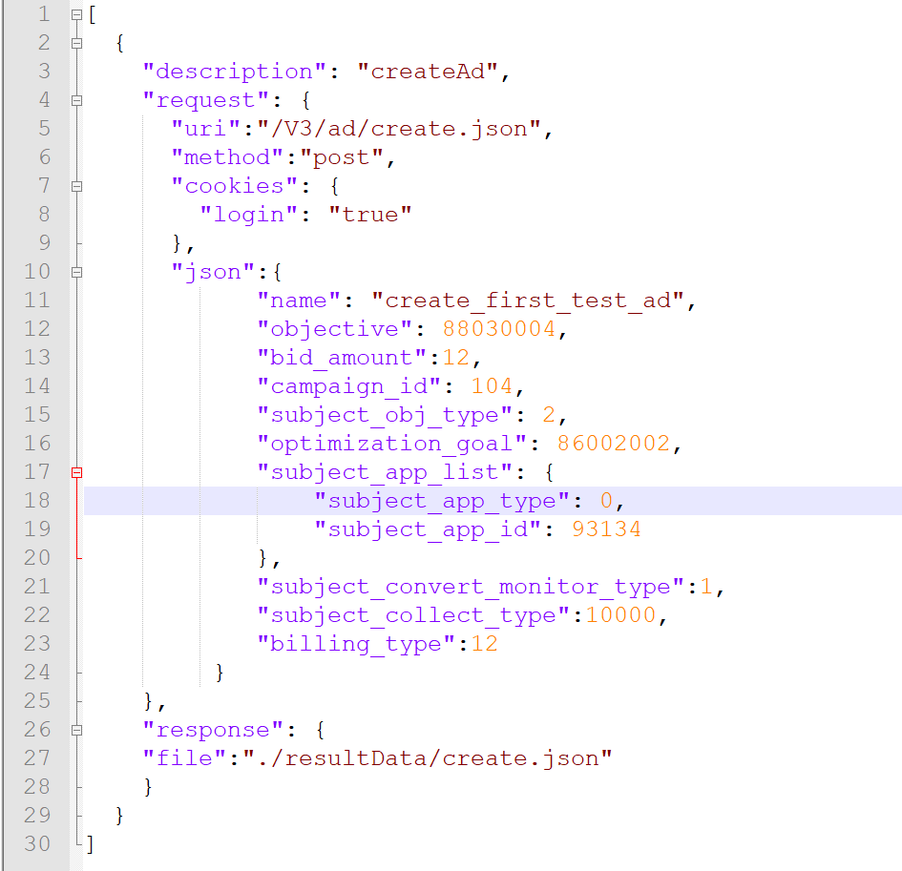

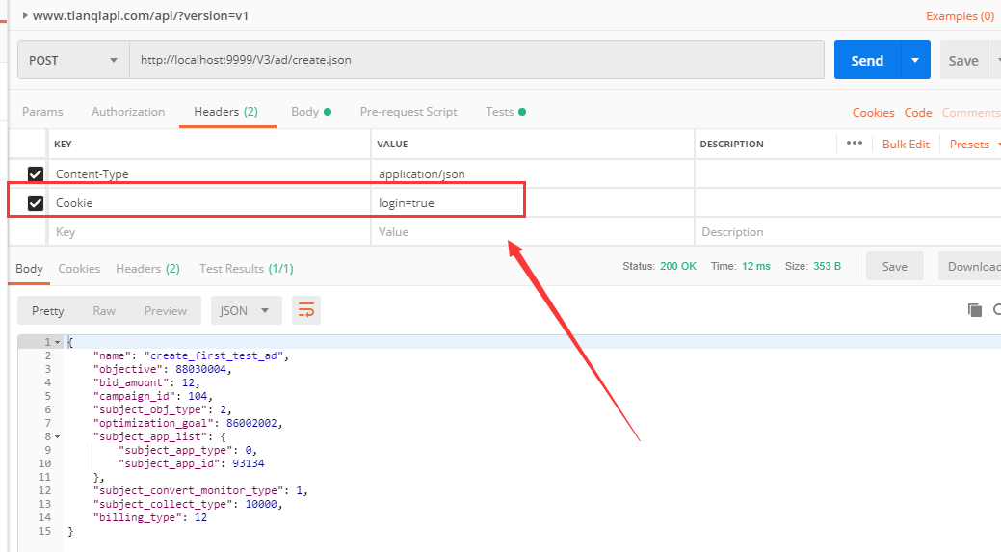

# 参考帖子链接：

入门：

<https://blog.csdn.net/jamieblue1/article/details/98969828>

全局设置：

<https://blog.csdn.net/qq_41829492/article/details/88093147>

全局设置后启动jar文件

<https://www.huangyunkun.com/2014/11/17/moco-global-config/>

Moco配置约定字段

<https://www.cnblogs.com/hanschen-coder/p/6528829.html>