Group 1: Single-Area OSPF(OPEN SHORTEST PATH FIRST) Concepts
Objective: Understand the basic idea of Single-Area OSPF and its advantages
Guide Questions:
1. What is Single-Area OSPF?
Single-Area OSPF is a type of Open Shortest Path First (OSPF) routing configuration where all routers belong to only one OSPF area, usually Area 0 (the backbone area). In this setup, every router shares the same link-state database, allowing OSPF to calculate the shortest paths efficiently.

2. How does Single-Area OSPF differ from multi-area OSPF?
Single-Area OSPF places all routers in one area (usually Area 0), making it easier to manage and ideal for smaller networks. Multi-Area OSPF divides the network into multiple areas connected through the backbone (Area 0), using Area Border Routers to improve scalability and performance in large networks.

-in comparison multi area divides the network into multiple areas arranged in a hierarchical structure. All non-backbone areas must connect to Area 0, and routers that connect different areas are called Area Border Routers (ABRs). While multi-area OSPF improves scalability for large networks, it is more complex to configure and manage than single-area OSPF.

IN BULLET FORM:
Single-Area OSPF:
- Uses only one area
- Simpler to configure and manage
- All routers maintain the same routing database
Multi-Area OSPF:
- Uses multiple areas connected to Area 0
- More complex configuration
- Reduces routing table size and processing overhead for large networks

3. What are the advantages of using a single area?
- Simple configuration and maintenance
- Faster network convergence- because all roosters have complete topology info.
- Less administrative overhead
- Ideal for small to medium-sized networks
- Easier troubleshooting - due to a unified routing database
-Easier troubleshooting since all routers share the same topology information

4. Can you draw a simple network diagram showing a single OSPF area?
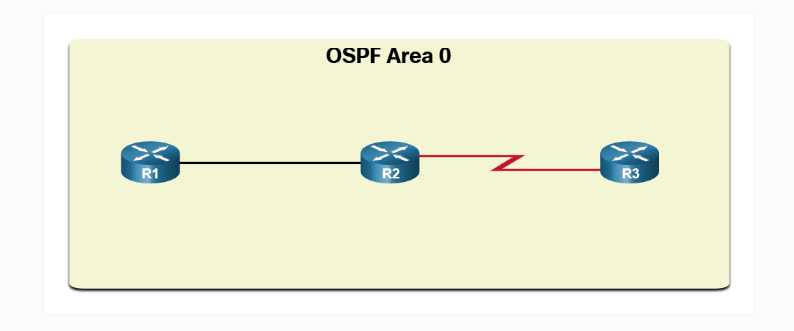

5. In what situations is Single-Area OSPF preferred?

Single-Area OSPF is preferred when:
- The network is small or medium in size
- There is no need for complex segmentation
- Network administrators want easy deployment and management
- The routing infrastructure does not generate excessive routing updates

