OVERLAY NETWORK MONITORING SYSTEM

DEVELOPER DOCUMENT

VERSION 1.0

**Team Name:** Smart Developers

**Team Members:**











Sana











1. **PREFACE:**

The main concern of the project is to provide the customer a simple and unified way of maintaining and updating its applications which interact with the monitoring system through a common RESTful API. This is the initial version of the document.

**Release v1.0 on 2017-09-13**

* Initial release of the document

The remainder of the document is organized as follows. In Section 2, Glossary and Abbreviations of terms used in the document is provided. Section 3, deals with introduction of the document. Section 4, describes the software description of the product. Section 5, deals with the system architecture. Section 6, deals with the structure of the database and RESTful API. In Section 7, we deal with extension the product.

1. **GLOSSARY AND ABBREVATIONS:**

* **API**: Application Programming Interface
  + An API is a set of routines, protocols, and tools for building software applications.
* **InfluxDB**: Influx Database
  + InfluxDB is an open source time series database. InfluxDB has no external dependencies and provides an SQL-like language with built in time-centric functions for querying a data structure composed of measurements, series, and points.
* **Grafana**:
  + Grafana is most commonly used for visualizing time series data for Internet infrastructure and application analytics but many use it in other domains including industrial sensors, home automation, weather, and process control. Grafana features pluggable panels and data sources allowing easy extensibility and a variety of panels, including fully featured graph panels with rich visualization options. There is built in support for many of the most popular time series data sources.
* **SSL**: Secure Sockets Layer
  + SSL is a standard security technology for establishing an encrypted link between a web server and a browser.
* **RTT**: Round Trip Time
* **HTTPS**: Hyper Text Transport Protocol Secure
* **RESTful**: Representative State Transfer

1. **INTRODUCTION:**

This document gives brief overview about the technical aspects of the product. This document also serves as the assistance for developers for adding new functionalities to the product.

1. **SOFTWARE DESCRIPTION OF THE PRODUCT:**

The software description is mainly based on backend & frontend. Therefore, the backend of this product is totally based on Python and is used to interact with the InfluxDB for storing metric data from time-to-time. Whereas, the frontend is written in HTML, CSS which is integrated with the Flask (Python) module to create a REST framework and interacts with the SQLAlchemy database for user/admin authentication. Graphical representation of the user’s measurement data is done using Grafana.

1. **SYSTEM ARCHITECTURE:**
   1. **PROGRAMMING LANGUAGES USED:**

* HTML
* CSS
* Python
* SQLAlchemy
* MySQL
  1. **ORGANISATION OF SOURCE CODE:**

**Front-End**

* welcome.html
* signup.html
* login.html
* login.html.html
* dash.html
* dashadmin.html
* nodes.html
* register.html
* account.html
* statistics.html
* logout.html
* account.css
* loginpage.css
* akhi.css
* dash.css
* log.css
* statistics.css

**Database**

* restful.py

**Back-End**

* user.py
* user_runner.py
* server.py

1. **STRUCTURE OF DATABASE:**

The product uses two databases, where one is SQLAlchemy and the other is InfluxDB.

**SQLAlchemy:**

1. A screenshot of a computer

   Description generated with very high confidenceA database with its name, “sd” is created as shown below:
2. 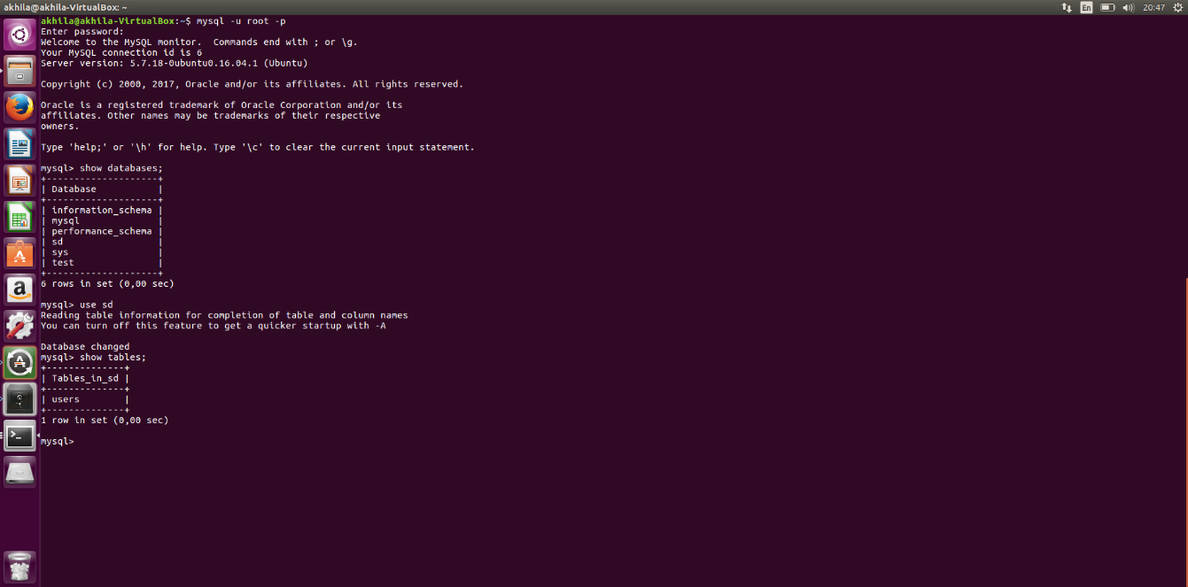The database consists of a single table named as “users” to store user credentials as shown below:
3. 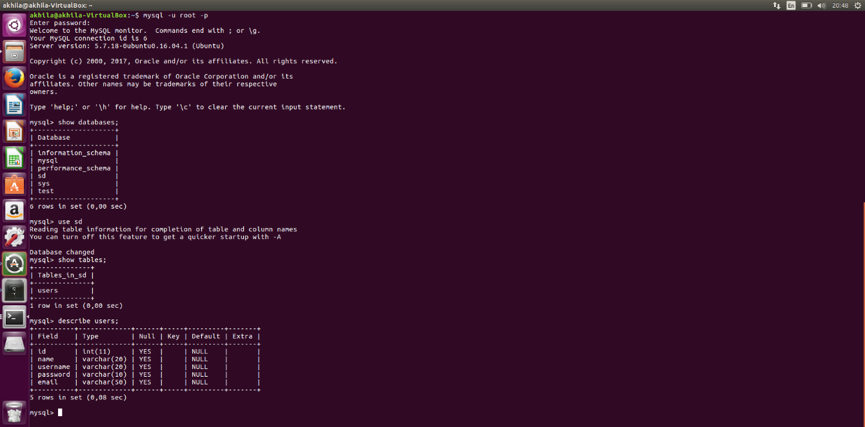The table consists of four columns regarding user credentials as shown below:

**InfluxDB:**

1. 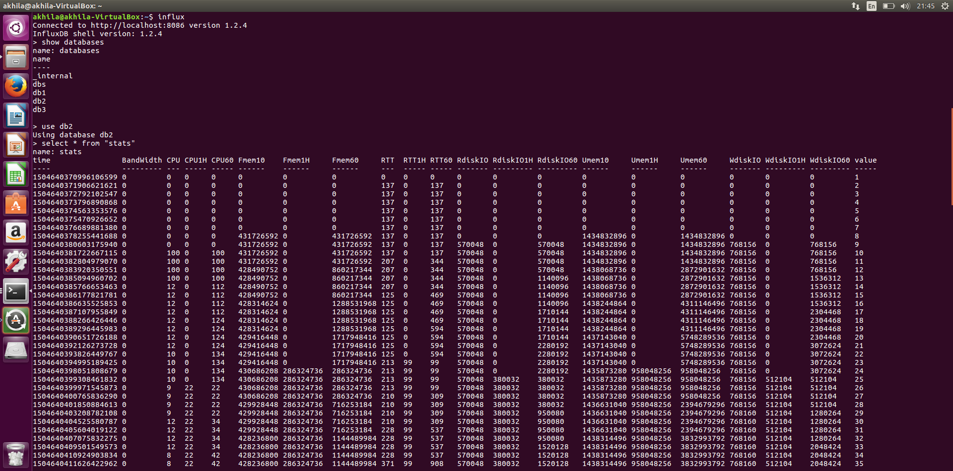Influx database (“db1”, “db2”, “db3” here we consider “db2”) consists of a table named as “stats” having columns as shown below:

**GUI of Frontend Interface:**

1. 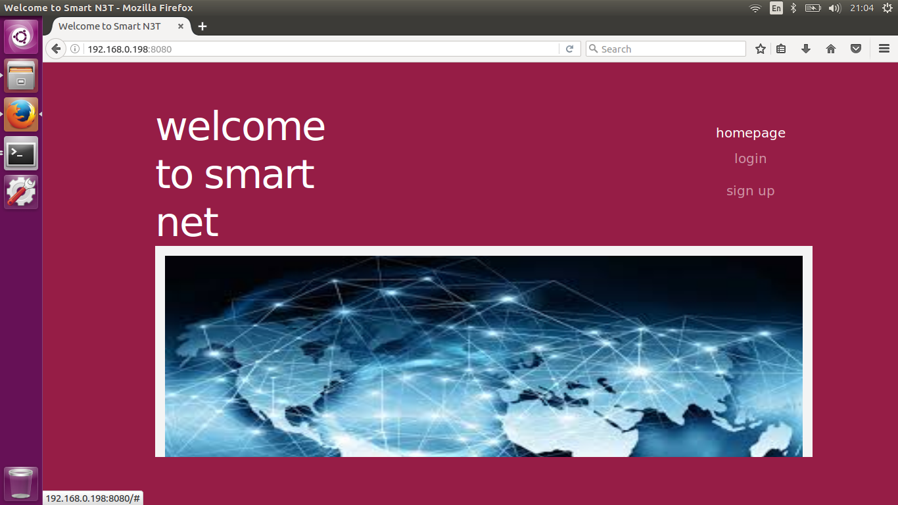Welcome page of our interface is as shown below:
2. 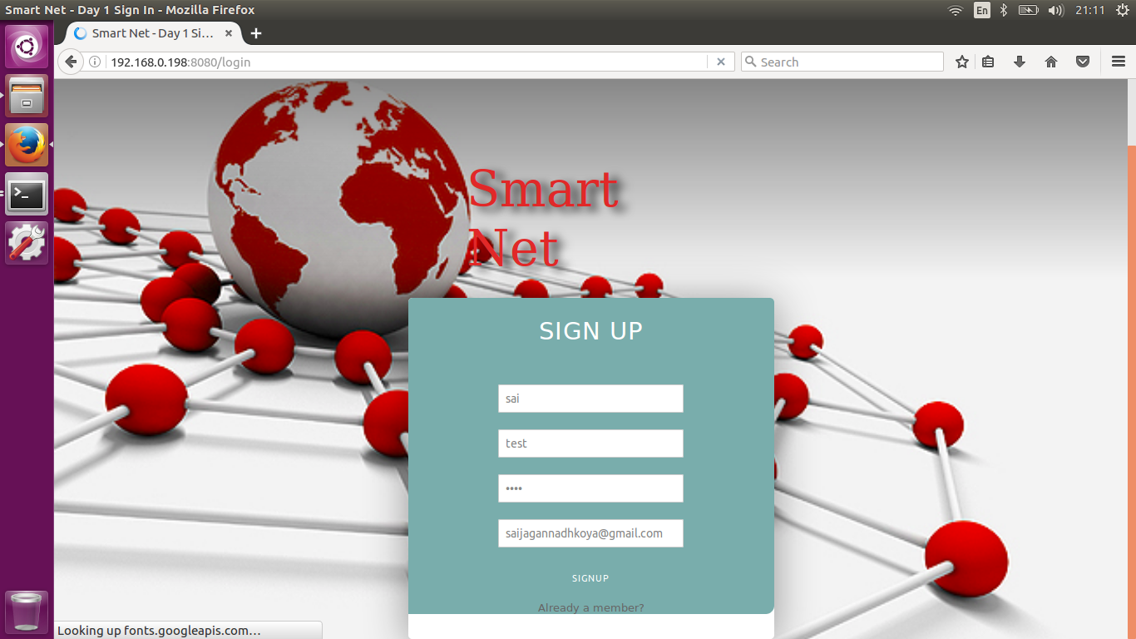For a new user, the interface for sign up is as shown below:
3. 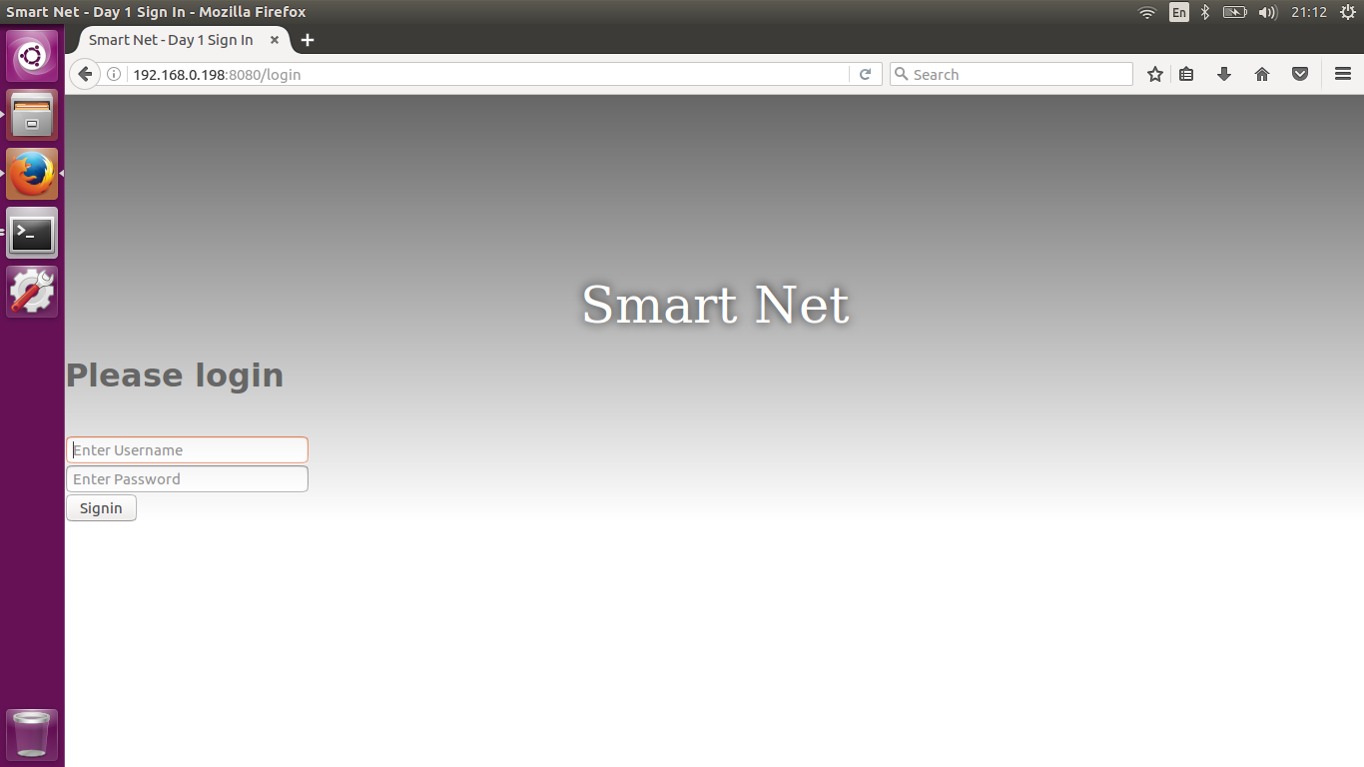After signup or for an old user, the login page is as shown below:
4. A user when logged in, redirects to a dashboard which consists of three options i.e. account settings, statistics, logout as shown below:

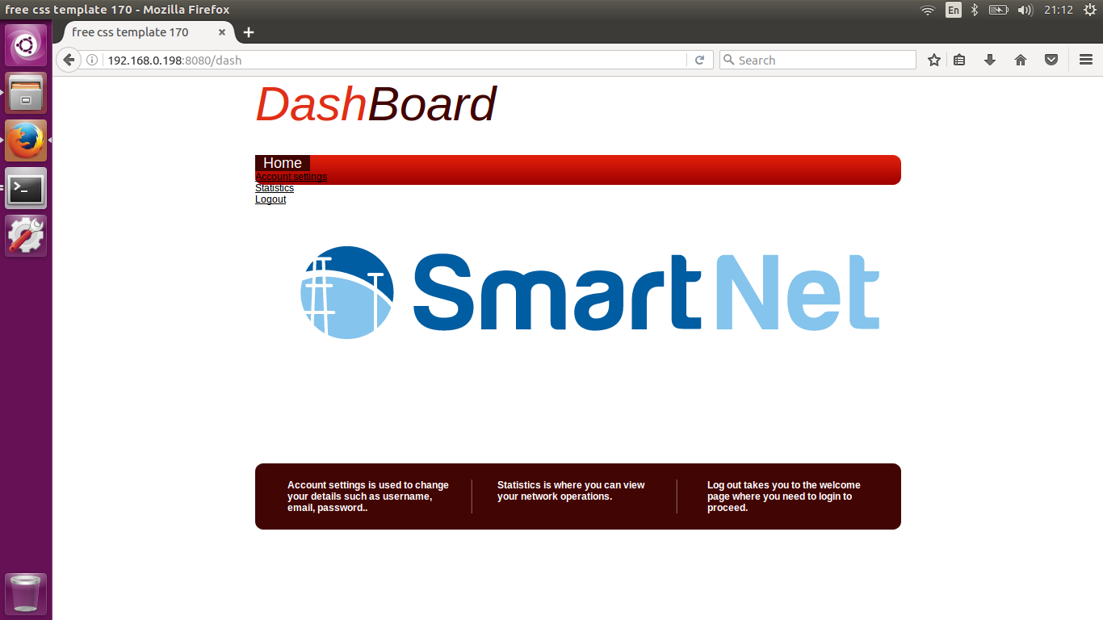

**Backend Server Output:**

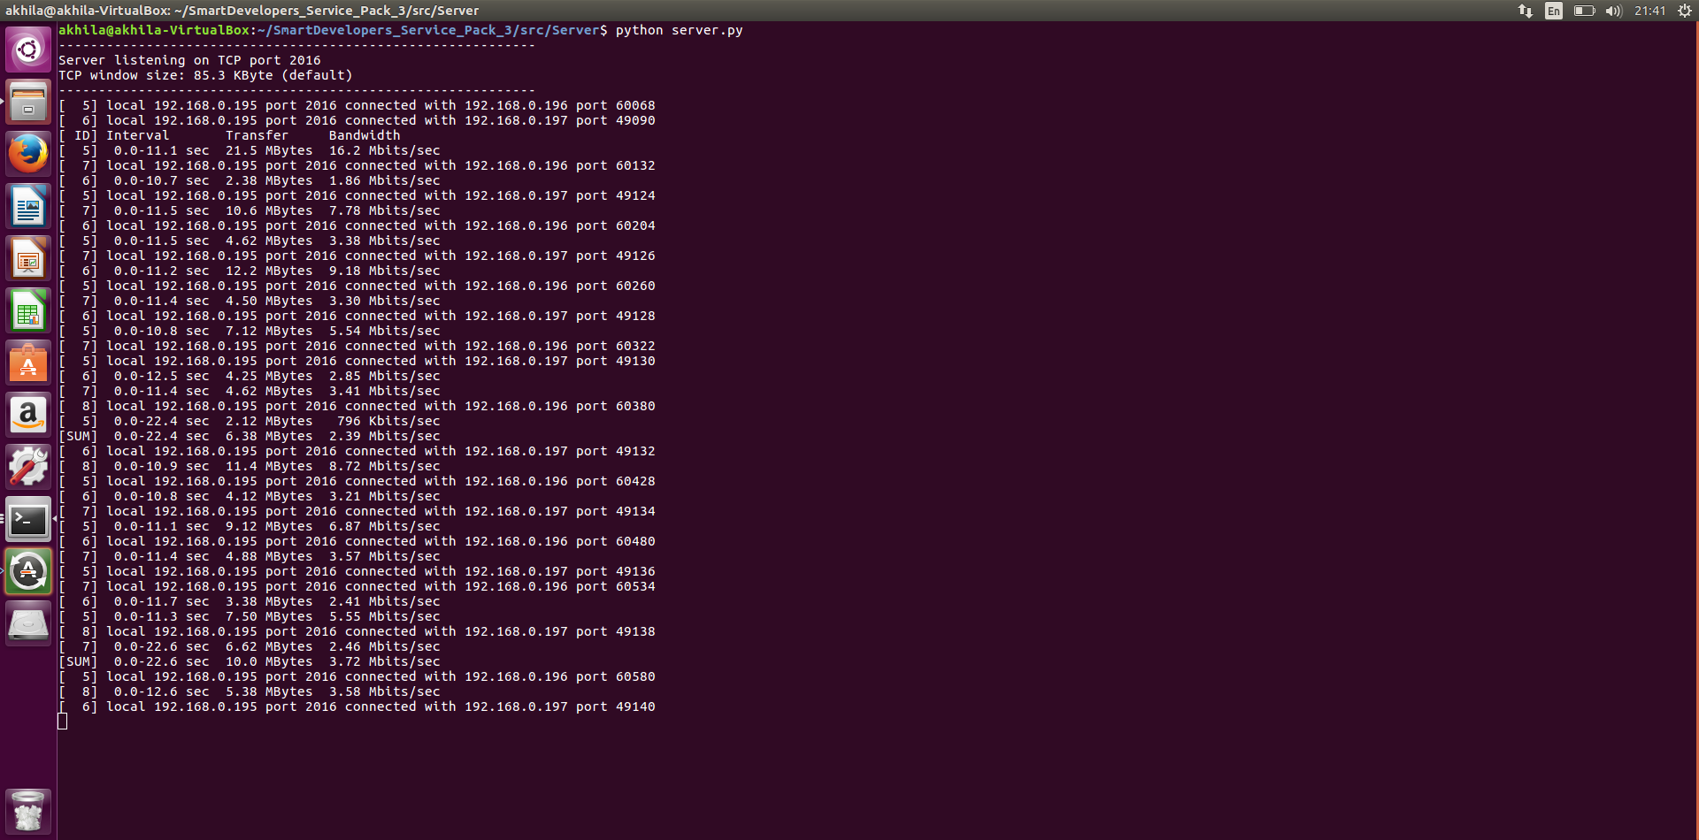

**Grafana Output of:**

1. Bandwidth & CPU

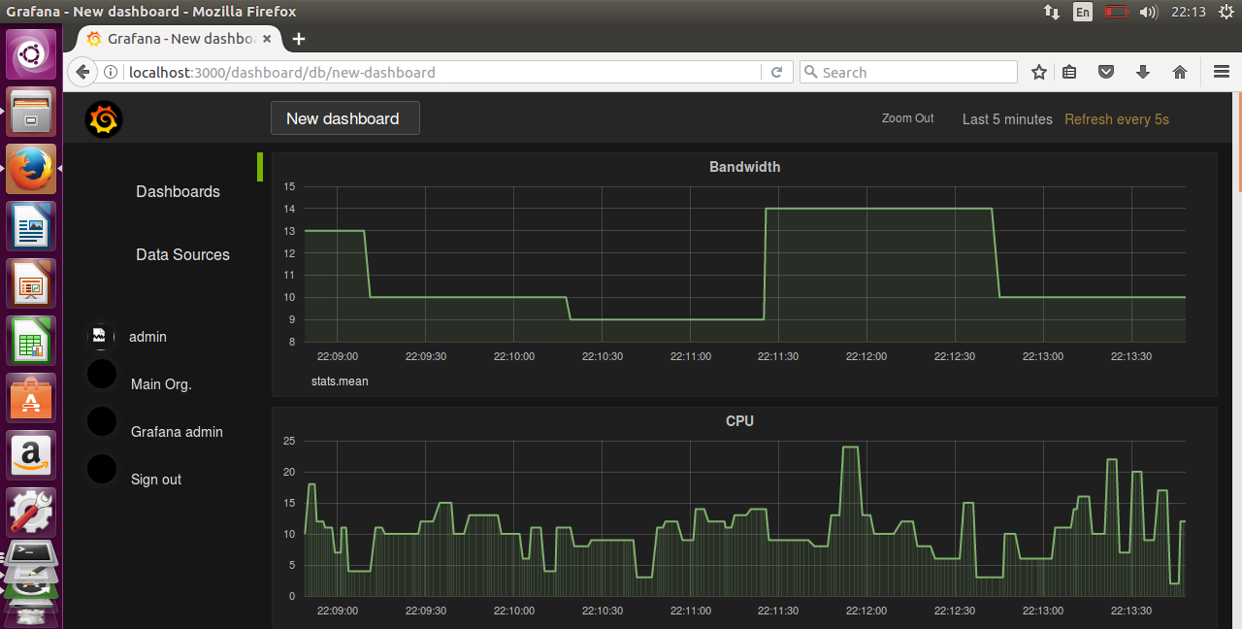

1. 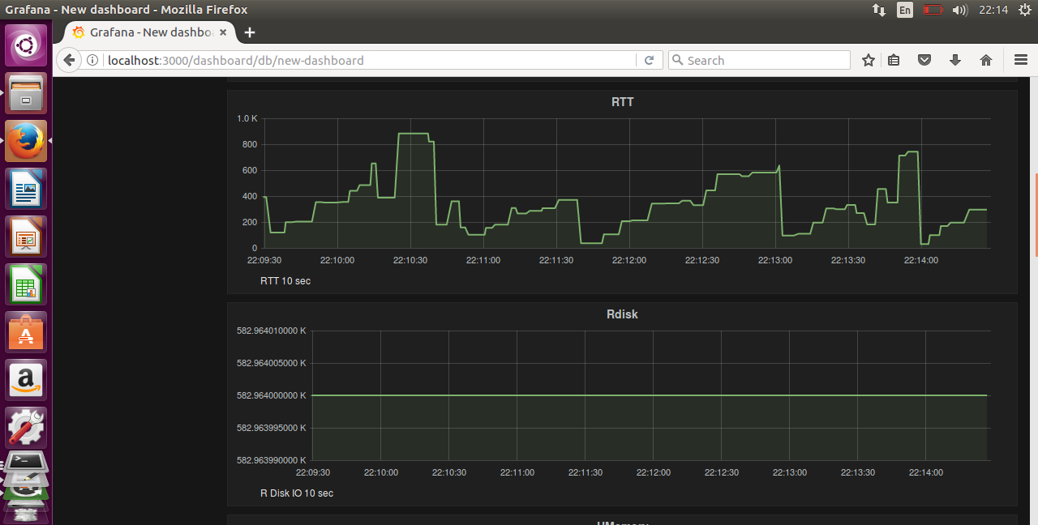Round-Trip-Time & Read Disk IO:
2. Used Memory & Free Memory:

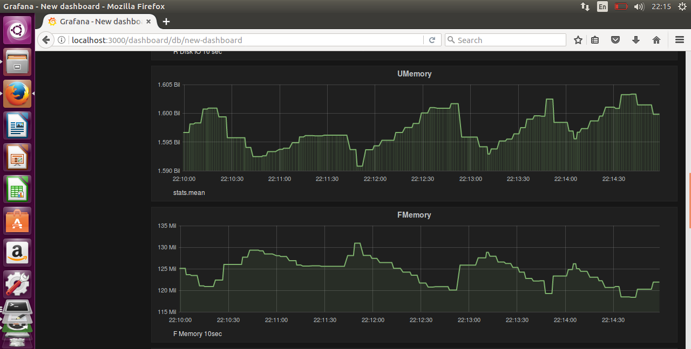

1. 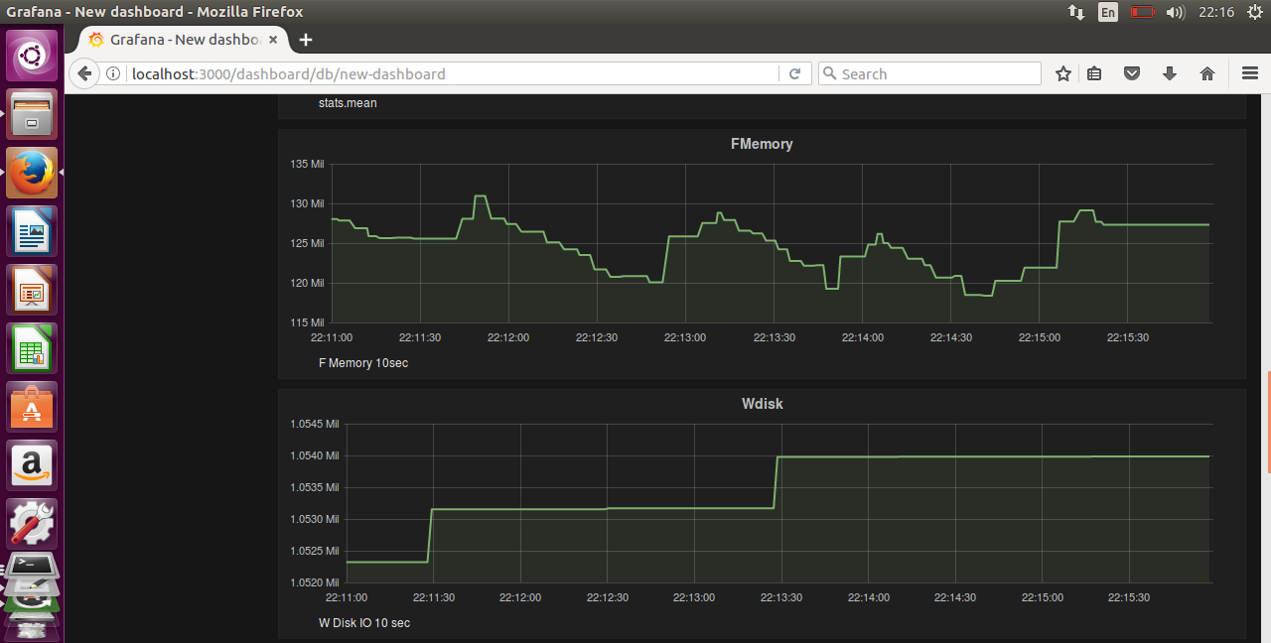Write Disk IO:
2. **RESTful API:**

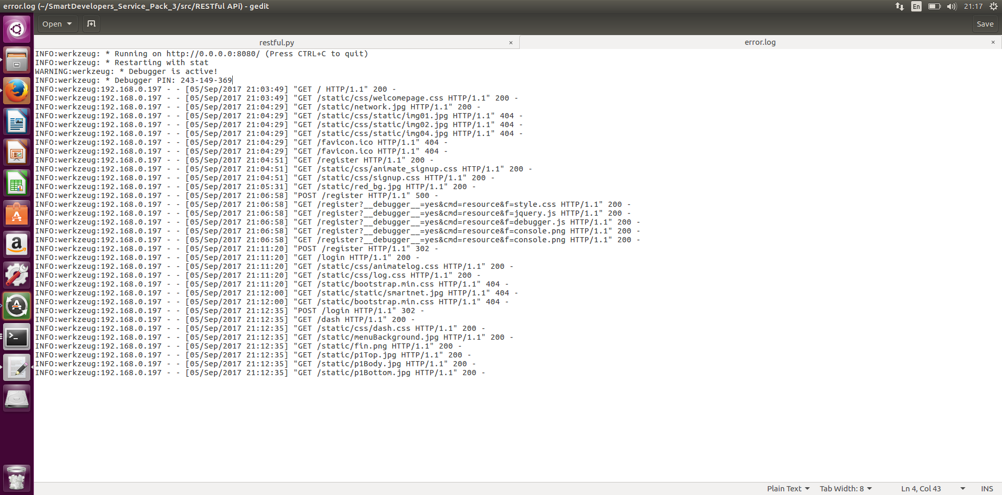RESTful API Server Results:

1. **EXTENSIONS FOR THE PRODUCT:**

The extension to this product would be addition of the averaging system for user metrics from different user streams, secure HTTP connection i.e. HTTP-SSL, large number of nodes.