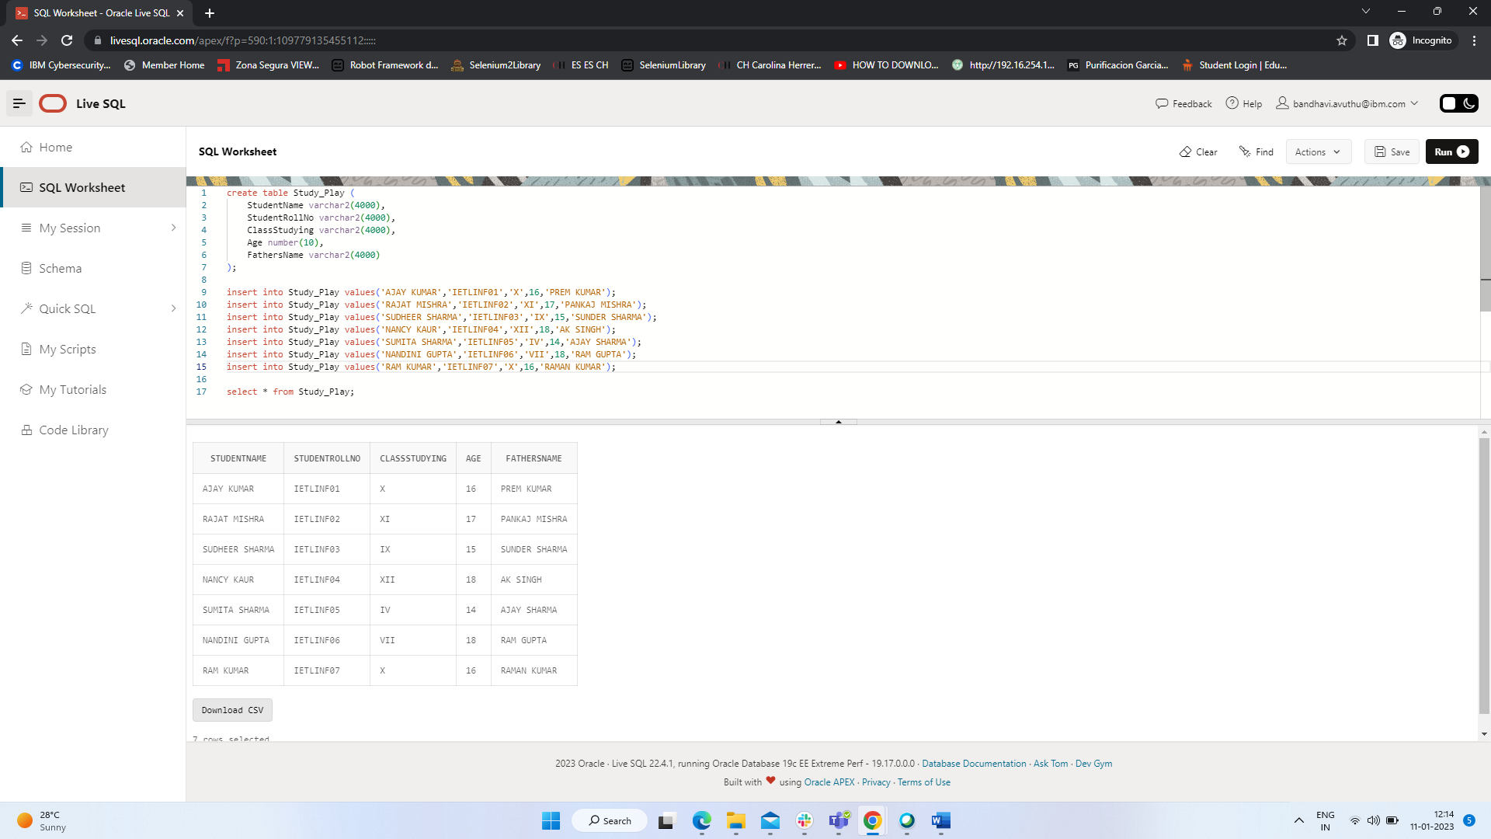

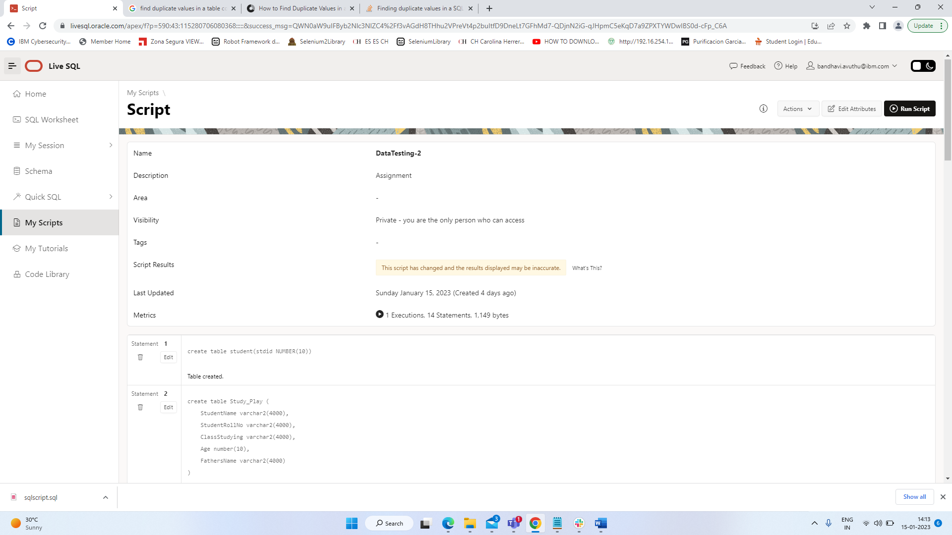

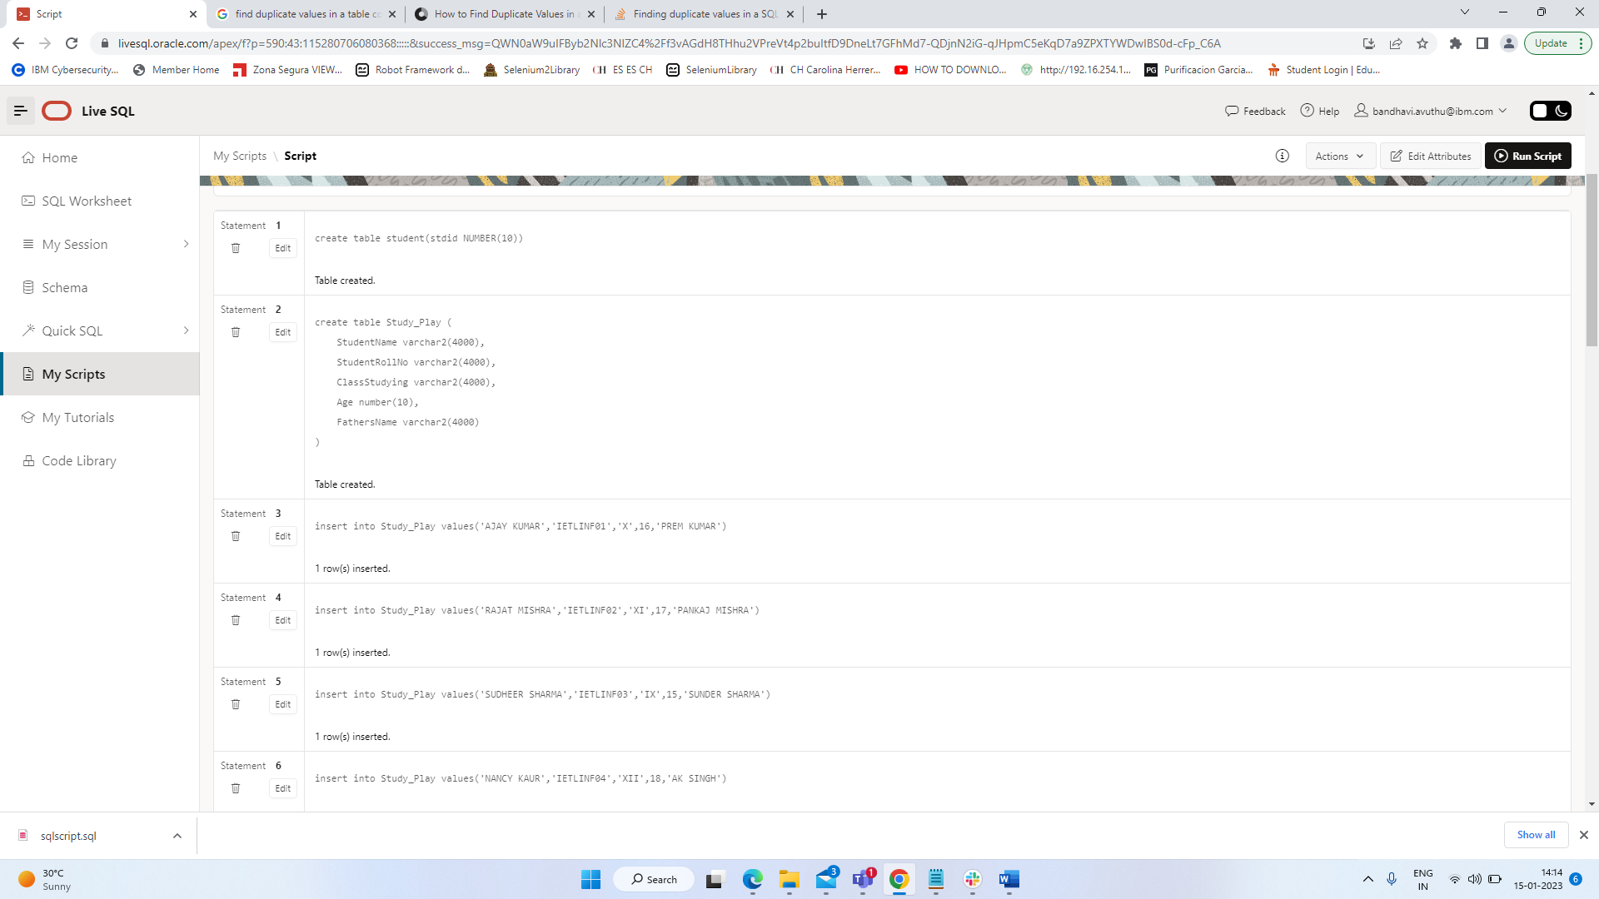

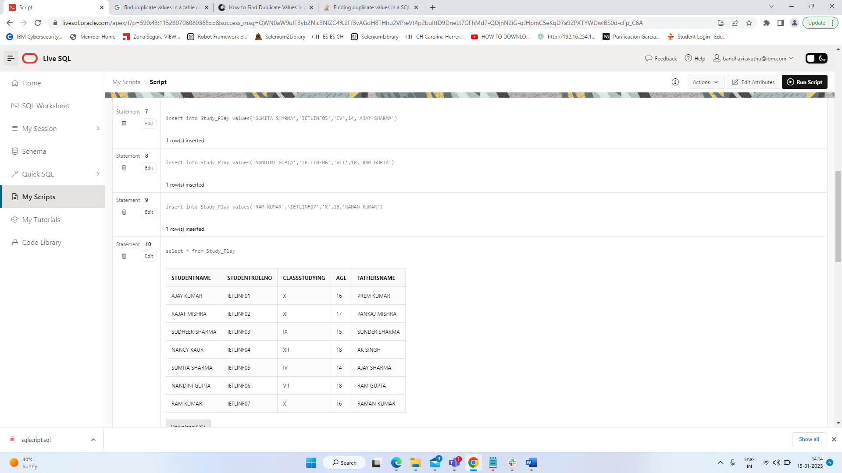

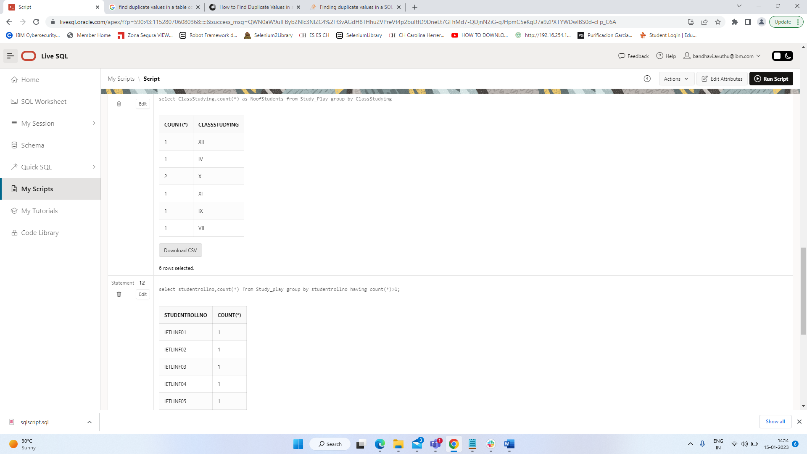

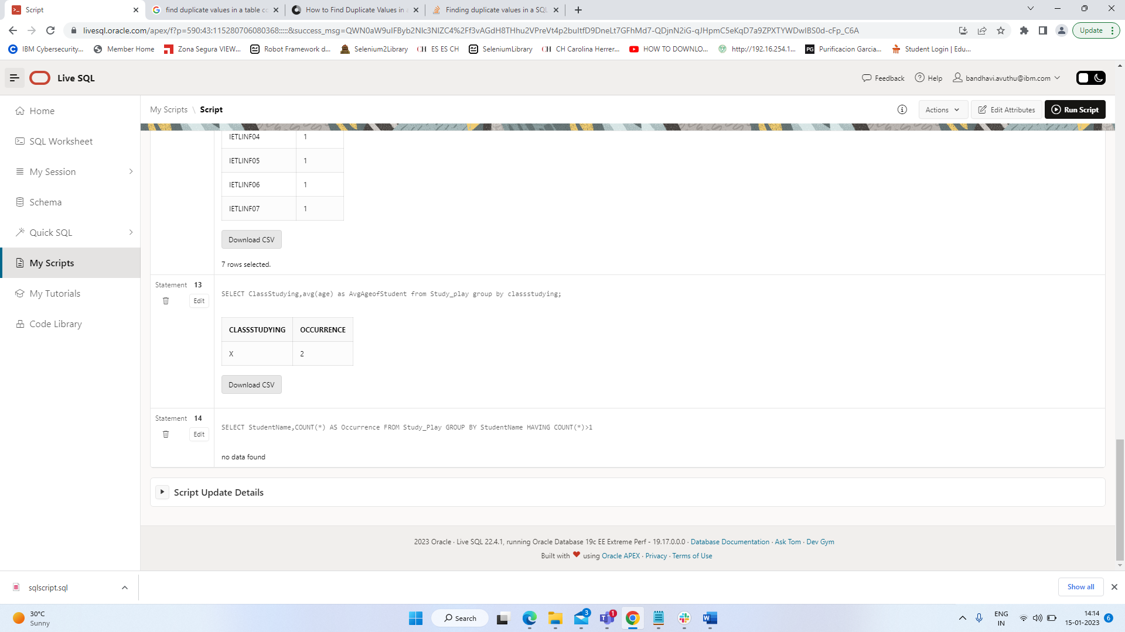



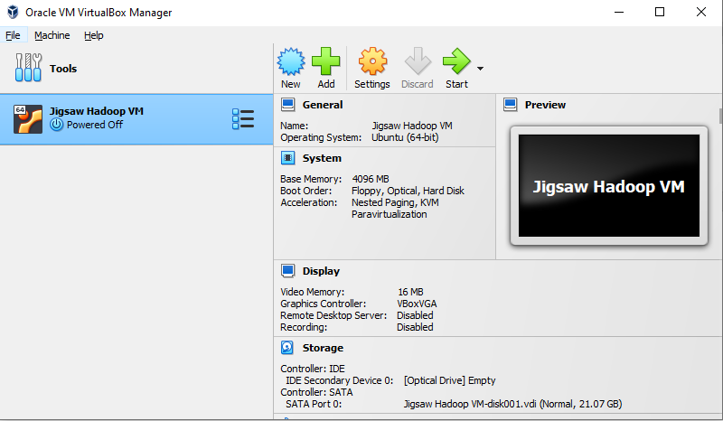



hive> CREATE EXTERNAL TABLE IF NOT EXISTS flights(

flDate TIMESTAMP,

AirlineCode INT,

FlightNum INT,

Origin STRING,

Destination STRING,

DepartureTime INT,

DepartureDelay INT,

ArrivalTime INT,

ArrivalDelay INT,

Airtime INT,

Distance INT

)

ROW FORMAT DELIMITED

FIELDS TERMINATED BY ','

STORED AS TEXTFILE

LOCATION '/user/hduser/airlines_data/flights';

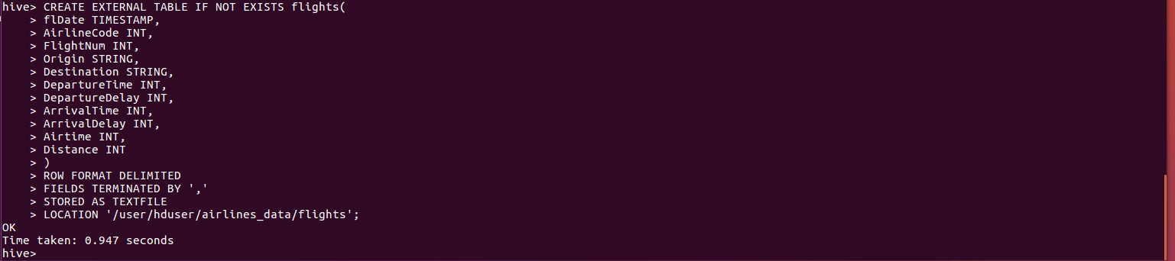

hive> SHOW TABLES;

hive> DESC flights;

hive> CREATE EXTERNAL TABLE IF NOT EXISTS airlines(

AirlineCode INT,

Description STRING

)

ROW FORMAT DELIMITED

FIELDS TERMINATED BY ','

STORED AS TEXTFILE

LOCATION '/user/hduser/airlines_data/airlines';

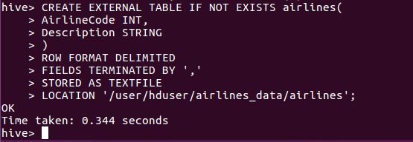

hive> SHOW TABLES;

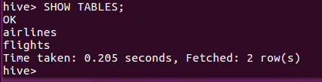

hive> DESC airlines;

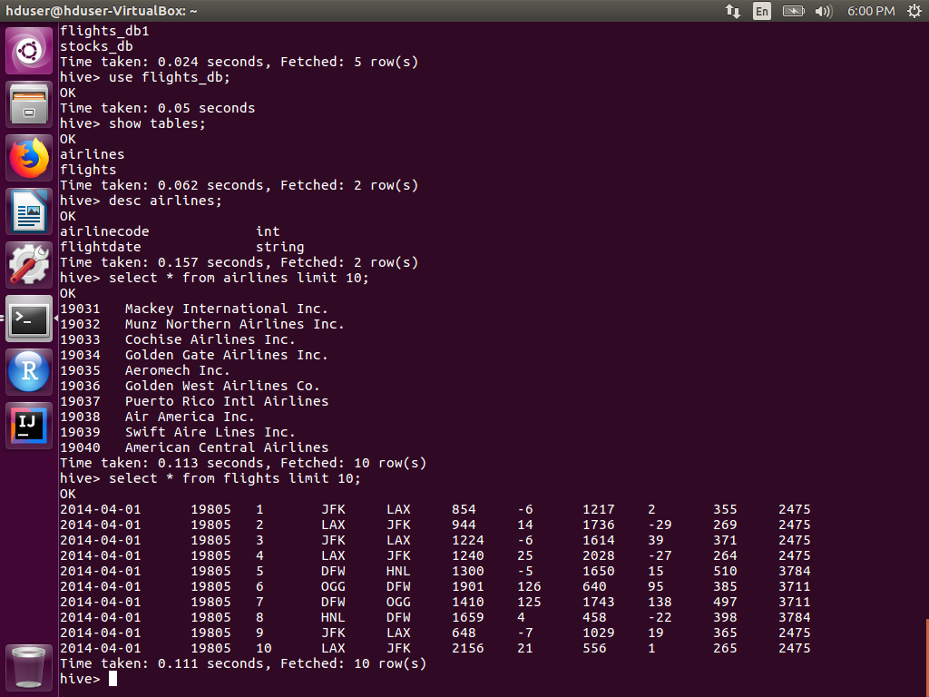

hive> set hive.cli.print.header=true;



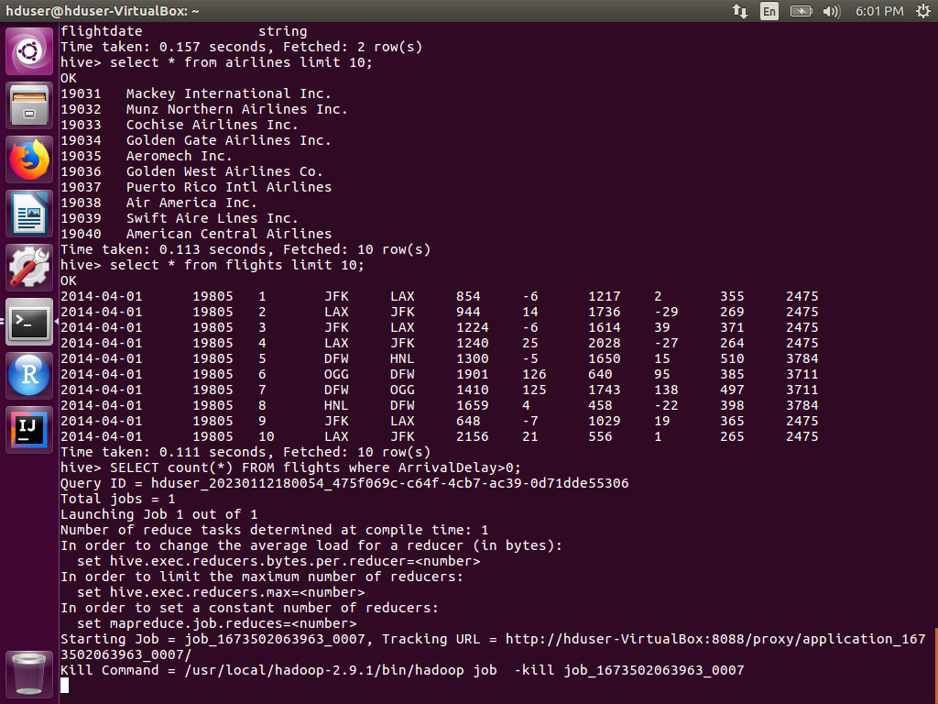

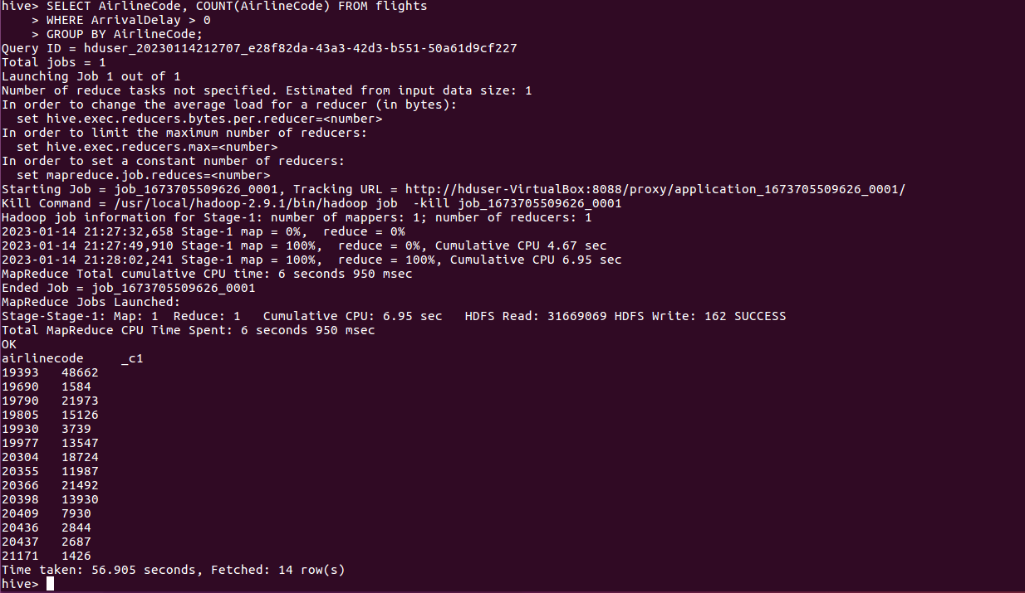

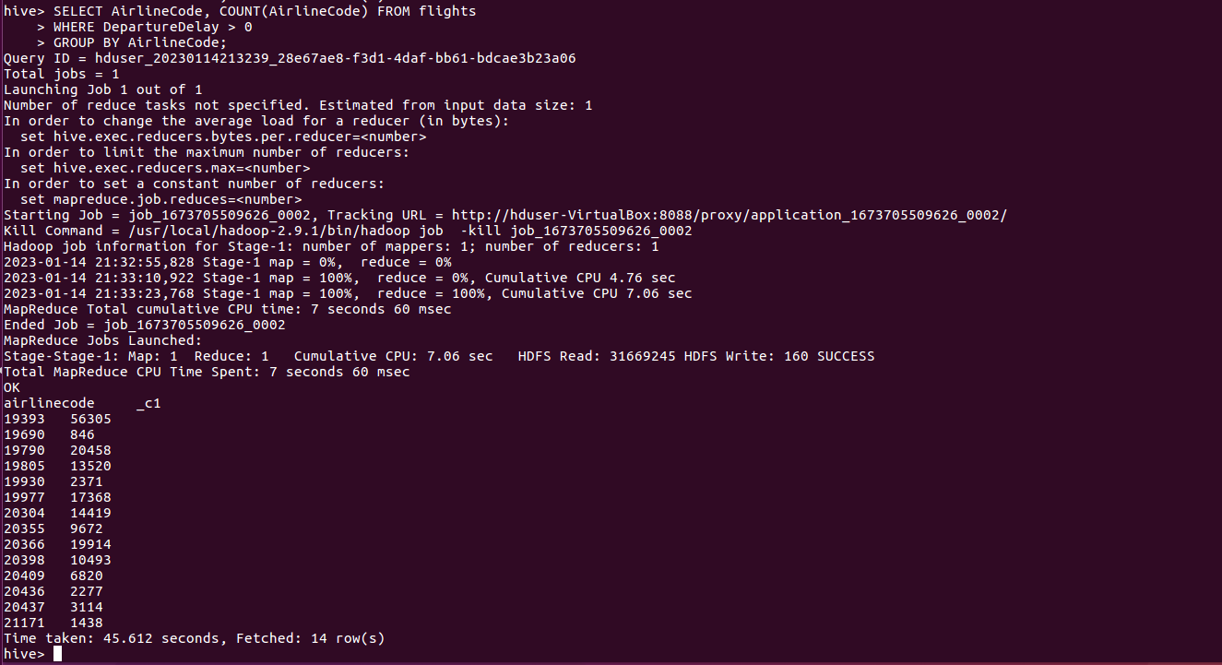

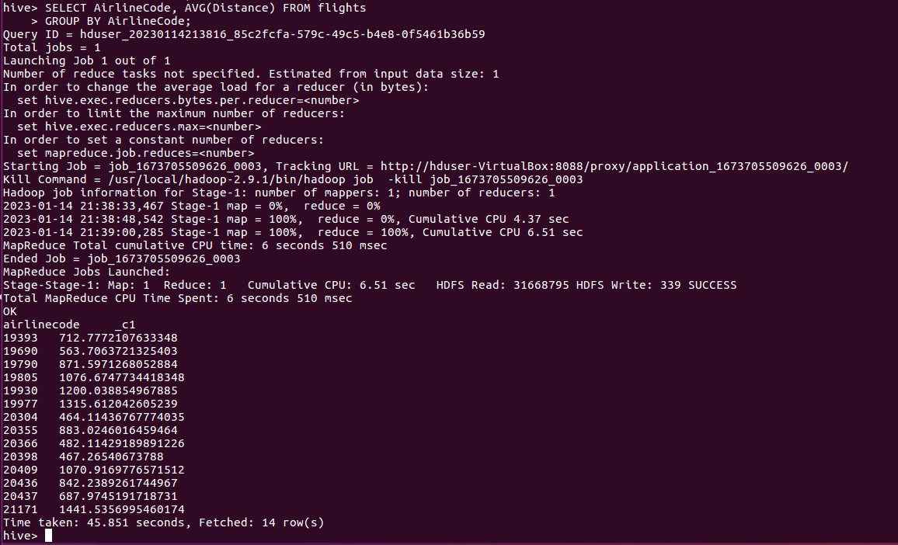

SELECT a.AirlineCode, a.Description, f.flDate, f.AirlineCode, f.FlightNum, f.Origin, f.Destination, f.DepartureTime, f.DepartureDelay, f.ArrivalTime, f.ArrivalDelay, f.Airtime, f.Distance

FROM airlines a

LEFT OUTER JOIN flights f

ON f.AirlineCode = a.AirlineCode

WHERE a.Description LIKE 'American Airlines Inc%';

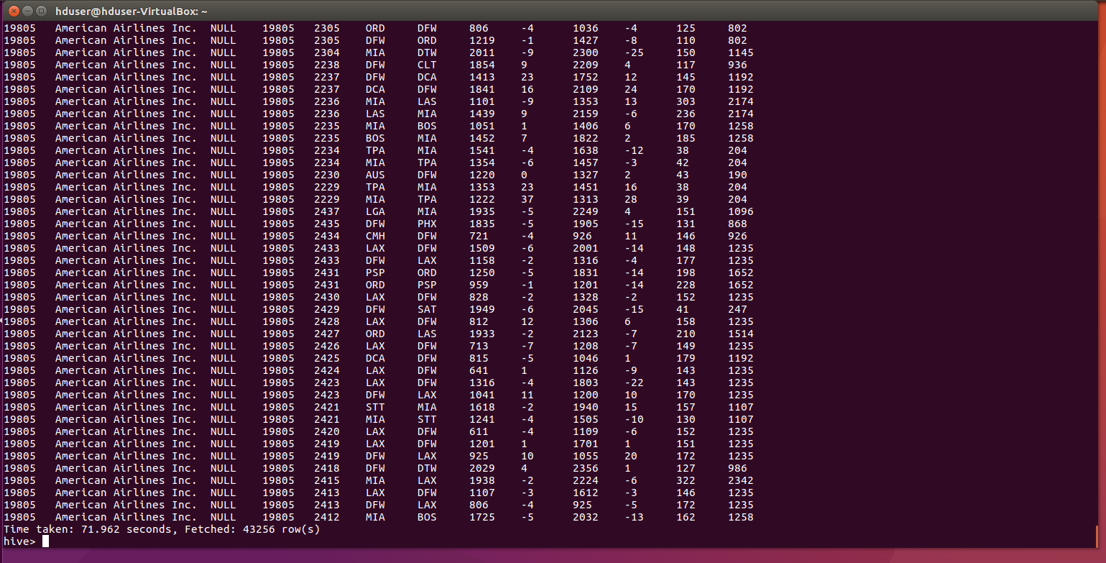

Stopping Hadoop services:

$ cd /usr/local/hadoop-2.9.1/sbin

$ ./stop-all.sh

$ jps

Closing the terminal