This project deals with a model of laser security alarm system egign.Laser security systems used to be difficult to istall and rarelyn available to anyone other rather than the suoer rich.Now there3 are are dozens of security systems on the market that utilize laser ans can effectively protect everything from small apartmenrs and bussinesses to large areas of property.Most home laser security systems consists of two parts: a basic alarm alarm unit and an infrared motion detector.Laser based security system is a type of security and alarm system that uses laser light and a light sensor.Why a laser to be used?It is known that a laser light goes through long distance without any scattering effect (disturbing) and it is only visible at source and thje destination point so it can be used as mediator between source and destination but to analysis the source a sensor is need,here the use of LDR is applicable .Just analysis is not enough alerting should be general alerting is sound effect so here buzzer act as alerting.Mak8ing use of this, a laser security system is designed.Its working : There is a laser diode that generates the laser beam which continuously strikes over the Light dependent resister sensors. When any person crosses the path, in inhibits laser to reach LDR and the sensor generate a low which is read by controller to power on the buzzer.

CERTIFICATE 2
ACKNOWLEDGEMENTS 3
ABSTRACT 4
LIST OF FIGURES 7
CHAPTER 1
INTRODUCTION 8
  - PRINCIPLE 9
  - OBJECTIVES: 9
CHAPTER 2
LITERATURE REVIEW 10
CHAPTER 3
METHODOLOGY 11
  - Working 12
  - BLOCK DIAGRAM 13
  - CIRCUIT DIAGRAM 14
  - COMPONENTS REQUIRED 15
  - COMPONENT DESCRIPTION 16
    - LASER: 16
    - LDR (Light Dependent Resistor): 17
    - LED (Light Emitting Diode): 18
    - BUZZER: 19
    - TRANSISTOR 20
    - RESISTOR 21
    - Capacitor 22
    - BATTERY: 23
    - BREADBOARD AND CONNECTING WIRES: 24
    - IC555 TIMER: 25
    - POTENTIOMETER 26
3.6. CIRCUIT DESIGN 27
3.7 MODEL CIRCUIT: 28
CHAPTER 4
ADVANTAGES AND DISADVANTAGES 29
  - ADVANTAGES: 29
  - DISADVANTAGES: 29
CHAPTER 5
RESULT AND DISCUSSION: 30
CHAPTER 6
CONCLUSION: 31
REFERENCE 32

LIST OF FIGURES

Figure | Page
01.Block diagram | 13
02.Circuit diagram | 14
03.Laser | 16
04.LDR | 17
05.LED | 18
06.Buzzer | 19
07.Transistor | 20
08.Resistor | 21
09.Capasitor | 22
10.Battery | 23
11.Breadboard and connecting wire | 24
12.IC555 TIMER | 25
13.Potentiometer | 26
14.Model circuit | 28
15.Final project | 30

Chapter 1

INTRODUCTION

Need of security is the basic necessity of any individual. The feeling that we are safe and everything around us is all right is imperative for a peaceful living. But in this unsafe world, when crime, terror and threats are on their peak, how can one attain that sense of security? Here, laser security system provides us with a solution and for this reason more and more people are installing them in order to stay safe and secure. Various electronic security systems can be used at home and other important working places for security and safety purposes. Laser Security alarm is a device used for security purposes. It has a wide application in fields of security and depence starting from the security of simple house hold material to a very high valued material of an organization. They once used to be expensive solutions for security needs. Owing to cost cutting and fast technological advancements, this form of security system is becoming more affordable. Lasers differ from other light sources in a few significant ways. There are two features that are important for security systems. Unlike a light bulb or flashlight, laser light doesn't spread out, it is a narrow beam. And laser light is essentially a single colour . Because laser light doesn't spread much, it can be sent it a long way and still have enough energy in a small are Auto trigger the security system detector. Because it's a single wave length, it can put a blocking filter on the detector to let laser light through without letting background light onto the detector. Laser light travels in a straight line. For instance, to protect the front of the yard, putting the laser at one comer and the detector at the other corner would do the job. That's not a very practical configuration, though. More typically, if it is needed to protect the perimeter of a room, or at least the enhances. So laser security systems start with a laser pointing to a small mirror. The first mirror is angled to direct the beam to a second small mirror, and so on until the final mirror directs the beam to the detector. If the beam is interrupted anywhere between the laser and the detector, the electronics will put the warning signal.

PRINCIPLE:

There are three essential components to a laser security system: a laser, a detector and sensing circuit. The laser is a concentrated light source that puts out a straight line, 'pencil beam, of light of a single colour. The detector is sensitive to light and puts out a voltage when the laser light hits it. The detector is connected to the sensing circuit. When the laser beam is interrupted and cannot reach the detector, its voltage output changes, and the circuit sense the change and put out a warning signal.

OBJECTIVE:

The core objective of this project is to design a laser security system with laser and light dependent resistor.

Chapter 2

LITERATURE REVIEW

Designing and Implementation of Security alarm system for organizations, industries, and houses based on lazer technology was review by Govinda et al. (2014) that administer double ways to implementing security . Firstly is by the use of lazer and LDR , in a case when there is any motion sensed by the lazer, it will sound an alarm and alert to the industries, organizations, or homeowners that they are an intrusion In this chapter, the researchers have made availablecompilations of information on laser and its significance to theinnovations of security. The following accounts will be for greaterattainment of understanding about laser and security systems.Studies about how these technologies have come into reality and theefforts of humanity to elevate the innovations of the past generationsup to the present era..
Laser based security system using Arduino UNO by Paramitha Mondal, Madhusree Mondal. The proposed system contains sensor, Arduino UNO, ESP Wi-Fi module, buzzer, LDR module. In this system once security system detects the intruder buzzer starts buzzing very loudly, spy camera takes the photo of the intruder and sends it to the registered email address for valid proof [14]. Laser based security system for home by Harshal Hemane, Debarati Sen. In this proposed system mirrors are used to reflect the laser rays to cover the region surrounding home in all direction. When laser light is incident on a mirror, it gets reflected from one mirror to another and falls on LDR. If any of the laser ray is blocked the buzzer produces beep sound [15]. Laser security alarm system by A.B.N.V. Prasad, K. Ravi Raj, K. Siva Ganesh, M. Lithin Siva swamy Naidu, N. Phaneendra. In this project based on the voltage drop across the LDR is considered to turn On and Off the transistor. If the voltage drop across the LDR is low transistor is turned Off, if the voltage across the LDR is high transistor is said to be turned On. Once the transistor is turned on buzzer produces beep sound [16]. Laser security system by Debarati Dutta. The proposed system contains LDR, IC555, transistor, buzzer which gives alert that the intruder has entered the monitored entrance through beep sound [17]. Door lock security using Raspberry Pi and QR Code by Arigela Sai Kalyan, Balibineni Bharat Teja Raju, Mudraboina Venkatesh. In this project the study is aimed to develop a web-based security door using QR code system for the laboratory where at the same

time the authorized person can perform access monitoring the student’s attendance [18]. The security alarm system or home automation comprises centralized control of lighting, appliances, temperature, and other systems, to provide better relaxation, ease, security, and efficiency.

Chapter 3

METHODOLOGY:

Working:

First, the Op– Amp circuit acts as a comparator i.e. it compares the voltages at the inverting and non-inverting terminals and produces an output accordingly. The LDR, resistor Voltage divider is connected to the non -inverting terminal of Op-Amp and a potentiometer is connected to the inverting terminal .Assume, the laser pointer is placed directly in line of sight to the LDR and the light from the laser is continuously being incident on LDR. In this situation, the resistance of LDR falls down to few Ohms and as a result, the voltage at the non – inverting terminal will be less than that at the inverting voltage. The output of the Op –Amp is low and the transistor is OFF. If the laser light is blocked by an intruder from falling on the LDR (even for a small duration), the resistance of the LDR goes to few hundreds of Ohms and as a result, the output of the Op-Amp will be HIGH. This will turn on the Transistor. As the output of the transistor is connected to the Trigger Pin (Pin 2) of the 555 Timer IC, if the transistor is ON ,the trigger pin gets a short low pulse and as a result, the output of the 555 becomes HIGH. This will activate the alarm by turning ON the buzzer. Since, the 555 Timer IC is configure das a Bi– Stable Multi vibrator, a small active low trigger pulse at the trigger pin will set its output to HIGH and in order to reset it a person need to push the reset button [1]. Until the reset push button is pushed, the alarm will stay on hence; place the reset button at a secret location so that only the owner can disable the alarm.
.

BLOCK DIAGRAM:
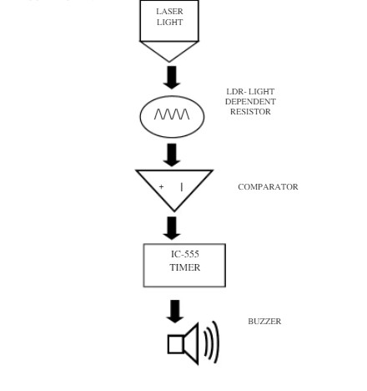
Figure 01: Block diagram

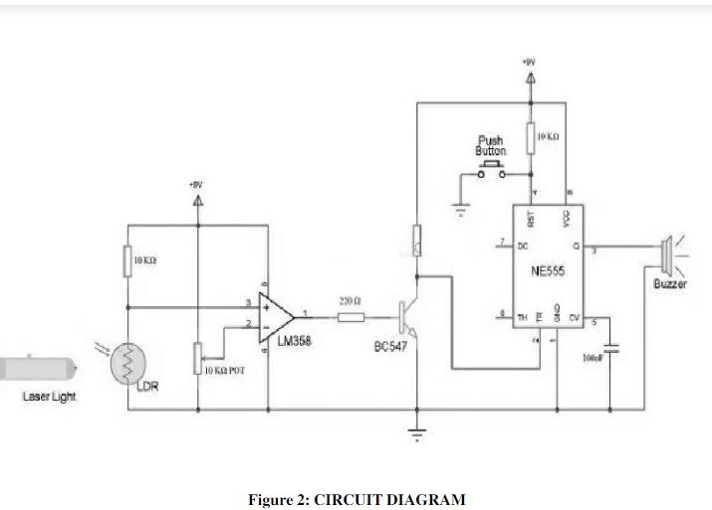

SL.NO | NAME OF THE COMPONENT | SPECIFICATIONS | QUANTITY
1 | Op– Amp IC | LM358 | 1
2 | Timer IC | IC555 | 1
3 | LDR | ---- | 1
4 | Resistors | 10 KΩ  220 Ω | 3  1
5 | Small Buzzer | --- | 1
6 | Potentiometer | 10 KΩ | 1
7 | NPN Transistor | BC547 | 1
8 | Capacitor | 100nF | 1
9 | Push Button | --- | 1
10 | Laser Pointer | --- | 1
11 | 9V Battery | --- | 1
12 | Connecting Wires | --- | 1
13 | Breadboard | --- | 1

LASER:

A laser is a device that emits light through a process of optical amplification based on the stimulated emission of electromagnetic radiation. The term "laser" originated as an acronym for "light amplification by stimulated emission of radiation". A laser differs from other sources of light in that it emits light coherently. Spatial coherence allows a laser to be focused to a tight spot, enabling applications such as laser cutting and lithography. Spatial coherence also allows a laser beam to stay narrow over great distances (collimation), enabling applications such as laser pointers. Lasers can also have high temporal coherence, which allows them to emit light with a very narrow spectrum, i.e., they can emit a single colour of light. Temporal coherence can be used to produce pulses of light as short as a femtosecond [4].



Figure 03: Laser

A photo resistor or light-dependent resistor (LDR) or photocell is a light-controlled variable resistor. The resistance of a photo resistor decreases with increasing incident light intensity; in other words, it exhibits photoconductivity. A photo resistor can be applied in light-sensitive detector circuits, and light- and dark-activated switching circuits [5].

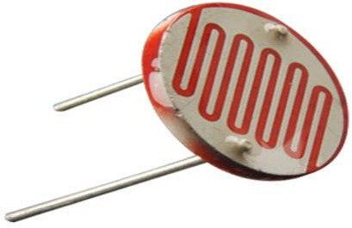

Figure 04: LDR

A light-emitting diode (LED) is a two-lead semiconductor light source. Like an ordinary diode, the LED diode works when it is forward biased. In this case, the n-type semiconductor is heavily doped than the p-type forming the p-n junction. When it is forward biased, the potential barrier gets reduced and the electrons and holes combine at the depletion layer (or active layer), light or photons are emitted or radiated in all directions. A typical figure blow showing light emission due electron-hole pair combining on forward biasing. It is a PN- junction diode, which emits light when activated. The explanation behind the emission of photons in an LED diode lies in the energy band theory of solids [6].
According to this theory, whether the electron-hole combining will give out photons or not depends on whether the material has a direct band gap or indirect band gap. Those semiconductor materials which have a direct band gap are the ones that emit photons. When a suitable voltage is applied to the leads, electrons are able to recombine with electron holes within the device, releasing energy in the form of photons. This effect is called electroluminescence and the colour of the light(corresponding to the energy of the photon) is determined by the energy band gap of the semiconductor. An LED is often small in area (less than I mm2) and integrated optical components may be used to shape its radiation pattern.
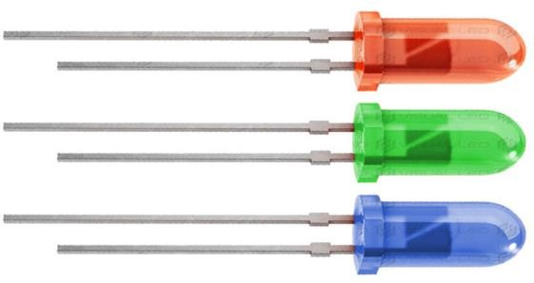
Figure 05 : LED

A buzzer or beeper is an audio signaling device, which may be mechanical, electromechanical, and piezoelectric. Typical uses of buzzers and beepers include alarm devices, timers and confirmation of user input such as a mouse click or key stroke. Early devices were based on an electromechanical system identical to an electric bell without the metal gong. Similarly, a relay may be connected to interrupt its own actuating current, causing the contacts to buzz. Often these units were anchored to a wall or ceiling to use it as a sounding board. The word "buzzer" comes from the rasping noise that electromechanical buzzers made. The buzzer consists of an outside case with two pins to attach it to power and ground. When current is applied to the buzzer it causes the ceramic disk to contract or expand. Changing this then causes the surrounding disc to vibrate. That's the sound that you hear. Adjust the potentiometer to increase or decrease the resistance of the potentiometer. If you increase the resistance of the potentiometer then it will decrease the Volume of the buzzer. If you decrease the resistance of the potentiometer then it will increase the Volume of the buzzer [3].

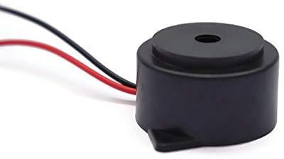

Figure 06: Buzzer

A transistor is a semiconductor device used to amplify and switch electronic signals and electrical power. Transistor has many functions, such as detecting, rectifying, amplifying, switching, voltage stabilizing; signal modulating and so on. It is composed of semiconductor material with at least three terminals for connection to an external circuit. A voltage or current applied to one pair of the transistor’s terminals changes the current through another pair of terminals. As a variable current switch, transistor can control the output current based on the input voltage Because the controlled (output) power can be higher than the controlling (input) power, a transistor can amplify a signal [7]. Today, some transistors are packaged individually, but many more are found embedded in integrated circuits.

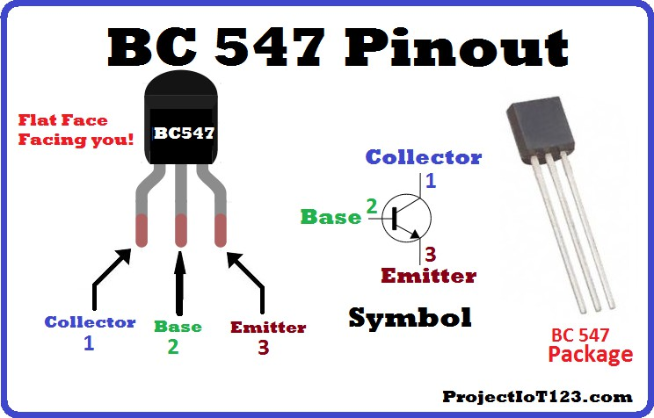

Figure 07: Transistor

A resistor is a passive two-terminal electrical component that implements electrical resistance as a circuit element. Resistors act to reduce current flow, and, at the same time, act to lower voltage levels within circuits. In electronic circuits resistors are used to limit current flow, to adjust signal levels, bias active elements, terminate transmission lines among other uses. High-power resistors that can dissipate many watts of electrical power as heat may be used as part of motor controls, in power distribution systems, or as test roads for generators. Fixed resistors have resistances that only change slightly with temperature, time or operating voltage. Variable resistors can be used to adjust circuit elements (such as a volume control or a lamp dimmer), or as sensing devices for heat, light, humidity, force, or chemical activity. Resistors are common elements of electrical networks and electronic circuits and are ubiquitous in electronic equipment. Practical resistors as discrete components can be composed of various compounds and forms. [8] Resistors are also implemented within integrated. The electrical function of a resistor is specified by its resistance: common commercial resistors are manufactured over a range of more than nine orders of magnitude. The nominal value of the resistance will fall within a manufacturing tolerance.
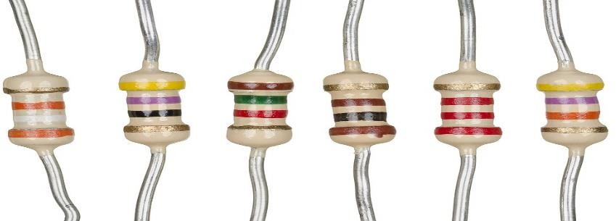
Figure 08: Resistor

Capacitors are widely used in electronic circuits for blocking direct current while allowing alternating current to pass. In filter networks, they smooth the output of power supplies .In resonant circuits they tune radios to particular frequencies. In electric power transmission systems, they stabilize voltage and power flow [9].

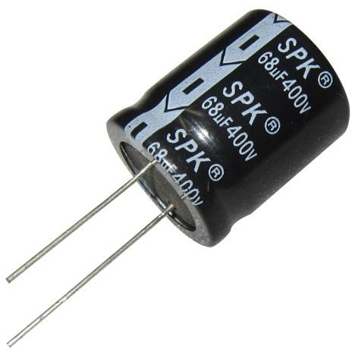

Figure 09: Capacitor

An electric battery is a device consisting of two or more electrochemical cells that convert stored chemical energy into electrical energy. Each cell contains a positive terminal, or cathode, and a negative terminal, or anode. Electrolytes allow ions to move between the electrodes and terminals, which allows current to flow out of the battery to perform work. Primary (single-use or "disposable") batteries are used once and discarded; the electrode materials are irreversibly changed during discharge. Common examples are the alkaline battery used for flashlights and a multitude of portable device. Secondary (rechargeable batteries) can be discharged and recharged multiple times; the original composition of the electrodes can be restored by reverse current. Examples include the lead-acid batteries used in vehicles and lithium ion batteries used for portable electronics [10]. Batteries come in many shapes and sizes, from miniature cells used to power hearing aids and wristwatches to battery banks the size of rooms that provide standby power for telephone exchanges and computer data centers.


Figure 10: Battery

A breadboard is a construction base for prototyping of electronics. These solder less breadboards does not require soldering, it is reusable. This makes it easy to use for creating temporary prototypes and experimenting with circuit design. A modern solder less breadboard socket consists of a perforated block of plastic with numerous tin plated phosphor bronze or nickel silver alloy spring clips under the perforations. Interconnecting wires and the leads of discrete components such as capacitors, resistors, and inductors, power supply, one or more signal generators, LED display or LCD modules, and logic probe scan be inserted into the remaining free holes to complete the circuit. A bus strip usually contains two rows: one for ground and one for a supply voltage. Typically the row intended for a supply voltage is marked in red, while the row for ground is marked in blue or black [11] .

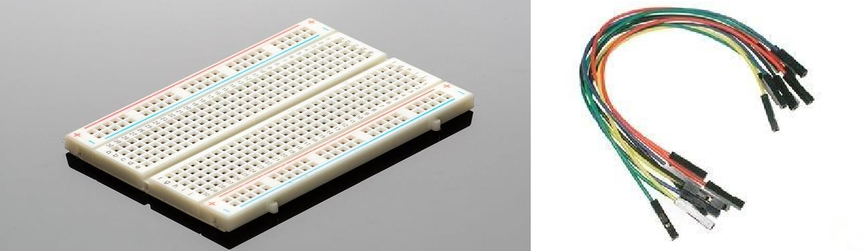

Figure 11: Breadboard & connecting wire

The 555 timer IC is an integrated circuit (chip) used in a variety of timer , pulse generation ,and oscillator applications. The 555 can be used to provide accurate time delays, as an oscillator, and as a flip-flop element. Derivatives provide two (556) or four (558) timing circuits in one package. In bi stable mode, the 555 timer acts as a SR flip-flop. The trigger and reset inputs (pins 2 and 4 respectively on a 555) are held high via pull-up resistors while the threshold input (pin 6) is grounded. Thus configured, pulling the trigger momentarily to ground acts as a 'set' and transitions the output pin (pin 3) to VCC (high state). Pulling there set input to ground acts as a 'reset' and transitions the output pin to ground (low state). No timing capacitors are required in a bi stable configuration. Pin 7 (discharge) is left unconnected, or may be used as an open-collector output [12].
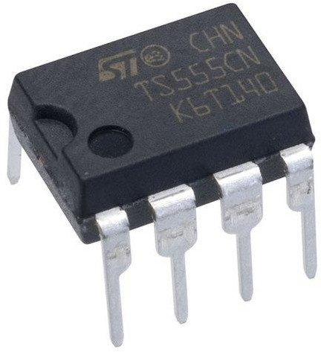

Figure 12: IC555 TIMER

A potentiometer is a three-terminal resistor with a sliding or rotating contact that forms an adjustable voltage divider. If only two terminals are used, one end and the wiper, it acts as a variable resistor or rheostat. The potentiometer is a simple device used to measure the electrical potentials (or compare the e.g. of a cell). One form of potentiometer is a uniform high-resistance wire attached to an insulating support, marked with a linear measuring scale. The basic working principle of this is based on the fact that the fall of the potential across any portion of the wire is directly proportional to the length of the wire, provided wire has uniform cross-sectional area and the constant current flowing through it. “When there is no potential difference between any two nodes there is electric current will flow” [13].

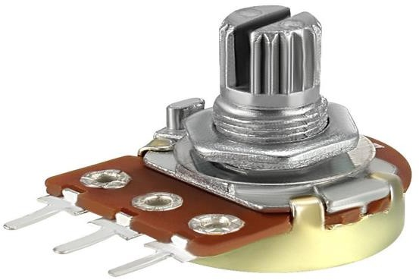

Figure 13: Potentiometer

The design of the laser security system circuit is very simple. Coming to the design of the circuit
,First, the LDR and a 10 K Ω resistor are connected in series with the voltage divider and its output (common point) is connected to the pin 3 (non– inverting) of the Op- Amp ICLM358.For the inverting terminal (pin 2), connected the wiper of a 10 KΩ potentiometer (other two terminal of the POT are connected to VCC and GND).The 8th and 4th pin of Op-Amp IC LM358 are connected to the voltage divider and ground respectively. The output of the Op – Amp (Pin 1) is connected to the base of the transistor (BC547)through a resistor of 220 ohms .The trigger pin of 555 (Pin 2) is connected to the common point of 10 KΩ resistor and collector of transistor common point. The other end of resistor is given to voltage divider. The emitter of the transistor is given to the ground The reset pin (pin 4) of the 555 is connected to VCC through a 10 KΩ resistor and a push button is connected between Pin 4 of 555 and GND. The non-inverting input (5th pin) is connected to ground through 100nano farad capacitor. A buzzer is connected to pin 3 of ic555 IC. The other end of buzzer is given to the ground The voltage divider (8th pin) of ic555 timer is given to voltage divider and the output pin (1st pin) is given to the ground.

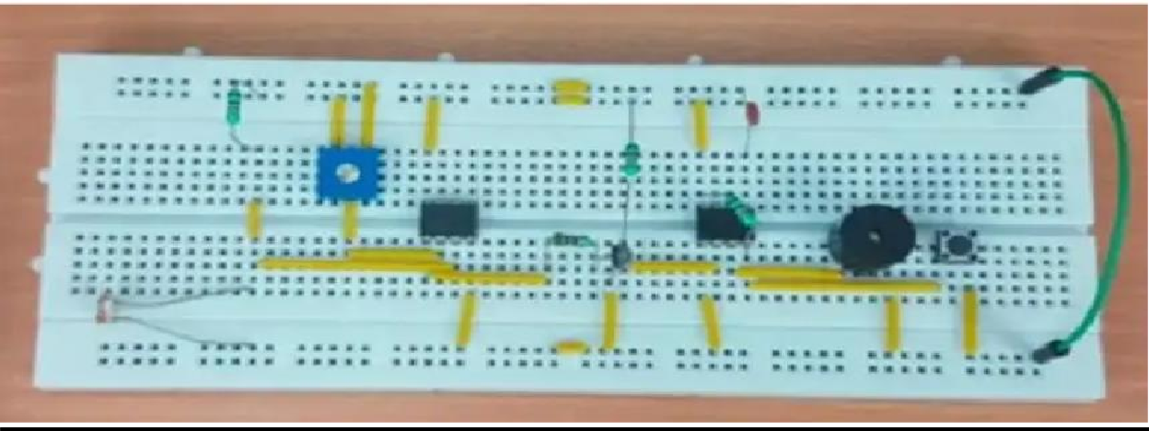
Figure 14: Model circuit

ADVANTAGES AND DISADVANTAGES

ADVANTAGES:

These are easy to install and work at both within as well as outside houses. These are very effective perimeter alarm systems around properties. In indoor systems can utilize the normal power outlets and jacks making them inconspicuous. At outside these can be easily be hidden behind the bushes or plants without causing any damage. They consume less power when compared to the laser system as the whole, which is expensive. These laser systems can be installed in homes either by self or by hiring a technical person .By technological innovations cost of the security systems has been cut to a large extent. So, making laser systems one among affordable security system options can be very safe. Lasers are strong in beam width and can be focused on the perfect target. By using laser security system one can be safe in the case of harmful effects to the body. As the beam width used in the laser security systems are not strong beam widths. The circuit, construction and setup for the Laser Security System are very simple. If used with a battery, the laser security system can work even when there is a power outage.

DISADVANTAGES:

The laser security system works only if the laser is obstructed. If the intruder passes without obstructing the laser, it is considered as a failure.
In order to secure a larger area, we need more lasers and corresponding sensors.

RESULT AND DISCUSSION:

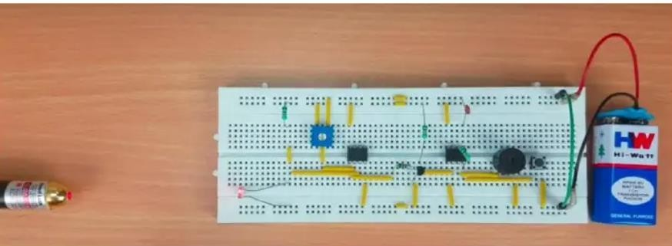
Figure 15: Final Project

When the laser beam falling over the LDR is interrupted by the object in the field of laser net, hence the LDR develops an output voltage and the alarm rings showing the sign of any intruders. The Laser Security System has been successfully designed and developed. The buzzer is turned on as the laser beam falling on the LDR is interrupted. The experimental model was made according to the circuit diagram and the result was as expected. The LDR has to be placed in dark place or inside a case so that the other source of light except the laser beam doesn’t affect the LDR. This helps the circuit to work faster and properly.

CONCLUSION:

Laser security system provides us the security against any crime, theft in our day to day life and so people are installing them in order to stay safe, secure and sound. Various electronic security systems can be used at home and other important working places for security and safety purposes. It is a great opportunity and source of saving man power contributing now a stage of electricity. The "Laser Security System" is an important helping system. Using this system robbery, thefts & crime can be avoided to large extend. Avoiding thieves results in the safety of our financial assets and thereby this system provides us protection against all. The Laser & LDR system is highly sensitive with a great range of working. The system senses the light emitted by the Laser falling over the LDR connected with the circuit. Whenever the beam of light is interrupted by any means, it triggers the alarm or siren. This highly reactive approach has low computational requirement, therefore it is well suited to surveillance, industrial application and smart environments.
.

REFERENCE:

- Website: https://www.electronicshub.org
Access Date: 21/05/2022
- Website: http://en.wikioedia.org/wiki/Main-Page
Access Date: 21/05/2022
- Website: https://en.wikipedia.org/wiki/Buzzer
Access Date: 21/05/2022
- Website: https://en.wikipedia.org/wiki/Laser
Access Date: 21/05/2022
- Website: https://en.wikipedia.org/wiki/LDR
Access Date: 21/05/2022
- Website: https://en.wikipedia.org/wiki/LED
Access Date: 21/05/2022
- Website: https://en.wikipedia.org/wiki/Transistor
Access Date: 21/05/2022
- Website: https://en.wikipedia.org/wiki/Resistor
Access Date: 21/05/2022
- Website: https://en.wikipedia.org/wiki/Capacitor
Access Date: 21/05/2022
- Website: https://en.wikipedia.org/wiki/Electric_battery
Access Date: 21/05/2022
- Website: https://en.wikipedia.org/wiki/Breadboard
Access Date: 21/05/2022
- Website: https://en.wikipedia.org/wiki/555_timer_IC
Access Date: 21/05/2022
- Website: https://en.wikipedia.org/wiki/Potentiometer

Access Date: 21/05/2022
- Parmitha Mondal, Madhusree Mondal, “Laser Based Security System Using Arduino UNO”,
Volume-8, Issue-6, June-2018.
Access Date: 21/05/2022
- Harshal Hemane, Debarati Sen, “Laser Based Security System for Home”, Volume-5, Issue- 1, January-2018.
Access Date: 21/05/2022
- A.B.N.V.Prasad, K.Ravi Raj, K.Siva Ganesh, M.Lithin Siva swamy Naidu, N.Phaneendra, “laser security alarm system”, Vol-7, Iss-2, Apr-2020.
Access Date: 21/05/2022
- Debarati Dutta, “Laser Security System”, Volume-7, Issue-4, April-2016.
Access Date: 21/05/2022
- Arigela Sai Kalyan, Balibineni Bharat Teja Raju, Mudraboina Venkatesh, “Door Lock
Security Using Raspberry Pi and QR Code”, Volume-8, Issue-3, March 2021.
Access Date: 21/05/2022

