Encounter Data Corrections — Void and Replacement
Business Design Document
Risk Adjustment Encounter Modernization • CareOregon IS Development • Draft for review
Sources: CMS guide “Voiding and Replacing Encounter Data Records”; CMS job aid “Avoiding Common Encounter Data System Edits”; Encounter Data Submission and Processing Guide §2.3.3–2.3.4; CSSC Risk Adjustment webinar Q&A.

1. Purpose and Scope
This document defines the business rules for correcting Medicare encounter data records (EDRs) previously submitted to CMS: when a correction is submitted as a replacement, when it must instead be submitted as a void followed by a new original, and the lifecycle controls that prevent the CMS rejections associated with corrections (edits 00265, 00699, 00755, 00760, and 00780). It is written for business analysts, QA, and operations; implementation detail is held in the companion engineering design.
In scope: professional (837-P) and institutional (837-I) encounter data records and chart review records (CRRs). Out of scope: initial encounter mapping rules, batching, and transmission mechanics.

2. Background and Transaction Mechanics
Every encounter CMS accepts is assigned an Internal Control Number (ICN), reported back on the MAO-002 status report. Corrections reference that ICN in Loop 2300 of the 837. Per the CMS guide, the data elements are populated as follows:

2.1 Void (cancels the accepted record)
Loop 2300 element | Value
CLM05-3 (Claim Frequency Type Code) | ‘8’ — this record voids a previously submitted and accepted record. All lines originally submitted must be included on the void EDR.
REF01 | ‘F8’
REF02 | ICN of the previously submitted and accepted record to be voided.

On acceptance, the previously accepted EDR — header and all lines — is set to void/off (inactive). If the void is accepted at the header level, the entire prior EDR is voided even if some lines on the void are rejected. Void EDRs are not subject to duplicate-logic checks, and a void affects only the record its ICN points to.

2.2 Replacement (replaces the accepted record in full)
Loop 2300 element | Value
CLM05-3 (Claim Frequency Type Code) | ‘7’ — this record replaces a previously submitted and accepted record.
REF01 | ‘F8’
REF02 | ICN of the previously submitted and accepted record being replaced.

On acceptance, the prior EDR is set to “adjusted” and the replacement becomes the active record with a new ICN. Replacements ARE subject to duplicate-logic checks: a replacement that duplicates another previously accepted EDR is rejected.

3. Key Matching Fields
CMS matches each correction against the stored accepted record on defined header-level key fields. A replacement is checked on 7 fields (mismatch → edit 00780, “Adjustment Must Match Original”); a void is checked on those 7 plus 4 more, 11 in total (mismatch → edit 00699, “Void Must Match Original”). In either case the correction rejects and the previously accepted EDR remains active.

3.1 Fields checked for both replacement and void (7)
Key field | Notes
Linked ICN (REF*F8) | Must be the ICN of the most recently accepted version of the encounter.
Beneficiary identifier | HICN or MBI is accepted; per CMS, this field does not need to match what was submitted on the original record.
Beneficiary last name — first 5 characters | Validated against the beneficiary’s name as of the date of service or CMS’s name history (per the CMS job aid, effective 2/19/2021); see BR-08 note.
Beneficiary first name — first character | Same validation basis as above.
Place of Service (Prof/DME) or Type of Bill (Inst) | A frequent mismatch cause — e.g., DME (4700) vs Professional (4800) classification.
Billing Provider NPI | The most frequently observed cause of 00780 rejections.
Payer ID | Derived by the CMS front end from the interchange receiver ID (ISA08); controlled by the envelope, not claim content.

3.2 Additional fields checked for void only (4 more; 11 total)
Additional key field | Notes
Submitted charges | Header level.
Date of service | Header level.
Number of encounter lines | Counts accepted AND rejected lines from the original submission.
Rendering Provider NPI | Where applicable.

What the asymmetry means: a void must faithfully reproduce the accepted record, lines included. A replacement locks only the 7 fields — dates of service, charges, service lines, and diagnoses are all correctable through a replacement.

4. Business Rules
Rule | Statement
BR-01 | A correction may be submitted only for an encounter whose latest version is EDPS-Accepted with its ICN recorded (prevents edit 00265).
BR-02 | Every correction references the ICN of the most recently accepted version of the encounter in REF02 (qualifier F8) — never an earlier version’s ICN. An ICN can be voided or replaced exactly once (prevents 00755/00760).
BR-03 | At most one correction per encounter chain may be in flight at any time; additional corrections queue until the pending one resolves on the MAO-002.
BR-04 | No single submission file may contain two corrections referencing the same ICN.
BR-05 | At the moment an acceptance is recorded from the MAO-002, the system captures and retains an immutable snapshot of the accepted record, including all 11 key fields and the full claim content. MAO-002 reports cannot be restored after 60 business days, so this snapshot store — not the report mailbox — is the system of record.
BR-06 | Replacements populate the 7 key fields from the accepted snapshot, never from current source data; all other content comes from the correction.
BR-07 | Voids are rendered entirely from the accepted snapshot, reproducing all 11 key fields and including every line from the original submission.
BR-08 | Per CMS guidance, if a correction changes any key matching field other than the beneficiary identifier — in practice: beneficiary name fields, Place of Service / Type of Bill, or Billing Provider NPI — it is submitted as a void of the accepted record followed by a new original. The new original carries frequency code 1, no ICN reference, and starts a new encounter chain. The new original is released only after the void is accepted (conservative default pending verification — see Section 10). Note: CMS validates the name fields against the beneficiary’s name history rather than the original submission, so some name corrections may in practice pass as replacements; the documented rule follows CMS’s written instruction, and name-related 00780/00699 rejections are escalated as beneficiary-data issues.
BR-09 | Beneficiary identifier updates (e.g., HICN to MBI, corrected MBI) never require a void: CMS accepts either identifier and does not require it to match the original record.
BR-10 | Every regenerated file receives fresh interchange, group, transaction, and BHT03 identifiers, even when claim content is identical, to avoid duplicate-file rejection (EDFES edit A8:746:40).
BR-11 | A replacement must not duplicate another previously accepted EDR; the pre-submission gate checks replacement content against the accepted-encounter store (voids are exempt from duplicate logic).

5. Correction Decision Flow
The flow below is applied to every correction request. Gates 1 and 2 enforce BR-01 through BR-03; the decision step applies BR-08.
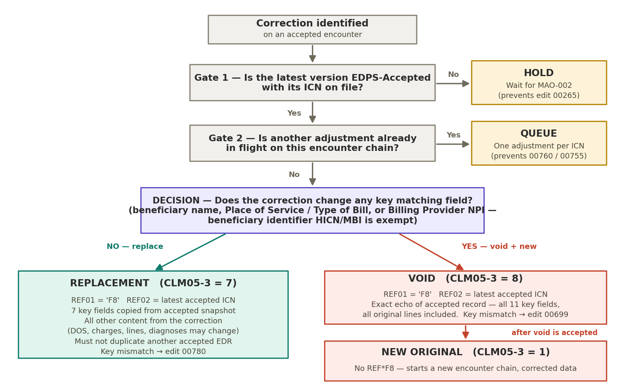

6. Encounter Lifecycle States
Each submission attempt progresses through the states below. Corrections are permitted only from the EDPS Accepted state. Rejections at any stage return the attempt to correction and regeneration as a new attempt — history is never overwritten.
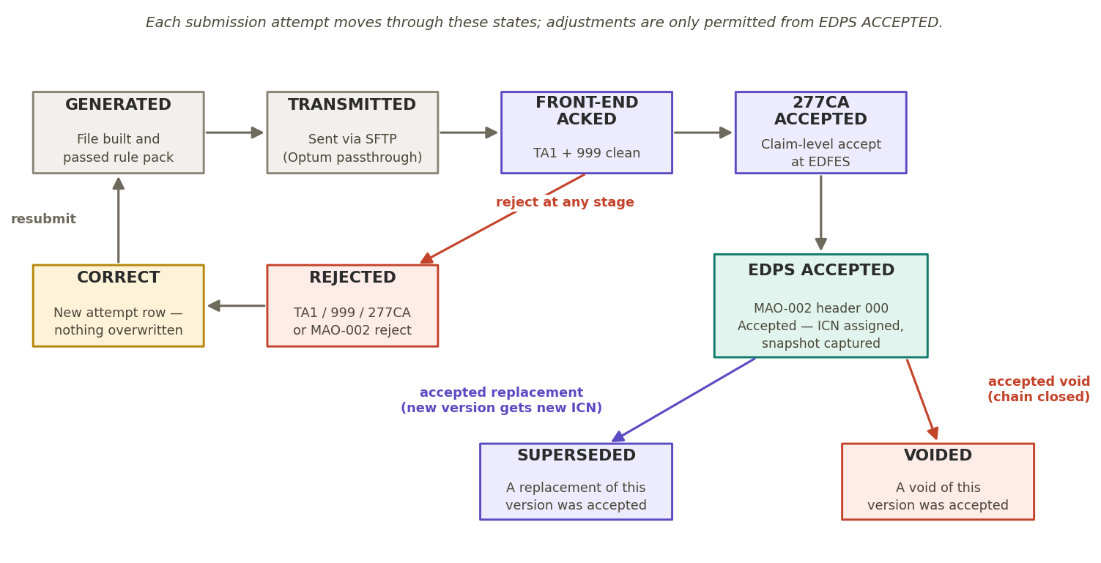
State | Meaning
Generated | File built from the submission layer and passed the pre-submission rule pack.
Transmitted | Delivered to the trading partner (pass-through) for forwarding to CMS.
Front-end acknowledged | TA1 and 999 acknowledgements returned clean.
277CA accepted | Claim-level acceptance at the CMS front end.
EDPS accepted | MAO-002 header line ‘000’ reports Accepted; ICN assigned; snapshot captured. The only state from which corrections may be initiated.
Rejected | Rejected at any stage (TA1/999/277CA/MAO-002); corrected and resubmitted as a new attempt.
Superseded (adjusted) | A replacement of this version was accepted; CMS sets the prior record to adjusted and the chain head moves to the new ICN.
Voided (inactive) | A void of this version was accepted; CMS sets the record — header and lines — to void/off. The chain is closed; a corrected resubmission, if any, begins a new chain.

7. Diagnosis-Only Corrections and Chart Review Records
Per CMS, a submitter wishing to modify only the diagnosis information on an accepted record has three options: (1) void the accepted record and resubmit a new original, (2) submit a replacement EDR, or (3) use a chart review record to add or delete diagnosis codes. Option 3 is often the lightest-weight path for risk-adjustment-driven diagnosis changes.
- A replacement of a CRR must itself be a CRR; record types must match between the correction and the record being corrected.
- Voiding a linked CRR does not void the encounter it links to, and voiding an encounter does not void its linked CRRs — each record is voided individually.
- Voiding a CRR-Delete reverses the deletion: diagnoses previously removed from risk adjustment consideration become considered again. Reconciliation must reflect this as a restoration.
- A CRR that deletes diagnoses must be linked (reference an ICN); unlinked delete attempts are rejected with edit 00805.

8. Rejection Prevention Summary
CMS edit | Official meaning | Prevented by
00780 | Adjustment Must Match Original (replacement; 7 key fields) | BR-05/06 snapshot rendering; BR-08 decision rule
00699 | Void Must Match Original (void; 11 key fields) | BR-05/07 — void rendered as exact echo of snapshot
00265 | Correct/Replace or Void ICN not in EDPS | BR-01 eligibility gate
00760 | Adjusted encounter already void/adjusted | BR-02 chain-head rule; BR-03 single in-flight; BR-04 in-file uniqueness
00755 | Void encounter already void/adjusted | Same as 00760
(duplicate logic) | Replacement duplicates a previously accepted EDR | BR-11 duplicate check against accepted store
00805 | Deleted diagnosis not allowed | Section 7 — CRR deletes must be linked
A8:746:40 | Duplicate submission (file hash) | BR-10 fresh envelope identifiers on every regeneration

9. Acceptance Criteria
- A replacement correcting a line quantity, charge amount, or date of service is rendered with the 7 key fields identical to the accepted snapshot, carries REF01=‘F8’ and REF02 = the latest accepted ICN, and is accepted by EDPS.
- When live source data (e.g., billing NPI in the provider master) changes after acceptance, a subsequently rendered correction still carries the snapshot values, not the current values.
- A correction changing Billing Provider NPI, Place of Service / Type of Bill, or a beneficiary name field produces a void followed by a new original; the new original carries no REF*F8.
- A rendered void reproduces all 11 key fields and every original line, including originally rejected lines in the line count.
- A beneficiary MBI update after acceptance results in a replacement, not a void.
- A replacement whose content duplicates another accepted EDR fails the pre-submission gate (BR-11) and is not transmitted.
- A correction requested while the encounter is not yet EDPS-Accepted is held, not transmitted.
- A second correction on the same encounter queues until the first resolves; when released, it references the newest accepted ICN.
- A file containing two corrections referencing the same ICN fails the pre-submission gate and is not transmitted.
- A regenerated file with identical claim content transmits with new envelope and BHT identifiers and is not rejected as a duplicate.
- Voiding a linked CRR-Delete results in the affected diagnoses being restored to risk-adjustment-considered status in reconciliation.

10. Open Items for Verification
- Whether a void and its corrected new original may travel in the same submission file, or must be sequenced across MAO-002 cycles. Until confirmed, BR-08 sequences them (conservative default).
- Whether the trading partner’s intake in pass-through mode imposes any additional sequencing behavior on corrections.
- Confirm current versions of the CMS correction guide and job aid at build time; the name-history validation and identifier flexibility carry effective dates.

