What is Meant by Cryptography?
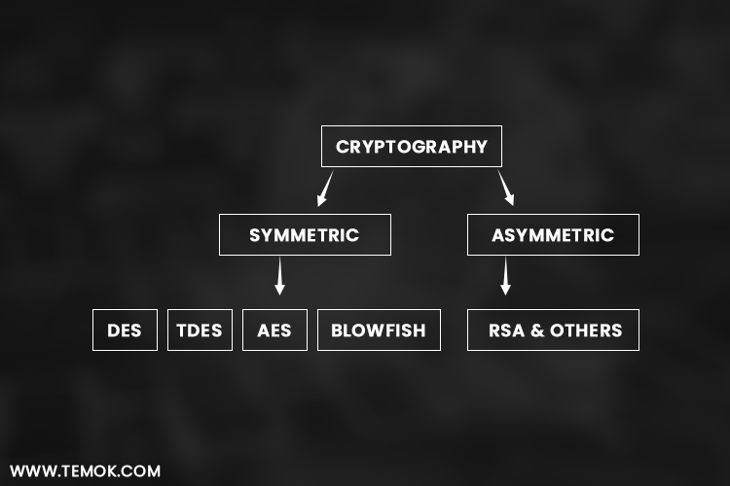
Simply transforming regular plain language into incomprehensible text and vice versa is known as cryptography. It is a means of storing and transferring data in a specific format that can only be read and processed by those supposed to. Cryptography may be used for user authentication and protecting data from theft or change.
Explain the Difference Between a Crypter and a Cryptographer
A cryptographer is somebody who does cryptography, and that implies planning or dissecting any part of encryption. A crypter, then again, is an individual attempting to guilefully camouflage some malware as anything different like a helpful program, so that it can be spread undetected.
In Cryptography, Interview Questions Explain What Is Meant by Confusion
Cryptographic interview questions like this confuse applicants that every Binary digit (bit) of the ciphertext must rely upon a few key pieces, darkening the linkages between the two. The property of confusion conceals the connection between the ciphertext and the key. This property causes it to be hard to track down the key from the ciphertext, and assuming that a solitary bit in a key is changed, the calculations of the upsides of most or each of the bits in the ciphertext will be influenced. Additionally, confusion widens the vagueness of ciphertext, and it is utilized by both square and stream figures.
In Cryptography Interview Questions Context, Explain What is Meant by Ciphertext
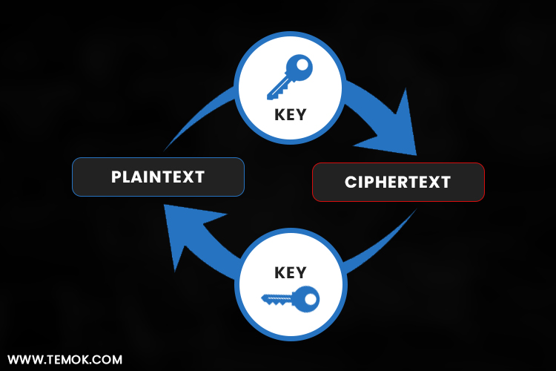
According to the Cryptography questions and answers pdf, the ciphertext is created when communication is encrypted into a completely incomprehensible and undecipherable state. To explain, the plaintext or cleartext is created when the transmitting party generates the written message “EAT WELL FOR HEALTHY LIFE.” The ciphertext is the message after it has been encrypted into the format “YLTHHEA RFO FILE LLEW TEA” while en route. The communication then becomes unencrypted or cleartext again after the receiving party receives the ciphertext and decrypts it into an intelligible and understandable version of “EAT WELL FOR HEALTHY LIFE.”
What Are a Couple of Significant Uses of Cryptography in The Modern World?
There are heaps of advantages of cryptography in the modern world, and a couple of them are:
Unleash Peak Performance With
Dedicated Servers

Your Own Server, Your Own Rules!
Order Now
- Chip-based installment cards
- PC and different passwords
- Internet business
- Guard interchanges
- Computerized Currencies
- Planning conventions
- Information Credibility
What Are The Significant Dangers to Any Information or Data That Needs Cryptography?
There are a ton of dangers indeed, and you may have no clue about that; as for headway in innovation, the converse impact of the equivalent has additionally improved everywhere. Programmers can take information, and any delicate data after spilling can make issues for the business, administration, and monetary organization just as for an individual exclusively. The break of private data can put the whole association in danger. In this manner, information should be secured.
Describe Secret Key Cryptography and Public Key Cryptography
The two of them are encryption calculations and add to information security. Secret Key Cryptography can be utilized for the two encryptions just as decoding. It is likewise viewed as an asymmetric approach and contains just one key. Then again, Public Key cryptography is essentially a symmetric way to approach. There are two keys in this methodology, and one is essentially the public key, and any client can get to the data. Moreover, on the other hand, the key is private and must be gotten to by the director.
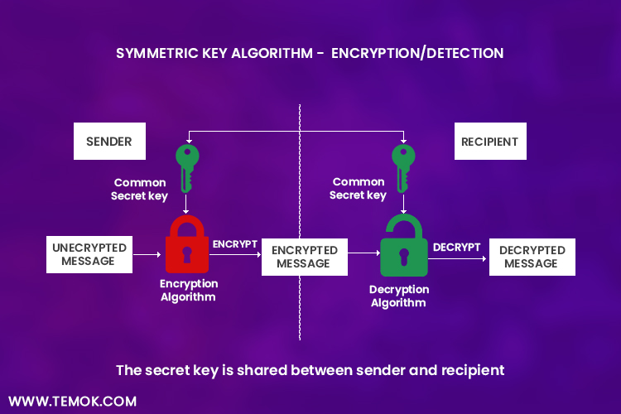
How Are Hash Capacities Unique to Secret Key Cryptography and Public Key Cryptography?
They are fundamentally viewed as single-way encryption. Not at all like Public Key Cryptography and Mystery/ Secret Key Cryptography, they lack any key in them, and their major capacity is to ensure that a document has arrived at its objective with practically no alteration.
If a Cryptography device isn’t accessible and you want to send privileged data, would you continue or stand by till the presence of the apparatus?
Everything relies upon the security of the actual organization in such a case. Assuming the organization is secure, the data could be shared. It is not the case, and I will presumably wait for the Cryptography device to be dynamic. This is because any data without appropriate encryption can undoubtedly be spilled.
What are the Central Aims of Cryptography?
There are 4 prime goals, and they are as follows:
- Secrecy
- Non-disavowal
- Realness or Authenticity.
- Integrity
List The Two Signature Schemes that are Deployed in Cryptography
Blind Signature Scheme and Special Signature Scheme.
Explain the One-Way work/function in the context of a cryptography interview question.
It is essentially a methodology that guarantees quicker data handling for cryptography when information should be sent in one manner, and no converse activity is conceivable. Capacities can be figured in one bearing inside an exceptionally limited ability to focus time; however, playing out the contrary errand can be incredibly overwhelming.
Write the Primary Principle of Cryptography
The fundamental guideline of this approach is only to compose and tackle codes so data security can be improved and that consequently prompts protection.
Tell me about the features of Interactive proof that are useful in Cryptography, as indicated by you, in this cryptography question.
- Zero Information
- Adequacy
- Culmination
They can add to upgrading data security up to a wonderful degree.
Is it conceivable to join Cryptography With Some other Information Security Approach?
In the realm of cryptography and network security viva questions, indeed, it’s feasible to do as such.
When must one use a cryptography shrinking generator?
When an immediate collaboration is needed in the results of Linear Feedback Shift Registers, this can be utilized. It is adaptable generally and has fantastic securing properties that make it a decent way to deal with trust. The shrinking generator can likewise be utilized to investigate how to get data. It can likewise be accustomed to forcing a cutoff on the size of information that should be controlled.
What precisely is the other name of Checksum in Cryptography?
It is known as a Message Authentication Code or MAC. It tends to be sorted as block chipper-based, unequivocally secure, stream figure-based, just as hash work-based.
What is the difference between encryption and decryption?
To begin answering the difference between encryption and decryption in cryptography questions, scrambling and descrambling are sometimes known as “encryption” and “decryption” in terms of decryption, respectively. For instance, when the sending party’s composed message “Take Care” is mixed, it becomes what is known as the “scrambled message.” This implies that the compiled idea has been concealed so that it would be unimportant, or in terms of cryptography, it would be indecipherable.
Moreover, in cryptography questions, it can be detailed that encryption can also be shown as the change of data from a logical state to an obvious vague state. When the receiving party gets this encoded compiled idea, it should be unscrambled into a coherent and understandable condition of the unique situation. This course of unscrambling is otherwise called decoding or decryption.
What is denoted by DSA?
A digital signature algorithm or DSA offers quick signature generation and data checks. It manages key dimensions up to one-thousand-and-twenty-four bites.
What type of information can be applied under cryptographic security?
There is no restriction on the information put away under cryptography. These incorporate individual monetary papers, passwords, private data, guard applications, business information, and methodologies, thus some more.
Why would data require cryptography?
There are many dangers to information in this day and age. Without much of a stretch, programmers could get information on your monetary exchanges, bank subtleties, etc., from your gadgets. Associations could go through immense reputational and monetary harm. A great deal of client information is in question too. These are the key reasons cryptography is a pivotal piece of information security and ought to be incorporated.
List down some applications of cryptography in this modern world
- Card Payments
- PC and different passwords
- Internet shopping
- Safeguard
- Digital currency
- Convention plan
- Information approval
In terms of Cryptography, explain MAC
MAC or Message Authentication code tests the realness or integrity of the message or media access control gadget.
Describe Rainbow Tables
Rainbow tables are pre-registered tables that comprise hash numerals or digits similar to plaintext codes. Also, these can be utilized by programmers to match taken hashes to likely passwords. It permits passwords or codes to be broken significantly quicker however requires high stockpiling capacities.
Define a three-way Handshake in Cryptography.
A three-way handshake in cryptography is deployed in an IP/TCP organization to interface between localhost or customers to a server.
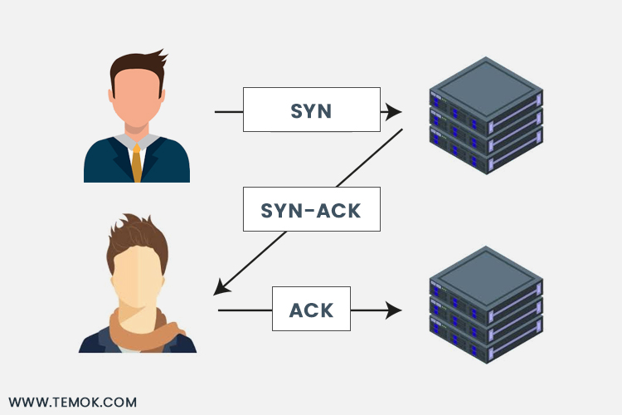
Define Salting
Salting is the process of obfuscating passwords by introducing an arbitrary value to them after they’ve been hashed.
What is the Reason behind the use of salting in cryptography?
Since individuals will generally reuse passwords, a hacker with a rundown of normal passwords or taken ones secures his position simply. A Salt is an arbitrarily created number, yet it decreases the chance of being in a predetermined table.
Describe a Session Key
A session key ordinarily gets correspondence between two groups. It is sent with each message among customer and server, client and customer, or two PCs. They are scrambled with the recipient’s public key.
In the Realm of cryptography, define FEAL.
A block cipher that has been intended to be proficient in hardware and software is known as the FEAL Algorithm.
Define Trapdoor Functions
Trapdoor Functions are such works that can undoubtedly be tackled in a single course; however, they are very tedious and troublesome in the other bearing. Playing out the opposite computation easily is conceivable yet requires a particular cycle.
In cryptography, what is meant by Blowfish?
When altering keys, a blowfish is indeed an asymmetric block key encryption that is efficient yet demands a pre-processing equivalent.
Why is SSL encrypting insufficient?
SSL only secures your information while it is in transit. It does not safeguard data after it reaches the recipient. SSL also does not encrypt your information. When it comes to processing metadata, this might be a flaw. This enables your prospective hacker to create a client profile and consider network layouts.
Is it feasible to use cryptography in conjunction with any other data protection method?
Yes, it is feasible to accomplish this.
What exactly do you mean when you say DNA computing?
It’s nothing more than a collection of arbitrary DNA strands that can be joined to solve a specific problem. It is equally effective across both basic and large-scale strands. Molecular computing is another term for DNA computing. It seeks to handle some highly complicated difficulties that might appear in the cryptography method using parallel search.
How much do you understand SAFER? What is the abbreviation for it?
SAFER is a block chipper that refers to Secure and Fast Encryption Routine. It is a commonly used byte-oriented technique with a 64-bit block capacity. It has very secure decryption and encryption techniques, with ten rounds of which six can be utilized freely. This technology is widely used in electronic payment cards.
What exactly is the Fast Data Encryption Algorithm?
It’s essentially a cryptosystem with a block size of 64 bits. Its primary goal is to ensure that the software is utilized and runs smoothly. However, it is not as widespread in the current context owing to the insecure method.
What is the purpose of a Key Distribution Center (KDC)?
The KDC comprises a system that contains the names and passwords of all end-users at the business or organization and many other authorized servers and networking devices.
What are the drawbacks of symmetric key encryption?
There are three significant flaws with symmetric key cryptography:
- Storage and retrieval of keys
- Distribution of keys
- Open systems
What is the title of the issuing authority that issues certificates for public key infrastructure?
Certificate Authority.
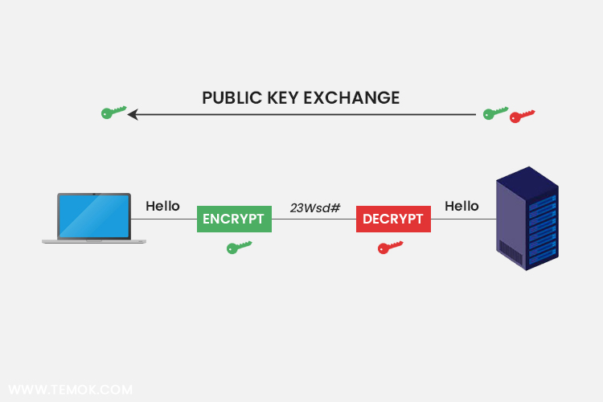
Define quantum cryptography
Quantum cryptography is a safe key exchange mechanism based on the physics of photons across an insecure channel.
What is meant by Shamir’s secret-sharing scheme?
Shamir’s secret sharing technique is a polynomial interpolation-based linear interpolation system. A polynomial degree (m 1) across the finite field GF (q).
What Are Some Other Hash Functions?
For a quick overview, hash functions are frequently classified into three types based on their design:
- those based on block ciphers
- those using modular arithmetic,
- and those with a “special” design
Explain a Compression Function
A compression function takes a defined length input and converts it into a shorter, fixed-length outcome. Then, a hash function may be created by using the compression algorithm again until the data packet has been processed.
Brief upon a Birthday Attack
The term “birthday attack” refers to a brute force attack. The birthday paradox is named after the surprise finding that the likelihood of two or more persons in a group of 23 sharing the same birthdate is more than 1/2.
What is Meant by Skipjack?
The Clipper chip’s encryption algorithm, Skipjack, was created by the National Security Agency. Because Skipjack utilizes 80-bit keys plus encrypts the information for 32 stages, or “rounds,” it may be more secure than DES. On the other hand, it employs 56bit keys as well as encrypts the information for just Sixteen rounds.
Are there any patents that cover the use of DSA?
Former NSA member David Kravitz claims a patent on DSA. Claus P. Schnorr claims that his invention covers specific DSA implementations.
Does a patent protect RSA?
RSA is protected by American Patent 4,405,829, issued on September 20, 1983, and is held by RSA Data Security, Inc. of Redwood City, California. The patent is set to expire in 2000, 17 years after it was awarded.
What Are the Signs That a Number Is Significant or Prime?
Probabilistic primality testing is often suggested since it is significantly faster than explicitly demonstrating whether an integer is significant or prime.
What is Cryptography’s Importance?
Cryptography plays a critical role in defending your digital assets from hackers by encrypting data as we progress into a new age.
Define Running-Key Ciphers
Book cipher is another name for running key cipher. The length of the cipher in this cipher is the same as the size of the original comment. Both the receiver and sender commit to encrypt and decode the message using the identical chapter of the identical book.
Which type of technology is used in Cryptography?
Blockchain tech (also known as distributed ledger technology, or DLT) is quickly gaining traction in various fields, from cryptocurrency to digital identification and cryptographic protocols. Even though it does not introduce any novel cryptographic concepts, it raises the standard in terms of the level of confidence needed for cryptographic application and key management regarding the considerable relevance of the transactions included.
List Down Three Main Types of Cryptographic Algorithms
The number of cryptographic keys used with each of the three basic classes of NIST-approved cryptographic algorithms is defined by the number of varieties of cryptographic keys associated with each. The main are as follows:
- Hash functions.
- Asymmetric-key algorithms.
- Symmetric-key algorithms.
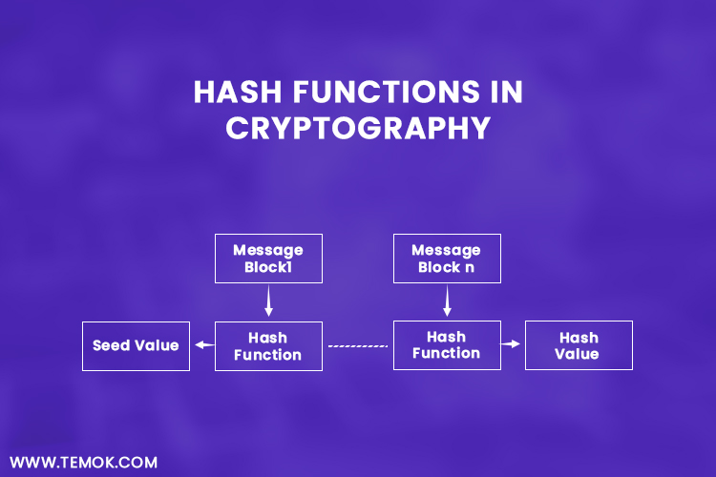
In general, this article has inspected a portion of the additional difficult parts of cryptography. An accomplished cryptographer ought to have the option to answer these, just as the applicant who is going after a cryptography job. On account of the last option, a decent up-and-comer ought to have the option to respond to these inquiries in somewhat detail. So, practicing on these cryptography interview questions enough using cryptography questions and answers pdf, and having a strong mathematical background will hopefully allow you to make it through the interview succinctly.
+4
FacebookXLinkedInEmailShare
Show Comments

