AI-ENABLED WAREHOUSE DOCUMENT MANAGEMENT SYSTEM
Conceptual Framework
The conceptual framework (Figure 1) illustrates the integration of Artificial Intelligence (AI), secure document processing, role-based access control, and workflow automation to enhance efficiency, accuracy, and transparency in warehouse document management.
The framework demonstrates how documents flow through the system from submission to archiving while being processed by AI components for classification, validation, analysis, and decision support. Unlike traditional systems, the proposed model introduces intelligent automation to reduce manual workload and improve operational performance.
Each warehouse must access its specific documents, while regulatory body
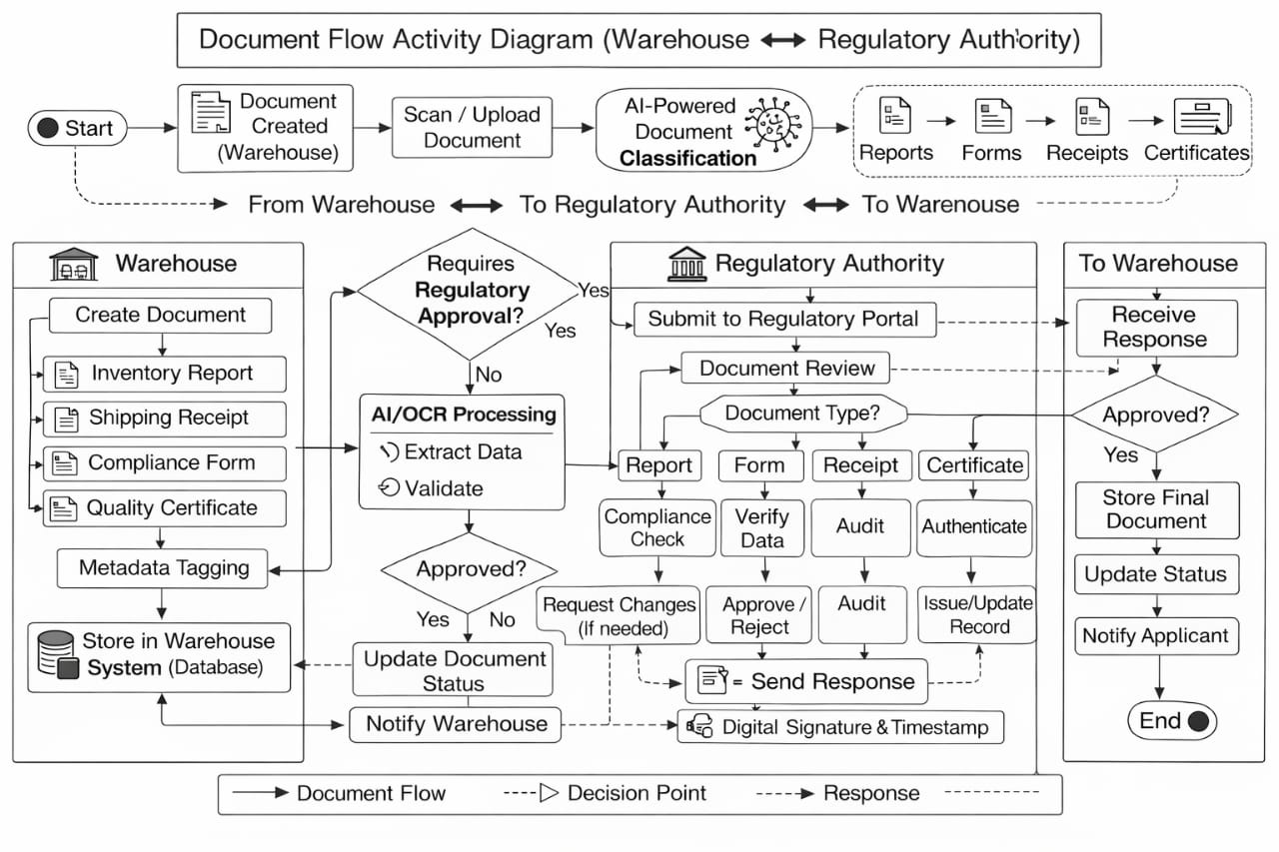
Figure 1: Activity diagram flow of whole system including AI
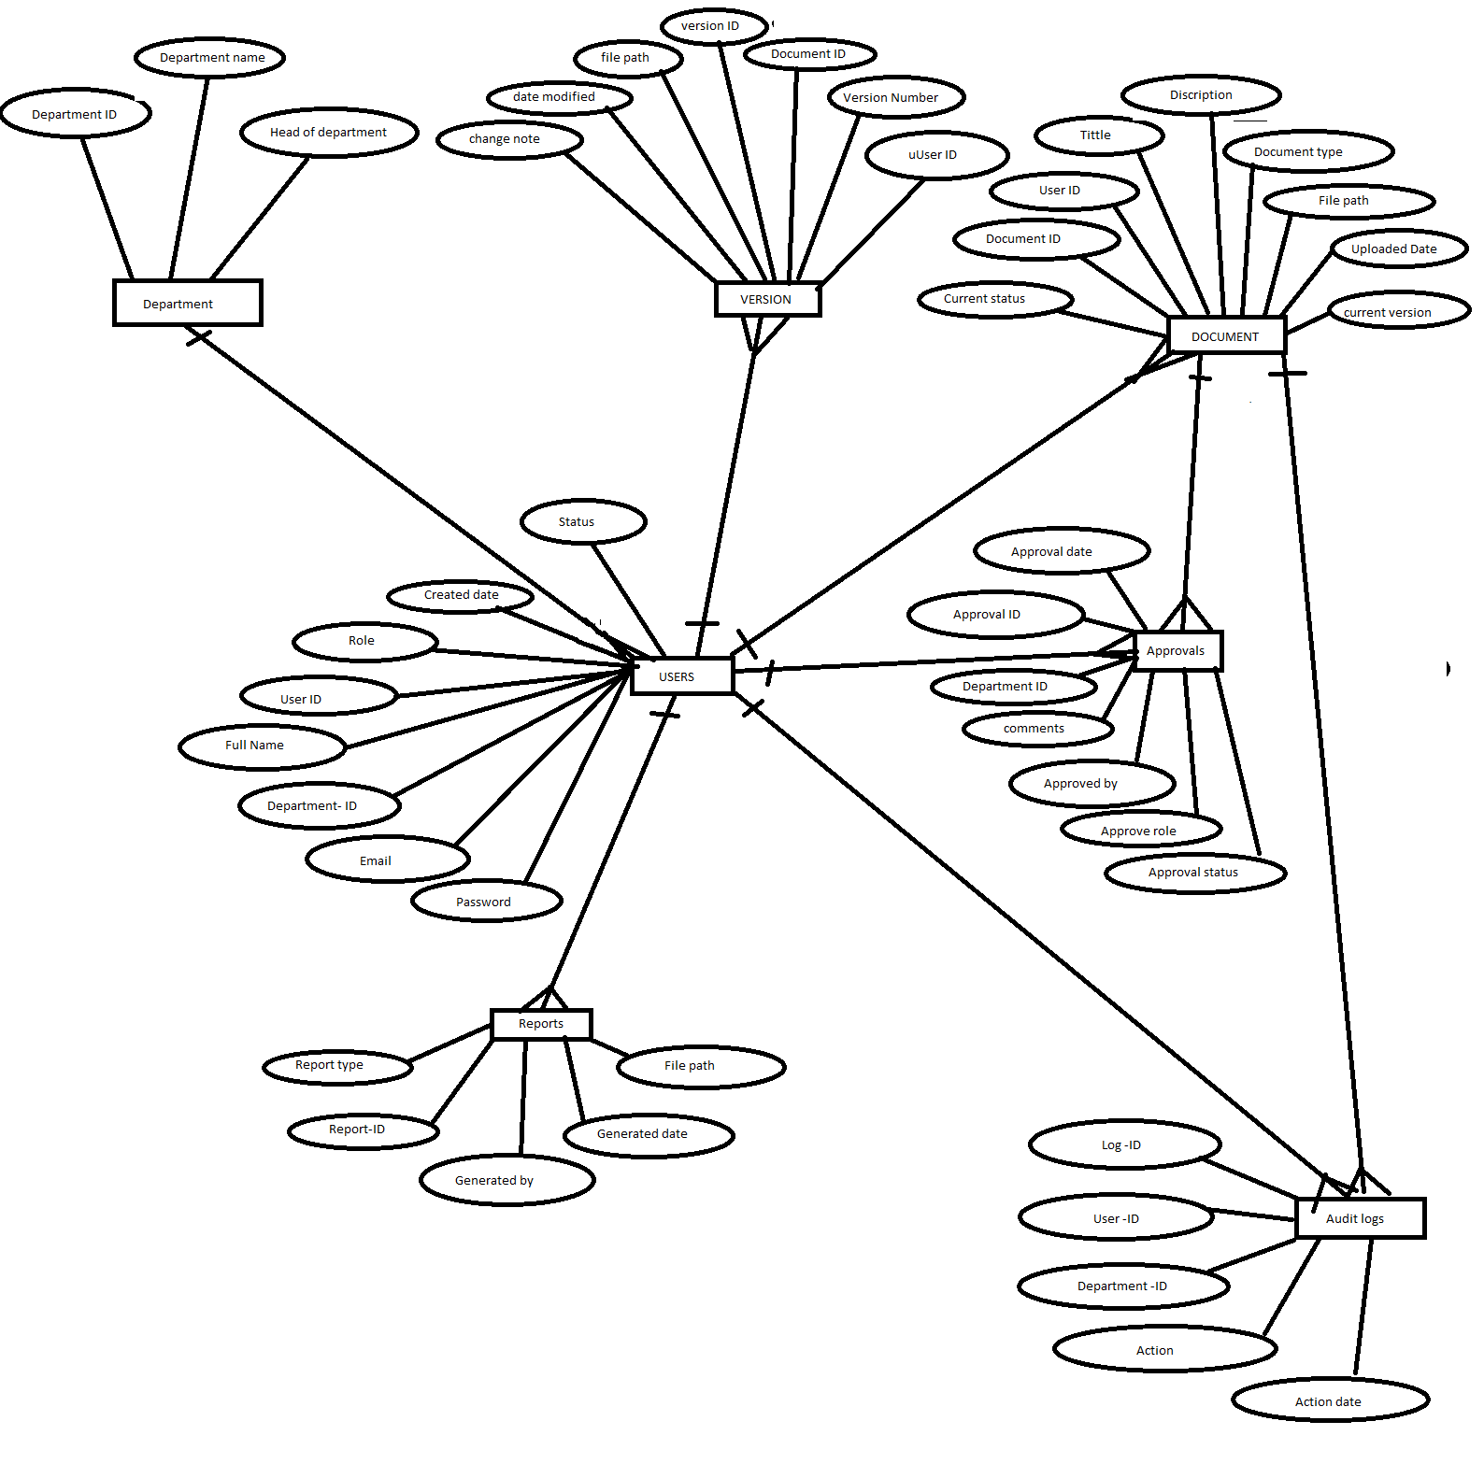Figure 2: Diagram of ERD
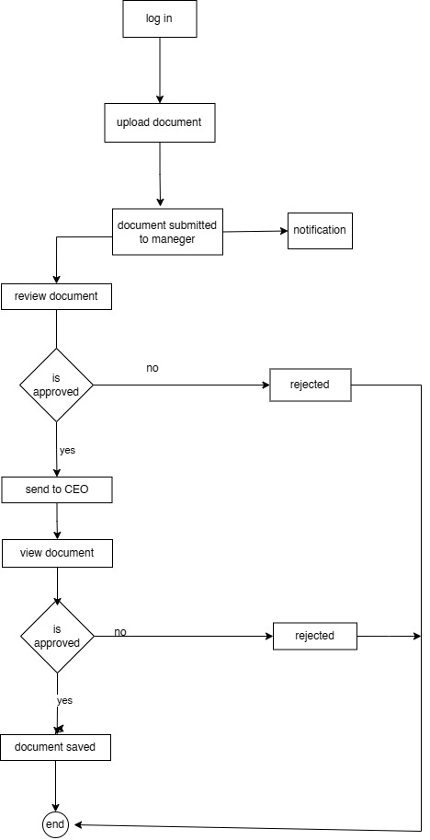Figure 3:Activity diagram for internal flow of documents
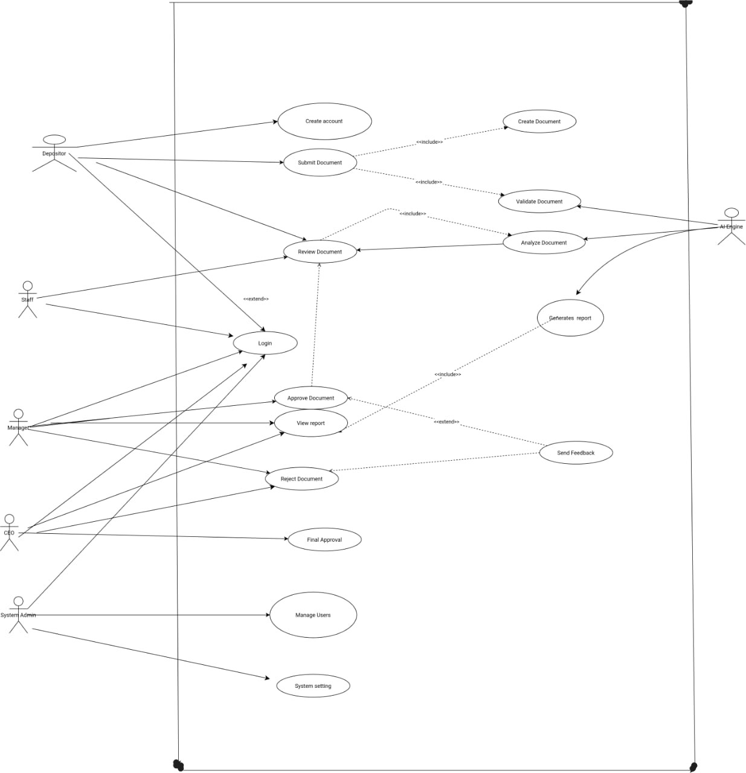Figure 4: USE CASE diagram
Key Components
• Document Submission
Warehouse users submit documents through a secure web interface. The system captures document metadata such as title, category, uploader identity, and timestamp for tracking and indexing.
• AI Processing Engine
The system integrates AI technologies to automate document handling:
- OCR (Optical Character Recognition): Extracts text from scanned documents
- Machine Learning Classification: Categorizes documents automatically
- Natural Language Processing (NLP): Enables semantic understanding and intelligent search
- Semantic search or preview
- Generation and analysis of report
- Validation and Error Detection: Ensures document completeness and correctness
- Recommendation Engine: Suggests approval or rejection decisions
• Approval Workflow System
A multi-level approval mechanism ensures accountability:
- Staff: Performs initial verification
- Manager: Reviews and makes approval decisions
- CEO: Conducts final validation and approval
• Reporting and Analytics
The system automatically generates analytical reports, enabling data-driven decision-making and performance monitoring.
• Access Control System
Role-based access control (RBAC) ensures that users only access functionalities relevant to their roles, enhancing system security and integrity.
• Notification and Feedback System
Automated notifications inform users about document status changes, approvals, rejections, and required modifications such as email or text
NOTE: When the depositor performs a search in the system, they should be provided with an option to select nearby (location) warehouses. The system should display a list of available warehouses, allowing the depositor to choose one from the list.

System Overview and Architecture
The proposed system adopts a three-tier architecture consisting of the Frontend Layer, Backend Layer, and AI Processing Layer to ensure modularity, scalability, and efficient system operation.
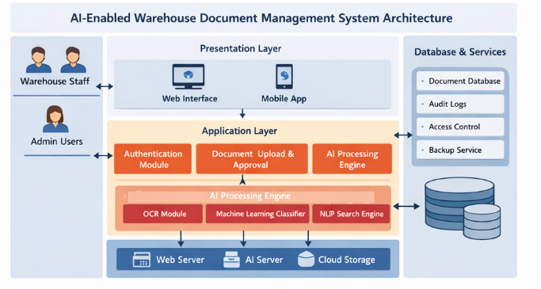
Frontend Layer (User Interface)
The frontend layer provides an interactive interface for different user roles:
Depositor – Submits warehouse documents
Staff – Registers and processes documents
Manager – Reviews and approves documents
CEO – Final approval and reporting
NOTE: Every user should be able to create, upload, submit documents

Documents within the warehouse follow a structured internal workflow to ensure proper verification and approval. A document is first created and submitted by the depositor, then reviewed by staff for initial verification. After that, it is forwarded to the manager for decision-making and finally to the CEO for final approval. At each stage, feedback can be provided and sent back to the previous level if corrections are required, ensuring accuracy and completeness before finalization.
Once the document is fully approved, it establishes a link between the warehouse and regulatory authorities. Approved documents such as inspection reports, compliance certificates, and transaction records are shared with regulators for monitoring, auditing, and compliance purposes. This connection ensures transparency, accountability, and adherence to regulations, allowing regulatory bodies to verify warehouse operations based on authenticated and approved documents

System Administrator – Manages system users and configuration
Phase 1 — System Access (Login Process)
Step 1: User Login

All users must log into the system before performing any task.
Actors involved:
Depositor, Staff, Manager, CEO, System Administrator
Process
User opens system login page
User enters: Username, Password
System verifies credentials, System identifies user role, System loads role-based dashboard
Output
Depositor Dashboard, Staff Dashboard, Manager Dashboard, CEO Dashboard, Admin Dashboard

Phase 2 — Document Submission (Depositor)
Actor: Depositor
Step 2: Depositor Uploads Document
Depositor submits warehouse documents into the system.
Process
Depositor logs into system
Depositor opens Submit Document page
Depositor fills form:
Document title
Document type
Description
Date
Upload file (PDF/Image)
Depositor clicks Submit
System Actions
System automatically:
Saves document into database
Stores file on server
Assigns Document ID
Sets status:
Status = Pending Staff Review
Records submission in audit log

Output
Documents should remain in depositor dashboard and if needed should be allowed to download
Document appears in:
Staff Dashboard → Pending Documents

Phase 3 — Document Registration (Staff)
Actor: Staff
Step 3: Staff Receives Document
Staff processes documents submitted by depositors.
Process
Staff logs into system
Staff opens:
Pending Documents
Staff selects document
Staff reviews document details
Staff Actions
Staff may:
Edit document information
Verify document
Add notes
Confirm document
System AI Processing
After staff confirmation:
System automatically:
Runs OCR
Extract text from document
Runs Classification Model
Assign category automatically
Examples:
Import document, Export document, Storage document, generates keywords, Saves metadata Status Update, System changes status: Pending Manager Approval
Output
Document appears in:
Manager Dashboard

Phase 4 — Document Approval (Manager)
Actor: Manager
Step 4: Manager Reviews Document
Manager evaluates documents before final approval.

Process
Manager logs into system
Manager opens:
Documents Awaiting Approval
Manager selects document
Manager Actions
Manager may:
✔Approve Document, ✔ Reject Document, ✔ Request Correction

If Approved
System updates status: Pending CEO Approval
If Rejected
System updates status: Rejected
Depositor receives notification.
Output
Approved documents appear in: CEO Dashboard
Phase 5 — Final Authorization (CEO)
Actor: CEO
Step 5: CEO Final Approval
CEO performs final authorization.

Process
CEO logs into system
CEO opens: Documents Awaiting Final Approval
CEO reviews document
CEO Actions
CEO may: ✔ Final Approve, ✔ Reject
If Approved
System updates: Status = Approved
Document becomes official warehouse record.
System Actions
System automatically: Archives document, enables search, Adds audit record. Generates report entry
Output
Document appears in: Approved Documents
Reports
Search System
Phase 6 — Document Retrieval (All Users)
Actors
Staff, Manager, CEO

Step 6: Search Document
Users retrieve stored documents.
Process
User enters: Document number,
Keyword
Category
System AI Actions
System uses:
✔ NLP search✔ Keyword search
Output
Matching documents displayed.
User can: View, Download, Print
Phase 7 — Reporting
Actors: Manager, CEO
Step 7: Generate Reports
Process
User selects:
Date range
Document type
Status
Output

System generates:
Document reports
Approval reports
Activity reports

Phase 8 — System Administration
Actor: System Administrator
Step 8: Manage System
Administrator controls system configuration.
Admin Functions
Admin can:✔ Create users
✔ Edit users
✔ Delete users
✔ Assign roles
Roles: Staff
Depositor
Manager
CEO
Admin Also Manages
System settings
Backup
Security
Complete Workflow Sequence
Step-by-Step Order
Admin creates users
User logs in
Depositor uploads document
Staff verifies document
System runs AI processing
Manager approves document
CEO final approval
Document archived
Users search document
Reports generated

Simple Developer Logic Flow
LOGIN
↓
ROLE IDENTIFICATION
↓
DEPOSITOR UPLOAD
↓
STAFF VERIFICATION
↓
AI PROCESSING
↓
MANAGER APPROVAL
↓
CEO APPROVAL
↓
DOCUMENT ARCHIVE
↓
SEARCH & REPORTING

TYPSE OF DOCUMENTS
FORMS
Application form(depositor>staff)
Permission form(staff>manager>CEO)
Warehouse inspector(compliance) form (staff should have a physical form and after performing inspection of a certain warehouse then will be uploaded to the system then every warehouse should be able to download and system should generate a general report for all warehouse that will be used for regulatory ranking by AI)

RECEIPTS
Warehouse receipt delivery (staff >depositor)
Goods cost receipt notes(staff>depositor)

CERTIFICATES
Quality certificates for depositor(warehouse>depositor)
Warehouse compliance certificates (regulatory body>warehouse)

REPORTS
Application report (staff>manager>CEO)
Ranking report (regulatory body>warehouse)
Inspection report (regulatory body>warehouse)
Warehouse operation cost structure reports(warehouse>regulatory)

