**Wedy Consulting Treatise**

Tying the Knot with Vendors: Uncovering the Wedding Planning Customer Journey

Bandie Ouch

Master of Science in Applied Psychology

University of Southern California

NEEDS REVISIONS as read by Dr. Luke Thelen as first reader on 9/8/2021

PASSED by Rumaiza Ali as second reader on 9/8/2021

PASSED as read by Dr. Luke Thelen as first reader on 9/9/2021

Readers: Dr. Luke Thelen and Rumaiza Ali

August 2021

**Abstract**

This research aims to uncover constructs which are strong indicators of consumer wants and needs using online reviews by past customers of wedding service providers through a web data scrub. Constructs identified are further explored through an in-depth interview of consumers who have recently been married or will be married in the near future. These interviews will function as qualitative support of the importance of previously identified constructs which stemmed from the data scrub. Additionally, participants detail their consumer journey to demonstrate in depth how they go about planning their wedding and when they use technology to aid them. Specifically, the bride or groom details platforms utilized, decisions made, choice criteria, and total rationale of large decisions made to determine common patterns and possible interjection points where an app like Wedy can possibly facilitate the customer buying process.

**Background**

A wedding is the single most important day of one’s life. In just one year, 2,015,603 marriages took place in the United States (CDC & NCHS, 2019). Ironically, a day to forever remember has its mental tolls; according to a Zola survey, 96% of couples reported that wedding planning was stressful (Hensley, 2019). It is also cited that wedding stress is ranked seventh amongst the forty-three major life events with perceived stress stemming from large weddings, disagreements in decisions and culture, and finance (Cramer & Lafreniere, 2003). From a finance standpoint, with most weddings going for around $33,391 on average in the United States, to juggling 15 different vendors to pull off the special event, it is no wonder why planning a wedding can take a lot out of engaged couples (Tiffany, 2019; WeddingWire, 2020).

Out of the whole wedding planning process, the #1 most stressful wedding planning task is reported to be handling the moving parts in a timely manner (Hensley, 2019). To assist with the hardships that come with this task, 88% of individuals in the 2020 WeddingWire Newlywed Report utilized an online resource to research vendors, access wedding planning websites, browse photo galleries and read vendor reviews (WeddingWire, 2020). In fact, couples cite that the most valuable aspect of reviews are the photos submitted by previous clients, the overall review rating, and the recency of the review being made (WeddingWire, 2020). The lasting issue of coordinating all vendors for a single set wedding date has been mediated through solutions such as wedding planners and, more recently, technology.

**The Current Study**

This study investigates how to approach the largely unsolved issue within the wedding industry by better understanding what type of individuals are getting married and their wedding planning needs in order to serve couples going through their wedding planning process.

**Company Background**

Wedy is the first wedding booking marketplace website and app powered in real-time. Created with the transparency that can help brides make decisions and supported through the expertise of seasoned wedding planners, their goal is to shake things up and revolutionize this cookie-cutter wedding industry. This transparent wedding planning app offers no hidden costs, instant response from vendors, and an easy-to-navigate design to make event planning simpler than ever. Wedy is committed to going above and beyond, empowering brides to be in control of bringing their dream wedding to life.

**Business Problems**

At a consumer level, Wedy would like to better understand their consumers’ journey from engagement to wedding. They desire to discover points of entry and uncover insights on the best points of intervention to introduce their app to potential consumers to convert them into active users. Research will help identify profiles of potential new consumers, their journey, and their choice tendencies in the market. Overall, this research will prove to help us learn more about potential consumers' wedding needs to determine suitable marketing tactics which can best reach the market that would likely use an app like Wedy. With large and successful organizations like WeddingWire, The Knot, and Zola; Wedy would like to identify the gaps and issues that they can help solve with their app.

Moving forward, a deep dive into literature will bring understanding to general ideologies of consumer behavior at a micro and macro level. This will help Wedy identify if there are intersections between the traditional consumer buying process and the wedding planning process. Additionally, a quick review on approaches to competitor analysis will assist Wedy in to different methods to go about gauging their competition. Overall, through the literature analysis, the following research objectives will be targeted:

**Research Objectives**

1. Understand the customer journey towards planning a wedding from the perspective of brides and grooms
2. Formulate major points within the journey and gauge potential interest to introduce a digital wedding planning platform
3. Identify alternative wedding planning resources and competitors

**Literature Review**

***What is customer behavior?***

In *Consumer Behavior & Marketing Strategy*, Paul & Olson explains consumer behavior is defined as the interaction between affect and cognition, behavior, and the environment (Paul & Olson, 2010). Affect can be understood as feelings and emotions, while cognition is more of the working thoughts on a product, brand, or service. The nature of consumer behavior is dynamic due to their environments being constantly fluctuating, shifting how customers feel, think, and behave (Olson). Over the years, studies have looked at how top companies such as Accenture, Amazon, Google, and KPMG have made the customer experience a top priority through dedicating internal departments completely to creating, analyzing, and managing the experience of consumers of their products and services (Lemon & Verhoef, 2016). Therefore, it is critical to be aware of the consumer behavior in the whole wedding market in order to be able to create and market an app that can potentially fill the gaps of the wedding industry.

***What is the customer journey?***

The direct and indirect interactions a consumer has with a brand are called touchpoints. From the beginning touchpoint of discovering a product to the end point of purchasing a product, overall can be considered the consumer journey (Olson). However, the diverse channels and sources of information affecting the consumers’ experience at different times creates multiple buying pathways and journeys, therefore analyzing and pinpointing touchpoints in the whole journey can be difficult yet crucial (2010). The customer journey may look different for every buyer, depending on the wants and needs, especially if the product or service being purchased is of greater monetary value (2010).

***How can you map the customer journey?***

The most traditional customer journey sequence comes in three stages: pre purchase, purchase, and post purchase (2010). Within each stage, consumers can exhibit unique behaviors dependent on what they are attempting to purchase and in what environment. In the prepurchase stage, a consumer will come across all types of information that helps them build an understanding of what’s in the market and general attitudes of how the brands they hear or see are created. It is also in the prepurchase stage where they will form some sort of consideration set or criteria of what they are looking for that can meet their goals in a product or service. In the purchase stage is where they solidify their choice and exchange their money for the service or product that they are considering. They will use the product or service in this stage. And finally, in the post-purchase stage the consumer will decide whether they like or dislike the product. During this stage, the consumer will also form an attitude towards the brand and can demonstrate loyalty by continuing to be a customer or advocate for the brand. This demonstration may come through leaving reviews or recommendations for others to use the brand. As mentioned previously, weddings can easily hire around 15 vendors on average, each journey leading up to the purchase or hire can be different for each circumstance. An app like Wedy can simplify the pre purchase process of searching and browsing multiple vendors on different mediums. However, since the customer journey can become extremely complex and look different for each bride and for each vendor, there is a need to understand how each journey plays out and seek to understand if commonalities or patterns exist within brides.

***What is a competitor analysis?***

Competitor identification is essential in understanding one’s business strategy and implementation of it. Through the competitor analysis one can understand how other companies are positionally fixed in the market and determine how their own product and or service is defined amongst the rest. Through Gur and Greckhamer’s (2019) work, the competitor analysis can be utilized in 4 different perspectives: Industry-Oriented, Strategic Groups-Oriented, Manager-Oriented, and Customer-Oriented. The manager-oriented perspective identifies competitors as whomever the manager identifies them as. The strategic groups-oriented perspective identifies competitors as groups of firms in relatively similar positions within the industry.

Through the industry-oriented approach, all firms in the industry can be considered competitors and the main interest is to explain performance differences across industries for those who are directly or indirectly able to be potential customers. They state that the geographic market proximity holds huge importance for shaping the competition. And secondly, the ability for some competitors to offer services that may serve a different market, but satisfies the customers' needs, thereby increasing the intensity of competition (2019).

And lastly, the customer-oriented perspective regards their competition to be whomever the customers utilize to satisfy their same needs. The customers themselves are the main say in laying out the perceptions based on unique factors or characteristics. This perspective also states hierarchical preferences and utilizes market characteristics to identify competitors themselves to understand who can satisfy their need (2019).

***How is reading online reviews beneficial to competitor analysis?***

When consumers search for a product, they are often searching for an extrinsic cue that can act as a heuristic to help them make the decision to go forward with purchase. A product or service’s brand, online review, and price are often heavy factors which are considered prior to a consumer purchase (Akdeniz, Calantone, and Voorhees 2013). A study of online reviews for booking platforms note that online reviews are an easily accessible way to provide previous consumers’ experience in a vicarious way to potential consumers to either reduce uncertainty or risk when booking in an unfamiliar way (2013). With the increase of the digital space, online platforms are often used as a source to identify customer preferences and competitors (He, Zha, & Li, 2013). Social media, blogs, and websites often contain users who share their opinions on services and products. This digital “Word of Mouth” has an extended reach as well as can offer richer content such as pictures and videos with enormous volume (Chong e. al., 2017).

**Methodology**

For this research, qualitative and quantitative methods are utilized. In the first phase, website scrubbing is completed to understand the scope of companies in the wedding industry from the consumer perspective. Then, qualitative in-depth interviews occurred to understand consumers’ values, their buying journey and use of technology as it relates to their wedding.

***Website Data Scrubbing***

This research begins with a website scrub of online review comments from previous customers of wedding-based apps in order to take the customer-oriented perspective of conducting a competitor analysis. The scrub specifically investigates what consumers generally have to say about several companies in the wedding or venue planning space. Seven companies were scrubbed, each varied in terms of product, services and features offered. The seven companies are: WeddingWire, Zola, Bridebook, The Knot, Sevenlogics, Wedding Spot, and Peerspace.

**Data Extraction and Coding.** The online reviews raw comments were extracted from the Apple Store and were pasted into Microsoft Excel. Twenty comments were randomly selected and extracted per company. They were qualitatively coded for constructs of strengths and weaknesses for 140 comments total. These codes were added to a codebook to identify the constructs for reference throughout analysis. Once the process of qualitative coding was completed, they were uploaded into SPSS to understand basic means and frequencies.

***Qualitative Interviews***

**Recruitment.** Recruitment took place through word of mouth on social media such as Facebook, LinkedIn and personal referrals. The target population of interest to recruit were men or women who were married in the last 3 years or will be married in the next 3 years.

**Survey**. For this study, a pre-screening survey was utilized to link directly to justify ability and interest to participate in the interview portion of the study. Pre-screening surveys were distributed using the platform Qualtrics (See Appendix A). General demographic questions were asked such as age, location, and religious affiliation as well as basic information about potential participants’ weddings such as wedding date, wedding budget and contributors to wedding expenses. The client, Wedy, is currently based in California, Texas, and Colorado, therefore a sample of participants getting married in those areas would translate into insights of interest to Wedy. At the end of the survey, participants were asked whether they would be willing to participate in an interview and were reached out afterwards to schedule. In total 56 participants took the pre-screening survey, however, only 44 were utilized as part of analysis as they were complete to its fullest extent.

**Sample Demographic.** Out of the 44 viable screened participants, 22 fully agreed to the interview portion and were interviewed. All participants were either Gen Z (18%) or Millennial (82%) aged. Most of the sample were female at 77%. The breakdown of ethnicity was 64% Asian, 27% White and 9% mixed race. When it comes to religion, there was a good mixture identifying as Protestant (23), Buddhist (18%), Roman Catholic (14%), Hindu(18%), Atheist (13%), Agnostic(14%). A large amount of the sample (76%) resided and were planning on getting married in the state of California while 4.8% were from Colorado and 9.5% in Texas. And lastly, the engaged and newlywed individuals were split in half, 50% engaged and the other 50% recently married.

**Interview Structure.** Qualitative in-depth interviews were either conducted on Phone or Zoom based on the ability and preference of the participant. Phone interviews were transcribed on Google Doc by the moderator during the interview, while Zooms sessions were recorded to refer to for analysis. Interviews lasted for the duration of 30-40 minutes per participant. The interview questions were asked accordingly as on the moderation guide which was created to ensure consistency of structure (See Appendix B). The first 5 minutes of the interview was focused on introductions and basic background questions, the next 35 minutes were separated into 3 main sections that included a values/attribute of importance in a wedding, pathways to engagement with vendors, and use of technology as it relates to wedding planning.

**Qualitative Coding.** Each interview transcript was received and transferred to Microsoft Excel. They were then assigned codes that captured the components of their response. All relevant questions key to answering research objectives were uploaded to SPSS for analysis.

**Results**

Through this study, we researched how brides and grooms can be understood as consumers through their values and how it relates to their process of searching and hiring wedding vendors. The wedding planning process has proven to be a difficult journey to follow and predict as there are multiple moving parts that may or may not be present depending on the values of the bride and groom. Though efforts have been made through technology by other companies to streamline this process, there currently is a large gap to understanding the exact wants and needs of the bride or groom. The first study investigates the current effort that competitors are making within their own individual platforms through a website data scrub analysis. Based upon the results of the scrub, the interview guide will be directed in a way to confirm common wedding companies used as well as discover the deeper needs, wants, and values the participants have and if a browsing platform like Wedy would have been useful.

***Website Data Scrub***

**Analysis Plan.** Online reviews from the Apple Store were used as the sole source of the qualitative data collected. Twenty reviews were extracted for each of the 7 competitor apps, they were qualitatively coded to capture the essence of the review made. Once they were qualitatively coded, they were uploaded to SPSS. Each company had a multiple response analysis run in order to get the basic frequencies. In addition, overalls rating scores and average number of reviews were also collected from the website to bring perspective on how each company compared off of one another.

**Competitors.** The 7 competitors that were analyzed were all phone apps that also come out on other platforms and devices such as iPad and desktop. They serve for a variety of functions, but all have the commonality in that it can be utilized for the purpose of helping plan a wedding. Figure 1 depicts the competitors and each of their total ratings from that App Store which includes The Knot, Zola, WeddingWire, Sevelogics, Peerspace, Wedding Spot, and Bridebook (from left to right). The Knot, Zola, and WeddingWire are wedding planning apps with multiple resources and features for brides to use, while Wedding Spot, Peerspace, and Bridebook are more centered on finding and browsing for vendors and venues. Sevenlogics is mainly used for on hand wedding planning and organization. The Knot has the highest number of ratings with 81,916 and Zola coming next with 47,939. Figure 2 showcases the average rating out of 5 from of all reviews from the App Store with the top 2 being Zola and Peerspace, and the lowest being Sevenlogics. The Knot, Zola and WeddingWire are the most utilized apps in the wedding app space, however all other companies put out apps that get very high ratings yielding over 4.5 out of 5 stars.

Figure 1. Competitor Total Ratings on App Store

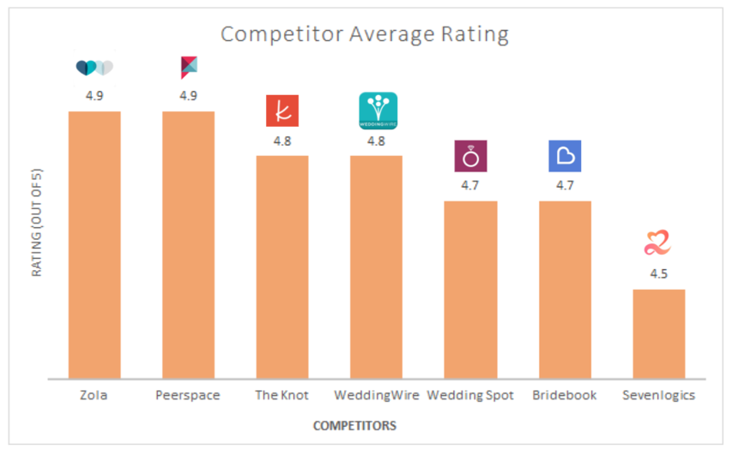

Figure 2. Competitors Average Ratings out of 5 on App Store

**Top Characteristics.** Across all competitors and based on the coded comments, the top 5 mentioned characteristics in the online reviews for the apps were that they were “Useful and Efficient”, “Easy to Use”, have “Comprehensive Features”, “Helps Organization” and they make it “Easy to Browse Venues” (see Figure 3). The Knot’s top 4 most mentioned characteristics are like the top 5 overall mentioned but excludes “Easy to Browse Venues”. The top characteristic for The Knot was “Useful and Efficient” being mentioned by 45% of the web scrub comments analyzed. Many also mentioned that The Knot is “Easy to Use” cited by 30% of the comments scrubbed.

*“I highly recommend The Knot, as I have tried using other wedding planning sites, but this is the only one that made it so* ***easy*** *with EVERYTHING in one place!” - The Knot User*

For the app Bridebook, 50% of its sample mentioned that it “Helps Organization”, 45% stating it has “Comprehensive Features”, and 35% saying its “Easy to Use”. WeddingWire’s top mentioned characteristic was its “Comprehensive Features” mentioned by 40% of the reviews analyzed. The next most mentioned characteristics are “Helps Organization” (30%) and “Useful and Efficient” (25%). Peerspace’’s top characteristic was uniquely that it was “Customer Friendly” (20%) and Sevenlogics, the planner app being called “Useful and Efficient” by 40% of the sample. Lastly, Wedding Spot’s top characteristic is that it is “Easy to Browse Venues” pointed out by 50% of the reviews.

*“Also, a great way to startup a wedding website and so much more overall a great app to* ***stay organized*** *and on top of everything!”- WeddingWire User*

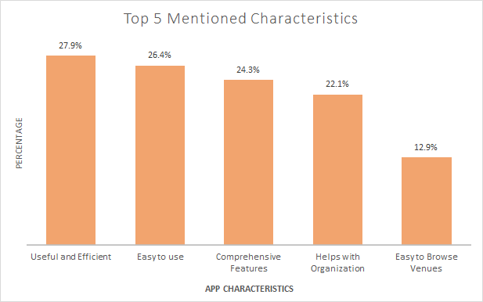

Figure 3. Top 5 Mentioned Characteristics based on Web Scrub

**Pain Points.** Through the website scrub, flaws of the apps also were made apparent through the users’ postings of online reviews. The top mentioned pain point was “Flaws in Design”. This was most common in the companies, The Knot, Zola, Sevenlogics, WeddingWire, and Peerspace (see Figure 4) The companies Wedding Spot and Bridebook were not cited to have any issues with the design within the comments scrubbed for this research.

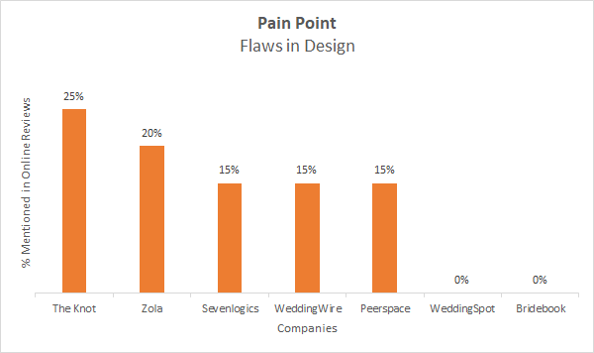

Figure 4. Mentions of Flaws in Design based upon Web Scrub

The second most mentioned pain point was common across all companies. This pain point was that there were issues in that it “Does not Load”. All companies had some mention that there was a loading issue, however, Peerspace stands at the top with 15% of the comments mentioning an issue (see Figure 5).

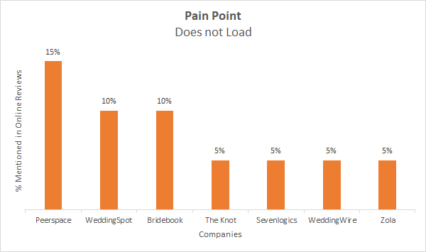

Figure 5. Mentions of Apps Not Loading based upon Web Scrub

**Vendor Browsing Capabilities.** Out of the seven apps analyzed, five of them have the capability to browse vendors. These five are The Knot, WeddingWire, Wedding Spot, Bridebook and Peerspace. Quality of vendors was also mentioned by 25% of the scrubbed comments for Bridebook, and by 15% by The Knot (see Figure 6). Reviewers also mentioned that they liked the direct messaging feature as well with it being noted on WeddingWire and The Knot the most in 20% of their comments. It was also mentioned by reviewers of Bridebook and Wedding Spot as well. Lastly, it was common amongst several reviewers that they would enjoy it was mentioned by 15% of the sample of both The Knot and Wedding Spot that not all top vendors are available on the app.

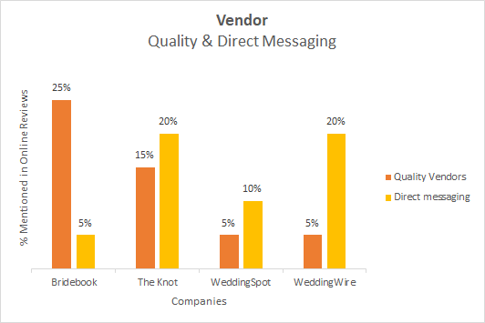

Figure 6. Mentions of Vendor Quality and Direct Messaging from Web Scrub

***Qualitative Screening Survey***

During the prescreening for the recruitment, data was collected for basic wedding information such as guest size, budget, and contributors to wedding expenses. The following are the results of all survey takers. As it relates to the size of weddings, 44% of the sample were larger and projected to have more than 150 guests, 21% of the sample had about 50-150 guests, and 35% had under 50 guests. Most budgets were larger than $30,000 (42%), 23% of the sample spent less than $10,000, and 19% of the sample spent between $20,001-$30,000. 2% of the sample was unsure. Lastly, the contributors of the wedding varied amongst the survey takers. The survey taker (34%) and spouse (33%) reported as the highest contributors to wedding expenses. This was followed by the survey taker’s family (18%) and the spouse’s family (15%).

***Qualitative Interview***

**Analysis Plan.** For the interview, insights uncovered through the website scrub will be utilized to carve our direction. Top characteristics of importance and pain points were kept in mind while and were written into the moderation guide to further confirm with qualitative backing and reasoning. The interview was split into three sections: General wedding attributes and values, consumer buying journey and wedding apps and platforms. Most of the questions in the interview were qualitative and required qualitative content coding. The coding was executed through understanding the responses from the interviewee, then adding multiple codes for any attribute, behavior or value depending on the nature of the question. Other questions included a rating on a scale of 1-10 to understand to what extent the participant feels a piece of technology or vendor was helpful. Responses including qualitative coded responses were uploaded to SPSS and had basic frequencies and counts run. The following are the results.

**General Wedding Attributes & Values.** This section focused on understanding the ideal wedding and what components are important to the bride or groom. When asked, “What do you ideally want in a wedding?”, the top two responses were wanting an outdoor event (18%) and to enjoy the day with family and friends (16%). Another 11% also mentioned that they would like to or have had a wedding that celebrates their cultural heritage.

*“My ideal wedding would have been at an outdoor venue with trees as the backdrop with the ability to serve a traditional Cambodian wedding course meal at the venue site under a canopy of lights.”- Participant*

When asked, “What components are important to you in a wedding?” 20% of the sample mentioned guests as an important factor and 16% prioritizing a memorable experience. Interestingly enough, 33% of millennials (age 25-40) state that venues are significant. On a scale of 1-10, with 1 being “Very Unorganized” and 10 being “Very Organized”, participants were asked, “How organized do you feel while planning for your wedding?” On average, out of 21 individuals the rating was 5.67. On the same scale, participants were asked “How much does money play a factor in the decisions you make?” with the average coming out to 6.67 out of 10. 67% of Millennials rating 7 or higher in money playing a role in decisions.

***Elopement.*** The last question in this section was about elopement. It asked if you ever thought about eloping, 59% of interviewees stated no. The top reason for not wanting to elope was that 46% wanted friends and family to attend the ceremony.

*“No...we both like celebrating with people. We both have a decent amount of family and friends. We want to enjoy it with them” - Interviewee*

Interestingly, 64% of Asian ethnicity stated they never thought about eloping. In addition, 89% of those projecting or having had a wedding with more than 150 guests have stated they never would elope. On the other hand, 86% of those who have weddings under 50 guests have thought about eloping. One hundred percent of the interview sample who had a budget of $20,000 or less stated they have thought about eloping before or have eloped, while 86% of those who have a budget of $20,001 or more have stated that they have not thought about elopement as an option.

**Consumer Buying Journey.** In this section, the questions are focused more on the process that brides or grooms go through to learn, hire, and engage with wedding vendors. Out of the 22 brides and grooms interviewed they hired 9 vendors on average. The top two types of vendors hired are photographers and venues with 87% of them hiring them. The pre purchase stage is all about behaviors done prior to hiring or buying a service. Therefore, questions on browsing behavior and consideration set were explored. A total of 73% of participants learned about what wedding vendors to include in their wedding through word of mouth while 50% of them learned about it by past experiences (attending a wedding or media), while 78% of the sample checked reviews while looking to hire vendors. A total of 100% of Gen Z checks for reviews. When asked to rate how helpful reviewing ratings are to considering who to hire on a scale of 1 to 10 (1 being Not Very Helpful and 10 being Very Helpful) the average rating was an 8.6. About 55% of the sample reviewed a portfolio of their vendor’s work or has had a trial with them. The helpfulness rating out of 10 for work trials and portfolios was an 8.6 out of 10. When asked what vendors can do to make them trust their work (that they are a quality service), 55% of respondents mentioned that meeting in person is helpful, while 41% suggested that responsiveness and professionalism (upon meeting in-person or phone) would be helpful. When asked how they received price quotas, the answers were diverse: 32% got it through calling, and 28% received it through in-person conversations as well as another 28% receiving it through the vendor’s personal website. Also 55% of the sample stated that they would likely leave a review and the reasons vary from vendors doing a bad job or good. All of them had the similar theme of wanting to help future brides and grooms.

*“ [I] always leave a review regardless if good or bad. I feel like that it would help others in the future” - Interviewee*

**Technology Used**. The last section of the interview focused on technology used. The most popular platforms used were Google (sheets, docs, web browser) with 50% of the sample using Google. In addition, 28% of participants used Instagram and The Knot. Pinterest and Microsoft (Excel and Word) were utilized by 23% of the sample.. WeddingWire, Minted, and Canva were used by 9% each, while 5% uses Zola, Wix each. When it comes to most liked features or characteristics, the most stated was Easy to use at 27%, then ability to browse vendors and improved communication with vendors was falling right after at 23% each.

*“[The Knot] It’s easy to use while looking for venues and to communicate the vendors” - Interviewee*

When asked if they would be open to using an app that allows you to browse vendors, 82% stated yes and on average rated it to be 6.9 out of 10 helpful, (with 1 being Not Very Helpful and 10 being Very Helpful). The last question asked was what features or circumstances needed to be fulfilled in order to use a new app with 23% of the interviewees stated it would need worthwhile features and reviews or ratings.

**Discussion**

The original purpose of the study was to gain a deeper understanding of how consumers in the wedding industry go about planning their wedding, particularly for Wedy, how they find vendors and eventually choose to hire them for their wedding. This includes the whole consumer journey such as touch points as well as the resources and competitor platforms utilized to find services brides and grooms need.

***Website Scrub***

Through collaboration with the client, the website scrub was conducted first to gain a grasp of the reviews brides and grooms were posting about wedding apps that are in the same industry and have similar functions as Wedy. Out of the 7 apps analyzed, by pure volume of reviews, The Knot was clearly the most utilized app having the most reviews on the apple app store, with Zola and WeddingWire coming up as close second and third. All other apps (Sevenlogics, Peerspace, Wedding Spot, and Bridebook) have a small number of reviews and show pain points which can leave them vulnerable to being outcompeted. These 4 smaller apps mentioned do not have comprehensive features like the larger 3 (Zola, WeddingWire, and The Knot). All companies had the commonality that the reviews will mention the app was useful, but all still had flaws within bugs and some within design. In addition, specific to being compared to Wedy’s vendor browsing functionality, it is important to consumers that there is a large variety and more complete listing of vendors on the app. Both The Knot and Wedding Spot had mentions that not all vendors were available through the search, therefore Wedy should ensure that they cover these gaps, if possible.

***Qualitative Interview***

**Attributes and Values**. Generally, brides and grooms are looking to have an enjoyable ocassion with their guests on their wedding day and want a memorable experience. Having a wedding that can honor cultural values was also a recurring concept that came up in interviews, but not depicted in the website scrub, which questions whether this can be an untapped market to help aid those looking for this experience. For most Millennials, cost played a stronger role in the decisions they made for their wedding.

**Elopement.** Eloping was found to not often be considered an option to those who project to have larger weddings and spend more, while those who had ended up or are planning for smaller weddings have absolutely thought of elopement as an option. Therefore, it can be assumed that depending on the brides or groom's budget, we can approximate whether or not elopement packages or services could be of interest to them.

**Consumer Buying Process.**

*Pre Purchase.* Before hiring vendors, brides and grooms tend to have information in mind on what services and vendors are necessary to the wedding they have in mind. Most have mentioned they have experienced a wedding, seen it in the media or heard about it by word of mouth from friends or family. Going deeper in the journey, brides or grooms often check reviews to help them decide who to hire and find it extremely helpful to do so. Contact with vendors prior to hiring tended to help solidify decisions in who to hire. This can be done through trials of work and viewing work portfolios (which was less common to do versus check reviews) but was seen just as helpful in helping decide who to hire. To increase trust that vendors would do a good job, respondents suggested improving vendor contact to gain a more thorough understanding of their personality and professionalism.

*Purchase.*To find vendors, most brides used some sort of browsing app such as Google to start. Some brides cited that they heard about other platforms through Google search like The Knot and started to use it from there on. Brides and grooms interviewed cited these platforms to be easy to use and specifically that The Knot had helped them browse/communicate with vendors just as the website scrub comments suggested as well. There was expressed interest in wanting a sole app to use that would allow brides and grooms to browse vendors. This proves that numerous types of individuals have shared interest in an app like Wedy which can help users with the function to find vendors.

*Post purchase.* Brides and grooms both felt the need to post reviews for bad experiences, good experiences, or both after weddings. All thought that it would help a future person who is thinking about hiring a certain vendor. Therefore, it is important to provide opportunities for users of Wedy to easily gain access to leaving reviews.

**Limitations**

*Validity.* Wedy is unique in that its main function is to be a marketplace to browse for all types of wedding vendors. The web scrub served as a general gauge of what consumers of wedding-centric companies want and are currently saying. However, the only true competitor in terms of features offered at the same single-feature level as Wedy is Wedding Spot, unfortunately its last update was in 2020. The Knot and WeddingWire does offer the same browsing capability, however, they do offer a plethora of other features and resources that makes it difficult to truly compare one single company to Wedy, which presents an issue of internal validity. On the other hand, the studies' limitations are the lack of external validity, or its transferability to other studies and populations. Although Wedy is based in California, Colorado, and Texas, this study’s sample is mainly California brides. The demographic of the sample is largely female and of Asian ethnicity, therefore the results may be based and transferable only to these populations.

*Small Sample Size* This study secondly suffers from a small sample size for both the web scrub and the interview portion. The different companies in the web scrub had a varied amount of reviews given which did not allow an ample amount to be scrubbed evenly across the board. Although random reviews were selected, there could potentially be more skewed results due to the lack of volume analyzed. As for the qualitative interview, the difficulty in recruitment of brides and grooms ultimately resulted into a small sample size may cause some results to be skewed, decreasing the power of the study data.

**Recommendations**

* Based on the web scrub, the top competitors in the wedding industry have a variety of services to offer. Only 2 (WeddingWire and The Knot) have the ability to browse venues and directly message vendors. Therefore, Wedy will be directly in competition with those companies. Since there is not a single, large company that is branded with a service to browse venues, we recommend sticking to branding Wedy with the positioning of a company that helps brides or grooms find vendors and or venues to further solidify in the consumers mind the main service Wedy has to offer.
* Through the web scrub, we also noticed users love an app that is useful and will help them stay on top of their organization. So, using this type of wording and value propositions will help lure in consumers to use Wedy.
* On the other hand, the main pain point mentioned was the fact that there were flaws in design. Therefore, minimizing flaws and running tests to ensure quality would help maintain Wedy’s image as a valuable app.
* Through analysis of the interview and pre-screening questionnaire, we saw a pattern in which is the cost of the wedding, of which wedding size was a main factor in whether or not a bride or groom would consider elopement. Be weary of branding Wedy as an elopement planning destination, to ensure opportunities for other brides with higher budgets and larger weddings to use the services. We recommend further studies to be completed to better understand how many brides are looking to elope using Wedy versus traditional weddings.
* Half of brides and grooms in the sample heard about companies and vendors through Google search. So improving Wedy’s searchability on that platform may benefit visibility in the target audience.
* Reviews are highly utilized by the Gen Z crowd. And many cited that they would likely utilize an app that they are unfamiliar with if it had great reviews or worthwhile features. So, improving the amount of past customers voices in the Apple Store reviews and, on the web, will be beneficial in converting browsers of digital apps into downloaders.

**References**

Akdeniz, B., R. J. Calantone, and C. M. Voorhees. 2013. “Effectiveness of Marketing Cues on Consumer Perceptions of Quality: The Moderating Roles of Brand Reputation and Third- Party Information.” Psychology & Marketing 30 (1): 76–89.

Chong, A. Y. L., Ch’ng, E., Liu, M. J., & Li, B. (2017). Predicting consumer product demands via Big Data: the roles of online promotional marketing and online reviews. *International Journal of Production Research*, *55*(17), 5142–5156. <https://doi.org/10.1080/00207543.2015.1066519>

[CDC & NCHS. Provisional number of marriages and marriage rate: United States, 2000-2019. National vital statistics reports. Hyattsville, MD: National Center for Health Statistics. 2019](https://www.cdc.gov/nchs/data/dvs/national-marriage-divorce-rates-00-19.pdf)

Cramer, Kenneth M, and Kathryn D Lafreniere. “Wedding Preparation Stress: Results of a Pilot Study.” *Guidance & Counseling*, vol. 19, no. 1, 2003.

Gur, F. A., & Greckhamer, T. (2019). Know Thy Enemy: A Review and Agenda for Research on Competitor Identification. *Journal of Management*, *45*(5), 2072–2100. <https://doi.org/10.1177/0149206317744250> .

He, W., Zha, S., & Li, L. 2013. Social media competitive analysis and text mining: A case study in the pizza industry. International Journal of Information Management, 33: 464-472

Hensley, Laura. “5 Effective Ways to Fight Wedding Planning Stress: Zola Expert Wedding Advice.”, Zola, 26 June 2019,[www.zola.com/expert-advice/5-effective-ways-to-fight -wedding-planning-stress](http://www.zola.com/expert-advice/5-effective-ways-to-fight%09-wedding-planning-stress).

Lemon, K. N., & Verhoef, P. C. (2016). Understanding Customer Experience Throughout the Customer Journey. *Journal of Marketing*, *80*(6), 69–96. https://doi.org/10.1509/jm.15.0420

Peter, J. Paul, and Jerry C. Olson. *Consumer Behavior & Marketing Strategy*. 9th ed., McGraw -Hill, 2010.

Tiffany, Kaitlyn. “Why Is the Wedding Industry so Hard to Disrupt?” *Why Silicon Valley Is Afraid of Wedding Industry Startups*, Vox, 1 Mar. 2019, [www.vox.com/the](http://www.vox.com/the) -goods/2019/3/1/18246428/wedtech-wedding-startups-zola-the-knot).

WeddingWire. “2020 Wedding Report.” *Newlywed Report 2020*, WeddingWire, 2020, go.weddingwire.com/newlywed-report/2020?_ga=2.231325400.69354306.1625704527- 119239640.1625704527.

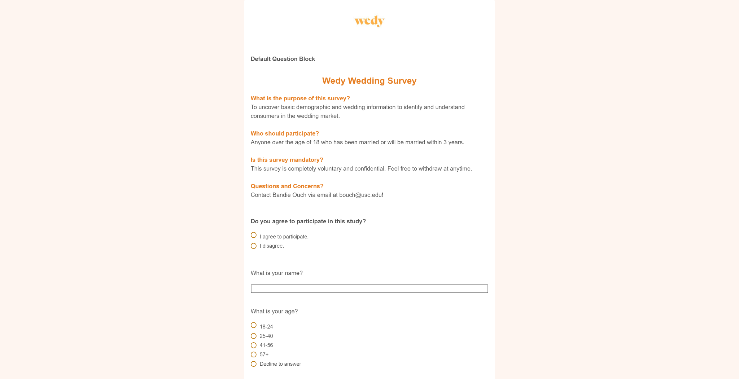**Appendix**

Item A

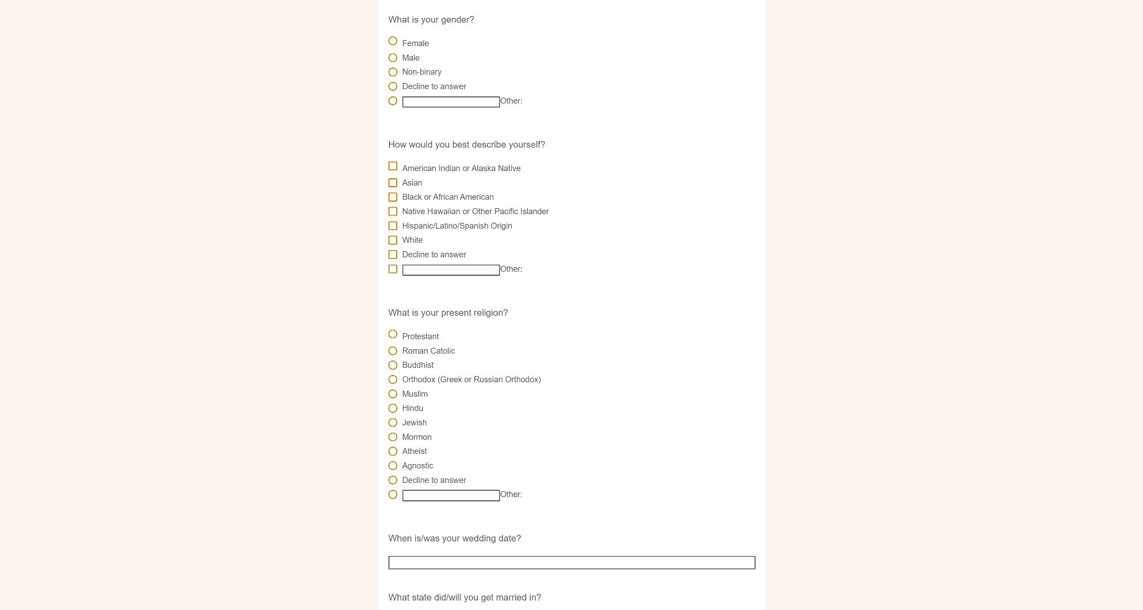

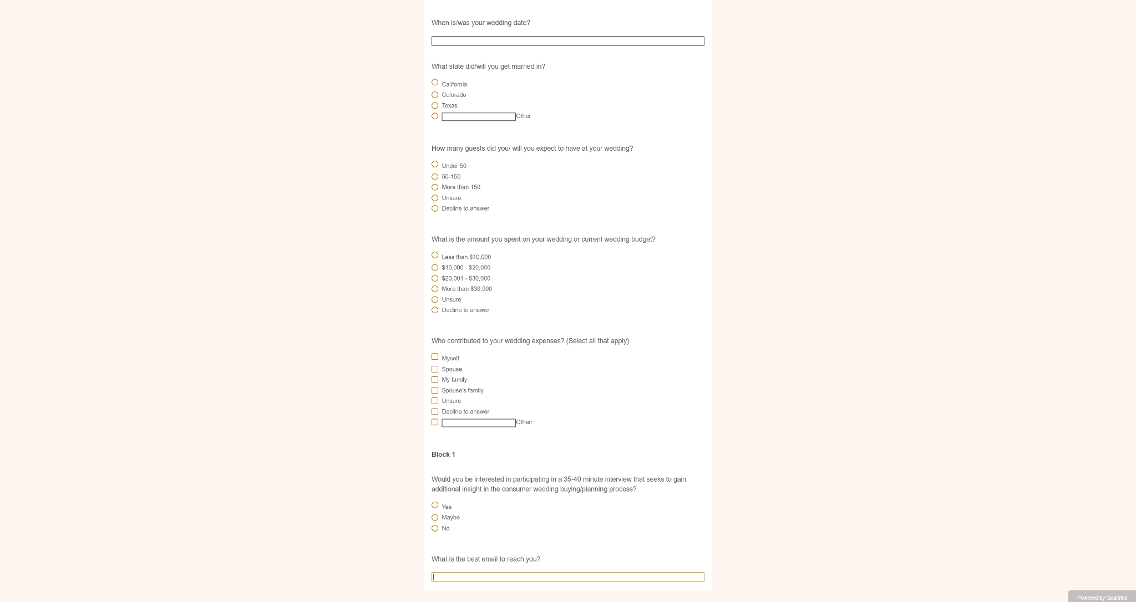

**Appendix**

Item B

**Qualitative Interview Moderation Guide**

**Tying the Knot: Understanding the Consumer Journey in a Digital Wedding Platform**

|  |  |
| --- | --- |
| **Introduction**  **(2 min)** | **Introduce Facilitator:**  Hello, my name is Bandie. I am a market research intern with Wedy and am also a graduate student at USC’s Masters of Applied Psychology program, studying organizational and consumer psychology. I appreciate your time and thank you so much for participating in my research today.  **Topic Overview:**  Today, we will be exploring the topic of weddings through a 35 minute interview. Particularly, I want to get to know you more and explore your thoughts, feelings, values and experiences as you planned or are going to plan your wedding. Through your participation today, we will uncover a full picture on how brides and grooms plan their weddings.  **Ground Rules:**   1. We will be recording our session. 2. The recordings and responses will only be referred to for research and educational purposes by myself, the Wedy team and my professor. 3. There are no “right” answers. Feel free to share anything you find relevant. 4. If you feel uncomfortable or would not like to share something specific, feel free to let me know you would like to skip the question. You are obligated to end the interview at any given time.   Do you have any questions?  *\*Answer any\**  So with that, let’s go ahead and dive into some background questions. |
| **Topic 1**  **(10 min)** | **General Wedding Attributes & Values**  Now that I have a good idea of your background. Let's talk more about the specifics of your wedding. The goal of these next round of questions is to understand the decisions you made in your wedding and the reasons why. So let’s begin!   1. Tell me about your (ideal) wedding? 2. What components of your wedding are most important to you?    1. Attributes?    2. Functional/Psychological Consequences?    3. Values? 3. On a scale of 1-10:    1. How happy or satisfied were you with how your wedding turned out?    2. How organized did you feel while planning for your wedding?    3. How much did money play a role in the decisions you made in your wedding? 4. If you could have changed anything about your wedding what would it be?    1. Why? 5. Was eloping ever considered as an option?    1. Why? |
| **Topic 2**  **(10 min)** | **Consumer Buying Journey**  Thank you for answering those questions. Let's move on and talk more about the vendors at your wedding and the journey you took to find, engage and hire them. Imagine you just got engaged and are looking to hire vendors for your wedding (like photographers, venue, etc.).  **Pre Purchase**   1. How did you learn about what vendors are necessary or nice to have in a wedding?    1. *\*Allow interviewee to list, then probe for additional ways\**    2. *Possible methods: Friends, Social Media, Personal Experiences* 2. While considering between vendors, did you read any reviews or check ratings for them?    1. *Were these ratings on a certain platform?*    2. *On a scale of 1-10, how helpful were these reviews in helping you decide to hire?* 3. While considering between vendors, did you check out examples of their work or have a trial of their work?    1. *On a scale of 1-10, how helpful were these work examples in helping you decide to hire?* 4. What information or details would you look for about a vendor in order to trust that they would do a good job?   **Purchase**   1. How many vendors did you turn out to have(or project to have) at your wedding? 2. What vendors were they?    1. *\*Allow interviewee to list, probe for additional\**    2. *Possible Vendors: Photographer, Videographer, Flowers, Venue, Hair, Makeup, Clothes, Officiant, DJ, Chef, Catering, Mixologist, Baker, Gifts, Wedding Planner* 3. For the vendors you listed, how did you gain price quotas for their services?    1. On a scale of 1-10, how hard or easy was it to communicate with a vendor upon initial interest in hiring them?    2. If you were to give advice to yourself about hiring vendors for your wedding, what would it be?   **Post Purchase**   1. After you hired your vendor(s), did you engage with them after your wedding?    1. How? 2. Did you post any form of review or rating on your experiences working with them for any of your vendors?    1. Who? Where? 3. Did you personally recommend any of your vendors to any friends or family?    1. Why? |
| **Topic 3**  **(10 min)** | **Wedding Apps & Platforms**   1. Did you use any form of technology while planning for your wedding?    1. What were they?    2. How did you discover them? 2. What features did you like or dislike about those apps or technology? 3. On a scale of 1-10 how helpful was each feature overall?    1. *Go through each feature named by participant* 4. **If vendor not mentioned**:    1. If an app existed that can help you find wedding vendors, Would you consider using this app?       1. On a scale of 1-10 how helpful would an app like this be for your wedding planning process?    2. What would it take for you to trust a new app that would provide this feature to help you find vendors? |
| **Closing**  **(3 min)** | **Concluding Thoughts:**  With that, we have concluded all of our questions for our interview.  Do you have any additional concluding thoughts you would like to share?  Awesome! Thank you so much for your participation with Wedy’s Market Research. I appreciate your time and willingness to share your experiences with how you planned your special day. |