ABOUT GIT

Git Definition
When you check for the definition of Git online, the best you can go something along these lines:Gitis a distributed version control system (DVCS) for tracking changes to files. But what does that mean? Git is an open-source VCS, which is not file-based, unlike other systems. Rather, it stores information as snapshots. Being a VCS, helps coders revert to their previous code when they hit a roadblock in the newer version, without affecting the original source code. On the other hand, what makes it different from other VCS is the way it sees data, which is more like a series of snapshots. It basically clicks a picture of how all your files look at the moment and saves the changes made to them over time.
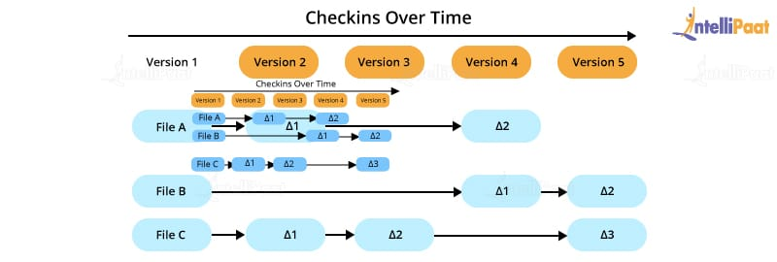
Before reading in detail about Git and its features, let’s briefly understand what VCS is.

What is Version Control System?
Version control systems or VCSs are a collection of various software tools that allow professionals to record the changes that have been made to the respective documents and files by tracking the modifications made to the program code. One of the main reasons why VCS is necessary is, often, software programs are developed by a group of developers who may be working from various parts of the globe. Since all of them make some contributions to the software code and keep making changes, it is important that the changes be communicated to other team members. This improves the management and efficiency while developing the software.

Types of Version Control Systems
Version control systems can largely be classified into the following three types:
- Local version control systems: Compared to the other types of version control systems, the local VCS is the simplest one that has a database consisting of the record of all the changes done to files while using revision control. Revision control systems (RCS) are among the most popular VCS tools that store patch sets on the disk. They can easily re-create the exact look of a file at any point in time by adding the patches.
- Centralized version control systems: They comprise a single repository, and all users get their own copies. Your changes will be reflected in the repository, i.e., when you commit, the team members can see the changes by updating. In simple terms, the other members can only see the changes you make if you commit, and they update. This VCS makes it easy for developers and programmers to collaborate and gain insights into what the rest of the team members are doing on a given project. Moreover, it enables administrators to know who can do which parts of the project.
- Distributed version control systems: These systems consist of several repositories, and all the users have their own repositories. The distributed version control systems require professionals to complete four steps to make their changes visible to other members of the team, unlike the centralized version control systems that required only two. Here, the other members will not be able to access your changes just by you committing your changes. When you commit, the changes will be reflected in your local repository only. Further, you must push the changes so that they can be visible in the central repository. Now, the other members cannot view the changes just by updating. First, they need to pull those changes into their respective repositories and then update. Git is the most common and popular distributed version control systems.
In this ‘What is Git?’ blog, let us discuss its features.

Features of Git
- Works on a distributed system: A distributed system is one that allows collaborators to access the central repository using a VCS, even from the remotest corner of the world. As Git maintains a snapshot every time a user pulls a file, the risk of data loss due to system failure or lack of Internet connection is mitigated. Users are allowed to work on the same bit of code simultaneously without getting interfered by others.
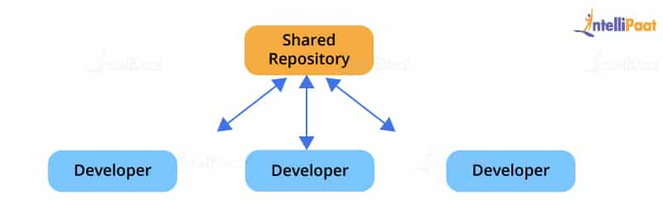
- Compatible with all operating systems: Git is compatible with almost all operating systems that are available today. Even the repositories created by other version control systems can be accessed by the Git repository.
- Allows for non-linear development: As users from remote parts of the world can access the Git repository, work on it, and update the project at any time they want, Git allows for development in a non-linear fashion. Git supports such a kind of development by providing its branching and merging features, and it uses specific tools for navigating through them. The projects are viewed in a tree form.
- Branches like a tree: While users are working on their projects, branches parallel to the main project file are created, so the original code is not affected. There is no restriction upon the number of branches created.
- Light as a cotton ball: One might think that making multiple copies of data from a central repository to a local one will eventually lead the system to crash due to overload. But, Git has got it covered. It compresses the data in such a way that it takes up minimal space, and whenever you need to retrieve data, the reverse technique is used. This helps save a lot of memory.
- Fast as a flash: Unlike other version control systems, Git is written in a language known to be the closest to the machine language, that is, C. Hence, it processes information much faster.
- Reliable: There will never be an issue of data loss as long as the copies of data in the central repositories are available in the local repositories of different collaborators.
You have learned in-depth about Git and its feature in this ‘What is Git?’ blog so far. Now, let’s gain insights into its architecture.

Git Architecture
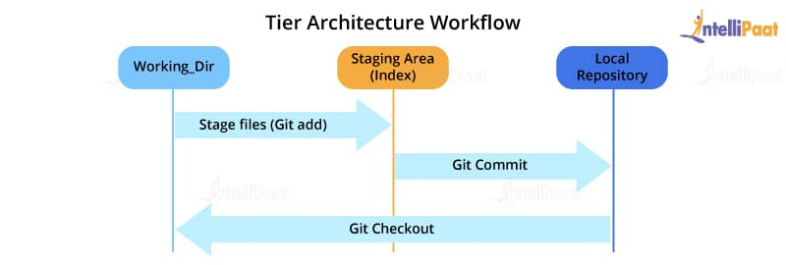
Most of the version control systems have a two-tier architecture. However, Git has a layer more, making it a three-tier architecture. But, why are there three layers of Git? Let’s find out.
The three layers are:
- Working directory: This is created when a Git project is initialized onto your local machine and allows you to edit the source code copied.
- Staging area: Post the edits, the code is staged in the staging area by applying the command, git add. This displays a preview for the next stage. In case further modifications are made in the working directory, the snapshots for these two layers will be different. However, these can be synced by using the same ‘git add’ command.
- Local repository: If no further edits are required to be done, then you can go ahead and apply the git commit command. This replicates the latest snapshots in all three stages, making them in sync with each other.
After reading about the architecture and getting a better knowledge of Git, this ‘What is Git?’ blog will help you understand how you can make use of Git.

How to use Git?
Much of Git’s popularity is attributed to its user-friendly nature. You can check out these simple concepts to perform certain basic operations and get acquainted withGit basics.
- Commit: This is an object that takes the current state of the repository.
- Pull: This operation copies the changes made to a project to the local repository from the remote one.
- Push: This operation copies the changes made to a project to the remote repository from the local one.
Now, let’s take a look at some of the basic and commonly used commands in Git.
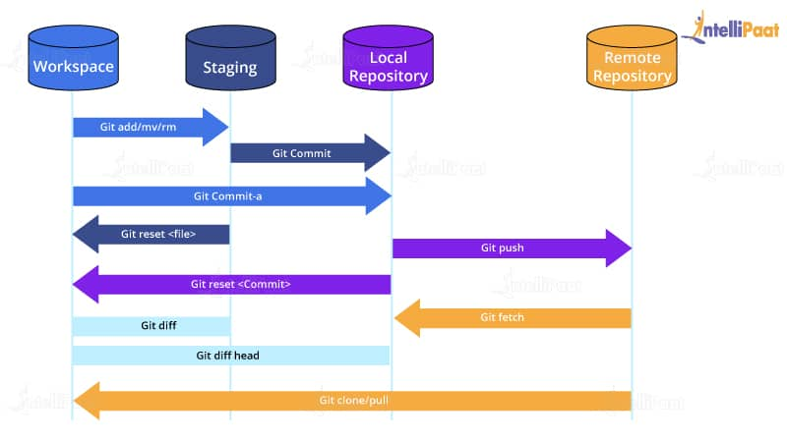
Now, let’s take a look at some of the basic and commonly used commands in Git.
Learn about the important terminologies in our blog on Git Cheat Sheet!

Git Commands
Based on what you work with, be it remote or local repositories, the Git commands change. Let’s take a look at the various commands in Git.

Git Commands When Working with Local Repositories
- git init: This Git command converts a directory into an empty repository. This is the initial step you need to take to build a repository. Once you run git init, you will be able to add and commit files and directories.
- git add: This command allows you to add files in the Git staging area. The file must be added to the index of Git before being available to commit to any particular repository. You can use this command to add directories, files, etc.
- git commit: The commit command in Git allows you to track the changes in the files in a local repository. Each commit has its own unique ID for reference.
- git status: The git status command returns the present state of a repository, like if the file is in the staging area but has not been committed.
- git config: There are numerous configurations and settings possible in Git, and this command allows you to assign these settings. User.name and user.email are the two significant settings that set the name and email address of a user.
- git branch: This command determines the branch of the local repository and allows you to add or delete a branch.
- git checkout: You can use this command to switch to another branch.
- git merge: The merge command allows you to integrate two or more branches together. It combines the changes made in the branches.

Git Commands When Working with Remote Repositories
- git remote: This Git command allows you to connect a remote repository to a local repository.
- git clone: You can use the clone command to create a local copy of an already existing remote repository. This allows you to copy and download the required repository to the system. It is similar to the init command while working with remote repositories as it allows you to build a local directory, consisting of all the necessary files and history of the repository.
- git pull: The pull command is used to run the latest version of any repository. This pulls all the changes made from the remote to the local repository.
- git push: This command sends local commits to the respective remote repository. It needs two parameters, i.e., the remote repository and the specific branch where it needs to be pushed.
There are numerous other Git commands that are of more advanced level, such as git stash, git log, git rm, etc.
Now, you will learn about the use of Git in DevOps.

Role of Git in DevOps
Git plays a vital role in DevOps. DevOps is responsible for the development and operation processes of software. It allows non-linear workflows in a distributed manner by providing data assurance to create quality software. This tool offers a space for developers to work. All the users are notified when any of the developers make changes in the file.
Git allows developers to collaborate and makes it easy for them to visualize the work, saving a lot of time and effort. Further, Git helps in code management that can be pushed to the shared repository, making the code ready to be integrated, tested, and deployed. It eases the communications between the development department and the operations department, making it the best suitable tool in DevOps.
Learn about the version control system and its hosting services in our Git and Github training!
Like all things, Git has its own set of advantages and disadvantages. In this extensive blog on ‘What is Git?’, let’s discuss them.

Advantages of Git
There are numerous advantages of Git, some of which are listed further in this ‘What is Git?’ blog.

Performance
Git is much stronger and reliable than other VCSs. Professionals can easily commit changes, compare version branches, and merge them. Besides, it allows for the better optimization of code for improved performance. The algorithms that are used to develop Git take complete advantage of the stored knowledge of attributes that help in developing source code files, types of file access patterns that help in recalling code files whenever required, and so on.

Security
Git is mainly built to secure the source code and maintain its integrity. All the data in the file, the relationship between the directories and files, commits, tags, versions, etc. are guarded through cryptographic algorithms like SHA-1. This algorithm secures the code and changes history from accidental and malicious attacks. Git ensures that the files, data, and the change history of the source code are secure.

Flexibility
Git is designed to be flexible, which allows it to support various types of non-linear workflows. It is also one of the most efficient tools in terms of dealing with small-scale and large-scale protocols and projects. Besides, its unique design makes it possible to support branching and tagging various business operations, storing all the user activities as an important part of the change history. Git is one of the very few VCSs that have this feature.

Wide Acceptance
Most developers need the security, performance, flexibility, and functionality that Git offers to build their projects. It is the most widely accepted VCS comparatively, and it provides universally accepted performance standards and usability.
Preparing for jobs? Check out the most important Git interview questions!

Disadvantages of Git
Even though Git seems like the perfect solution for various problems related to the software development life cycle (SDLC), it has its shortcomings.
- Its steep learning curve itself is a disadvantage, which is due to the non-intuitive nature of its commands. You need a much deeper understanding of the internals of Git to avoid inconsistencies while executing.
- Binary files are not Git’s forte. Whenever files containing non-text content are updated or used frequently, Git gets dragged and slowed down.
- It does create a conducive environment for a large number of developers distributed over a large geographical area but, at the same time, creates a lot of conflict and confusion while merging codes. To solve this problem, developers can establish an open communication channel before merging their bits of changes with the project.
Git is being used by large companies to achieve their benchmark goals. As products are developed all around the world, it is increasingly becoming the platform of integration. The introduction toGithas contributed to the building of a large community by following the mantra of developing ecosystems for SDLC. With a long way ahead for more technological advancements, Git has definitely found its place at the top. Hopefully, this ‘What is Git?’ blog helped you understand the basics of Git and inspired you to start the coding journey with it.

