

SIMATS SCHOOL OF ENGINEERING
SAVEETHA INSTITUTE OF MEDICAL AND TECHNICAL SCIENCES
CHENNAI-602105

Automated Network Security Testing Tools

A CAPSTONE PROJECT REPORT

Submitted in the partial fulfillment for the award of the degree of
BACHELOR OF ENGINEERING
IN
INFORMATION TECHNOLOGY

Submitted by
B. Santhi Swaroop (192211969)
N. Manoj Reddy (192210044)

Under the Supervision of
Dr. S.K.SARAVANAN

NOVEMBER 2024

DECLARATION

We, Santhi Swaroop. B, Manoj Reddy. N, students of Bachelor of Engineering in the Department of Computer Science and Engineering, Saveetha Institute of Medical and Technical Sciences, Saveetha University, Chennai, hereby declare that the work presented in this Capstone Project Work entitled Online Job Portal and Recruitment Management System is the outcome of our own Bonafide work and is correct to the best of our knowledge and this work has been undertaken taking care of Engineering Ethics.

(Santhi Swaroop. B 192211969)
(Manoj Reddy. N 192210044)

Date:
Place:

CERTIFICATE

This is to certify that the project entitled “Online Job Portal and Recruitment Management System” submitted by Santhi Swaroop. B, Manoj Reddy. N has been carried out under my supervision. The project has been submitted as per the requirements in the current semester of B. Tech Information Technology.

Teacher-in-charge
Dr. S.K.Saravanan

Table of Contents

S.NO | TOPICS
1 | Abstract
2 | Introduction
3 | Project Description  About your project
4 | Problem Description  Program to build a simple Software for < >
5 | Tool Description  User interface  Features
6 | Operations  User (Job Seeker) Operations:  Register  Login  Search Vacancy  Filter by Location and Category  Apply for Vacancy  Logout  Director Operations:  Register  Login  View Applied application  Accept or Reject application  Logout
7 | Approach / Module Description / Functionalities  The idea is to form an individual functions for every operation. All the functions are unified together to form software.
8 | Implementation  Coding
9 | Output  Output with Screenshots
10 | Conclusion  Future Enhancement  References

Abstract:
The Online Job Portal and Recruitment Management System is a dynamic web-based platform designed to bridge the gap between job seekers and employers, simplifying the recruitment process. Job seekers, or Users, can register, browse job vacancies, apply for positions, and filter job listings based on location, category, and other preferences. Users can also save jobs for future reference and set privacy levels for their profiles to control who can view their information.
Directors, representing employers, can post job vacancies with detailed information such as descriptions, contact details, and images. They can also view the applicants who have applied for their vacancies and evaluate their suitability. Directors can manage their posted vacancies and select the most qualified candidates.
Admins oversee the entire platform, ensuring smooth operation by approving directors, managing users, and generating detailed reports on system activities, job applications, and user interactions. Admins are responsible for maintaining the integrity and functionality of the portal.
With features like real-time notifications, daily updates, and seamless application processes, this system offers an efficient and user-friendly experience for job seekers, employers, and administrators alike, reducing time, cost, and effort in the job recruitment process.

Introduction:
The Online Job Portal and Recruitment Management System is a modern, web-based platform developed to simplify the job recruitment process for both job seekers and employers. In today’s fast-paced digital world, traditional hiring methods can be inefficient and time-consuming. This system aims to eliminate those challenges by providing a centralized, user-friendly platform that facilitates seamless interaction between job seekers and employers.

The system is designed with two primary roles: Director (Employer) and User (Job Seeker), each with distinct functionalities and responsibilities:

1. Director (Employer): Employers or directors can register on the platform, post job vacancies, and manage applicants. Directors can provide detailed descriptions for job openings, including images, contact details, and required qualifications. They can also view applications submitted by job seekers, evaluate candidates, and select the most suitable individuals for the job roles.

2. User (Job Seeker): Job seekers can register on the platform to search and apply for jobs. The system allows users to filter job listings by criteria such as location, job category, and more. Users can save job listings of interest, apply for jobs directly, and set privacy levels for their profiles, ensuring control over who views their information.

The platform offers advanced features like real-time notifications, daily updates, and comprehensive job search functionality, ensuring a smooth user experience. Job seekers can filter jobs based on their preferences, save jobs for later, and receive timely updates on their application status. Privacy settings enable users to protect their personal data by controlling who can view their resumes and profiles.

The Online Job Portal and Recruitment Management System enhances the recruitment process by offering a faster, more efficient, and cost-effective way for job seekers and employers to connect. By digitalizing the application process, the system eliminates manual procedures, making it easier for job seekers to apply and for employers to find suitable candidates quickly. This centralized system increases productivity, reduces administrative overhead, and promotes a more transparent and accessible job market.

In essence, the system aims to improve the efficiency of the hiring process, providing a seamless interface for both job seekers and employers. It supports the evolving demands of the job market, facilitating quicker and more effective job matching.

Problem Description:

The objective of this program is to build a simple software system for an Online Job Portal and Recruitment Management System. This software will allow job seekers to search, apply, and manage their job applications, while employers (directors) can post job vacancies, review applicants, and select suitable candidates. The system aims to reduce the time, effort, and cost involved in the traditional hiring process by automating key tasks and providing a centralized platform for both job seekers and employers.

Features for Job Seekers (Users):
1. Registration and Login:
- Job seekers can create an account by providing personal information and a resume.
- After registration, users can log in to the platform to access job listings and apply for jobs.

2. Search and Filter Jobs:
- Users can search for job vacancies using various criteria such as job title, company name, location, and category.
- Users can filter jobs based on their preferences, such as location or job category.

3. Apply for Jobs:
- Once a user finds a suitable job listing, they can apply directly through the platform by submitting their resume and relevant details.

4. Privacy Settings:
- Job seekers can set privacy levels for their profiles, deciding who can view their resumes and other personal information.

Features for Employers (Directors):
1. Registration and Login:
- Employers can create an account to post job vacancies and manage applicants.
- After registration, directors can log in to post new vacancies, view applicants, and track their job openings.

2. View Applied Users:
- Directors can view the list of job seekers who have applied for their vacancies, along with their resumes and profiles.

3. Select Candidates:
- Employers can review applications, shortlist candidates, and make decisions regarding job offers.

Challenges to Address:
- User Experience: Ensuring that both job seekers and employers can easily navigate the system and access the functionalities they need.
- Data Security and Privacy: Ensuring that user data, including resumes and personal details, is securely stored and accessible only to authorized users.
- Efficiency: Making the job application and recruitment process as efficient as possible by reducing manual work and automating repetitive tasks.

This system will ultimately simplify the process of job searching and recruitment, benefiting both job seekers and employers by providing a seamless, efficient, and secure platform for job applications and hiring.

Tool Description:
The Online Job Portal and Recruitment Management System is a web-based software solution developed to facilitate job seekers and employers (directors) in the job application and recruitment process. The system provides a streamlined, user-friendly interface that enhances the experience for all users involved by simplifying the management of job vacancies, applications, and user data.
This system is designed using technologies such as HTML, CSS, JavaScript for the frontend, and PHP/MySQL for backend functionalities, allowing for smooth interaction and communication between job seekers and employers.

User Interface:
The User Interface (UI) is designed to be intuitive and accessible, ensuring users can easily navigate the system. The UI is structured around three primary user roles: Job Seekers (Users), Employers (Directors), and Administrators.
1. Job Seeker (User) Interface:
- Registration/Login Page: Users can register by entering their personal details (name, contact info, resume upload) and can log in to access their profile.
- Dashboard: Once logged in, users are presented with a dashboard displaying job search features, saved jobs, applied jobs, and recent notifications.
- Job Listings: A list of available job vacancies, showing job titles, company names, and basic job details. Users can click on each listing for more detailed information.
- Apply for Jobs: Users can apply for jobs directly from the listings by submitting their resumes and required information.
2. Employer (Director) Interface:
- Registration/Login Page: Employers can register their organization and job postings, then log in to manage vacancies and applicants.
- Dashboard: After logging in, directors access a dashboard where they can view active job postings, pending applications, and recent notifications.
- View Applications: Directors can view applications for each job posting, including a list of job seekers who have applied, their resumes, and cover letters.
- Shortlist Candidates: Directors can mark candidates as shortlisted, schedule interviews, or send rejection notifications.

Features:
For Job Seekers (Users):
- User Registration and Profile Management: Job seekers can create an account, upload resumes, and set their privacy preferences.
- Job Search with Filters: Users can search and filter job listings based on location, job category, experience, and other criteria.
- Job Application: Users can apply to jobs directly through the portal, submitting resumes and cover letters for specific vacancies.
- Saved Jobs: Users can save jobs they are interested in to apply later or for future reference.
- Privacy Settings: Users can control who can view their profile and resume, ensuring their information is shared only with selected employers.
For Employers (Directors):
- Employer Registration and Profile Management: Directors can register their organization and create their profile for posting jobs.
- Job Posting: Directors can post job vacancies, including descriptions, required skills, contact details, and other necessary information.
- View and Manage Applications: Employers can view applications for their posted jobs, review resumes, and shortlist candidates.
- Candidate Communication: Directors can communicate directly with job seekers via the platform, scheduling interviews or sending rejection notifications.
- Notifications: Directors are notified of new job applications, shortlisting status, and candidate updates.
- Dashboard: A personalized dashboard displaying posted vacancies, applicant statuses, and notifications.
For Admins:
- User Management: Admins can approve/reject director registrations and manage job seeker profiles.
- System Monitoring: Admins can track system activity, view reports, and analyze data related to job postings, applications, and platform usage.
- Data Security: Admins ensure that all data entered by users is securely stored and accessible only by authorized users.
- Reporting and Analytics: Admins can generate reports on user activity, job postings, and recruitment metrics.
- Notifications: Admins receive notifications about system activity, user registrations, and any issues or updates within the platform.
Operations:
User (Job Seeker) Operations:
- Register:
  - Job seekers (users) can create an account by providing their personal details, uploading a resume, and setting up a profile.
  - Information required typically includes name, email, phone number, skills, experience, and resume.
- Login:
  - After registering, job seekers can log in using their credentials (email/username and password).
  - Once logged in, users can access the job search functionality and other profile-related features.
- Search Vacancy:
  - Job seekers can search for available job vacancies based on various criteria such as job title, company, or job description keywords.
  - A search bar or advanced search options will help users narrow down job listings according to their preferences.
- Filter by Location and Category:
  - Users can filter job listings by location (e.g., city, region) and job category (e.g., IT, marketing, engineering).
  - Additional filters such as experience level or salary range can be applied to find relevant job postings.
- Apply for Vacancy:
  - Once a job seeker finds a job that interests them, they can apply by submitting their resume, cover letter, and any required information.
  - The application is then sent directly to the employer (director) for review.
- Logout:
  - Users can log out of the system when finished to ensure the security and privacy of their profile and information.

Director (Employer) Operations:
- Register:
  - Directors (employers) can register by providing details about their company or organization, including name, contact information, and company profile.
  - They may also need to provide verification details to confirm their employer status before being granted access to post job vacancies.
- Login:
  - After registration, directors can log in using their credentials (email/username and password).
  - Once logged in, directors can post new vacancies, view applications, and manage other recruitment tasks.
- View Applied Applications:
  - Directors can view the applications submitted by job seekers for the vacancies they posted.
  - Applications are displayed with the applicant’s profile, resume, cover letter, and any other submitted details.
- Accept or Reject Applications:
  - Directors can evaluate the applications and choose to either accept or reject job seekers for the positions.
  - They can send interview invitations to shortlisted candidates or send rejection notifications to those not selected.
- Logout:
  - Directors can log out of the system when they are finished managing their job postings and applications, ensuring security and confidentiality.

Approach / Module Description / Functionalities:
The Online Job Portal and Recruitment Management System is designed using a modular approach where each operation or feature is implemented as an individual function. These functions are then integrated into the system to create a cohesive software solution. Each module is focused on a specific task or set of tasks to ensure that the system is clean, organized, and scalable.
1. User (Job Seeker) Module:
- Register (User Registration):
  - Function: Manages the registration of job seekers, collecting necessary details like name, email, phone number, resume, and profile picture.
  - Process: The user enters their details, which are validated and stored in the database.
- Login (User Authentication):
  - Function: Authenticates job seekers based on their credentials (email/username and password).
  - Process: The system checks the user’s credentials and grants access to the job seeker’s dashboard if authenticated successfully.
- Search Vacancy (Job Search Functionality):
  - Function: Allows job seekers to search for job listings based on keywords, job titles, or company names.
  - Process: Users enter search terms, and the system queries the database to retrieve relevant job listings.
- Filter by Location and Category (Filtering Job Listings):
  - Function: Enables users to filter job listings by location, job category, and other parameters.
  - Process: Users apply filters, and the system displays job postings that match the selected criteria.
- Apply for Vacancy (Job Application):
  - Function: Allows job seekers to apply for job vacancies by submitting their resume and other required details.
  - Process: The system sends the application, along with the user's details, to the respective employer.
- Logout (Session Termination):
  - Function: Logs out the user and terminates their session.
  - Process: The session is destroyed, and the user is redirected to the login page.

2. Director (Employer) Module:
- Register (Employer Registration):
  - Function: Manages the registration of employers (directors), including their company details and job posting privileges.
  - Process: The employer enters their company details, and once verified, they are allowed to post job vacancies.
- Login (Employer Authentication):
  - Function: Authenticates employers using their credentials (email/username and password).
  - Process: The system checks the credentials against the database and grants access to the director’s dashboard upon successful login.
- View Applied Applications (Manage Applicants):
  - Function: Allows directors to view a list of applicants who have applied for their job postings.
  - Process: The system displays the list of applicants, along with their resumes and cover letters.
- Accept or Reject Applications (Applicant Selection):
  - Function: Enables the director to review applicants and decide whether to accept or reject them.
  - Process: The director evaluates each applicant and sends notifications of acceptance or rejection.
- Logout (Session Termination):
  - Function: Logs the director out of the system.
  - Process: The session is terminated, and the director is redirected to the login page.

Implementation:
Applicant and Director Side:
Register.php:
<?php
include 'db.php';
$registration_success = false;
if (!$conn) {
die("Database connection failed: " . mysqli_connect_error());
}
if ($_SERVER['REQUEST_METHOD'] == 'POST') {
$username = $_POST['username'];
$password = password_hash($_POST['password'], PASSWORD_BCRYPT);
$role = $_POST['role'];
$stmt = $conn->prepare("INSERT INTO users (username, password, role) VALUES (?, ?, ?)");
if (!$stmt) {
die("Prepare failed: " . $conn->error);
}
$stmt->bind_param("sss", $username, $password, $role);
if ($stmt->execute()) {
$registration_success = true;
} else {
echo "<script>alert('Registration failed: " . $stmt->error . "');</script>";
}

$stmt->close();
}

$conn->close();
?>
<!DOCTYPE html>
<html lang="en">
<head>
<meta charset="UTF-8">
<meta name="viewport" content="width=device-width, initial-scale=1.0">
<title>Register</title>
<style>
/* Background styling */
body {
display: flex;
align-items: center;
justify-content: center;
min-height: 100vh;
margin: 0;
font-family: Arial, sans-serif;
background: url('https://i.ibb.co/cwm1Y3H/image.png') no-repeat center center fixed;
background-size: cover;
color: #fff;
}
.register-container {
display: flex;
align-items: center;
justify-content: center;
width: 100%;
height: 100%;
}
.register-box {
background: rgba(255, 255, 255, 0.1);
padding: 40px;
border-radius: 20px;
box-shadow: 0px 4px 15px rgba(0, 0, 0, 0.3);
backdrop-filter: blur(10px);
width: 350px;
text-align: center;
border: 1px solid rgba(255, 255, 255, 0.2);
transition: transform 0.3s ease, box-shadow 0.3s ease;
}
.register-box:hover {
transform: scale(1.05);
box-shadow: 0px 8px 20px rgba(255, 153, 51, 0.6);
}
.register-box h1 {
font-size: 26px;
font-weight: bold;
margin-bottom: 20px;
color: #ffffff;
}
.register-box .password-container {
position: relative;
width: 100%;
}
.register-box input[type="text"],
.register-box input[type="password"],
.register-box select {
width: 100%;
padding: 10px;
margin: 10px 0;
border: 2px solid transparent;
border-radius: 10px;
background: rgba(255, 255, 255, 0.2);
color: #ffffff;
transition: all 0.3s ease;
}
.register-box input[type="text"]:focus,
.register-box input[type="password"]:focus {
outline: none;
box-shadow: 0 0 10px 2px rgba(255, 153, 51, 0.7), 0 0 20px rgba(255, 153, 51, 0.5);
}
.register-box button {
width: 100%;
padding: 10px;
margin-top: 15px;
border: none;
border-radius: 10px;
background-color: #FF9800;
color: #ffffff;
font-weight: bold;
cursor: pointer;
transition: background-color 0.3s ease;
}
.register-box button:hover {
background-color: #e68a00;
}
.login-link {
display: block;
margin-top: 20px;
color: #ffffff;
text-decoration: none;
opacity: 0.8;
transition: opacity 0.3s ease;
}
.login-link:hover {
opacity: 1;
}
/* Success message styling */
.success-message {
position: fixed;
top: 20px;
right: 20px;
background-color: #4CAF50;
color: #fff;
padding: 15px 25px;
border-radius: 8px;
box-shadow: 0px 4px 10px rgba(0, 0, 0, 0.2);
font-weight: bold;
animation: fadeOut 5s forwards; /* Fades out after 5 seconds */
}
@keyframes fadeOut {
0% { opacity: 1; }
90% { opacity: 0.9; }
100% { opacity: 0; display: none; }
}
</style>
</head>
<body>
<?php if ($registration_success): ?>
<div class="success-message">User registered successfully!</div>
<?php endif; ?>
<div class="register-container">
<div class="register-box">
<h1>Register for Job Portal</h1>
<form action="" method="POST">
<input type="text" name="username" placeholder="Username" required>
<div class="password-container">
<input type="password" name="password" placeholder="Password" required id="password">
<span class="eye-icon" onclick="togglePassword()">👁️</span>
</div>
<select name="role" required>
<option value="applicant">Applicant</option>
<option value="director">Director</option>
</select>
<button type="submit">Register</button>
</form>
<a href="index.php" class="login-link">Already have an account? Login</a>
</div>
</div>
<script>
function togglePassword() {
const passwordField = document.getElementById("password");
const type = passwordField.type === "password" ? "text" : "password";
passwordField.type = type;
}
</script>
</body>
</html>

OUTPUT:

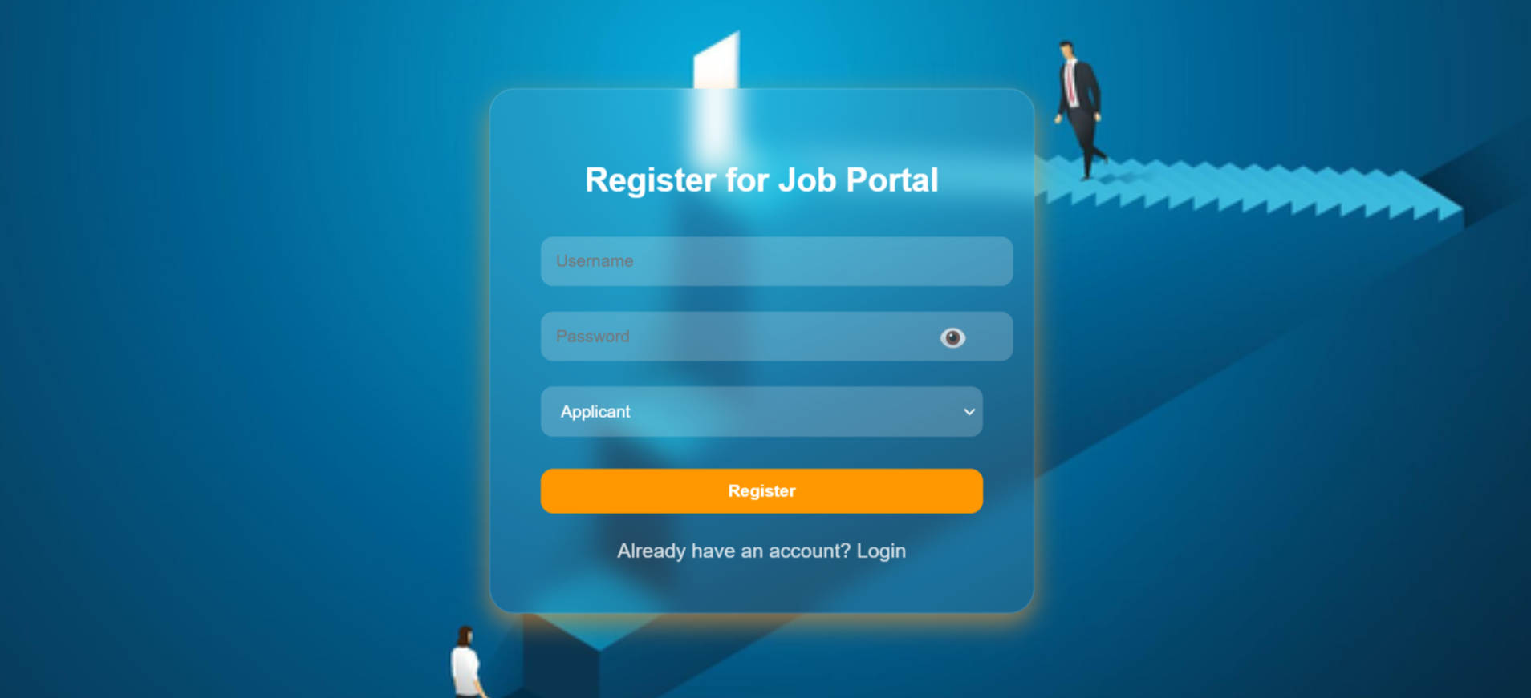

Login Page:
Index.php:
<?php
session_start();
include 'db.php';
if ($_SERVER['REQUEST_METHOD'] == 'POST') {
$username = $_POST['username'];
$password = $_POST['password'];
$stmt = $conn->prepare("SELECT * FROM users WHERE username=?");
$stmt->bind_param("s", $username);
$stmt->execute();
$result = $stmt->get_result();
$user = $result->fetch_assoc();
if ($user && password_verify($password, $user['password'])) {
$_SESSION['user_id'] = $user['id'];
$_SESSION['role'] = $user['role'];
if ($user['role'] === 'director') {
header('Location: director_dashboard.php');
} else {
header('Location: home.php');
}
} else {
echo "<p style='color: red; text-align: center;'>Invalid credentials</p>";
}
}
?>
<!DOCTYPE html>
<html lang="en">
<head>
<meta charset="UTF-8">
<meta name="viewport" content="width=device-width, initial-scale=1.0">
<title>Login</title>
<style>
/* Background styling */
body {
display: flex;
flex-direction: column;
align-items: center;
justify-content: center;
min-height: 100vh;
margin: 0;
font-family: Arial, sans-serif;
background: url('https://i.ibb.co/pJv6t4c/image.png') no-repeat center center fixed;
background-size: cover;
color: #fff;
}
/* Welcome Text */
.welcome-text {
font-size: 50px;
font-weight: bold;
color: #fff;
background: linear-gradient(45deg, #FF9800, #FF4081, #00E5FF, #76FF03);
background-clip: text;
-webkit-background-clip: text;
text-fill-color: transparent;
text-align: center;
animation: shine 1.5s ease-in-out infinite alternate;
text-shadow: 0 0 10px rgba(255, 255, 255, 0.8), 0 0 20px rgba(255, 255, 255, 0.6), 0 0 30px rgba(255, 255, 255, 0.4);
margin-top: 20px;
margin-bottom: 50px; /* Added space between welcome text and login box */
}
@keyframes shine {
0% {
text-shadow: 0 0 20px rgba(255, 255, 255, 0.6), 0 0 30px rgba(255, 255, 255, 0.5), 0 0 40px rgba(255, 255, 255, 0.3);
}
100% {
text-shadow: 0 0 20px rgba(255, 255, 255, 1), 0 0 40px rgba(255, 255, 255, 0.8), 0 0 60px rgba(255, 255, 255, 0.5);
}
}
/* Centered login box */
.login-container {
display: flex;
align-items: center;
justify-content: center;
width: 100%;
height: 100%;
}
.login-box {
background: rgba(255, 255, 255, 0.1);
padding: 30px;
border-radius: 20px;
box-shadow: 0px 4px 15px rgba(0, 0, 0, 0.3);
backdrop-filter: blur(10px);
width: 300px;
text-align: center;
border: 1px solid rgba(255, 255, 255, 0.2);
position: relative;
overflow: hidden;
transition: transform 0.3s ease, box-shadow 0.3s ease;
}
/* Pop effect on hover for login box */
.login-box:hover {
transform: scale(1.05);
box-shadow: 0px 8px 20px rgba(255, 153, 51, 0.6);
}
/* Title styling */
.login-box h1 {
font-size: 24px;
font-weight: bold;
margin-bottom: 20px;
color: #ffffff;
}
/* Input fields styling */
.login-box input[type="text"],
.login-box input[type="password"] {
width: 100%;
padding: 10px;
margin: 10px 0;
border: 2px solid transparent;
border-radius: 10px;
background: rgba(255, 255, 255, 0.2);
color: #ffffff;
position: relative;
z-index: 1;
overflow: hidden;
transition: transform 0.3s ease, box-shadow 0.3s ease;
}
/* Pop effect on hover/focus for input fields */
.login-box input[type="text"]:hover,
.login-box input[type="password"]:hover,
.login-box input[type="text"]:focus,
.login-box input[type="password"]:focus {
transform: scale(1.05);
box-shadow: 0 0 10px 2px rgba(255, 153, 51, 0.7), 0 0 20px rgba(255, 153, 51, 0.5);
}
/* Button styling */
.login-box button {
width: 100%;
padding: 10px;
margin-top: 15px;
border: none;
border-radius: 10px;
background-color: #FF9800;
color: #ffffff;
font-weight: bold;
cursor: pointer;
transition: background-color 0.3s ease;
}
.login-box button:hover {
background-color: #e68a00;
}
/* Register link styling */
.register-link {
display: block;
margin-top: 20px;
color: #ffffff;
text-decoration: none;
opacity: 0.8;
transition: opacity 0.3s ease;
}
.register-link:hover {
opacity: 1;
}
</style>
</head>
<body>
<div class="welcome-text">
Welcome to Job Portal
</div>
<div class="login-container">
<div class="login-box">
<h1>Login to Job Portal</h1>
<form action="" method="POST">
<input type="text" name="username" placeholder="Username" required>
<div style="position: relative;">
<input type="password" name="password" id="password" placeholder="Password" required>
<span class="eye-icon" id="eye-icon">&#128065;</span> <!-- Eye Icon -->
</div>
<button type="submit">Login</button>
</form>
<a href="register.php" class="register-link">Register</a>
</div>
</div>
<script>
// JavaScript to toggle password visibility
const eyeIcon = document.getElementById('eye-icon');
const passwordInput = document.getElementById('password');

// Initially, password is hidden with the closed eye icon
let isPasswordVisible = false;

eyeIcon.addEventListener('click', function() {
if (isPasswordVisible) {
passwordInput.type = 'password'; // Hide password
eyeIcon.innerHTML = '&#128065;'; // Show closed eye icon
isPasswordVisible = false;
} else {
passwordInput.type = 'text'; // Show password
eyeIcon.innerHTML = '&#128586;'; // Show open eye icon
isPasswordVisible = true;
}
});
</script>
<!-- Footer -->
<footer>
&copy; 2024 Job Portal. All rights reserved.
</footer>
</body>
</html>

OUTPUT:
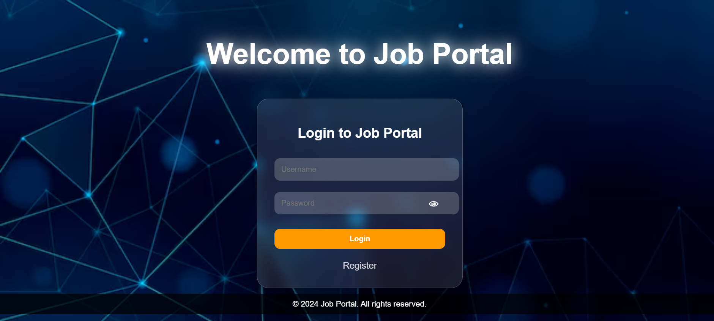

Home Page
home.php:
<?php
session_start();
include 'db.php';
?>
<!DOCTYPE html>
<html lang="en">
<head>
<meta charset="UTF-8">
<meta name="viewport" content="width=device-width, initial-scale=1.0">
<title>Job Portal - Home</title>
<style>
/* Reset default margin and padding */
* {margin: 0;
padding: 0;
box-sizing: border-box; }
body {font-family: Arial, sans-serif;
background: linear-gradient(135deg, #83a4d4, #b6fbff);
display: flex;
justify-content: center;
padding: 20px;
color: #333;
min-height: 100vh; }
.container {
display: flex;
width: 100%;
max-width: 1200px; }
/* Sidebar styling */
.sidebar {
width: 250px;
background-color: #ffffffcc;
padding: 20px;
border-radius: 8px;
margin-right: 20px;
box-shadow: 0 4px 8px rgba(0, 0, 0, 0.1);
transition: transform 0.3s ease; }
.sidebar:hover {
transform: translateY(-3px); }
.sidebar h2 {
font-size: 1.5em;
font-weight: bold;
color: #007bff;
margin-bottom: 20px; }
.sidebar label {
display: block;
margin-top: 15px;
font-weight: bold;
color: #555; }
.sidebar select,
.sidebar button {
width: 100%;
padding: 10px;
margin-top: 5px;
margin-bottom: 15px;
border: 1px solid #ddd;
border-radius: 5px;
box-sizing: border-box; }
.sidebar button {
background-color: #007bff;
color: white;
font-weight: bold;
border: none;
cursor: pointer;
transition: background-color 0.3s ease; }
.sidebar button:hover {
background-color: #0056b3; }
.sidebar a {
display: inline-block;
margin-top: 20px;
color: #007bff;
text-decoration: none;
font-weight: bold; }
.sidebar a:hover {
color: #0056b3; }
/* Main content area */
.content {
flex: 1; }
.content h2 {
font-size: 1.8em;
color: #333;
margin-bottom: 20px;
border-bottom: 2px solid #ddd;
padding-bottom: 10px; }
/* Job card grid */
.job-list {
display: flex;
flex-wrap: wrap;
gap: 20px; }
/* Job card styling */
.job-card {
width: calc(33% - 20px);
background-color: #ffffffcc;
border: 1px solid #ddd;
border-radius: 12px;
padding: 20px;
box-shadow: 0 4px 8px rgba(0, 0, 0, 0.15);
transition: transform 0.3s ease, box-shadow 0.3s ease;
text-align: center; }
.job-card:hover {
transform: translateY(-5px);
box-shadow: 0 6px 12px rgba(0, 0, 0, 0.2); }
/* Job card content */
.job-card img {
width: 120px;
height: 120px;
margin-bottom: 15px;
object-fit: contain;
border-radius: 50%;
border: 3px solid #007bff;
transition: transform 0.3s ease; }
.job-card img:hover {
transform: scale(1.05); }
.job-card h3 {
font-size: 1.3em;
margin-bottom: 10px;
color: #333; }
.job-card p {
margin: 5px 0;
color: #555; }
/* Apply button styling */
.apply-btn:hover {
background-color: #218838; }
.no-jobs img {
width: 180px;
margin-bottom: 20px;
border-radius: 50%;
border: 4px solid #ff6b6b; }}
.no-jobs p {
font-size: 1em;
color: #555; }
/* Job card styling */
.job-card {
width: calc(33% - 20px);
background-color: #ffffffcc;
border: 1px solid #ddd;
border-radius: 12px;
padding: 20px;
box-shadow: 0 4px 8px rgba(0, 0, 0, 0.15);
transition: transform 0.3s ease, box-shadow 0.3s ease, border 0.3s ease;
text-align: center;
position: relative;}
.job-card:hover {
transform: translateY(-5px);
box-shadow: 0 6px 12px rgba(0, 0, 0, 0.2);
border: 2px solid transparent;}
/* Glowing effect with a colorful gradient */
.job-card:hover::before {
content: "";
position: absolute;
top: 0;
left: 0;
right: 0;
bottom: 0;
border-radius: 12px;
box-shadow: 0 0 20px 8px rgba(255, 105, 180, 0.8), /* Pink */
0 0 25px 12px rgba(255, 165, 0, 0.7), /* Orange */
0 0 30px 16px rgba(34, 193, 195, 0.8); /* Aqua */
z-index: -1; /* Place behind the content */}
</style>
</head>
<body>
<div class="container">
<!-- Sidebar for filters -->
<div class="sidebar">
<h2>Filters</h2>
<form action="" method="GET">
<label for="location">Location</label>
<select name="location" id="location">
<option value="">Select Location</option>
<option value="Chennai">Chennai</option>
<option value="Bengaluru">Bengaluru</option>
<option value="Delhi">Delhi</option>
<option value="Mumbai">Mumbai</option>
<option value="Hyderabad">Hyderabad</option>
<option value="Pune">Pune</option>
<option value="Kolkata">Kolkata</option>
<option value="Ahmedabad">Ahmedabad</option>
<option value="Jaipur">Jaipur</option>
<option value="Lucknow">Lucknow</option>
<option value="Indore">Indore</option>
<option value="Coimbatore">Coimbatore</option>
<option value="Chandigarh">Chandigarh</option>
<option value="Bhopal">Bhopal</option>
</select>
<label for="category">Category</label>
<select name="category" id="category">
<option value="">Select Category</option>
<option value="Software Developer">Software Developer</option>
<option value="Data Scientist">Data Scientist</option>
<option value="Product Manager">Product Manager</option>
<option value="Graphic Designer">Graphic Designer</option>
<option value="Digital Marketing">Digital Marketing</option>
<option value="Human Resources">Human Resources</option>
<option value="Sales">Sales</option>
<option value="Operations Manager">Operations Manager</option>
<option value="Business Analyst">Business Analyst</option>
<option value="Project Manager">Project Manager</option>
<option value="Customer Support">Customer Support</option>
<option value="Content Writer">Content Writer</option>
<option value="Financial Analyst">Financial Analyst</option>
<option value="Network Engineer">Network Engineer</option>
<option value="Data Engineer">Data Engineer</option>
<option value="Data Analyst">Data Analyst</option>
<option value="Cybersecurity Analyst">Cybersecurity Analyst</option>
<option value="HR Manager">HR Manager</option>
<option value="IT Support">IT Support</option>
<option value="Cloud Architect">Cloud Architect</option>
<option value="Database Administrator">Database Administrator</option>
<option value="Embedded Systems Engineer">Embedded Systems Engineer</option>
<option value="Telecom Engineer">Telecom Engineer</option>
<option value="Mobile App Developer">Mobile App Developer</option>
<option value="Firmware Engineer">Firmware Engineer</option>
</select>
<button type="submit">Apply Filters</button>
</form>
<a href="logout.php">Logout</a>
</div>
<!-- Main content area for job listings -->
<div class="content">
<h2>Recommended Jobs</h2>
<div class="job-list">
<?php
// Filter job listings
$location = isset($_GET['location']) ? $_GET['location'] : '';
$category = isset($_GET['category']) ? $_GET['category'] : '';
$sql = "SELECT * FROM jobs WHERE 1=1";
$params = [];
$types = "";
if (!empty($location)) {
$sql .= " AND location = ?";
$params[] = $location;
$types .= "s";}
if (!empty($category)) {
$sql .= " AND category = ?";
$params[] = $category;
$types .= "s";}
$stmt = $conn->prepare($sql);
if (!empty($params)) {
$stmt->bind_param($types, ...$params); }
$stmt->execute();
$result = $stmt->get_result();
// Display job listings
if ($result->num_rows > 0) {
while ($row = $result->fetch_assoc()) {
echo "<div class='job-card'>";
if (!empty($row['logo'])) {
echo "<img src='images/" . htmlspecialchars($row['logo']) . "' alt='" . htmlspecialchars($row['company']) . " logo'>";}
echo "<h3>" . htmlspecialchars($row['company']) . "</h3>";
echo "<p><strong>Location:</strong> " . htmlspecialchars($row['location']) . "</p>";
echo "<p><strong>Category:</strong> " . htmlspecialchars($row['category']) . "</p>";
echo "<p><strong>Vacancies:</strong> " . htmlspecialchars($row['vacancies']) . "</p>";
echo "<p><strong>Requirements:</strong> " . htmlspecialchars($row['requirements']) . "</p>";
echo "<p><strong>Salary:</strong> " . htmlspecialchars($row['salary']) . " LPA</p>";
echo "<a href='apply.php?job_id=" . htmlspecialchars($row['id']) . "' class='apply-btn'>Apply</a>";
echo "</div>";
} else {
echo "<div class='no-jobs'>";
echo "<img src='https://i.ibb.co/rpPvQ4x/download.jpg' alt='No jobs available'>";
echo "<h3>No jobs found</h3>";
echo "<p>We're sorry, but no jobs were found that match your criteria.<br>Please try adjusting your filters or check back later.</p>";
echo "</div>";}
// Close connection
$stmt->close();
$conn->close();?>
</div>
</div>
</div>
</body>
</html>

OUTPUT:
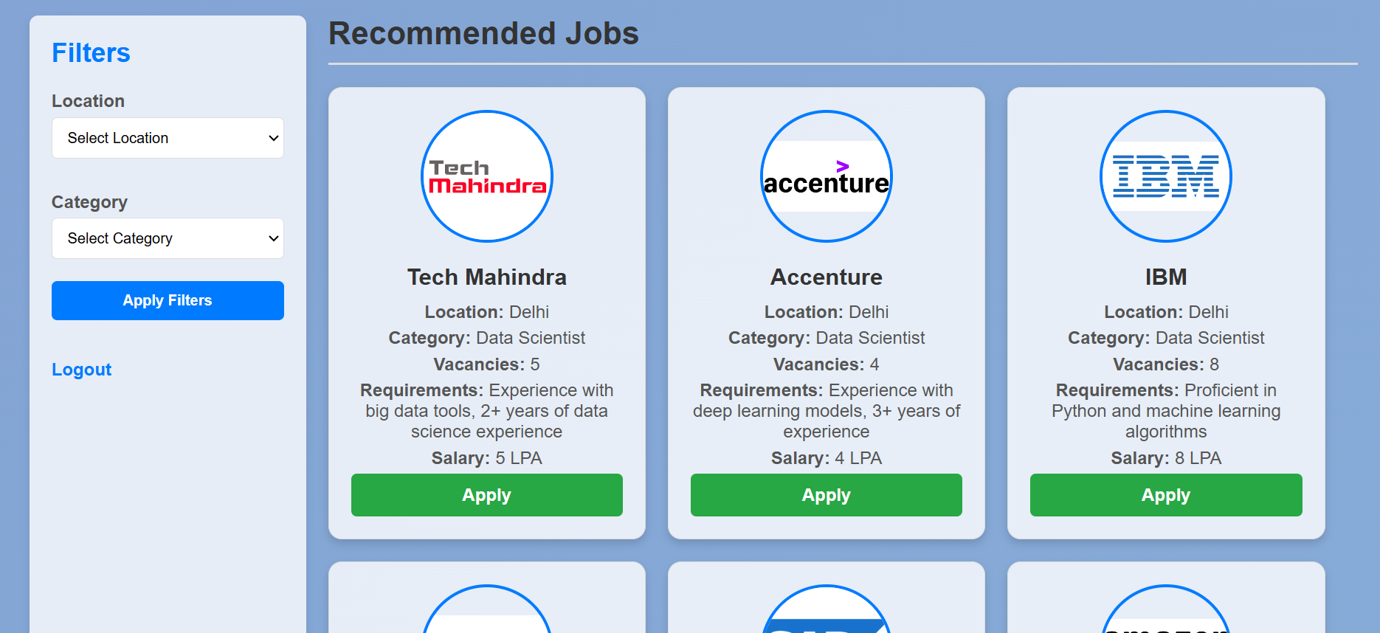

Job apply:
Apply.php:
<?php
session_start();
include 'db.php';
$success_message = '';
if ($_SERVER['REQUEST_METHOD'] == 'POST') {
$job_id = $_POST['job_id'];
$applicant_id = $_SESSION['user_id']; // Assumes user ID is stored in session
$name = $_POST['name'];
$email = $_POST['email'];
$phone = $_POST['phone'];
$resume_text = $_POST['resume'];
// Handling file upload
if (isset($_FILES['resume_file']) && $_FILES['resume_file']['error'] == 0) {
$resume_file = $_FILES['resume_file']['name'];
$target_dir = "uploads/";
$target_file = $target_dir . basename($resume_file);
move_uploaded_file($_FILES['resume_file']['tmp_name'], $target_file);
} else {$target_file = null;}
// Insert application data into database
$stmt = $conn->prepare("INSERT INTO applications (vacancy_id, applicant_id, name, email, phone, resume, resume_file) VALUES (?, ?, ?, ?, ?, ?, ?)");
$stmt->bind_param("iisssss", $job_id, $applicant_id, $name, $email, $phone, $resume_text, $target_file);
if ($stmt->execute()) {
$success_message = "Application submitted successfully!";
} else {
$success_message = "Error: " . $stmt->error;}}?>
<!DOCTYPE html>
<html lang="en">
<head>
<meta charset="UTF-8">
<meta name="viewport" content="width=device-width, initial-scale=1.0">
<title>Apply for Job</title>
<style>
/* Background styling for glass effect */
body {
display: flex;
flex-direction: column;
align-items: center;
justify-content: center;
min-height: 100vh;
font-family: Arial, sans-serif;
background-image: url('https://i.ibb.co/jW5Rq4m/image.png');
background-size: cover;
background-attachment: fixed;
margin: 0;
overflow: hidden;
animation: moveBackground 20s linear infinite; }
@keyframes moveBackground {
0% { background-position: 0% center; }
50% { background-position: 100% center; }
100% { background-position: 0% center; }
.home-button:hover {
background-color: rgba(0, 86, 179, 0.7); }
.application-form {
background: rgba(255, 255, 255, 0.2);
backdrop-filter: blur(10px);
border-radius: 15px;
padding: 30px;
box-shadow: 0 4px 15px rgba(0, 0, 0, 0.3);
width: 400px;
text-align: center;
color: #fff;
border: 1px solid rgba(255, 255, 255, 0.2); }
.application-form h2 {
margin-bottom: 20px;
color: #ffcc00;
text-shadow: 2px 2px 4px rgba(0, 0, 0, 0.3); }
.application-form input,
.application-form textarea,
.application-form button {
width: 100%;
padding: 12px;
margin: 10px 0;
border-radius: 8px;
border: 1px solid rgba(255, 255, 255, 0.3);
background: rgba(255, 255, 255, 0.5);
color: #333;
font-size: 16px; }
.application-form button {
background-color: rgba(40, 167, 69, 0.7);
color: #ffffff;
border: none;
cursor: pointer;
transition: background-color 0.3s ease; }
.application-form button:hover {
background-color: rgba(33, 136, 56, 0.7); }
.rocket-container {
display: none;
position: fixed;
bottom: 30px;
left: 50%;
transform: translateX(-50%);
z-index: 100; }
.rocket {
width: 50px;
height: 100px;
background-color: #FF5733;
clip-path: polygon(50% 0%, 100% 100%, 0% 100%);
position: relative;
animation: rocketFly 2s forwards; }
.rocket:before {
content: '';
position: absolute;
bottom: -15px;
left: 50%;
transform: translateX(-50%);
width: 10px;
height: 20px;
background-color: #333;
border-radius: 50%;}
@keyframes rocketFly {
0% { transform: translateY(0) rotate(0); opacity: 1; }
50% { transform: translateY(-250px) rotate(180deg); opacity: 1; }
100% { transform: translateY(-500px) rotate(360deg); opacity: 0; }}
</style>
</head>
<body>
<button class="home-button" onclick="window.location.href='home.php'">Home</button>
<div class="application-form">
<h2>Job Application Form</h2>
<?php if (isset($success_message) && $success_message): ?>
<div class="rocket-container" id="rocketContainer">
<div class="rocket" id="rocket"></div></div>
<div class="success-message" id="rocketMessage" style="display: none;">
<?php echo $success_message; ?></div><script>
// Show success message and rocket animation after form submission
document.addEventListener('DOMContentLoaded', function() {
setTimeout(function() {
document.getElementById('rocketMessage').style.display = 'block';
document.getElementById('rocketContainer').style.display = 'block';
setTimeout(function() {
document.getElementById('rocket').style.animation = 'rocketFly 2s forwards';}, 100); }, 500); });</script><?php endif; ?>
<form action="" method="POST" enctype="multipart/form-data">
<input type="hidden" name="job_id" value="<?php echo $_GET['job_id']; ?>">
<input type="text" name="name" placeholder="Full Name" required>
<input type="email" name="email" placeholder="Email Address" required>
<input type="tel" name="phone" placeholder="Phone Number" required>
<textarea name="resume" placeholder="Enter your resume details here" required></textarea>
<input type="file" name="resume_file" accept=".pdf,.doc,.docx" required>
<button type="submit">
<span class="rocket-button"></span> Submit Application</button></form>
</div>
</body>
</html>

OUTPUT:
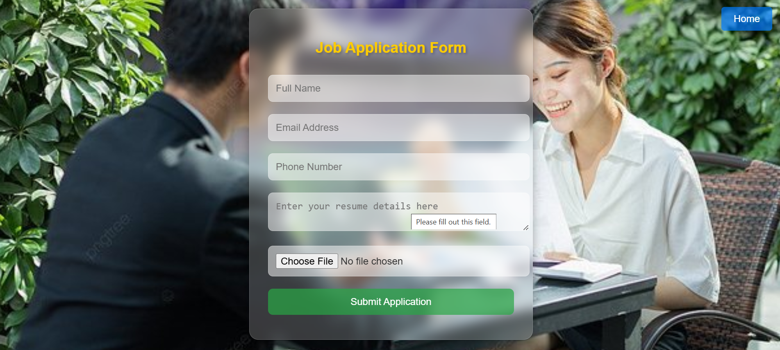
Director Side:
director_dashboard.php:
<?php
session_start();
include 'db.php';
// Fetch the selected status filter from the URL or set default as 'pending'
$statusFilter = isset($_GET['status']) ? $_GET['status'] : 'pending';
// SQL query to get applications based on the selected status
$sql = "SELECT * FROM applications WHERE status = ?";
$stmt = $conn->prepare($sql);
$stmt->bind_param("s", $statusFilter);
$stmt->execute();
$result = $stmt->get_result();
?>
<!DOCTYPE html>
<html lang="en">
<head>
<meta charset="UTF-8">
<meta name="viewport" content="width=device-width, initial-scale=1.0">
<title>Director Dashboard</title>
<style>
body {
font-family: Arial, sans-serif;
background: linear-gradient(135deg, #83a4d4, #b6fbff);
padding: 20px;
transition: background-color 0.3s ease; }
.container {
display: flex;
justify-content: space-between;
transition: transform 0.3s ease; }

.sidebar {
width: 250px;
background-color: #f4f4f4;
padding: 20px;
border-radius: 8px;
margin-right: 20px;
box-shadow: 0 4px 8px rgba(0, 0, 0, 0.1);
transition: box-shadow 0.3s ease, transform 0.3s ease; }
.sidebar:hover {
transform: scale(1.05);
box-shadow: 0 6px 15px rgba(0, 0, 0, 0.2); }
.content {
flex: 1;
transition: transform 0.3s ease; }
.job-card {
padding: 20px;
border: 1px solid #ddd;
margin-bottom: 20px;
border-radius: 8px;
background-color: #fff;
box-shadow: 0 2px 8px rgba(0, 0, 0, 0.1);
transition: transform 0.3s ease, box-shadow 0.3s ease;
position: relative;
display: flex;
flex-direction: column;
justify-content: space-between; }
.job-card:hover {
transform: scale(1.02);
box-shadow: 0 4px 12px rgba(0, 0, 0, 0.15); }
.job-card h3 {
margin-top: 0;
font-size: 18px;
font-weight: bold;
color: #333; }
.job-card p {
margin: 5px 0;
font-size: 14px;
color: #555; }
.job-card p strong {
color: #333; }
.status-btn {
color: white;
text-decoration: none;
padding: 8px 16px;
background-color: #2d9cdb;
border-radius: 5px;
margin-right: 10px;
text-align: center;
transition: background-color 0.3s ease, transform 0.2s ease; }
.status-btn:hover {
background-color: #1e7bbf;
transform: scale(1.05); }
.status-btn:active {
background-color: #1a5b87; }
.logout-btn {
display: inline-block;
background-color: #ff4d4d;
color: #fff;
text-decoration: none;
padding: 10px 20px;
margin-top: 20px;
border-radius: 5px;
text-align: center;
width: 100%;
box-sizing: border-box;
transition: background-color 0.3s ease, transform 0.2s ease; }
.logout-btn:hover {
background-color: #ff1a1a;
transform: scale(1.05); }
.logout-btn:focus {
outline: none;
box-shadow: 0 0 5px rgba(255, 77, 77, 0.8); }
.delete-checkbox {
margin-right: 10px;
transform: scale(1);
transition: transform 0.2s ease; }
.delete-checkbox:hover {
transform: scale(1.1); }
.select-all {
font-size: 16px;
margin-bottom: 10px;
cursor: pointer;
transition: transform 0.2s ease; }
.select-all:hover {
transform: scale(1.05); }
.delete-btn {
display: inline-block;
background-color: #e74c3c;
color: #fff;
padding: 10px 20px;
border: none;
border-radius: 5px;
cursor: pointer;
transition: background-color 0.3s ease, transform 0.2s ease;
margin-top: 10px; }
.delete-btn:hover {
background-color: #c0392b;
transform: scale(1.05); }
.delete-btn:focus {
outline: none;
box-shadow: 0 0 5px rgba(231, 76, 60, 0.8);}
.dropdown select {
background-color: #fff;
color: #333;
border: 2px solid #ddd;
border-radius: 5px;
padding: 10px;
font-size: 16px;
cursor: pointer;
width: 100%;
transition: background-color 0.3s ease, transform 0.2s ease; }

.dropdown select:hover {
background-color: #f0f0f0;
transform: scale(1.05);}
.dropdown select:focus {
outline: none;
box-shadow: 0 0 5px rgba(0, 128, 0, 0.8);
transform: scale(1.05);}
</style>
<script>
// JavaScript function to select or deselect all checkboxes
function toggleSelectAll(source) {
checkboxes = document.querySelectorAll('.delete-checkbox');
for (var i = 0; i < checkboxes.length; i++) {
checkboxes[i].checked = source.checked;}}
</script>
</head>
<body>
<div class="container">
<!-- Sidebar for filters -->
<div class="sidebar">
<h2>Filters</h2>
<form action="" method="GET">
<label for="status">Application Status:</label>
<div class="dropdown">
<select name="status" id="status" onchange="this.form.submit()">
<option value="pending" <?php if ($statusFilter == 'pending') echo 'selected'; ?>>Pending</option>
<option value="accepted" <?php if ($statusFilter == 'accepted') echo 'selected'; ?>>Accepted</option>
<option value="rejected" <?php if ($statusFilter == 'rejected') echo 'selected'; ?>>Rejected</option>
</select>
</div>
</form>
<a href="logout.php" class="logout-btn">Logout</a>
</div>
<!-- Main content area for job listings -->
<div class="content">
<h2>Applications (Status: <?php echo ucfirst($statusFilter); ?>)</h2>
<!-- Form to submit selected applications for deletion -->
<form action="delete_applications.php" method="POST">
<label class="select-all">
<input type="checkbox" onclick="toggleSelectAll(this)"> Select All
</label>
<div class="job-list">
<?php
if ($result->num_rows > 0) {
while ($application = $result->fetch_assoc()) {
echo "<div class='job-card'>";
echo "<input type='checkbox' name='application_ids[]' value='{$application['id']}' class='delete-checkbox'>";
echo "<h3>Application ID: {$application['id']}</h3>";
echo "<p><strong>Name:</strong> {$application['name']}</p>";
echo "<p><strong>Email:</strong> {$application['email']}</p>";
echo "<p><strong>Phone:</strong> {$application['phone']}</p>";
echo "<p><strong>Resume Text:</strong> {$application['resume']}</p>";
// Display resume file if available
if (!empty($application['resume_file'])) {
echo "<p><a href='{$application['resume_file']}' target='_blank'>Download Resume</a></p>"; }
// Accept and Reject buttons
echo "<a href='process_application.php?id={$application['id']}&status=accepted' class='status-btn'>Accept</a>";
echo "<a href='process_application.php?id={$application['id']}&status=rejected' class='status-btn'>Reject</a>";
echo "</div>";}
} else {
echo "<p>No applications found.</p>";}
?>
</div>
<input type="submit" name="delete_selected" value="Delete Selected" class="delete-btn">
</form>
</div>
</div>
</body>
</html>
OUTPUT:
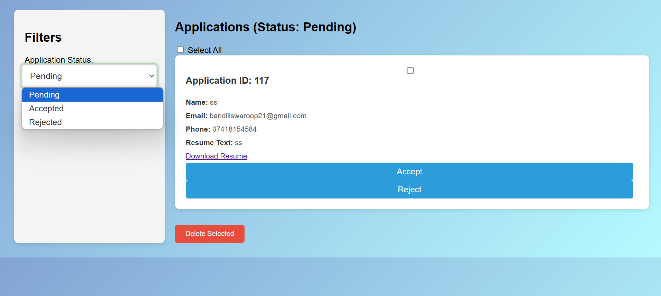
Db.php:
<?php
$servername = "localhost";
$username = "root";
$password = "";
$dbname = "job_portal";
// Create connection
$conn = new mysqli($servername, $username, $password, $dbname);
// Check connection
if ($conn->connect_error) {
die("Connection failed: " . $conn->connect_error);
}?>

Delete_application.php:

