Question: A navigation system processes coordinates of multiple delivery points to identify the farthest pair of locations for route planning. The system currently checks all possible
pairs using a brute-force approach.
a) Explain how the brute-force method works for this problem.
b) Derive the time complexity for computing all pair distances.
c) Analyze why this approach becomes inefficient as the number of points increases.

Aim
To implement the Brute-Force algorithm for finding the farthest pair among multiple delivery locations represented as Cartesian coordinates and to analyze its computational complexity.

Problem Statement
A navigation system receives coordinates of several delivery locations. The objective is to determine the pair of locations that are separated by the maximum distance.
The existing system uses a Brute-Force approach, where every possible pair of points is examined. This report explains the working of the algorithm, derives its time complexity, and analyzes why this approach becomes inefficient for large datasets.

Objectives
- Understand the Brute-Force strategy.
- Calculate Euclidean distance between every pair of points.
- Find the farthest pair.
- Derive mathematical time complexity.
- Analyze the efficiency of the algorithm.

Algorithm Used
Brute-Force Algorithm
The Brute-Force technique solves the problem by checking every possible pair of points without using any optimization.
For each point:
- Compare it with every remaining point.
- Compute the Euclidean distance.
- Keep track of the maximum distance.
- Return the pair having the largest distance.
This guarantees the correct solution because no pair is ignored.

Mathematical Formula
For two points
$$P_{1}\left(x_{1} , y_{1}\right)$$
and
$$P_{2}\left(x_{2} , y_{2}\right)$$
Distance is
$$d=\sqrt{{\left(x_{2}-x_{1}\right)}^{2}+{\left(y_{2}-y_{1}\right)}^{2}}$$
Algorithm
Start
Input n points
maxDistance = 0
For i = 0 to n−1
For j = i+1 to n−1
Calculate Euclidean distance
If distance > maxDistance
Update maximum distance
Store current pair
Display farthest pair
Stop

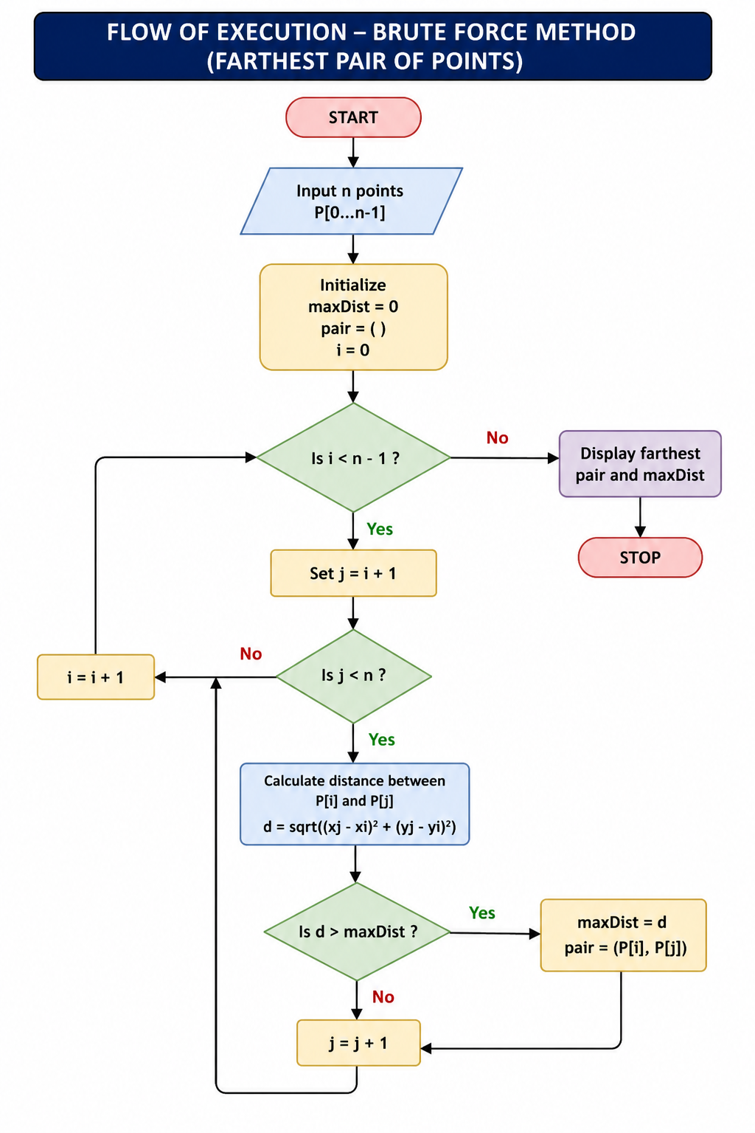
Flow of Execution

Python Program
import math
points = [
(2, 3),
(5, 8),
(9, 4),
(1, 7),
(6, 1)

max_distance = 0
farthest_pair = ()
for i in range(len(points)):
for j in range(i + 1, len(points)):
x1, y1 = points[i]
x2, y2 = points[j]
distance = math.sqrt((x2 - x1) ** 2 + (y2 - y1) ** 2)
if distance > max_distance:
max_distance = distance
farthest_pair = (points[i], points[j])
print("Farthest Pair :", farthest_pair)
print("Maximum Distance :", round(max_distance, 2))

Sample Input
(2,3)
(5,8)
(9,4)
(1,7)
(6,1)

Sample Output
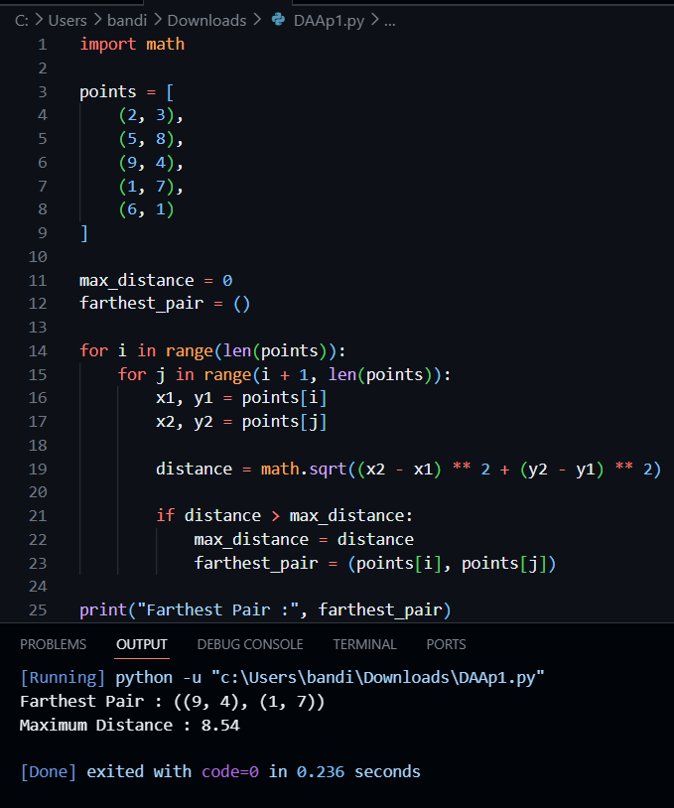
Explanation of the Program
- Store all delivery locations as coordinate pairs.
- Initialize the maximum distance as zero.
- Compare every point with every other point.
- Calculate Euclidean distance.
- Update the maximum distance whenever a larger distance is found.
- Display the farthest pair.
Since every possible pair is examined, the algorithm always produces the correct answer.
(a) Explanation of the Brute-Force Method
The Brute-Force method systematically compares every delivery location with every other delivery location.
If there are n locations,
- First location compares with remaining n−1
- Second compares with n−2
- Third compares with n−3
- Continue until all pairs are checked.
The algorithm never skips any combination.
Hence, the farthest pair is guaranteed to be found.
Although simple and reliable, this method performs many unnecessary comparisons when the number of locations becomes very large.

(b) Time Complexity Derivation
Suppose there are n points.
The number of comparisons is
$$\left(n-1\right)+\left(n-2\right)+\left(n-3\right)+...+1$$
This equals
$$\frac{n\left(n-1\right)}{2}$$
Each comparison performs
- subtraction
- multiplication
- addition
- square root

All of these require constant time:
$$O\left(1\right)$$Therefore, $T\left(n\right)=\frac{n\left(n-1\right)}{2}$
Ignoring constants, $T\left(n\right)=O\left(n^{2}\right)$
Mathematical Proof
Expand,
$$=\frac{n^{2}-n}{2}$$
Ignoring lower-order terms,
$$T\left(n\right)=O\left(n^{2}\right)$$

Space Complexity
Only a few variables are stored:
- maximum distance
- point indices
- temporary coordinates
No additional data structure proportional to n is created.
Therefore,
Space=O (1)

(c) Why the Brute-Force Method Becomes Inefficient
As the number of delivery locations increases, the number of pairwise comparisons grows quadratically.
Example:
Number of Points | Comparisons
10 | 45
50 | 1225
100 | 4950
500 | 124750
1000 | 499500
5000 | 12497500
10000 | 49995000
The table shows that doubling the number of points increases the comparisons by approximately four times.
Consequently:
- Execution time increases rapidly.
- CPU utilization becomes high.
- Large datasets require substantial processing time.
- Real-time navigation systems experience delays.
- Battery consumption increases on mobile devices.
- Route planning becomes slower.
Hence, the Brute-Force method is practical only for small datasets.

Performance Analysis
Case | Time Complexity
Best Case | O(n²)
Average Case | O(n²)
Worst Case | O(n²)
Unlike many algorithms, the Brute-Force method must examine every pair regardless of the input arrangement. Therefore, all three cases have the same complexity.

Advantages
- Very easy to implement.
- Simple logic.
- Always produces the correct result.
- Suitable for small datasets.
- Useful as a reference solution for validating optimized algorithms.

Limitations
- Large execution time for many points.
- Quadratic growth in comparisons.
- Not suitable for real-time navigation systems with thousands of locations.
- Poor scalability.

Real-World Applications
- Delivery route planning
- Drone navigation
- Geographic Information Systems (GIS)
- Emergency response planning
- Logistics optimization
- Fleet management

Result
The Brute-Force algorithm was successfully implemented to determine the farthest pair of delivery locations. The algorithm correctly examined all possible point pairs and identified the maximum distance. Time complexity analysis showed that the algorithm performs O(n²) operations due to exhaustive pairwise comparisons, while the space complexity remains O (1). Although accurate and simple, the method becomes inefficient for large-scale navigation datasets because the number of comparisons grows quadratically with the number of locations.

Conclusion
The Brute-Force approach guarantees the correct identification of the farthest pair by evaluating every possible combination of delivery points. Mathematical analysis confirms that its time complexity is O(n²), making it computationally expensive for large datasets. While it is an excellent introductory algorithm due to its simplicity and correctness, practical navigation systems handling thousands of locations should employ more efficient computational geometry algorithms to improve scalability and reduce execution time.

