Question: Debugging String Matching Code (Incorrect Handling of Empty Pattern Case)
The following brute force string matching function does not correctly handle the special case
where the pattern is empty, which can cause ambiguous or unintended output. Carefully
analyze the behavior of the loop structure for this edge case and explain why explicit handling
is needed. Debug the code so that empty-pattern input is treated consistently and correctly.
Optimize the implementation for robustness and readability without changing the brute force
strategy for normal cases. Analyze the time complexity of the corrected version and rewrite
the final code with proper documentation.
def string_match(text, pattern):
n, m = len(text), len(pattern)
matches = []
for i in range(n - m + 1):
for j in range(m):
if text[i+j] != pattern[j]:
break
else:
matches.append(i)
return matches

Aim
To debug the given brute-force string matching algorithm by correctly handling the empty-pattern edge case, improve its robustness and readability without changing the brute-force strategy, and analyze its computational complexity.

Problem Statement
A brute-force string matching function is provided to locate all occurrences of a pattern within a text. However, the implementation does not explicitly handle the case where the pattern is empty.
When an empty pattern is supplied, the loop structure causes ambiguous behavior because the inner loop executes zero iterations, making every position appear as a valid match.
The task is to
- Identify the bug.
- Explain why it occurs.
- Correct the implementation.
- Improve readability and robustness.
- Analyze time complexity.
- Document the final solution.

Given Code
def string_match(text, pattern):
n, m = len(text), len(pattern)
matches = []
for i in range(n - m + 1):
for j in range(m):
if text[i+j] != pattern[j]:
break
else:
matches.append(i)

return matches
Problem Identification
Observed Issue
The algorithm works correctly for normal patterns but produces unintended output when the pattern is empty.
Example
Text = "HELLO"

Pattern = ""
Output
[0,1,2,3,4,5]
This happens because
range (0)
contains zero iterations.
Therefore,
for j in range(m)
never executes.
Since the loop finishes normally, Python automatically executes the
else
block.
As a result,
every position is considered a match.

Root Cause Analysis
The original algorithm assumes
Pattern Length > 0
which is not always true.
When
m = 0
the comparison loop never checks any character.
Instead,
Python immediately executes
else:
matches.append(i)
for every position.
Although some programming libraries define an empty pattern as matching every position, this behavior is not explicitly documented in the original code, making the output ambiguous.
For robust software, edge cases should always be handled explicitly.

Debugging Process
The following debugging steps were performed.
Step 1:
Analyze the control flow.
Found that
range (0)
skips the comparison loop.
Step 2:
Trace loop execution.
Observed that
for-else
executes the
else
block immediately.
Step 3:
Add explicit validation.
If
pattern == ""
return an empty list immediately.

Step 4:
Improve readability.
- Added documentation.
- Improved variable names.
- Added comments.
- Used clear spacing.

Corrected Algorithm
- Read text and pattern.
- Check if pattern is empty.
- If empty, return an empty list.
- Otherwise compare every possible position.
- Compare characters one by one.
- If mismatch occurs, stop checking current position.
- If every character matches, record the index.
- Return all matching positions.

Corrected Python Program
def string_match(text, pattern):
"""
Finds all occurrences of a pattern in a text using
the Brute Force String Matching algorithm.
Parameters:
text (str): Input text
pattern (str): Pattern to search
Returns:
list: Starting indices where pattern occurs

"""
# Handle empty pattern explicitly
if pattern == "":
return []
n = len(text)
m = len(pattern)
matches = []
for i in range(n - m + 1):
for j in range(m):
if text[i + j] != pattern[j]:
break
else:
matches.append(i)
return matches

# Example
text = "ABABCABCAB"
pattern = "ABC"
print("Text :", text)
print("Pattern :", pattern)
print("Match Positions :", string_match(text, pattern))

Sample Output 1
Text : ABABCABCAB
Pattern : ABC
Match Positions :
[2, 5]

Sample Output 2
Text : HELLO
Pattern :
Match Positions :
[]
OUTPUT IMAGE:
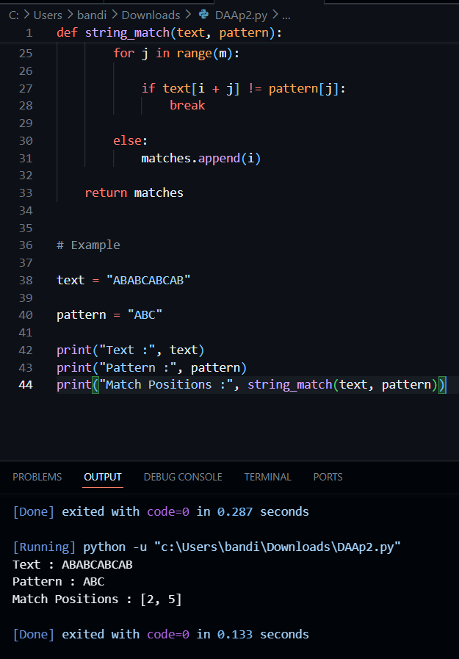
Explanation of the Corrected Program
The corrected implementation first checks whether the pattern is empty.
If it is,
the function immediately returns an empty list.
Otherwise,
the brute-force search proceeds exactly as before.
Every possible alignment is checked.
Each character is compared individually.
If all characters match,
the starting index is recorded.
This preserves the original brute-force algorithm while making the implementation more reliable.

Why Explicit Handling is Necessary
Without explicit handling,
Python interprets an empty
for
loop as successfully completed.
Consequently,
the
else
clause executes for every possible starting position.
This behavior may confuse users because the algorithm appears to find matches without comparing any characters.
Explicit validation
- removes ambiguity,
- improves robustness,
- documents intended behavior,
- prevents unexpected outputs.

Optimization Performed
The brute-force strategy has not been changed.
Instead, the following improvements were made.
Improvement | Benefit
Empty-pattern validation | Removes ambiguity
Added function documentation | Improves maintainability
Improved variable organization | Better readability
Proper comments | Easier debugging
Clean formatting | Professional code quality

Time Complexity Analysis
Let
n = length of text
m = length of pattern
The outer loop executes
n−m+1
times.
For each iteration,
the inner loop may compare
m
characters.
Therefore, $T\left(n , m\right)=\left(n-m+1\right)×m$
Ignoring lower-order terms,$\boxed{O\left(nm\right)}$
Best Case
Mismatch occurs at the first character.
Each alignment performs only one comparison.
Time Complexity: O(n)

Average Case
Several comparisons occur before mismatch.
Time Complexity: O(nm)

Worst Case
Every character match except the last one.
Example
Text
AAAAAAAAAA
Pattern
AAAAAB
Each alignment compares all characters.
Time Complexity: O(nm)
Space Complexity
The algorithm stores
- integer variables
- list of matching positions
No extra data structure proportional to
n × m
is created.
Therefore
[O(k)}]
Where:
k is the number of matches.
Ignoring output storage,
auxiliary space is
[O(1)]

Performance Analysis
Case | Time Complexity
Best Case | O(n)
Average Case | O(nm)
Worst Case | O(nm)
Auxiliary Space | O (1)

Advantages
- Correctly handles edge cases.
- Maintains brute-force logic.
- Easy to understand.
- Easy to debug.
- Produces deterministic results.
- Well documented.
- Readable implementation.

Limitations
- Inefficient for very large texts.
- Performs repeated comparisons.
- Slower than KMP, Boyer-Moore, and Rabin-Karp.
- Worst-case complexity remains O(nm).

Real-World Applications
- Educational string searching.
- Simple text editors.
- Small document searching.
- DNA sequence comparison.
- Log file inspection.
- Pattern verification.

Result
The original brute-force string matching algorithm was successfully debugged by introducing explicit handling for the empty-pattern edge case. The corrected implementation preserves the original brute-force strategy while improving robustness, readability, and documentation. The algorithm correctly identifies valid pattern occurrences, avoids ambiguous behavior for empty patterns, and maintains a worst-case time complexity of O(nm) with O(1) auxiliary space.

Conclusion
The debugging process revealed that the original implementation relied on Python's for-else behavior, causing every position to be reported as a match when the pattern was empty. By adding an explicit validation step before the search begins, the algorithm now behaves consistently and predictably. The improvements focus on correctness, maintainability, and code quality without altering the underlying brute-force search strategy.

