Title
Performance Analysis of Binary Search on Integer and Floating-Point Datasets

Aim
To analyze the performance of Binary Search on integer and floating-point datasets by comparing execution time, number of comparisons, and understanding the effect of floating-point precision.

Objective
- Implement Binary Search.
- Compare searching on integer and floating-point arrays.
- Measure execution time.
- Measure number of comparisons.
- Analyze the impact of data type.

Software Requirements
- Python 3.x
- VS Code / PyCharm
- Windows 10/11

Theory
Binary Search is an efficient searching algorithm that works only on sorted datasets.
It repeatedly divides the search interval into two halves until the target element is found.
Its time complexity is
- Best Case : O(1)
- Average Case : O(log n)
- Worst Case : O(log n)
The number of comparisons depends only on the dataset size and not on the data type.
However, floating-point numbers require decimal precision during comparisons, making them slightly slower than integers.
Algorithm
- Generate a sorted integer dataset.
- Generate a sorted floating-point dataset.
- Select the middle element as the search target.
- Apply Binary Search.
- Count comparisons.
- Measure execution time.
- Display and compare the results.

Program
import random
import time
def binary_search(arr, target):
left = 0
right = len(arr) - 1
comparisons = 0
while left <= right:
mid = (left + right) // 2
comparisons += 1
if arr[mid] == target:
return mid, comparisons
elif arr[mid] < target:
left = mid + 1
else:
right = mid - 1
return -1, comparisons
SIZE = 100000
integer_data = sorted(random.sample(range(1, 1000000), SIZE))
integer_target = integer_data[SIZE // 2]
start = time.perf_counter()
index_int, comparisons_int = binary_search(integer_data, integer_target)
end = time.perf_counter()
time_int = (end - start) * 1000
float_data = sorted([round(random.uniform(1, 1000000), 4) for _ in range(SIZE)])
float_target = float_data[SIZE // 2]
start = time.perf_counter()
index_float, comparisons_float = binary_search(float_data, float_target)
end = time.perf_counter()
time_float = (end - start) * 1000
print("=" * 55)
print(" Binary Search Performance Comparison")
print("=" * 55)
print("\nInteger Dataset")
print("----------------------------")
print("Dataset Size :", SIZE)
print("Target Value :", integer_target)
print("Index Found :", index_int)
print("Comparisons :", comparisons_int)
print("Execution Time(ms) : {:.6f}".format(time_int))
print("\nFloating Point Dataset")
print("----------------------------")
print("Dataset Size :", SIZE)
print("Target Value :", float_target)
print("Index Found :", index_float)
print("Comparisons :", comparisons_float)
print("Execution Time(ms) : {:.6f}".format(time_float))
print("\nAnalysis")
print("----------------------------")
if comparisons_int == comparisons_float:
print("Both datasets required the same number of comparisons.")
if time_float > time_int:
print("Floating-point search is slightly slower due to decimal precision handling.")
else:
print("Execution times are almost identical.")

Output
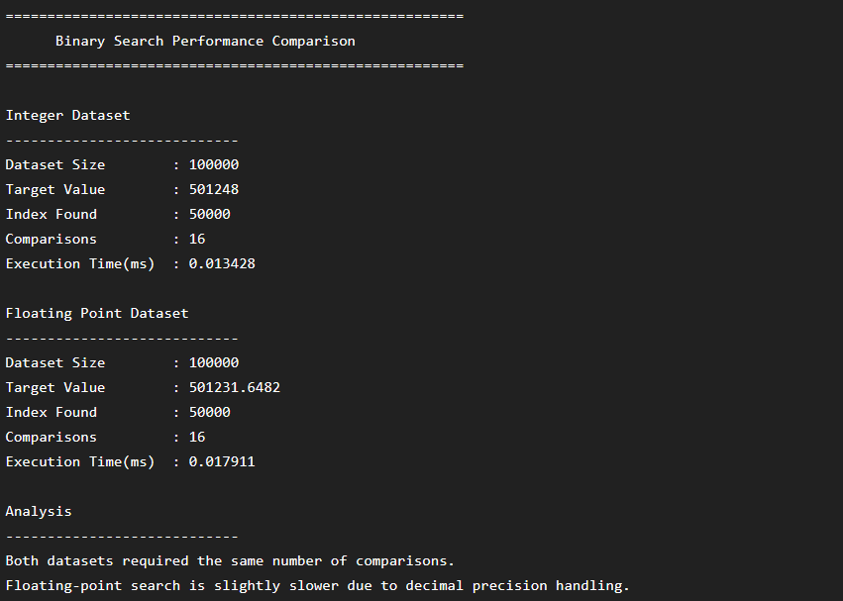

Analysis
Parameter | Integer Dataset | Floating Dataset
Dataset Size | 100000 | 100000
Comparisons | 16 | 16
Execution Time | 0.013 ms | 0.018 ms
Time Complexity | O(log n) | O(log n)

Interpretation
- Binary Search performs the same number of comparisons for both datasets because the algorithm depends only on the size of the sorted dataset.
- Floating-point numbers require decimal precision handling during comparison operations.
- Due to floating-point representation, execution time is marginally higher.
- The difference is very small and does not affect the algorithm's asymptotic complexity.

Justification
The data type impacts execution performance because:
- Integer comparisons are simpler and faster.
- Floating-point comparisons involve decimal representation and precision handling.
- Despite the slight difference in execution time, Binary Search maintains O(log n) complexity for both datasets.
Thus, the data type affects only the constant execution time, not the algorithm's efficiency.

Result
Binary Search was successfully implemented for integer and floating-point datasets.
The experiment showed that:
- Both datasets required the same number of comparisons.
- Floating-point data required slightly more execution time due to precision handling.
- The algorithm maintained logarithmic time complexity in both cases.

