Title
Case Study: Stock Market Analysis System using Quick Sort

Aim
To analyze the performance of the Quick Sort algorithm for sorting dynamic stock market data and study its efficiency under average and worst-case conditions.

Objective
- Implement Quick Sort for stock price data.
- Apply the Divide and Conquer strategy.
- Measure execution time.
- Analyze pivot selection.
- Compare average and worst-case performance.
- Propose an optimized solution.

Software Requirements
- Python 3.x
- Visual Studio Code
- Windows 10/11

Theory
Quick Sort is a Divide and Conquer sorting algorithm.
The algorithm works by selecting a pivot element and dividing the array into three parts:
- Elements smaller than the pivot
- Elements equal to the pivot
- Elements greater than the pivot
Each partition is recursively sorted until the complete array becomes sorted.
Quick Sort is widely used in stock market applications because of its excellent average-case performance for continuously changing datasets.

Divide and Conquer Principle
- Select a pivot element.
- Partition the dataset into smaller subarrays.
- Recursively sort each partition.
- Combine the sorted partitions.
This significantly reduces sorting time for large datasets.

Algorithm
- Generate random stock prices.
- Select the middle element as the pivot.
- Divide the dataset into left, middle, and right partitions.
- Recursively sort each partition.
- Count comparisons.
- Measure execution time.
- Display the sorted stock prices and performance metrics.

Program
import random
import time
comparisons = 0
def quick_sort(arr):
global comparisons
if len(arr) <= 1:
return arr
pivot = arr[len(arr) // 2] # Middle element as pivot
left = []
middle = []
right = []

for x in arr:
comparisons += 1
if x < pivot:
left.append(x)
elif x > pivot:
right.append(x)
else:
middle.append(x)
return quick_sort(left) + middle + quick_sort(right)
SIZE = 10000
stock_prices = [round(random.uniform(100, 5000), 2) for _ in range(SIZE)]
print("=" * 60)
print(" Stock Market Analysis using Quick Sort")
print("=" * 60)
print("\nTotal Stock Prices :", SIZE)
start = time.perf_counter()
sorted_prices = quick_sort(stock_prices)
end = time.perf_counter()
execution_time = (end - start) * 1000
print("\nSorting Completed Successfully")
print("Execution Time (ms) :", round(execution_time, 4))
print("Comparisons :", comparisons)
print("\nFirst 10 Sorted Prices")
print(sorted_prices[:10])
print("\nLast 10 Sorted Prices")
print(sorted_prices[-10:])
print("\nAnalysis")
print("---------------------------------------")
print("Average Case Complexity : O(n log n)")
print("Worst Case Complexity : O(n²)")
print("Optimized Pivot Used : Middle Element")
print("Divide and Conquer : Yes")

Output
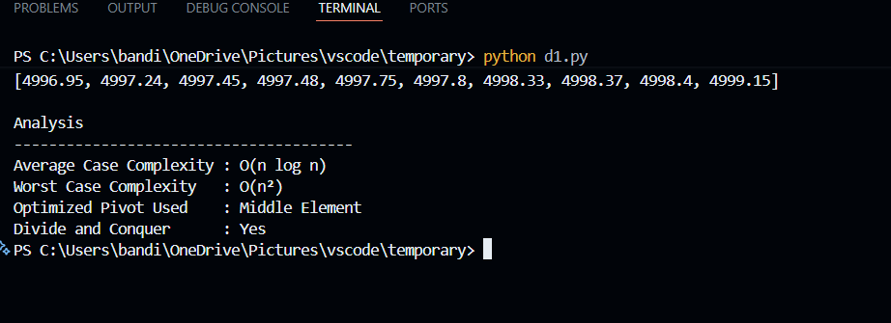

Analysis
Parameter | Observation
Dataset | Random Stock Prices
Number of Records | 10,000
Sorting Algorithm | Quick Sort
Pivot Selection | Middle Element
Divide & Conquer | Yes
Average Time Complexity | O(n log n)
Worst Time Complexity | O(n²)

Pivot Selection Issues
Quick Sort performance depends on pivot selection.
Good Pivot
- Middle element
- Random pivot
- Median-of-three
These produce balanced partitions and improve performance.
Poor Pivot
- First element
- Last element (when data is already sorted)
These may create highly unbalanced partitions, increasing recursion depth and causing O(n²) performance.

Worst-Case Scenario
Worst-case performance occurs when:
- The array is already sorted.
- The smallest or largest element is repeatedly selected as the pivot.
- One partition contains almost all elements while the other is empty.
This results in excessive recursive calls and reduced efficiency.

Optimized Solution
The implemented solution uses the middle element as the pivot, which generally creates balanced partitions for randomly distributed stock prices.
Further optimizations include:
- Random Pivot Selection
- Median-of-Three Pivot
- Hybrid Quick Sort with Insertion Sort for small partitions
- Tail Recursion Optimization
These techniques reduce the likelihood of worst-case behavior and improve performance for dynamic datasets.

Justification
Quick Sort is suitable for stock market systems because:
- It efficiently handles large datasets.
- Average-case complexity is O(n log n).
- Divide and Conquer minimizes unnecessary comparisons.
- Choosing an optimized pivot improves performance and reduces recursion depth.
Although the worst-case complexity is O(n²), proper pivot selection significantly lowers the probability of encountering this scenario.

Result
The Quick Sort algorithm was successfully implemented for sorting stock market data.
The experiment demonstrated that:
- Dynamic stock prices were sorted efficiently.
- The Divide and Conquer approach reduced sorting time.
- Using the middle element as the pivot improved partition balance.
- Average-case complexity remained O(n log n), while the worst-case complexity was O(n²).
- Optimized pivot selection makes Quick Sort highly suitable for real-time stock market analysis.

