**DAY-2 PROGRAMS:-**

**NAME:** B. Murali Krishna

**REG NO:** 192111072

1. Write a java program for average of 15 students.

**Program:-**

import java.util.*;  
public class Average_of_15_Students {  
 public static void main(String[] args)  
 {  
 Scanner s=new Scanner(System.*in*);  
 int i;  
 int avg, sum=0;  
 int a[]=new int[15];  
 System.*out*.println("Enter Each Student Marks:");  
 for(i=0;i<a.length;i++)  
 {  
 System.*out*.println("Enter "+(i+1)+" Marks:");  
 a[i]=s.nextInt();  
 sum=sum+a[i];  
 }  
 avg=sum/ a.length;  
 System.*out*.println("Sum is = "+sum);  
 System.*out*.println("Average is ="+avg);  
 }  
}

**Output:-**

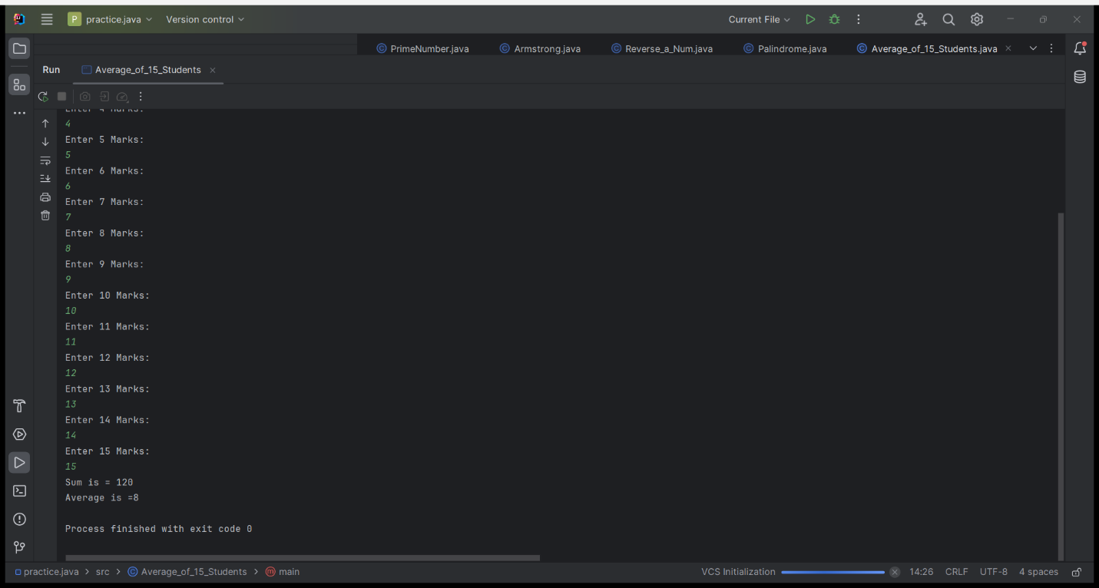

2. Write a java program for Matrix Addition.

**Program:-**

import java.util.*;  
class MatrixAddition{  
 public static void main(String[] args){  
 Scanner s=new Scanner(System.*in*);  
 int r,c;  
 int i,j;  
 System.*out*.print("Enter no of rows:");  
 r=s.nextInt();  
 System.*out*.print("Enter no of columns:");  
 c=s.nextInt();  
 int a[][]=new int[r][c];  
 int b[][]=new int[r][c];  
 int sum[][]=new int[r][c];  
 System.*out*.print("Enter elements of Matrix-A:");  
 for(i=0;i<r;i++){  
 for(j=0;j<c;j++){  
 a[i][j]=s.nextInt();  
 }  
 }  
 System.*out*.print("Enter elements of Matrix-B:");  
 for(i=0;i<r;i++){  
 for(j=0;j<c;j++){  
 b[i][j]=s.nextInt();  
 }  
 }  
 System.*out*.print("The resultant matrix of A+B is:\n");  
 for(i=0;i<r;i++){  
 for(j=0;j<c;j++){  
 sum[i][j]=a[i][j]+b[i][j];  
 System.*out*.print(sum[i][j]+" ");  
 }  
 System.*out*.println();  
 }  
 }  
}

**Output:-**

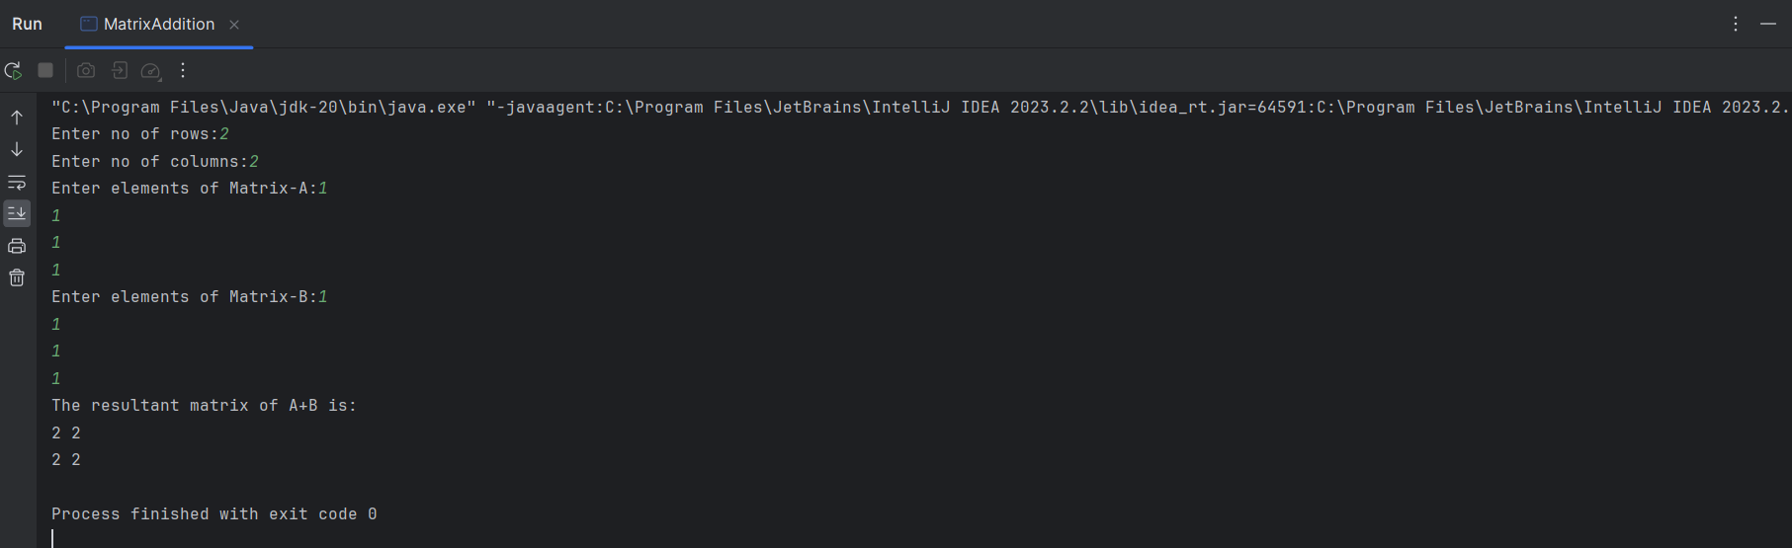

3. Write a java program for Matrix Subtraction.

**Program:-**

import java.util.*;  
class MatrixSubtraction{  
 public static void main(String[] args){  
 Scanner s=new Scanner(System.*in*);  
 int r,c;  
 int i,j;  
 System.*out*.print("Enter no of rows:");  
 r=s.nextInt();  
 System.*out*.print("Enter no of columns:");  
 c=s.nextInt();  
 int a[][]=new int[r][c];  
 int b[][]=new int[r][c];  
 int sum[][]=new int[r][c];  
 System.*out*.print("Enter elements of Matrix-A:");  
 for(i=0;i<r;i++){  
 for(j=0;j<c;j++){  
 a[i][j]=s.nextInt();  
 }  
 }  
 System.*out*.print("Enter elements of Matrix-B:");  
 for(i=0;i<r;i++){  
 for(j=0;j<c;j++){  
 b[i][j]=s.nextInt();  
 }  
 }  
 System.*out*.print("The resultant matrix of A-B is:\n");  
 for(i=0;i<r;i++){  
 for(j=0;j<c;j++){  
 sum[i][j]=a[i][j]-b[i][j];  
 System.*out*.print(sum[i][j]+" ");  
 }  
 System.*out*.println();  
 }  
 }  
}

**Output:-**

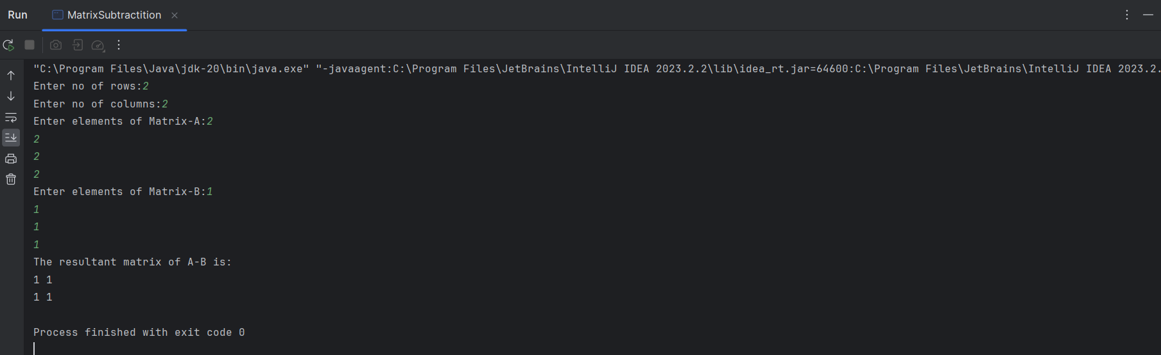

4. Write a java program for finding area of rectangle using OOPS concept.

**Program:-**

import java.util.*;  
class Rectangle{  
 int height, width;  
 void area(){  
 Scanner s=new Scanner(System.*in*);  
 System.*out*.print("Enter the Height:");  
 height=s.nextInt();  
 System.*out*.print("Enter the width:");  
 width=s.nextInt();  
 }  
 void result(){  
 int result=height*width;  
 System.*out*.println("The area of Rectangle is "+result);  
 }  
}  
  
class Rect{  
 public static void main(String[] args){  
 Rectangle obj=new Rectangle();  
 obj.area();  
 obj.result();  
 }  
}

**Output:-**

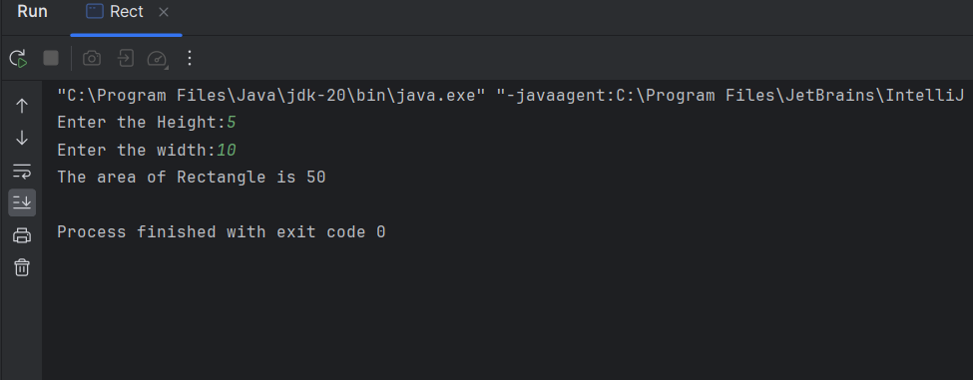

5. Write a java program for finding the area of circle using OOPS concept .

**Program:-**

import java.util.*;  
class Circle{  
 int radius;  
 void area(){  
 Scanner s=new Scanner(System.*in*);  
 System.*out*.print("Enter the Radius:");  
 radius=s.nextInt();  
 }  
 void result(){  
 double result=3.14*radius*radius;  
 System.*out*.println("The area of Circle is "+result);  
 }  
}  
  
class Circ{  
 public static void main(String[] args){  
 Circle obj=new Circle();  
 obj.area();  
 obj.result();  
 }  
}

**Output:-**

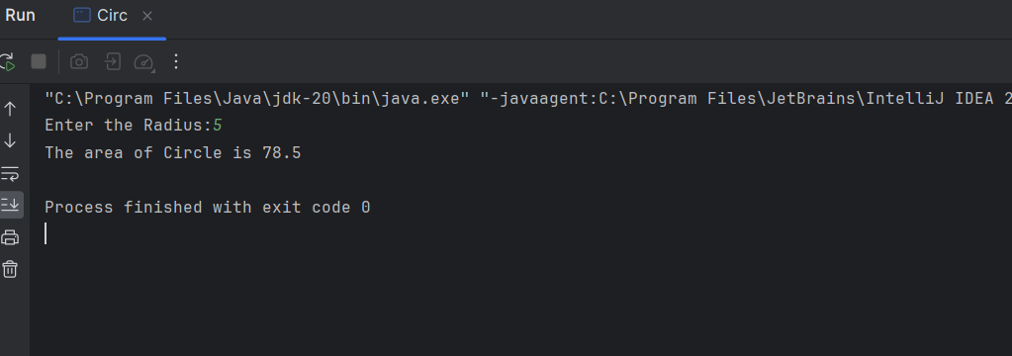

6. Write a java program for finding the area of triangle using OOPS concept.

**Program:-**

import java.util.*;  
class Triangle{  
 int height, breadth;  
 void area(){  
 Scanner s=new Scanner(System.*in*);  
 System.*out*.print("Enter the Height:");  
 height=s.nextInt();  
 System.*out*.print("Enter the Breadth:");  
 breadth=s.nextInt();  
 }  
 void result(){  
 double result=0.5*height*breadth;  
 System.*out*.println("The area of Triangle is "+result);  
 }  
}  
  
class Tri{  
 public static void main(String[] args){  
 Triangle obj=new Triangle();  
 obj.area();  
 obj.result();  
 }  
}

**Output:-**

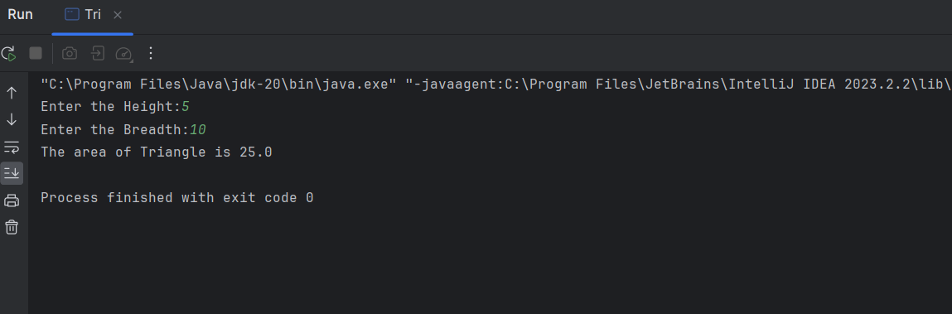

7. Write a java program to calculate simple interest using OOPS concept.

**Program:-**

import java.util.*;  
class SI{  
 int p, t, r;  
 void simpleinterest(){  
 Scanner s=new Scanner(System.*in*);  
 System.*out*.print("Enter the Principal Amount:");  
 p=s.nextInt();  
 System.*out*.print("Enter the Rate of Interest:");  
 r=s.nextInt();  
 System.*out*.print("Enter the Time Period:");  
 t=s.nextInt();  
 }  
 void result(){  
 int si=(p*t*r)/100;  
 System.*out*.println("The Simple Interest is:"+si);  
 }  
}  
  
class Simple_Interest{  
 public static void main(String[] args){  
 SI obj=new SI();  
 obj.simpleinterest();  
 obj.result();  
 }  
}

**Output:-**

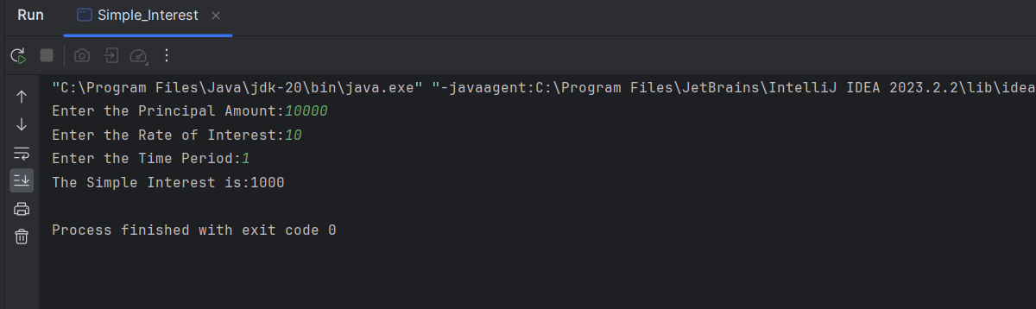

8. Write a java program for BOX using OOPS Constructor.

**Program:-**

import java.util.*;  
class BOX{  
 double width, height, depth;  
 BOX(double w, double h, double d){  
 width=w;  
 height=h;  
 depth=d;  
 }  
 double volume(){  
 return width*height*depth;  
 }  
 public static void main(String[] args){  
 Scanner s=new Scanner(System.*in*);  
 System.*out*.print("Enter the Height:");  
 double height=s.nextDouble();  
 System.*out*.print("Enter the Width:");  
 double width=s.nextDouble();  
 System.*out*.print("Enter the Depth:");  
 double depth=s.nextDouble();  
 BOX b3=new BOX(width, height, depth);  
 double res=b3.volume();  
 System.*out*.println("The volume is "+res);  
 }  
}

**Output:-**

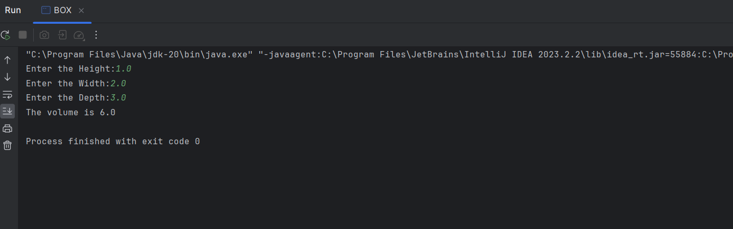

9. Write a java program for Sum of series using OOPS Concept.

**Program:-**

import java.util.*;  
class SumSeries{  
 int n;  
 void Sum(){  
 Scanner s=new Scanner(System.*in*);  
 System.*out*.print("Enter the no of elements in the series: ");  
 n = s.nextInt();  
 }  
 void result(){  
 int sum=0;  
 for(int i=0;i<=n;i++){  
 sum=sum+i;  
 }  
 System.*out*.println("The Sum of "+n+" terms is : "+sum);  
 }  
}  
  
class Sum{  
 public static void main(String[] args){10  
 SumSeries obj=new SumSeries();  
 obj.Sum();  
 obj.result();  
 }  
}

**Output:-**

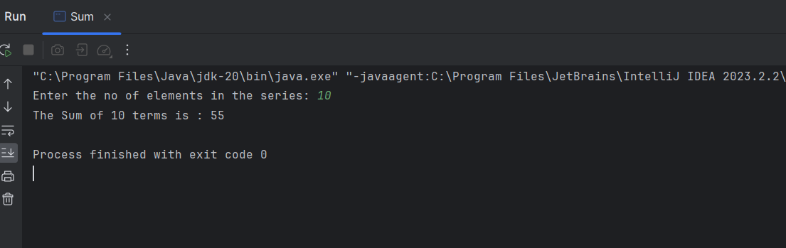

**ASSIGNMENT – 2:-**

1. Implement a class Account. An account has

• a balance

• functions to add

• and withdraw money,

• and a function to inquire about the current balance.

Condition:

1. Pass a value into a constructor to set an initial balance.

2. If no value is passed the initial balance should be set to $0.

3. Charge a $5 penalty if an attempt is made to withdraw more money than is available in the account.

4. Enhance the Account class to compute interest on the current balance.

**Program:-**

import java.util.*;  
class Account{-  
 int ib=0, cb, add, wd, pen=0, intr, choice, roi, t;  
 Account()  
 {  
 cb=ib;  
 Scanner s=new Scanner(System.*in*);  
 System.*out*.print("Your Initial Balance is:"+ib+"\n");  
 while(choice!=4) {  
 System.*out*.print("1.ADD Money\n2.Withdraw Money\n3.Balance Enquiry\n4.Exit\n");  
 System.*out*.print("Choose your choice:");  
 choice = s.nextInt();  
 switch (choice) {  
 case 1:  
 System.*out*.print("Enter the Money to add:");  
 add = s.nextInt();  
 cb = cb + add;  
 break;  
 case 2:  
 System.*out*.print("Enter the Money to withdraw:");  
 wd = s.nextInt();  
 if (wd > cb) {  
 pen = 5;  
 System.*out*.println("You cannot withdraw more amount than your current balance\n");  
 System.*out*.println("You have to pay Penalty of "+pen+" rupees!!");  
 cb=cb-pen;  
 System.*out*.println("Your current balance is : "+cb);  
 } else {  
 cb = cb - wd;  
 }  
 break;  
 case 3:  
 System.*out*.println("Your current Balance is = " + cb);  
 break;  
 case 4:  
 System.*out*.print("Exiting the program!! Thank you.\n");  
 break;  
 default:  
 System.*out*.print("Enter a valid Choice!!");  
 }  
 }  
 }  
 void interest(){  
 Scanner s=new Scanner(System.*in*);  
 System.*out*.print("Enter your Interest rate:");  
 roi=s.nextInt();  
 System.*out*.print("Enter the Time Period:");  
 t=s.nextInt();  
 intr=(roi*cb*t)/100;  
 System.*out*.println("You'll get an interest of "+intr+" for your current balance for "+t+" Months.");  
 }  
}  
  
class BankAccount{  
 public static void main(String[] args){  
 Account obj=new Account();  
 obj.interest();  
 }  
}

**Output:-**

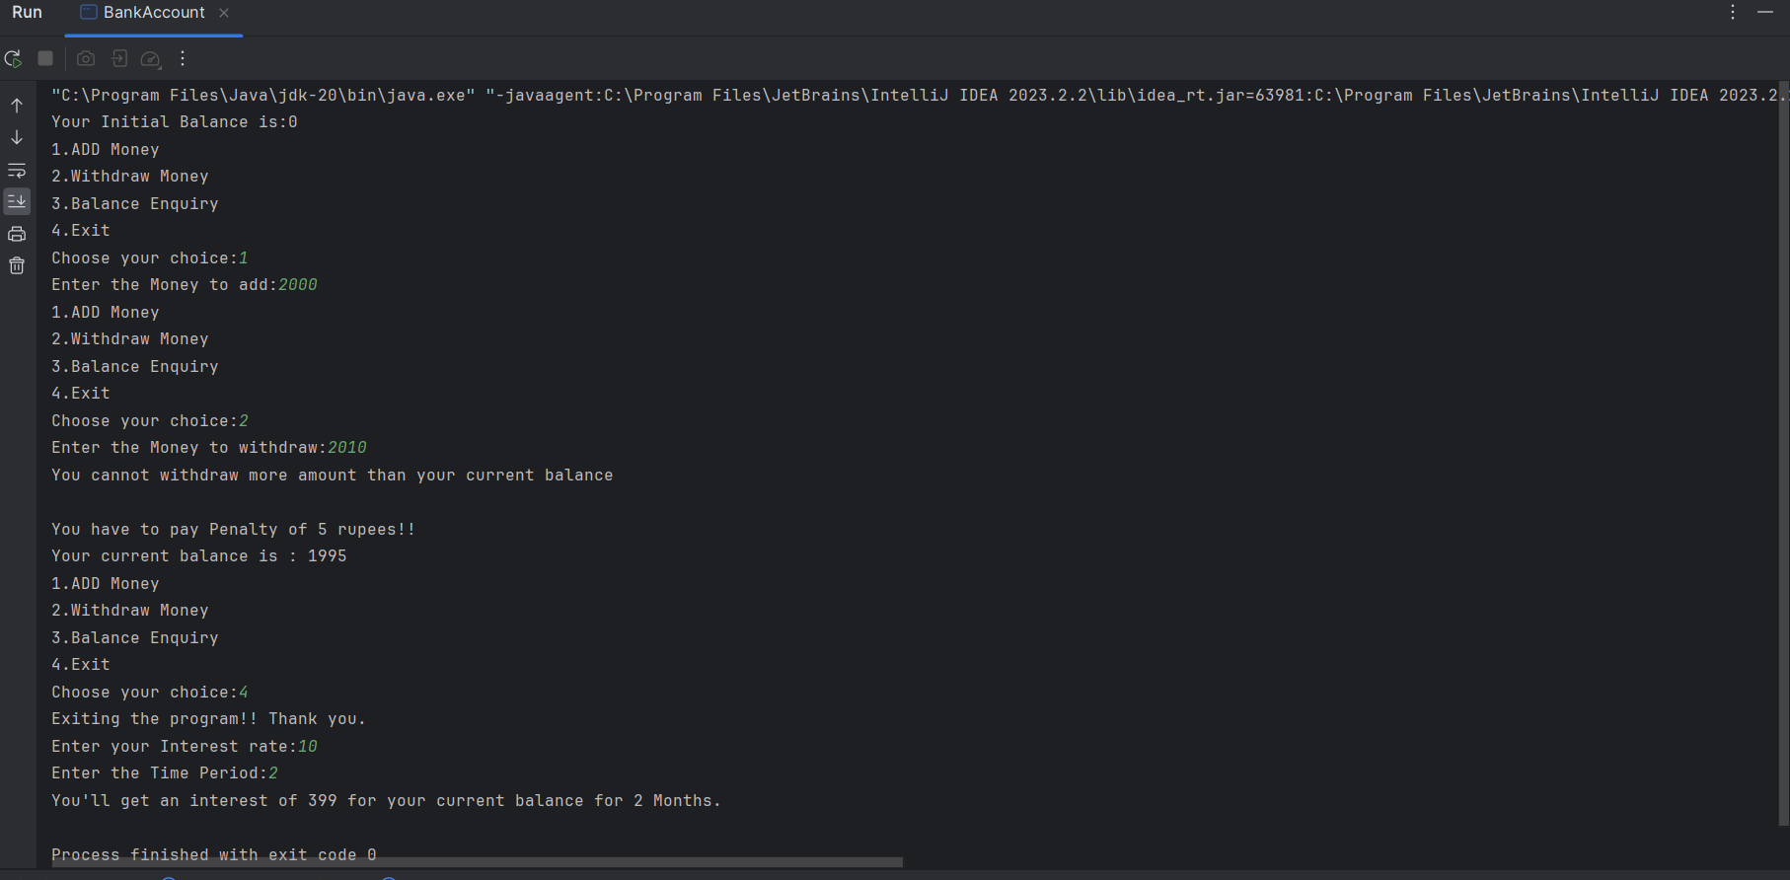

2. Write a class called Triangle that can be used to represent a triangle. It should include the following methods that return Boolean values indicating if the particular property holds:

• isRight (a right triangle)

• isScalene (no two sides are the same length)

• isIsosceles (exactly two sides are the same length)

• isEquilateral (all three sides are the same length)

**Program:-**

import java.util.Scanner;  
class TriangleType {  
 private int sideA, sideB, sideC, angle;  
 public TriangleType(int sideA, int sideB, int sideC, int angle) {  
 this.sideA = sideA;  
 this.sideB = sideB;  
 this.sideC = sideC;  
 this.angle = angle;  
 }  
 public boolean isRight() {  
 return angle == 90;  
 }  
 public boolean isScalene() {  
 return sideA != sideB && sideB != sideC && sideC != sideA;  
 }  
 public boolean isIsosceles() {  
 return sideA == sideB || sideB == sideC || sideC == sideA;  
 }  
 public boolean isEquilateral() {  
 return sideA == sideB && sideB == sideC;  
 }  
}  
  
class TType {  
 public static void main(String[] args) {  
 Scanner scanner = new Scanner(System.*in*);  
 System.*out*.print("Enter side A: ");  
 int sideA = scanner.nextInt();  
 System.*out*.print("Enter side B: ");  
 int sideB = scanner.nextInt();  
 System.*out*.print("Enter side C: ");  
 int sideC = scanner.nextInt();  
 System.*out*.print("Enter the Angle: ");  
 int angle = scanner.nextInt();  
 TriangleType triangle = new TriangleType(sideA, sideB, sideC, angle);  
 System.*out*.println("Is Right Triangle: " + triangle.isRight());  
 System.*out*.println("Is Scalene Triangle: " + triangle.isScalene());  
 System.*out*.println("Is Isosceles Triangle: " + triangle.isIsosceles());  
 System.*out*.println("Is Equilateral Triangle: " + triangle.isEquilateral());  
 }  
}

**Output:-**

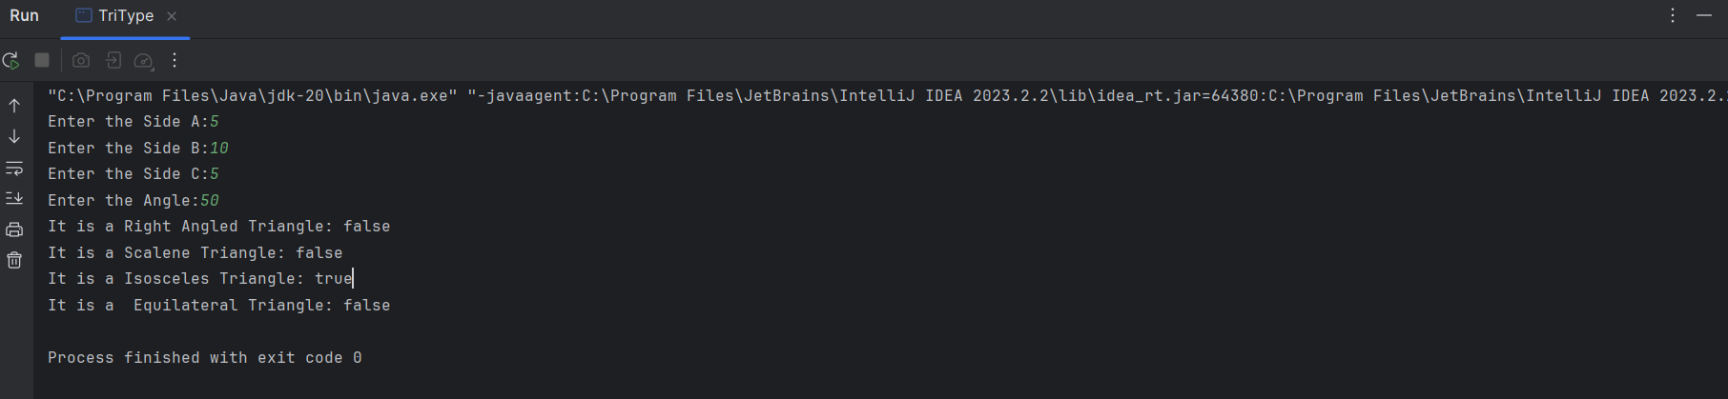

3. Write a program for matrix multiplication.

Sample Input:

Mat1 = 1 2

5 3

Mat2 = 2 3

4 1

Sample Output:

Mat Sum = 10 5

     22    18

**Program:-**

//Matrix Multiplication  
import java.util.*;  
class MatrixMultiplication{  
 public static void main(String[] args){  
 Scanner s=new Scanner(System.*in*);  
 int ar, br, ac, bc;  
 int i,j,k;  
 System.*out*.print("Enter no of rows for Matrix-A:");  
 ar=s.nextInt();  
 System.*out*.print("Enter no of columns for Matrix-A:");  
 ac=s.nextInt();  
 System.*out*.print("Enter no of rows for Matrix-B:");  
 br=s.nextInt();  
 System.*out*.print("Enter no of columns for Matrix-B:");  
 bc=s.nextInt();  
 if(ac!=br){  
 System.*out*.print("Matrix Multiplication not possible!!");  
 return;  
 }  
 int a[][]=new int[ar][ac];  
 int b[][]=new int[br][bc];  
 int res[][]=new int[ar][bc];  
 System.*out*.print("Enter elements of Matrix-A:");  
 for(i=0;i<ar;i++){  
 for(j=0;j<ac;j++){  
 a[i][j]=s.nextInt();  
 }  
 }  
 System.*out*.print("Enter elements of Matrix-B:");  
 for(i=0;i<br;i++){  
 for(j=0;j<bc;j++){  
 b[i][j]=s.nextInt();  
 }  
 }  
 System.*out*.print("The resultant matrix of A*B is:\n");  
 for(i=0;i<ar;i++){  
 for(j=0;j<bc;j++) {  
 res[i][j] = 0;  
 for (k = 0; k < ac; k++) {  
 res[i][j] += a[i][k] * b[k][j];  
 }  
 }  
 }  
 for(i=0;i<ar;i++){  
 for (j = 0; j < bc; j++) {  
 System.*out*.print(res[i][j]+ " ");  
 }  
 System.*out*.println();  
 }  
 }  
}

**Output:-**

