13 - BPO MANAGEMENT SYSTEM

USE CASE DIAGRAM:

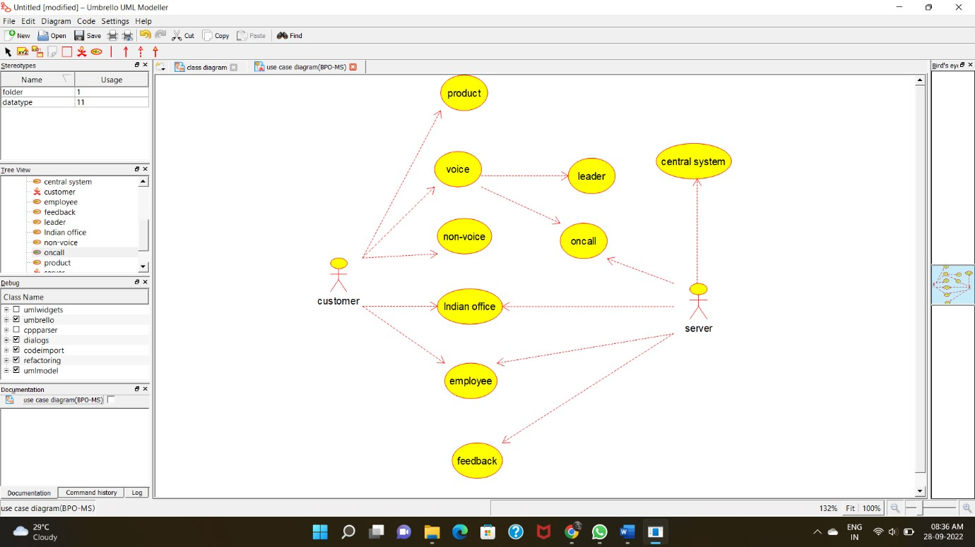

CLASS DIAGRAM:

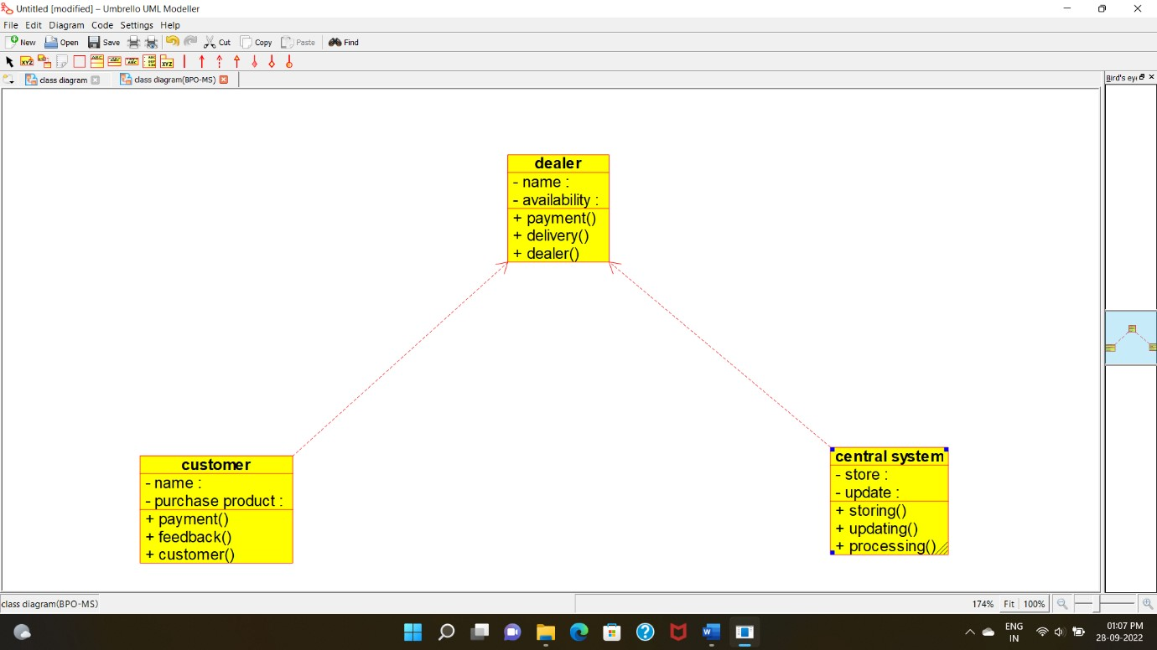

ACTIVITY DIAGRAM:

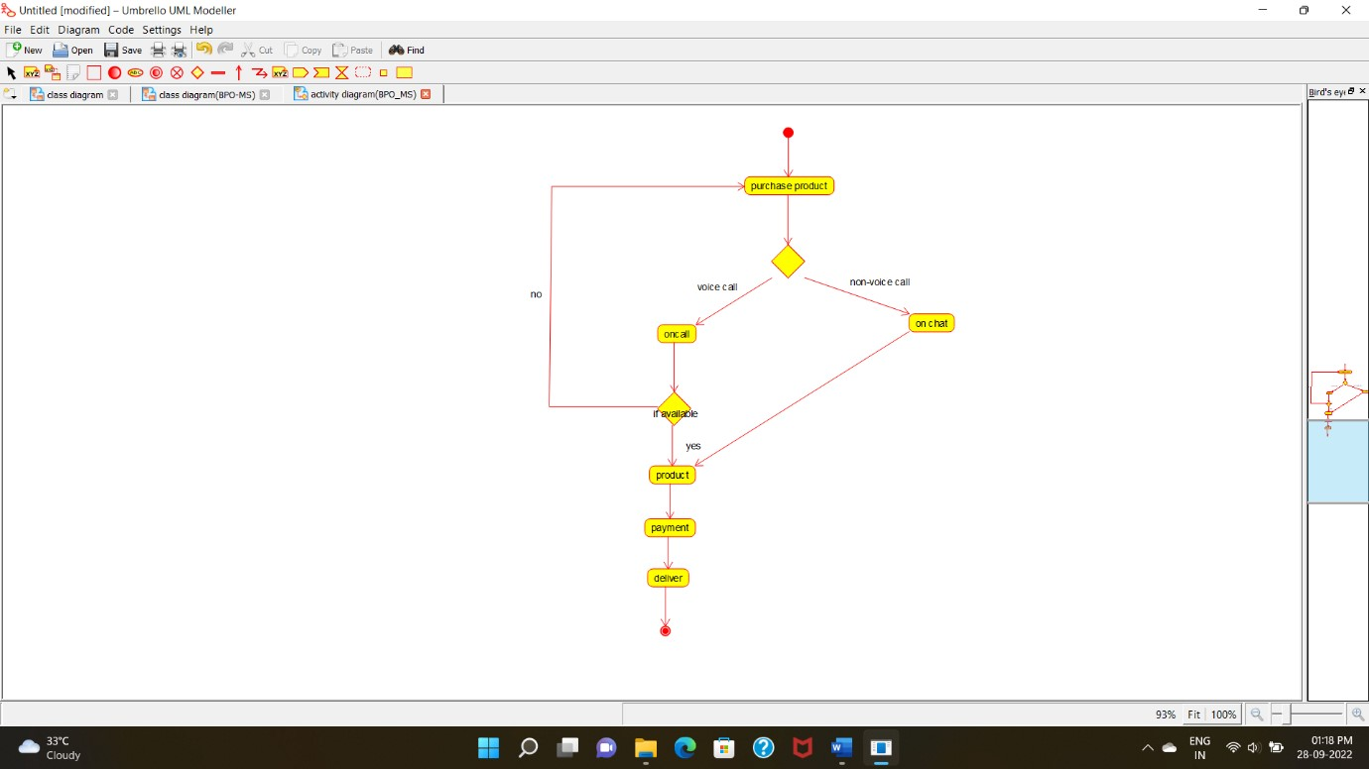

SEQUENCE DIAGRAM:

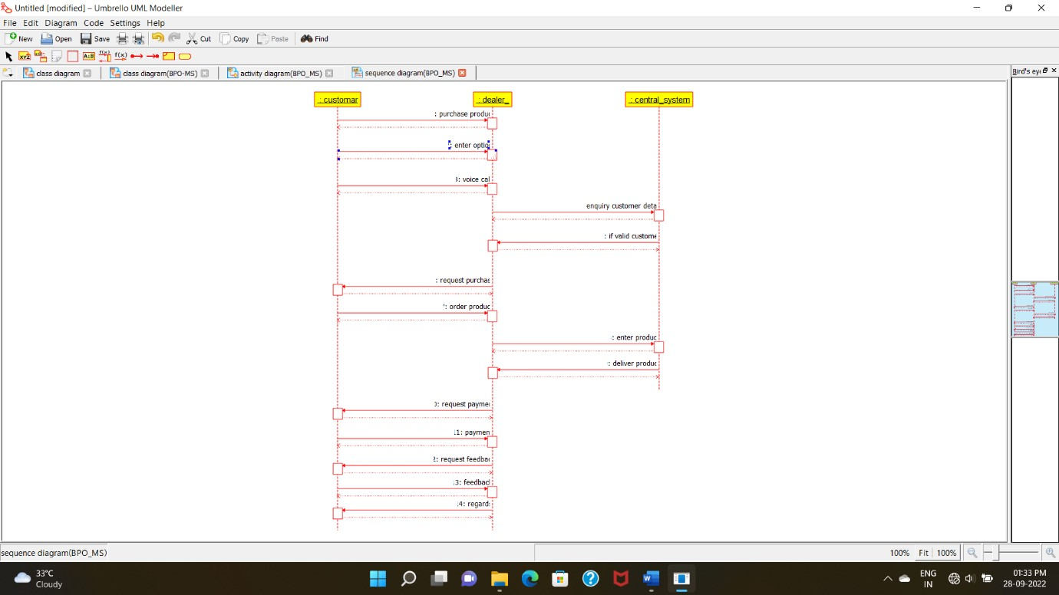

COLLABORATION DIAGRAM:

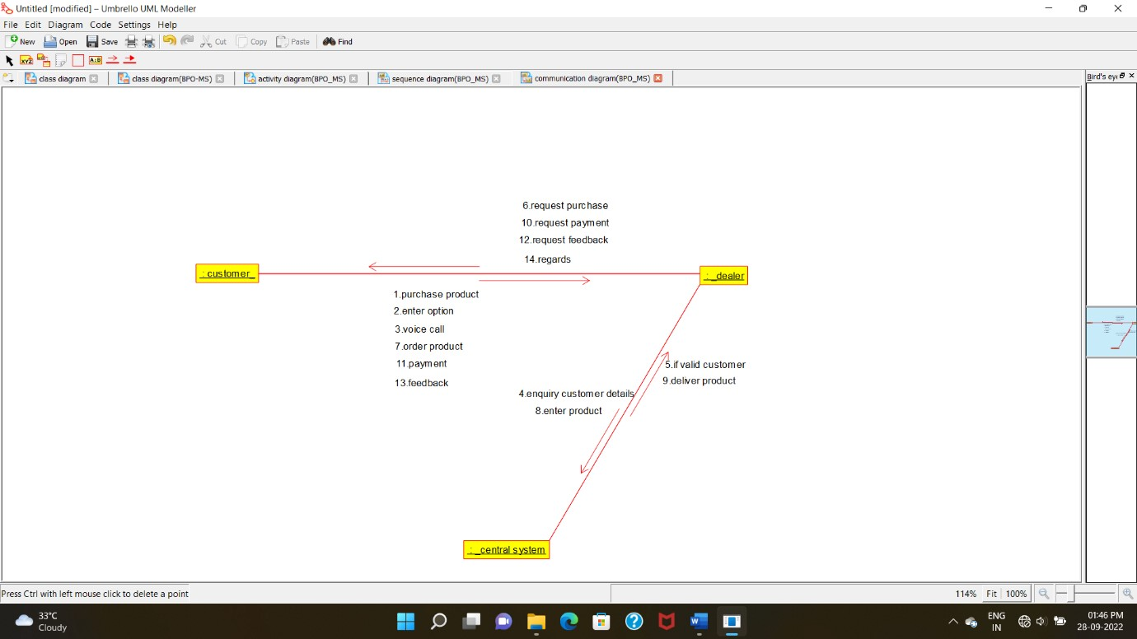

STATECHART DIAGRAM:

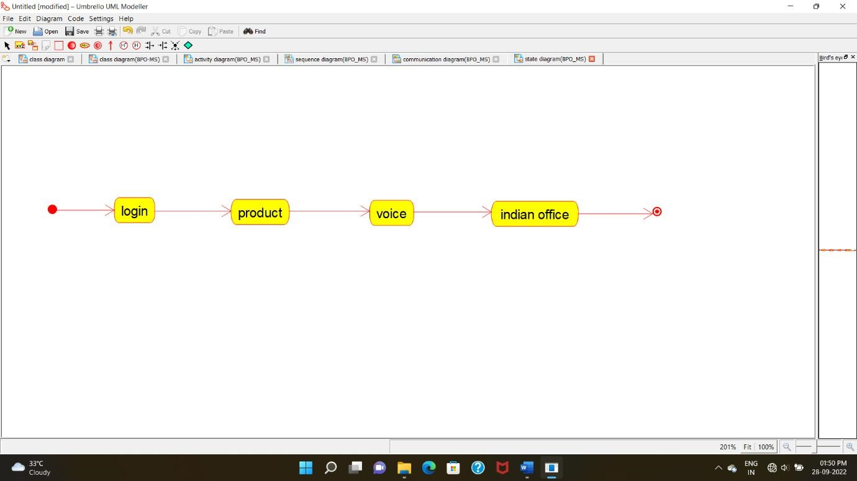

COMPONENT DIAGRAM:

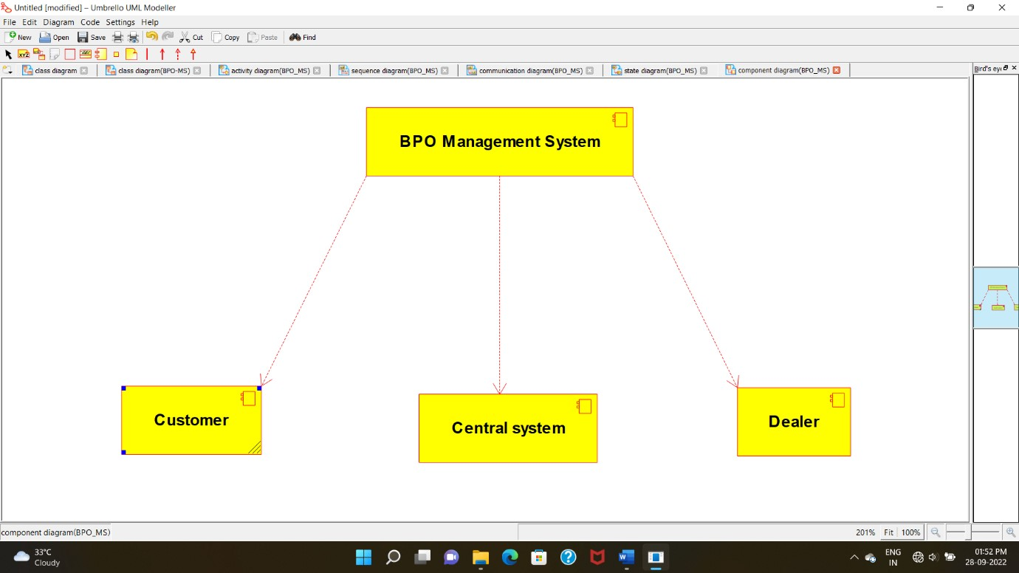

DEPLOYMENT DIAGRAM:

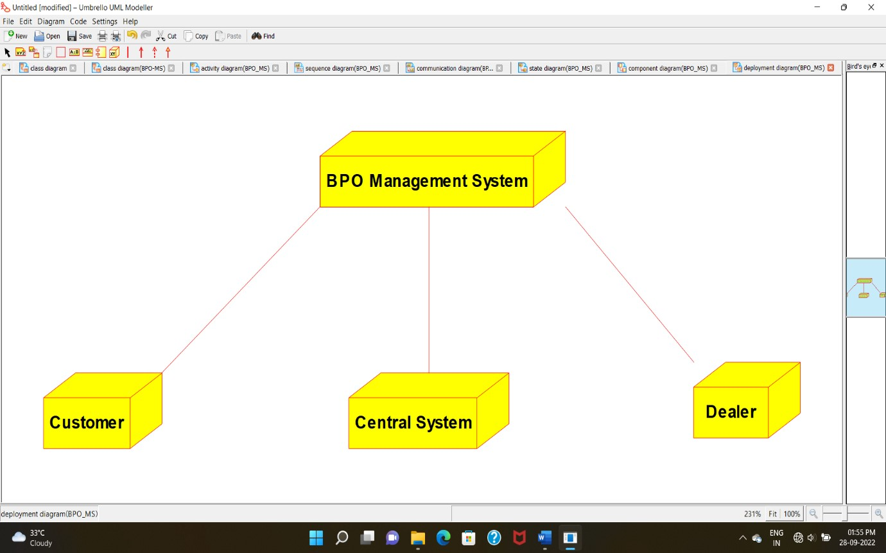

**CODE:**

CENTRAL SYSTEM*:*

/**

* Class central_system

*/ public class central_system {

//

// Fields

//

private void store; private void update;

//

// Constructors

//

public central_system () { };

//

// Methods

//

//

// Accessor methods

//

/**

* Set the value of store
* @param newVar the new value of store

*/

private void setStore (void newVar) { store = newVar;

}

/**

* Get the value of store
* @return the value of store

*/ private void getStore () { return store;

}

/**

* Set the value of update
* @param newVar the new value of update

*/

private void setUpdate (void newVar) { update = newVar;

}

/**

* Get the value of update
* @return the value of update

*/

private void getUpdate () { return update;

}

//

// Other methods

//

/**

*/

public void storing()

{

}

/**

*/

public void updating()

{

}

/**

*/

public void processing()

{

}

}

CUSTOMER:

/**

* Class customer

*/ public class customer {

//

// Fields

//

private void name; private void purchase_product;

//

// Constructors

//

public customer () { };

//

// Methods

//

//

// Accessor methods

//

/**

* Set the value of name
* @param newVar the new value of name

*/

private void setName (void newVar) { name = newVar;

}

/**

* Get the value of name
* @return the value of name

*/

private void getName () { return name;

}

/**

* Set the value of purchase_product
* @param newVar the new value of purchase_product

*/

private void setPurchase_product (void newVar) {

purchase_product = newVar;

}

/**

* Get the value of purchase_product
* @return the value of purchase_product

*/

private void getPurchase_product () { return purchase_product;

}

//

// Other methods

//

/**

*/

public void payment()

{

}

/**

*/

public void feedback()

{

}

/**

*/

public void customer()

{

}

}

DEALER:

/**

* Class dealer */ public class dealer {

//

// Fields

//

private void name; private void availability;

//

// Constructors

//

public dealer () { };

//

// Methods

//

//

// Accessor methods

//

/**

* Set the value of name
* @param newVar the new value of name

*/

private void setName (void newVar) { name = newVar;

}

/**

* Get the value of name
* @return the value of name

*/

private void getName () { return name;

}

/**

* Set the value of availability
* @param newVar the new value of availability

*/

private void setAvailability (void newVar) { availability = newVar;

}

/**

* Get the value of availability
* @return the value of availability

*/

private void getAvailability () { return availability;

}

//

// Other methods

//

/**

*/

public void payment()

{

}

/**

*/

public void delivery()

{

}

/**

*/

public void dealer()

{

}

}