15 – BLOOD BANK REGISTRATION SYSTEM

USE CASE DIAGRAM:

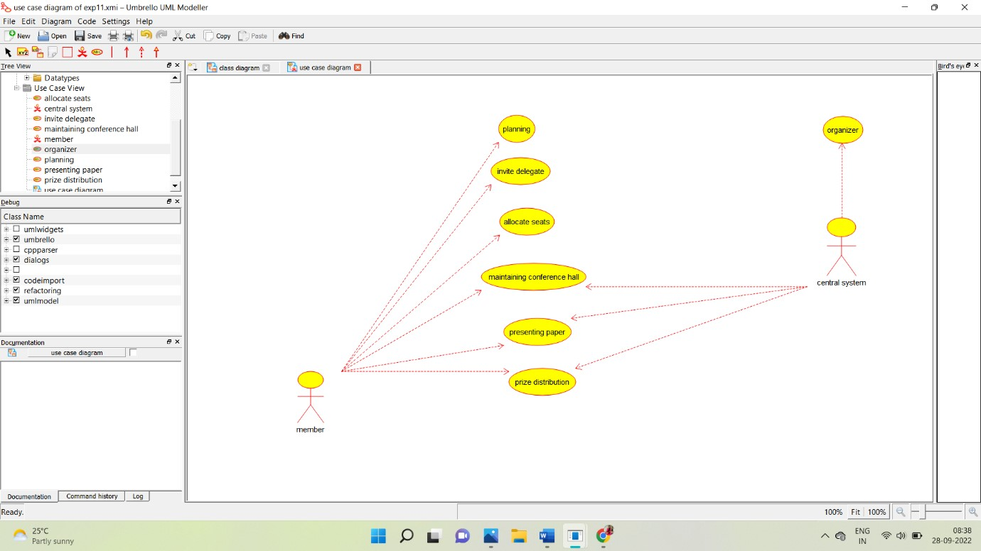

CLASS DIAGRAM:

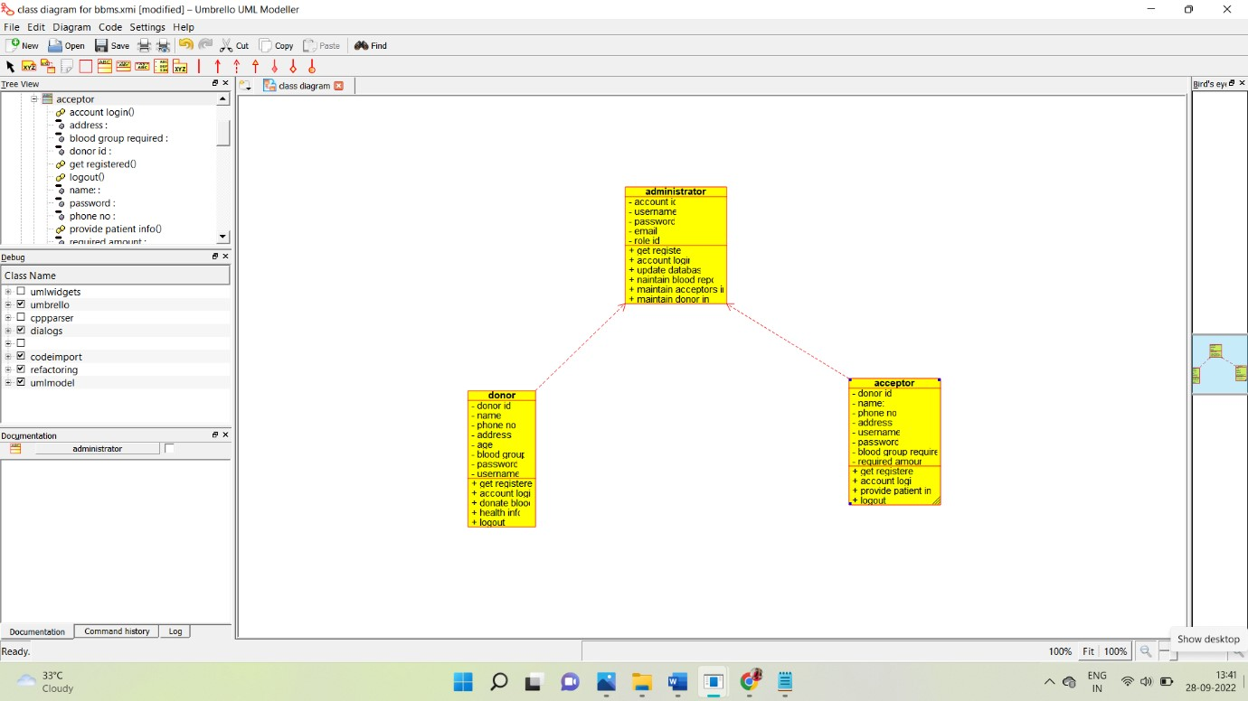

ACTIVITY DIAGRAM:

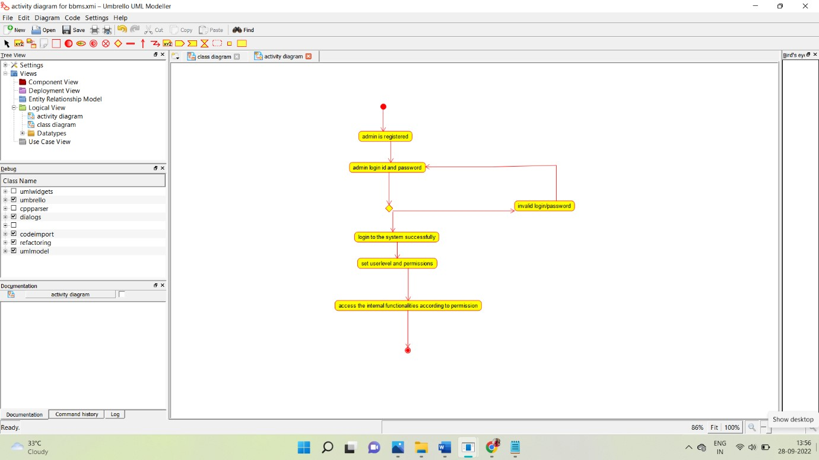

SEQUENCE DIAGRAM:

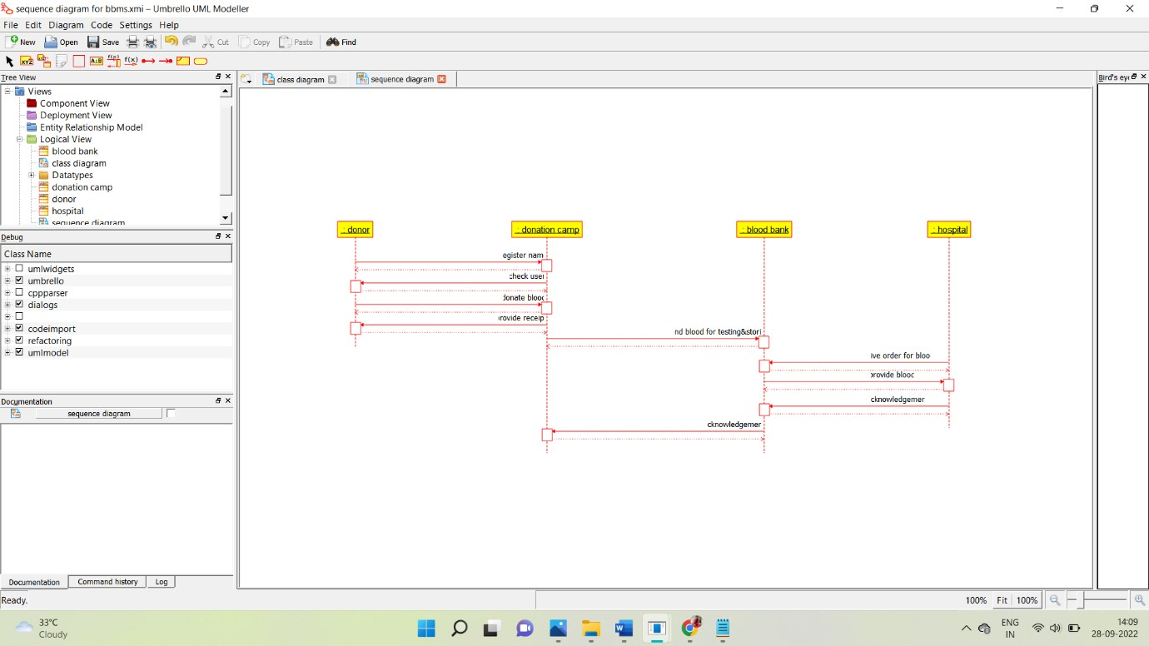

COLLABORATION DIAGRAM:

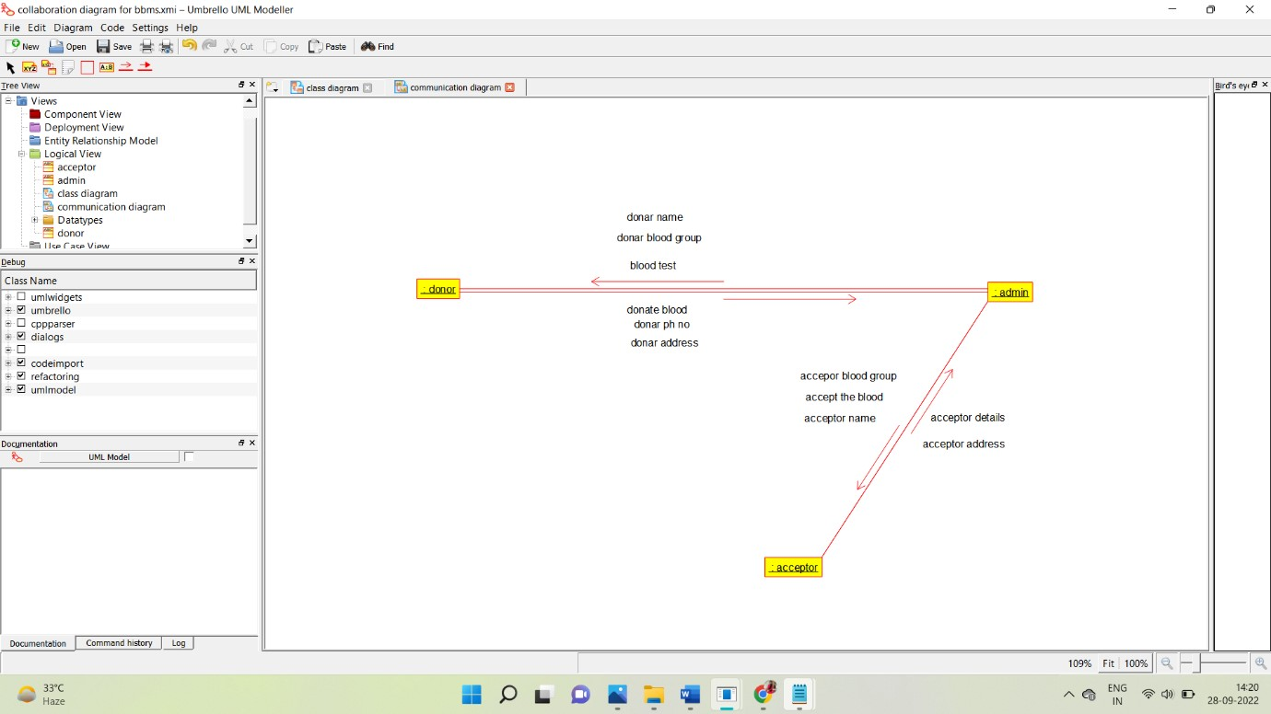

STATE CHART DIAGRAM:

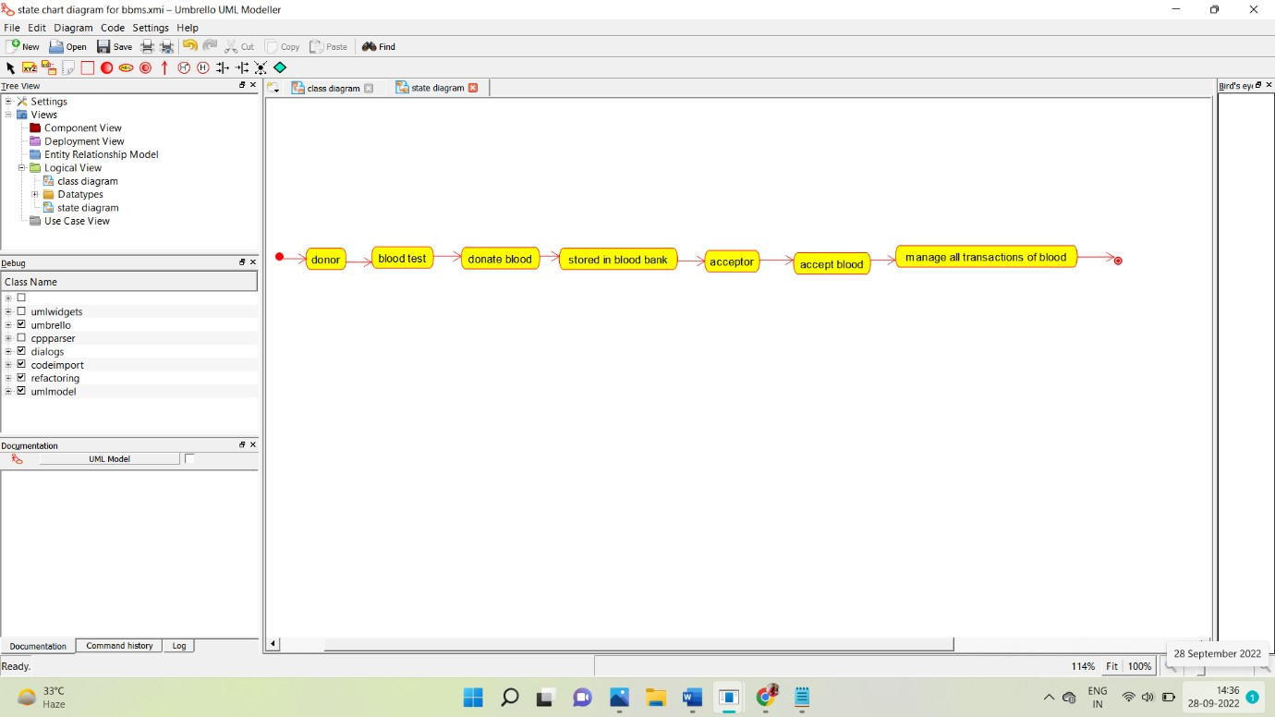

COMPONENT DIAGRAM:

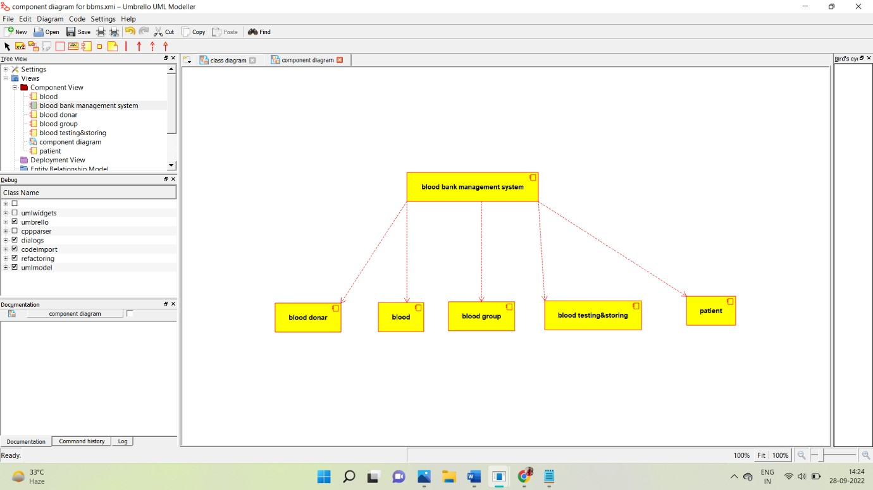

DEPLOYMENT DIAGRAM:

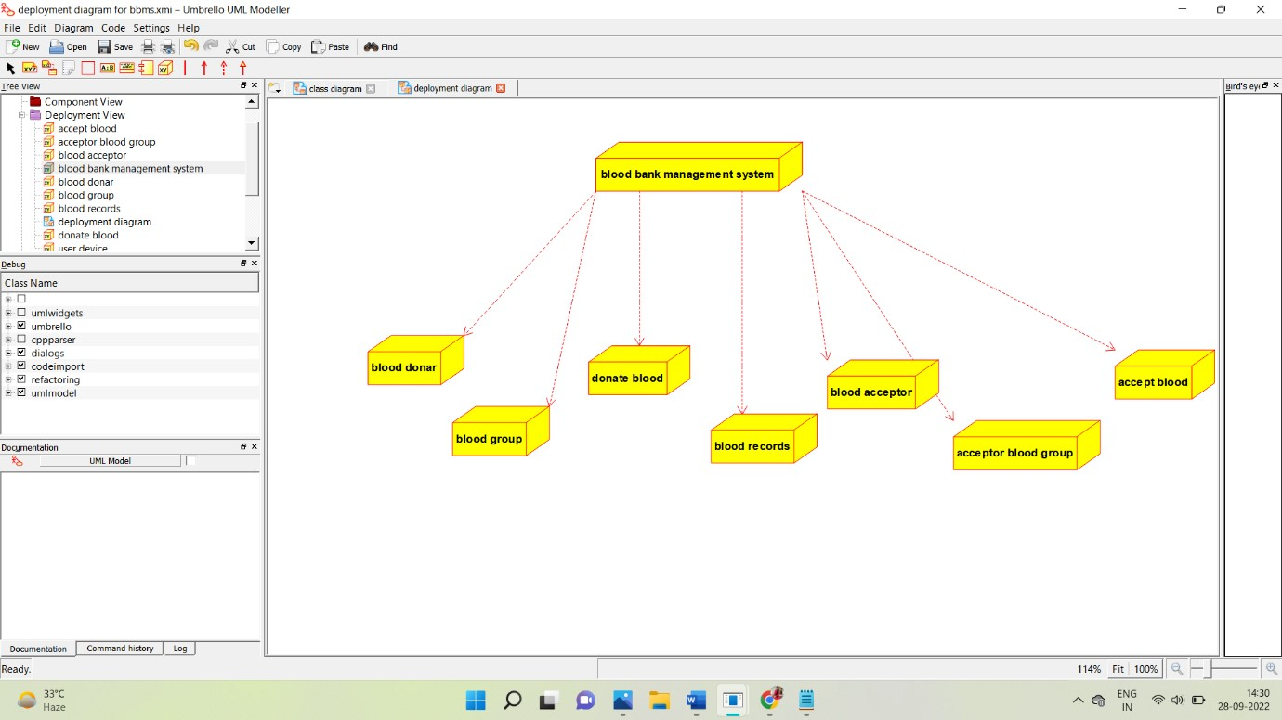

CODE:

/**

* Class administrator

*/

public class administrator {

//

// Fields

//

private void account_id; private void username; private void password; private void email; private void role_id;

//

// Constructors

//

public administrator () { };

//

// Methods

//

//

// Accessor methods

//

/**

* Set the value of account_id
* @param newVar the new value of account_id

*/

private void setAccount_id (void newVar) { account_id = newVar;

}

/**

* Get the value of account_id
* @return the value of account_id

*/

private void getAccount_id () { return account_id;

}

/**

* Set the value of username
* @param newVar the new value of username

*/

private void setUsername (void newVar) {

username = newVar;

}

/**

* Get the value of username
* @return the value of username

*/

private void getUsername () { return username;

}

/**

* Set the value of password
* @param newVar the new value of password

*/

private void setPassword (void newVar) { password = newVar;

}

/**

* Get the value of password
* @return the value of password

*/ private void getPassword () {

return password;

}

/**

* Set the value of email
* @param newVar the new value of email

*/

private void setEmail (void newVar) { email = newVar;

}

/**

* Get the value of email
* @return the value of email

*/

private void getEmail () { return email;

}

/**

* Set the value of role_id
* @param newVar the new value of role_id

*/ private void setRole_id (void newVar) {

role_id = newVar;

}

/**

* Get the value of role_id
* @return the value of role_id

*/

private void getRole_id () { return role_id;

}

//

// Other methods

//

/**

*/

public void get_register()

{

}

/**

*/

public void account_login_()

{

}

/**

*/

public void update_database()

{

}

/**

*/

public void naintain_blood_report()

{

}

/**

*/

public void maintain_acceptors_info()

{

}

/**

*/

public void maintain_donor_info()

{ }

**

* Class donor

*/

public class donor {

//

// Fields

//

private void donor_id; private void name; private void phone_no; private void address; private void age; private void blood_group; private void password; private void username;

//

// Constructors

//

public donor () { };

//

// Methods

//

//

// Accessor methods

//

/**

* Set the value of donor_id
* @param newVar the new value of donor_id

*/

private void setDonor_id (void newVar) {

donor_id = newVar;

* Get the value of donor_id
* @return the value of donor_id

*/

private void getDonor_id () { return donor_id;

}

/**

* Set the value of name
* @param newVar the new value of name

*/

private void setName (void newVar) { name = newVar;

}

/**

* Get the value of name
* @return the value of name

*/

private void getName () { return name;

* Set the value of phone_no
* @param newVar the new value of phone_no

*/

private void setPhone_no (void newVar) { phone_no = newVar;

}

/**

* Get the value of phone_no
* @return the value of phone_no

*/

private void getPhone_no () { return phone_no;

}

/**

* Set the value of address
* @param newVar the new value of address

*/

private void setAddress (void newVar) {

address = newVar;

* Get the value of address
* @return the value of address

*/

private void getAddress () { return address;

}

/**

* Set the value of age
* @param newVar the new value of age

*/

private void setAge (void newVar) { age = newVar;

}

/**

* Get the value of age
* @return the value of age

*/ private void getAge () {

return age;

* Set the value of blood_group
* @param newVar the new value of blood_group

*/

private void setBlood_group (void newVar) { blood_group = newVar;

}

/**

* Get the value of blood_group
* @return the value of blood_group

*/

private void getBlood_group () { return blood_group;

}

/**

* Set the value of password
* @param newVar the new value of password

*/

private void setPassword (void newVar) {

password = newVar;

* Get the value of password
* @return the value of password

*/

private void getPassword () { return password;

}

/**

* Set the value of username
* @param newVar the new value of username

*/

private void setUsername (void newVar) { username = newVar;

}

/**

* Get the value of username
* @return the value of username

*/ private void getUsername () {

return username;

//

// Other methods

//

/**

*/

public void get_registered()

{

}

/**

*/

public void account_login()

{

}

/**

*/

public void donate_blood()

{

/**

*/

public void health_info()

{

}

/**

*/

public void logout()

{

}

}

/**

* Class acceptor

*/

public class acceptor {

//

// Fields

//

private void donor_id; private void name_; private void phone_no; private void address; private void username; private void password; private void blood_group_required; private void required_amount;

//

// Constructors

//

public acceptor () { };

//

// Methods

//

//

// Accessor methods

//

* Set the value of donor_id
* @param newVar the new value of donor_id

*/ private void setDonor_id (void newVar) { donor_id = newVar;

}

/**

* Get the value of donor_id
* @return the value of donor_id

*/

private void getDonor_id () { return donor_id;

}

/**

* Set the value of name_
* @param newVar the new value of name_

*/

private void setName_ (void newVar) {

name_ = newVar;

* Get the value of name_
* @return the value of name_

*/ private void getName_ () { return name_;

}

/**

* Set the value of phone_no
* @param newVar the new value of phone_no

*/

private void setPhone_no (void newVar) { phone_no = newVar;

}

/**

* Get the value of phone_no
* @return the value of phone_no

*/

private void getPhone_no () {

return phone_no;

* Set the value of address
* @param newVar the new value of address

*/ private void setAddress (void newVar) { address = newVar;

}

/**

* Get the value of address
* @return the value of address

*/

private void getAddress () { return address;

}

/**

* Set the value of username
* @param newVar the new value of username

*/

private void setUsername (void newVar) {

username = newVar;

* Get the value of username
* @return the value of username

*/ private void getUsername () { return username;

}

/**

* Set the value of password
* @param newVar the new value of password

*/

private void setPassword (void newVar) { password = newVar;

}

/**

* Get the value of password
* @return the value of password

*/

private void getPassword () {

return password;

* Set the value of blood_group_required
* @param newVar the new value of blood_group_required

private void setBlood_group_required (void newVar) { blood_group_required = newVar;

}

/**

* Get the value of blood_group_required
* @return the value of blood_group_required

*/

private void getBlood_group_required () { return blood_group_required;

}

/**

* Set the value of required_amount
* @param newVar the new value of required_amount

*/

private void setRequired_amount (void newVar) {

required_amount = newVar;

* Get the value of required_amount
* @return the value of required_amount

*/ private void getRequired_amount () { return required_amount;

}

//

// Other methods

//

/**

*/

public void get_registered()

{

}

/**

*/

public void account_login()

{ } /**

*/

public void provide_patient_info()

{

}

/**

*/

public void logout()

{

}