20 - LIBRARY MANAGEMENT SYSTEM

# USE CASE DIAGRAM:

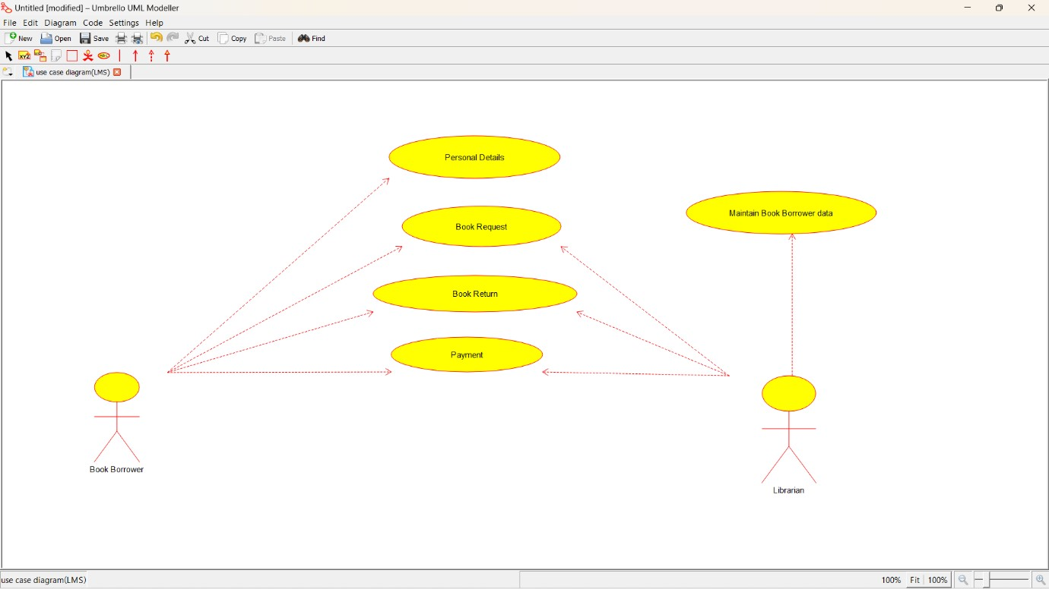

CLASS DIAGRAM:

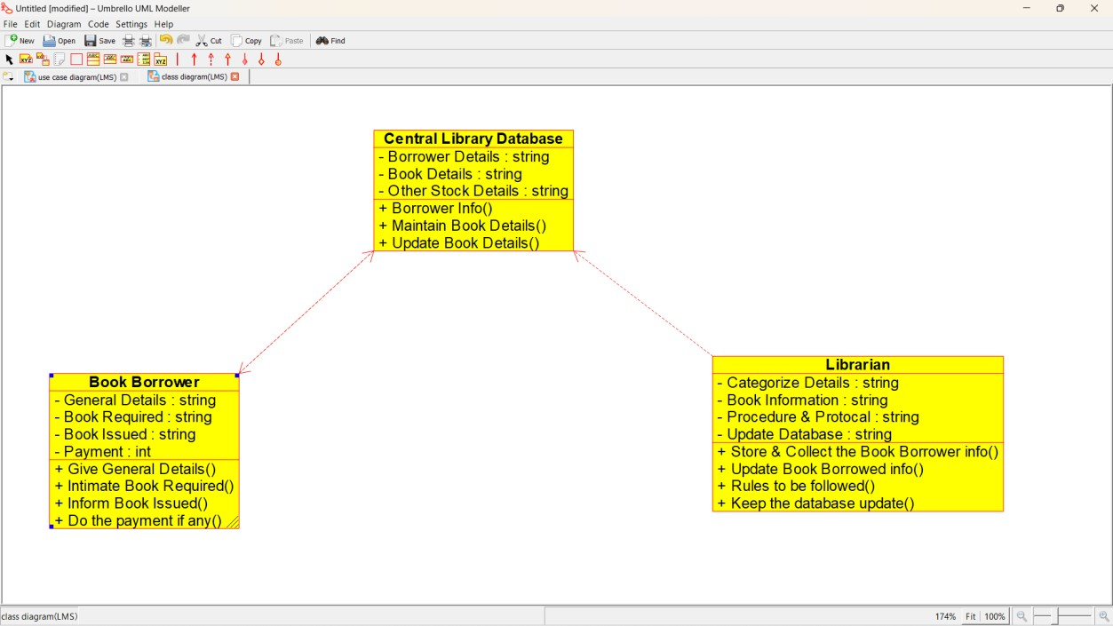

ACTIVITY DIAGRAM:

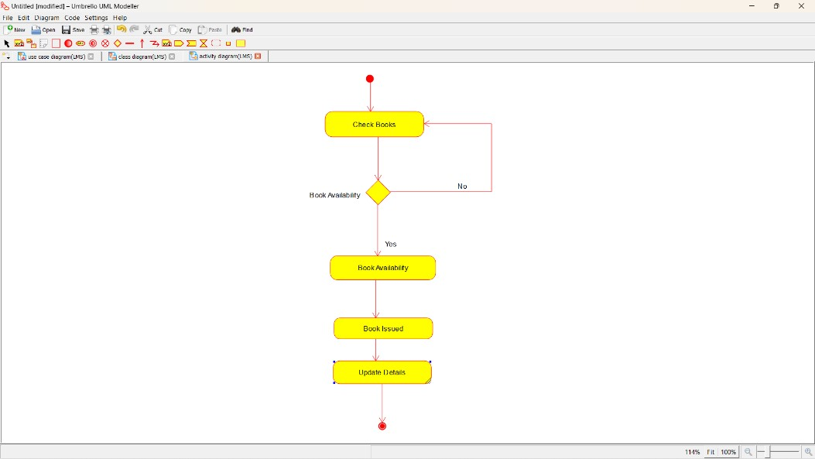

SEQUENCE DIAGRAM:

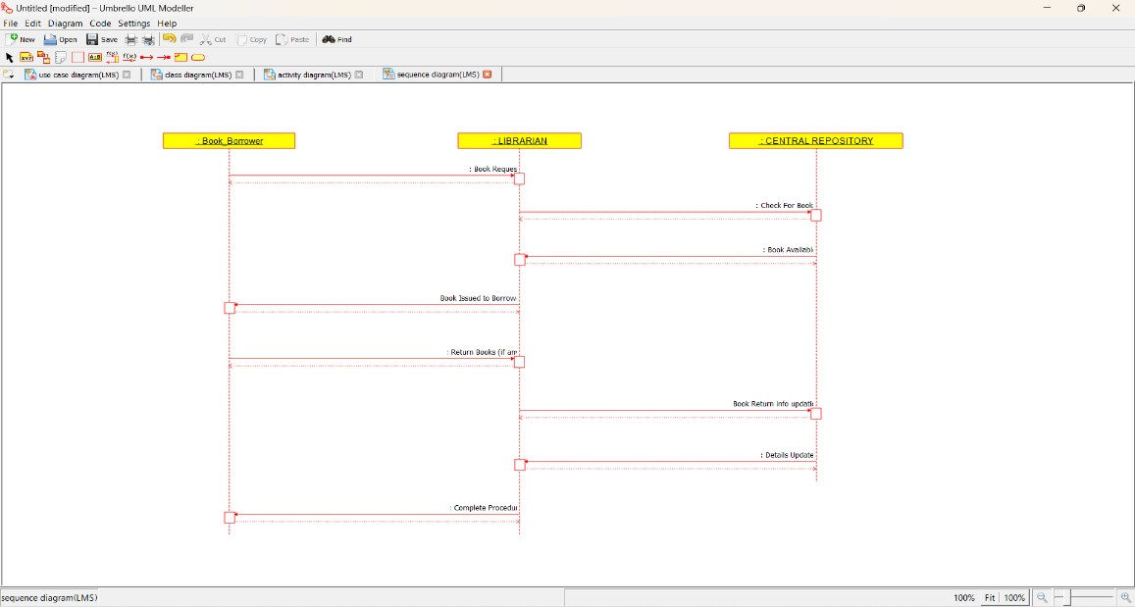

COLLABORATION DIAGRAM:

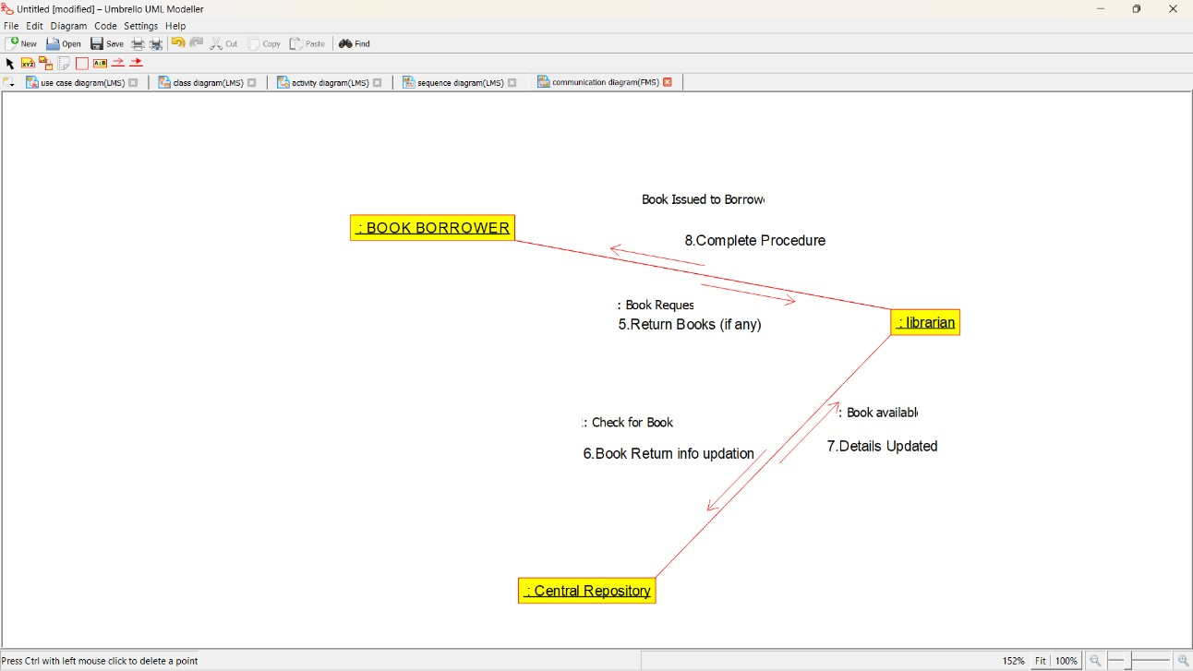

STATE CHART DIAGRAM:

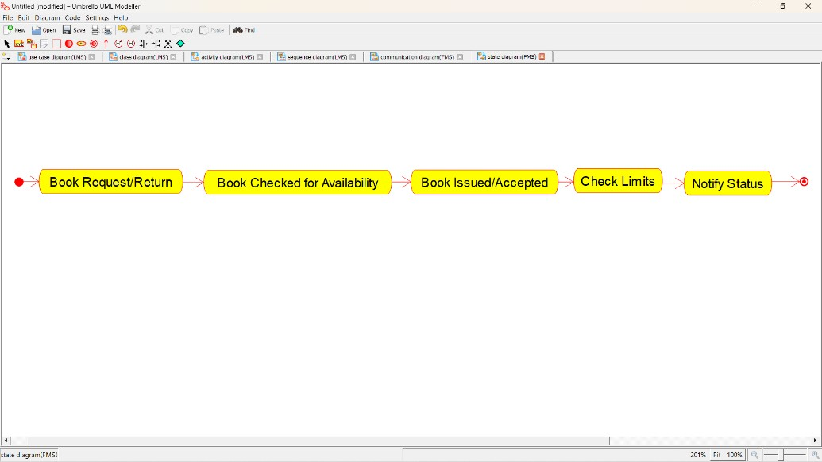

COMPOMEMT DIAGRAM:

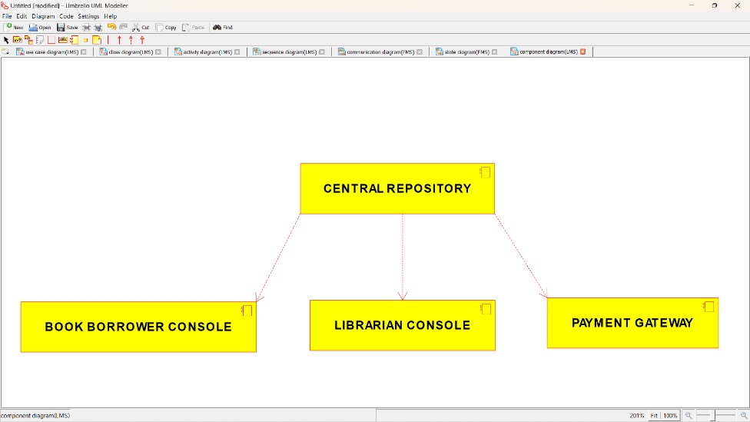

# DEPLOYMENT DIAGRAM:

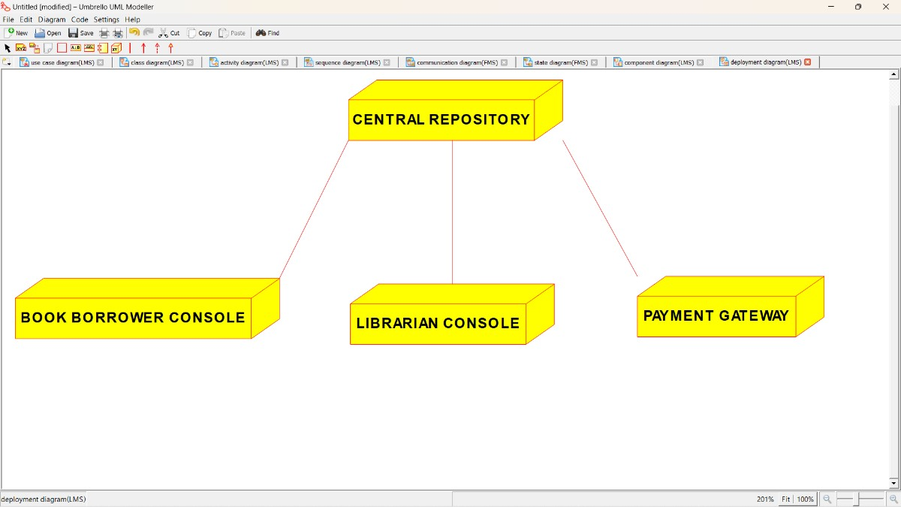

**CODE:**

/**

* Class Central_Library_Database

*/

public class Central_Library_Database {

//

// Fields

//

private String Borrower_Details; private String Book_Details; private String Other_Stock_Details;

//

// Constructors

//

public Central_Library_Database () { };

//

// Methods

//

//

// Accessor methods

//

/**

* Set the value of Borrower_Details
* @param newVar the new value of Borrower_Details

*/

private void setBorrower_Details (String newVar) {

Borrower_Details = newVar;

}

/**

* Get the value of Borrower_Details
* @return the value of Borrower_Details

*/

private String getBorrower_Details () { return Borrower_Details;

}

/**

* Set the value of Book_Details
* @param newVar the new value of Book_Details

*/

private void setBook_Details (String newVar) {

Book_Details = newVar;

}

/**

* Get the value of Book_Details
* @return the value of Book_Details

*/

private String getBook_Details () { return Book_Details;

}

/**

* Set the value of Other_Stock_Details
* @param newVar the new value of Other_Stock_Details

*/

private void setOther_Stock_Details (String newVar) {

Other_Stock_Details = newVar;

}

/**

* Get the value of Other_Stock_Details
* @return the value of Other_Stock_Details

*/

private String getOther_Stock_Details () {

return Other_Stock_Details;

}

//

// Other methods

//

/**

*/

public void Borrower_Info()

{

}

/**

*/

public void Maintain_Book_Details()

{

}

/**

*/

public void Update_Book_Details()

{

}

}

/**

* Class Book_Borrower

*/

public class Book_Borrower {

//

// Fields

//

private String General_Details; private String Book_Required; private String Book_Issued;

private int Payment;

//

// Constructors

//

public Book_Borrower () { };

//

// Methods

//

//

// Accessor methods

//

/**

* Set the value of General_Details
* @param newVar the new value of General_Details

*/

private void setGeneral_Details (String newVar) {

General_Details = newVar;

}

/**

* Get the value of General_Details
* @return the value of General_Details

*/

private String getGeneral_Details () { return General_Details;

}

/**

* Set the value of Book_Required
* @param newVar the new value of Book_Required

*/

private void setBook_Required (String newVar) {

Book_Required = newVar;

}

/**

* Get the value of Book_Required
* @return the value of Book_Required

*/

private String getBook_Required () { return Book_Required;

}

/**

* Set the value of Book_Issued
* @param newVar the new value of Book_Issued

*/

private void setBook_Issued (String newVar) {

Book_Issued = newVar;

}

/**

* Get the value of Book_Issued
* @return the value of Book_Issued

*/

private String getBook_Issued () {

return Book_Issued;

}

/**

* Set the value of Payment
* @param newVar the new value of Payment

*/

private void setPayment (int newVar) {

Payment = newVar;

}

/**

* Get the value of Payment
* @return the value of Payment

*/

private int getPayment () { return Payment;

}

//

// Other methods

//

/**

*/

public void Give_General_Details()

{

}

/**

*/

public void Intimate_Book_Required()

{

}

/**

*/

public void Inform_Book_Issued()

{

}

/**

*/

public void Do_the_payment_if_any()

{

}

}

/**

* Class Librarian

*/

public class Librarian {

//

// Fields

//

private String Categorize_Details; private String Book_Information; private String Procedure_Protocal; private String Update_Database;

//

// Constructors

//

public Librarian () { };

//

// Methods

//

//

// Accessor methods

//

/**

* Set the value of Categorize_Details
* @param newVar the new value of Categorize_Details

*/

private void setCategorize_Details (String newVar) {

Categorize_Details = newVar;

}

/**

* Get the value of Categorize_Details
* @return the value of Categorize_Details

*/

private String getCategorize_Details () { return Categorize_Details;

}

/**

* Set the value of Book_Information
* @param newVar the new value of Book_Information

*/

private void setBook_Information (String newVar) {

Book_Information = newVar;

}

/**

* Get the value of Book_Information
* @return the value of Book_Information

*/

private String getBook_Information () { return Book_Information;

}

/**

* Set the value of Procedure_Protocal
* @param newVar the new value of Procedure_Protocal

*/

private void setProcedure_Protocal (String newVar) {

Procedure_Protocal = newVar;

}

/**

* Get the value of Procedure_Protocal
* @return the value of Procedure_Protocal

*/

private String getProcedure_Protocal () { return Procedure_Protocal;

}

/**

* Set the value of Update_Database
* @param newVar the new value of Update_Database

*/

private void setUpdate_Database (String newVar) {

Update_Database = newVar;

}

/**

* Get the value of Update_Database
* @return the value of Update_Database

*/

private String getUpdate_Database () { return Update_Database;

}

//

// Other methods

//

/**

*/

public void Store_Collect_the_Book_Borrower_info()

{

}

/**

*/

public void Update_Book_Borrowed_info()

{

}

/**

*/

public void Rules_to_be_followed()

{

}

/**

*/

public void Keep_the_database_update()

{

}

}