# 21- HOSPITAL MANAGEMENT SYSTEM

# USE CASE DIAGRAM:

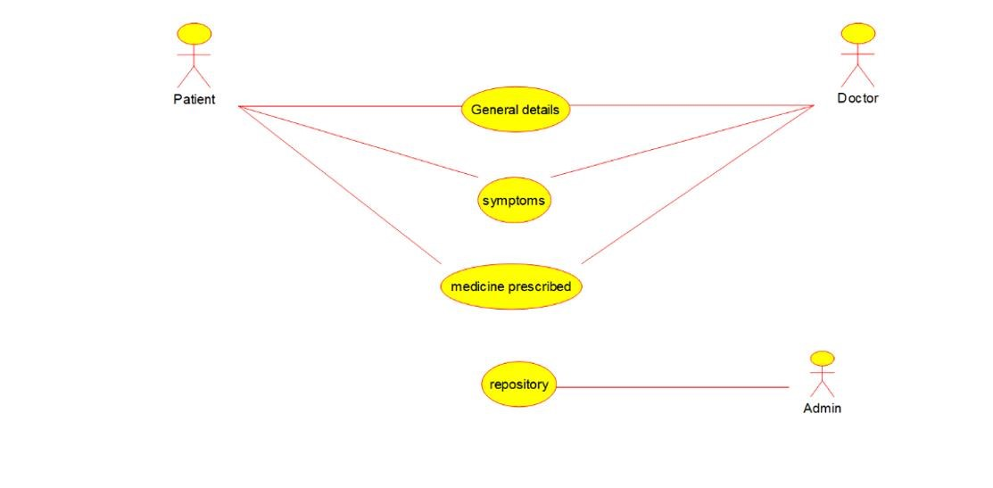

# CLASS DIAGRAM:

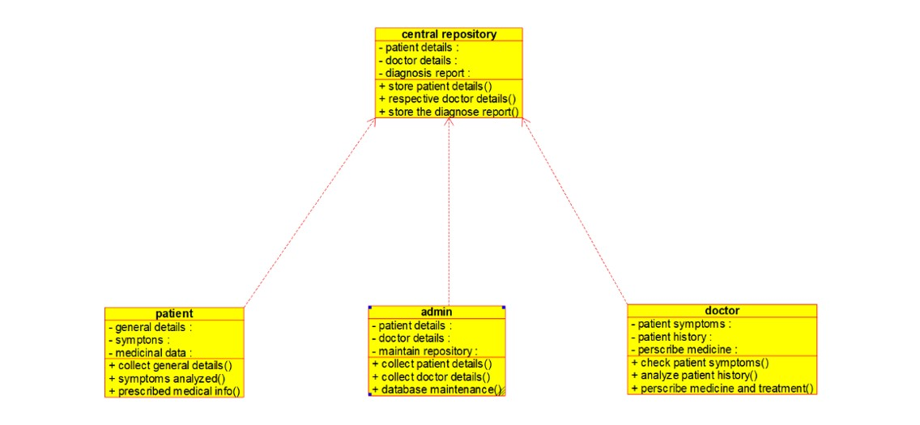

# ACTIVITY DIAGRAM:

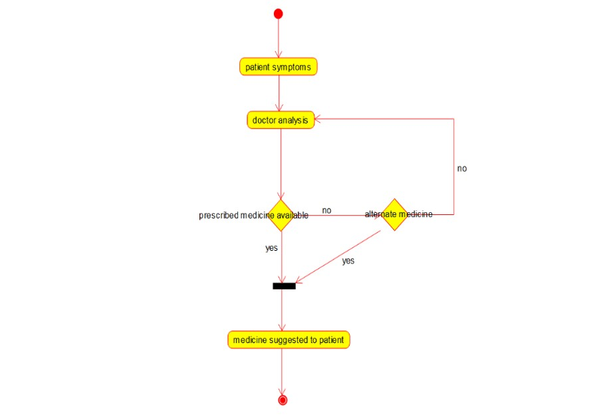

# SEQUENCE DIAGRAM:

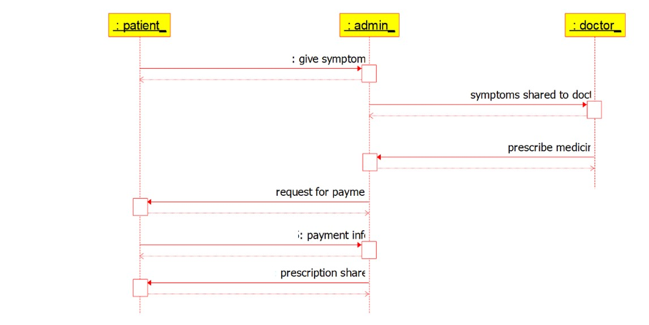

# COLLOBORATION DIAGRAM:

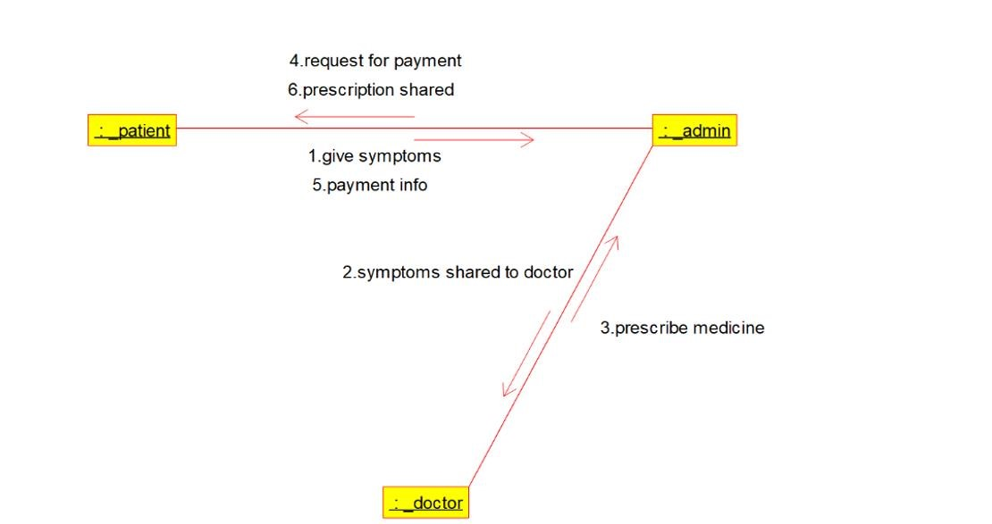

# STATE CHART DIAGRAM:

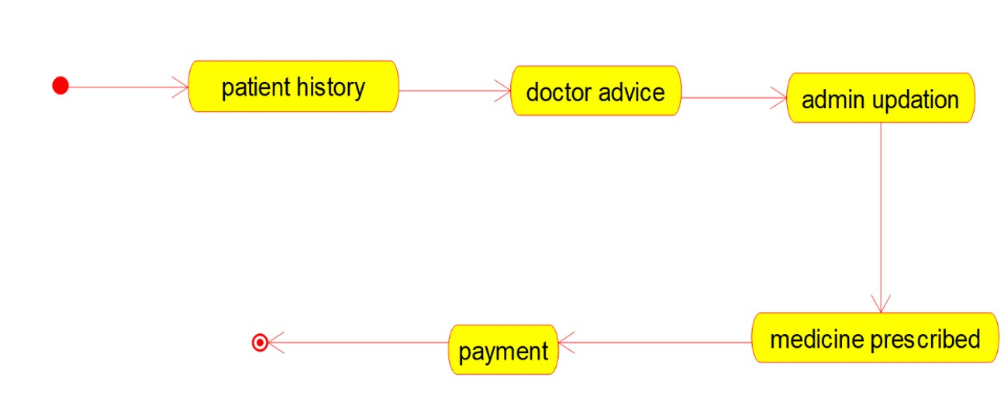

# COMPONENT DIAGRAM:

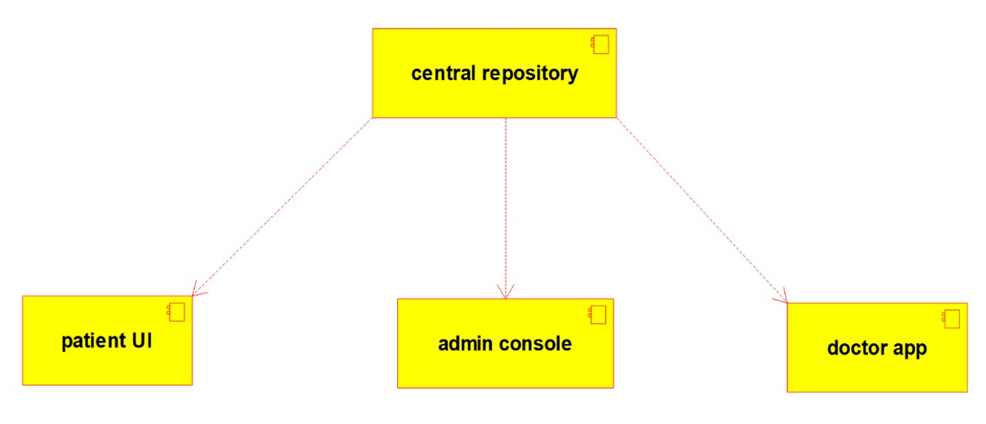

# DEPLOYMENT DIAGRAM:

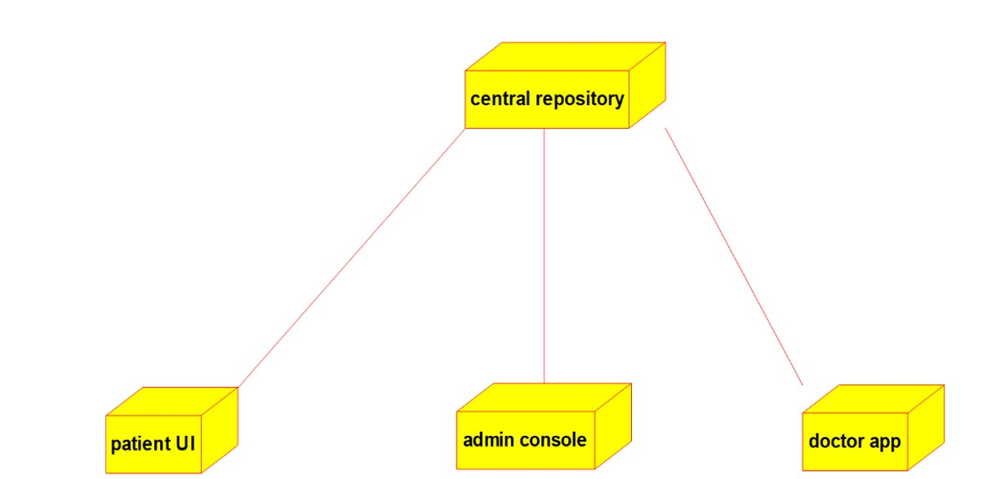

**CODE:**

**CENTRAL REPOSITORY:**

/**

* Class central_repository

*/

public class central_repository {

//

// Fields

//

private void patient_details; private void doctor_details; private void diagnosis_report;

//

// Constructors

//

public central_repository () { };

//

// Methods

//

//

// Accessor methods

//

/**

* Set the value of patient_details
* @param newVar the new value of patient_details

*/

private void setPatient_details (void newVar) { patient_details = newVar;

}

/**

* Get the value of patient_details
* @return the value of patient_details

*/

private void getPatient_details () { return patient_details;

}

/**

* Set the value of doctor_details
* @param newVar the new value of doctor_details

*/

private void setDoctor_details (void newVar) { doctor_details = newVar;

}

/**

* Get the value of doctor_details
* @return the value of doctor_details

*/

private void getDoctor_details () { return doctor_details;

}

/**

* Set the value of diagnosis_report
* @param newVar the new value of diagnosis_report

*/

private void setDiagnosis_report (void newVar) { diagnosis_report = newVar;

}

/**

* Get the value of diagnosis_report
* @return the value of diagnosis_report

*/

private void getDiagnosis_report () { return diagnosis_report;

}

//

// Other methods

//

/**

*/

public void store_patient_details()

{

}

/**

*/

public void respective_doctor_details()

{

}

/**

*/

public void store_the_diagnose_report()

{

}

}

**PATIENT:**

/**

* Class patient */ public class patient {

//

// Fields

//

private void general_details; private void symptons; private void medicinal_data;

//

// Constructors

//

public patient () { };

//

// Methods

//

//

// Accessor methods

//

/**

* Set the value of general_details
* @param newVar the new value of general_details

*/

private void setGeneral_details (void newVar) { general_details = newVar;

}

/**

* Get the value of general_details
* @return the value of general_details

*/

private void getGeneral_details () { return general_details;

}

/**

* Set the value of symptons
* @param newVar the new value of symptons

*/

private void setSymptons (void newVar) { symptons = newVar;

}

/**

* Get the value of symptons
* @return the value of symptons

*/

private void getSymptons () { return symptons;

}

/**

* Set the value of medicinal_data
* @param newVar the new value of medicinal_data

*/

private void setMedicinal_data (void newVar) { medicinal_data = newVar;

}

/**

* Get the value of medicinal_data
* @return the value of medicinal_data

*/

private void getMedicinal_data () { return medicinal_data;

}

//

// Other methods

//

/**

*/ public void collect_general_details()

{

}

/**

*/

public void symptoms_analyzed()

{

}

/**

*/

public void prescribed_medical_info()

{

}

}

**ADMIN:**

/**

* Class admin

*/ public class admin {

//

// Fields

//

private void patient_details; private void doctor_details; private void maintain_repository;

//

// Constructors

//

public admin () { };

//

// Methods

//

//

// Accessor methods

//

/**

* Set the value of patient_details
* @param newVar the new value of patient_details

*/

private void setPatient_details (void newVar) { patient_details = newVar;

}

/**

* Get the value of patient_details
* @return the value of patient_details

*/

private void getPatient_details () { return patient_details;

}

/**

* Set the value of doctor_details
* @param newVar the new value of doctor_details

*/

private void setDoctor_details (void newVar) { doctor_details = newVar;

}

/**

* Get the value of doctor_details
* @return the value of doctor_details

*/ private void getDoctor_details () {

return doctor_details;

}

/**

* Set the value of maintain_repository
* @param newVar the new value of maintain_repository

*/

private void setMaintain_repository (void newVar) { maintain_repository = newVar;

}

/**

* Get the value of maintain_repository
* @return the value of maintain_repository

*/

private void getMaintain_repository () { return maintain_repository;

}

//

// Other methods

//

/**

*/

public void collect_patient_details()

{

}

/**

*/

public void collect_doctor_details()

{

}

/**

*/

public void database_maintenance()

{

}

}

**DOCTOR:**

/**

* Class doctor

*/ public class doctor {

//

// Fields

//

private void patient_symptoms; private void patient_history; private void perscribe_medicine;

//

// Constructors

//

public doctor () { };

//

// Methods

//

//

// Accessor methods

//

/**

* Set the value of patient_symptoms * @param newVar the new value of patient_symptoms

*/

private void setPatient_symptoms (void newVar) { patient_symptoms = newVar;

}

/**

* Get the value of patient_symptoms
* @return the value of patient_symptoms

*/

private void getPatient_symptoms () { return patient_symptoms;

}

/**

* Set the value of patient_history
* @param newVar the new value of patient_history

*/

private void setPatient_history (void newVar) { patient_history = newVar;

}

/**

* Get the value of patient_history
* @return the value of patient_history

*/

private void getPatient_history () { return patient_history;

}

/**

* Set the value of perscribe_medicine
* @param newVar the new value of perscribe_medicine

*/

private void setPerscribe_medicine (void newVar) {

perscribe_medicine = newVar;

}

/**

* Get the value of perscribe_medicine
* @return the value of perscribe_medicine

*/

private void getPerscribe_medicine () { return perscribe_medicine;

}

//

// Other methods

//

/**

*/

public void check_patient_symptoms()

{

}

/**

*/

public void analyze_patient_history()

{

}

/**

*/

public void perscribe_medicine_and_treatment()

{

}

}