22- ONLINE INSURANCE PROCESSING SYSTEM

USE CASE DIAGRAM:

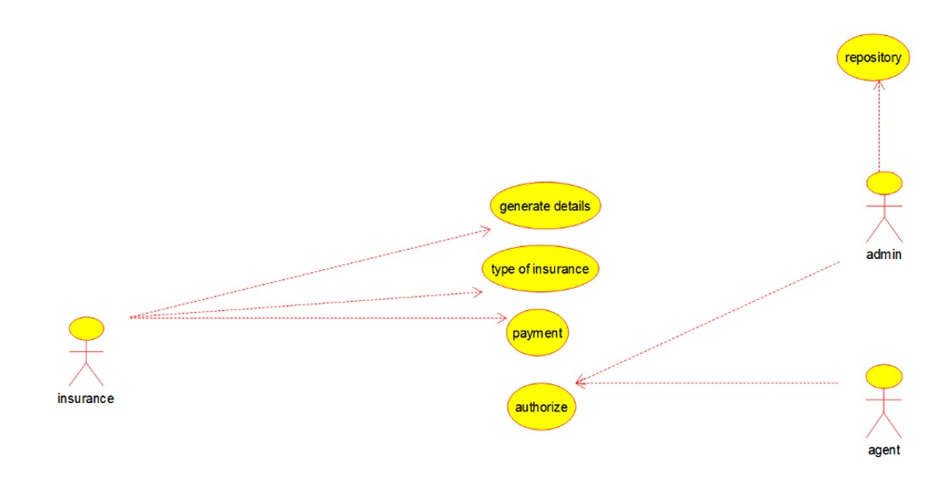

CLASS DIAGRAM:

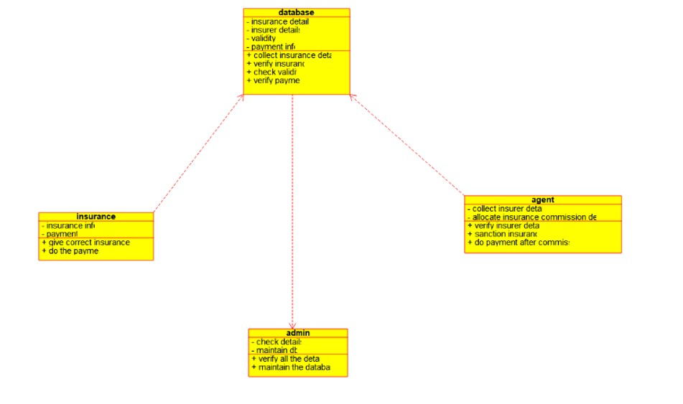

ACTIVITY DIAGRAM:

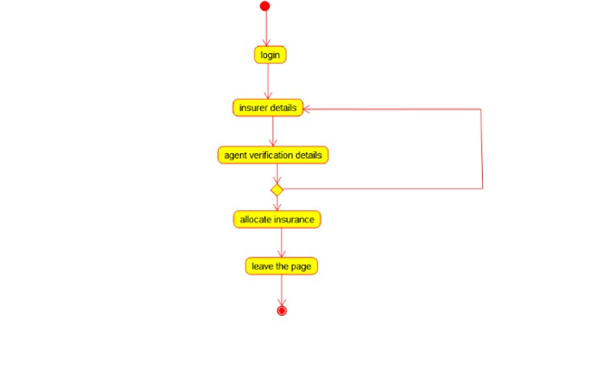

SEQUENCE DIAGRAM:

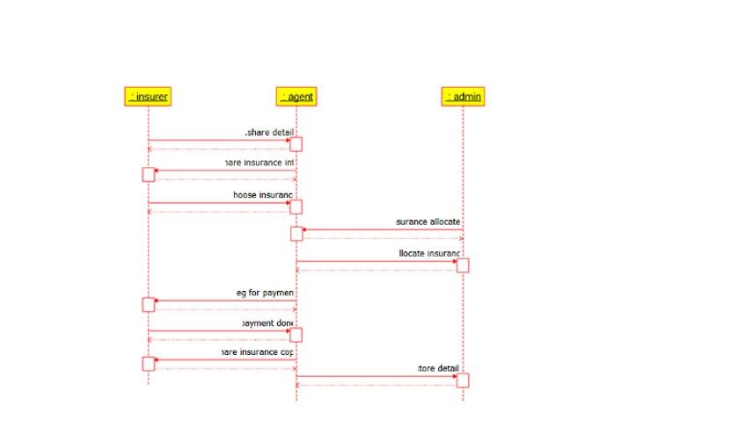

COLLOBORATION DIAGRAM:

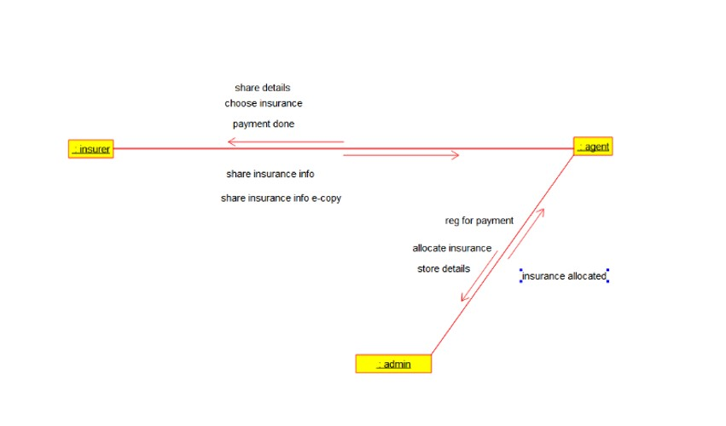

STATE CHART DIAGRAM:

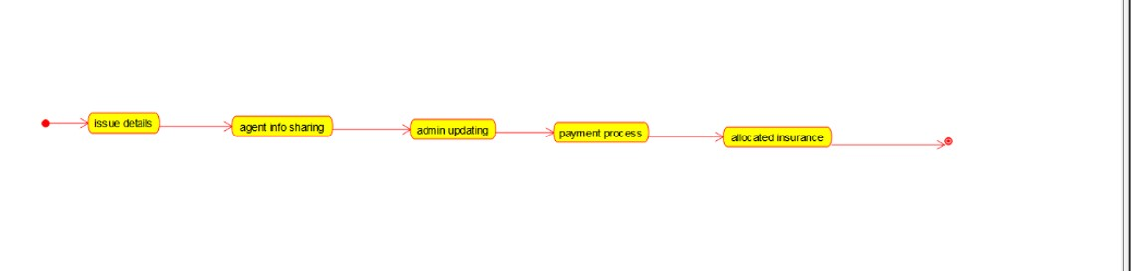

COMPONENET DIAGRAM:

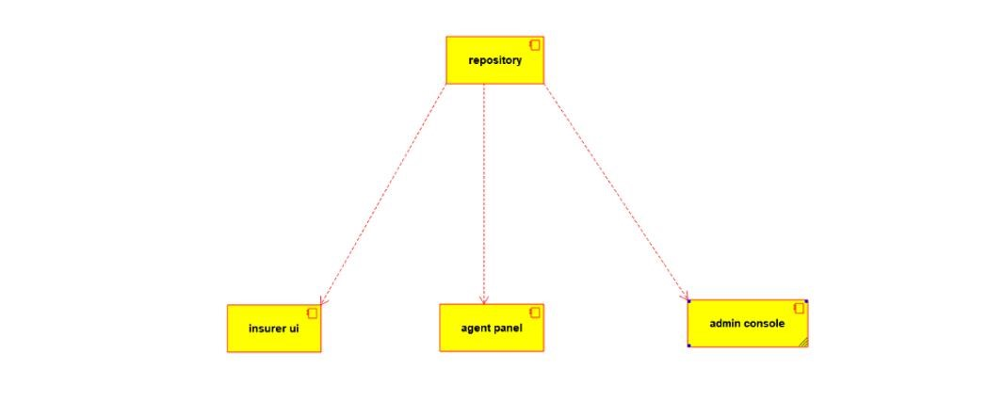

DEPLOYMENT DIAGRAM:

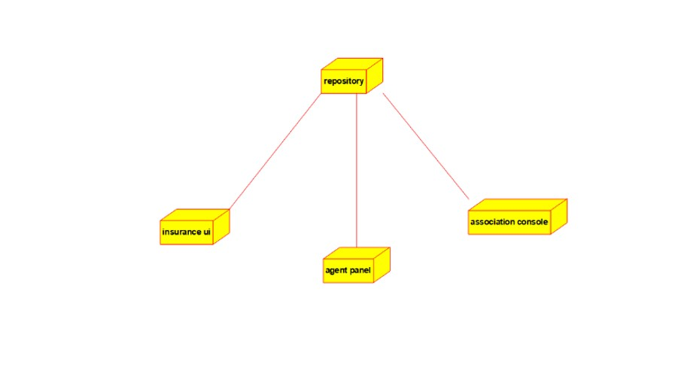

CODE:

/**

* Class admin

*/

public class admin {

//

// Fields

//

private void check_details; private void maintain_db;

//

// Constructors

//

public admin () { };

//

// Methods

//

//

// Accessor methods

//

/**

* Set the value of check_details
* @param newVar the new value of check_details */

private void setCheck_details (void newVar) { check_details = newVar;

}

/**

* Get the value of check_details
* @return the value of check_details

*/

private void getCheck_details () { return check_details;

}

/**

* Set the value of maintain_db
* @param newVar the new value of maintain_db

*/

private void setMaintain_db (void newVar) { maintain_db = newVar;

}

/**

* Get the value of maintain_db
* @return the value of maintain_db

*/

private void getMaintain_db () { return maintain_db;

}

//

// Other methods

//

/**

*/

public void verify_all_the_details()

{

}

/**

*/

public void maintain_the_database()

{

}

}

/**

* Class agent

*/ public class agent {

//

// Fields

//

private void collect_insurer_details; private void allocate_insurance_commission_details;

//

// Constructors

//

public agent () { };

//

// Methods

//

//

// Accessor methods

//

/**

* Set the value of collect_insurer_details
* @param newVar the new value of collect_insurer_details

*/

private void setCollect_insurer_details (void newVar) { collect_insurer_details = newVar;

}

/**

* Get the value of collect_insurer_details
* @return the value of collect_insurer_details

*/

private void getCollect_insurer_details () { return collect_insurer_details;

}

/**

* Set the value of allocate_insurance_commission_details
* @param newVar the new value of allocate_insurance_commission_details

*/

private void setAllocate_insurance_commission_details (void newVar) { allocate_insurance_commission_details = newVar;

}

/**

* Get the value of allocate_insurance_commission_details
* @return the value of allocate_insurance_commission_details

*/

private void getAllocate_insurance_commission_details () { return allocate_insurance_commission_details;

}

//

// Other methods

//

/**

*/

public void verify_insurer_details()

{

}

/**

*/

public void sanction_insurance()

{

}

/**

*/

public void do_payment_after_commission()

{

}

}

/**

* Class database

*/

public class database {

//

// Fields

//

private void insurance_details; private void insurer_details; private void validity; private void payment_info;

//

// Constructors

//

public database () { };

//

// Methods

//

//

// Accessor methods

//

/**

* Set the value of insurance_details
* @param newVar the new value of insurance_details

*/

private void setInsurance_details (void newVar) { insurance_details = newVar;

}

/**

* Get the value of insurance_details
* @return the value of insurance_details

*/

private void getInsurance_details () { return insurance_details;

}

/**

* Set the value of insurer_details
* @param newVar the new value of insurer_details

*/

private void setInsurer_details (void newVar) { insurer_details = newVar;

}

/**

* Get the value of insurer_details
* @return the value of insurer_details

*/

private void getInsurer_details () { return insurer_details;

}

/**

* Set the value of validity
* @param newVar the new value of validity

*/

private void setValidity (void newVar) { validity = newVar;

}

/**

* Get the value of validity
* @return the value of validity

*/

private void getValidity () { return validity;

}

/**

* Set the value of payment_info
* @param newVar the new value of payment_info

*/

private void setPayment_info (void newVar) { payment_info = newVar;

}

/**

* Get the value of payment_info
* @return the value of payment_info

*/

private void getPayment_info () { return payment_info;

}

//

// Other methods

//

/**

*/

public void collect_insurance_details()

{

}

/**

*/

public void verify_insurance()

{

}

/**

*/

public void check_validity()

{

}

/**

*/

public void verify_payment()

{

}

}

/**

* Class insurance

*/

public class insurance {

//

// Fields

//

private void insurance_info; private void payment;

//

// Constructors

//

public insurance () { };

//

// Methods

//

//

// Accessor methods

//

/**

* Set the value of insurance_info
* @param newVar the new value of insurance_info

*/

private void setInsurance_info (void newVar) { insurance_info = newVar;

}

/**

* Get the value of insurance_info
* @return the value of insurance_info

*/

private void getInsurance_info () { return insurance_info;

}

/**

* Set the value of payment
* @param newVar the new value of payment

*/

private void setPayment (void newVar) { payment = newVar;

}

/**

* Get the value of payment
* @return the value of payment

*/

private void getPayment () { return payment;

}

//

// Other methods

//

/**

*/

public void give_correct_insurance_info()

{

}

/**

*/

public void do_the_payment()

{

}

}