# 23 - ONLINE SHOPPING SYSTEM

# USE CASE DIAGRAM:

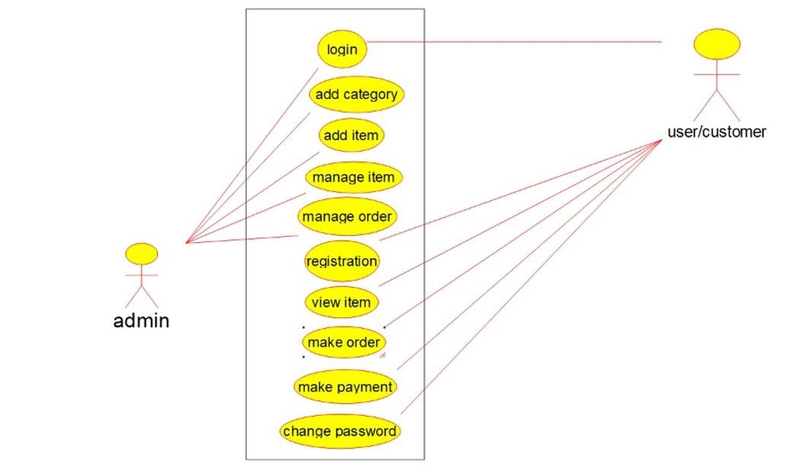

# CLASS DIAGRAM:

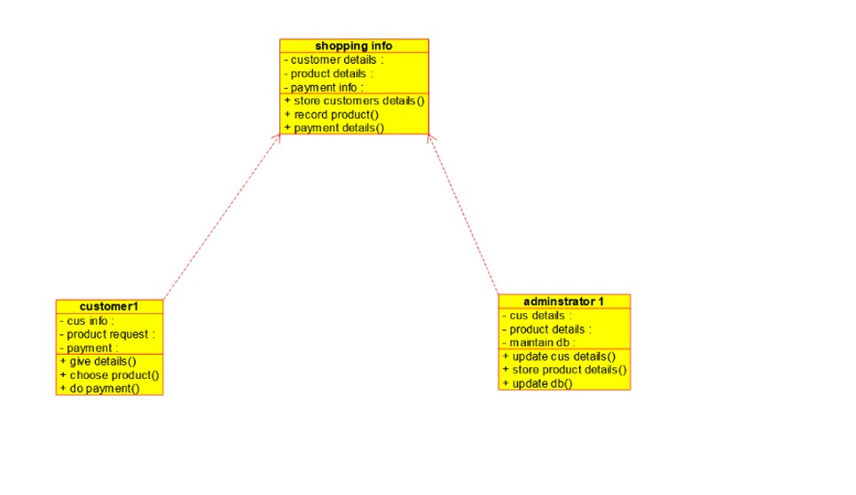

# ACTIVITY DIAGRAM :

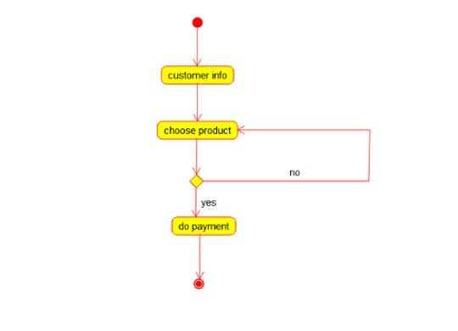

# SEQUENCE DIAGRAM:

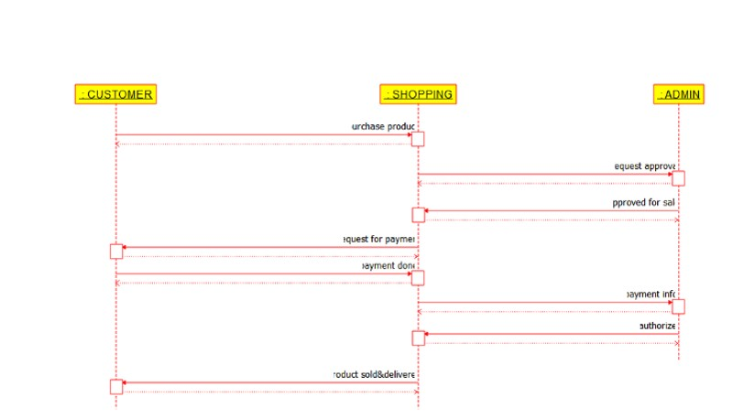

# COLLOBORATION DIAGRAM:

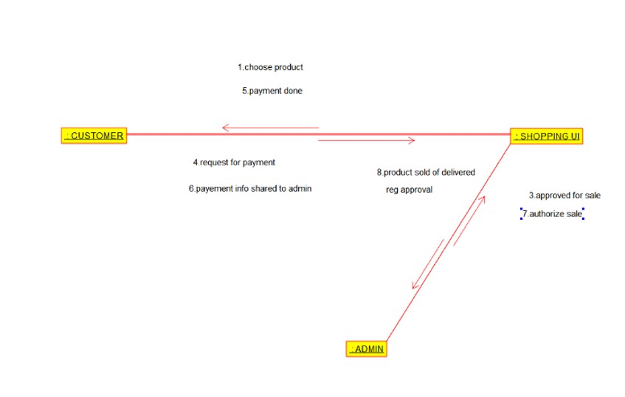

# STATE CHART DIAGRAM:

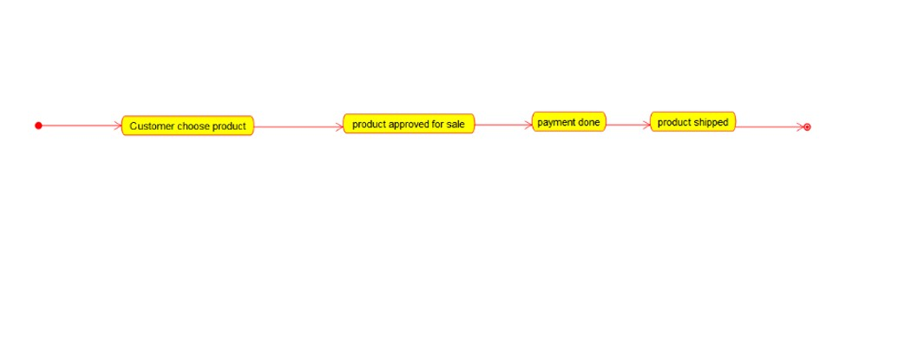

# COMPONENT DIAGRAM:

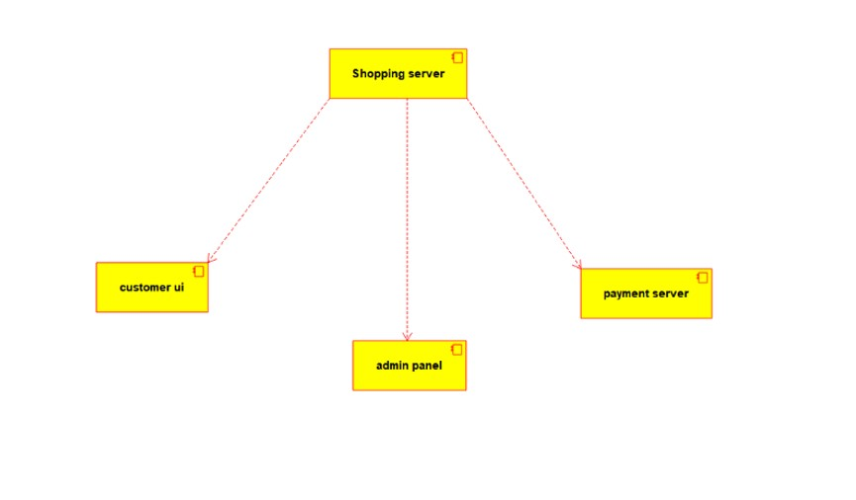

# DEPLOYMENT DIAGRAM:

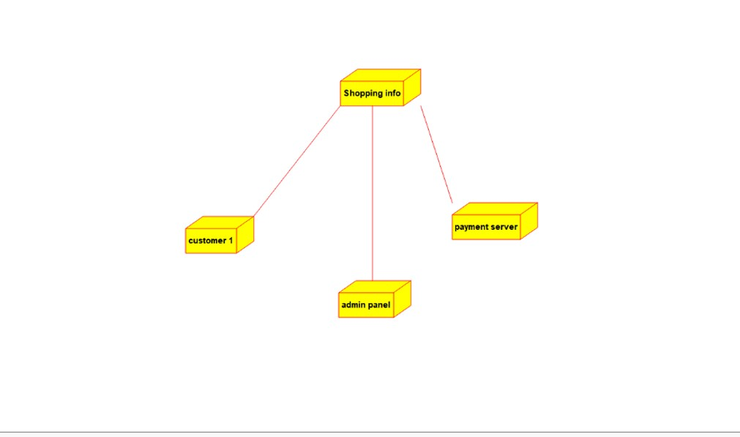

# **CODE:**

/**

* Class shopping_info

*/

public class shopping_info {

//

// Fields

//

private void customer_details; private void product_details; private void payment_info;

//

// Constructors

//

public shopping_info () { };

//

// Methods

//

//

// Accessor methods

//

/**

* Set the value of customer_details * @param newVar the new value of customer_details

*/

private void setCustomer_details (void newVar) { customer_details = newVar;

}

/**

* Get the value of customer_details
* @return the value of customer_details

*/

private void getCustomer_details () { return customer_details;

}

/**

* Set the value of product_details
* @param newVar the new value of product_details

*/

private void setProduct_details (void newVar) { product_details = newVar;

}

/**

* Get the value of product_details
* @return the value of product_details

*/

private void getProduct_details () { return product_details;

}

/**

* Set the value of payment_info
* @param newVar the new value of payment_info

*/

private void setPayment_info (void newVar) { payment_info = newVar;

}

/**

* Get the value of payment_info
* @return the value of payment_info

*/

private void getPayment_info () { return payment_info;

}

//

// Other methods

//

/**

*/

public void store_customers_details()

{

}

/**

*/

public void record_product()

{

}

/**

*/

public void payment_details()

{

}

}

/**

* Class customer1

*/

public class customer1 {

//

// Fields

//

private void cus_info; private void product_request; private void payment;

//

// Constructors

//

public customer1 () { };

//

// Methods

//

//

// Accessor methods

//

/**

* Set the value of cus_info
* @param newVar the new value of cus_info

*/

private void setCus_info (void newVar) { cus_info = newVar;

}

/**

* Get the value of cus_info
* @return the value of cus_info

*/

private void getCus_info () { return cus_info;

}

/**

* Set the value of product_request
* @param newVar the new value of product_request

*/

private void setProduct_request (void newVar) { product_request = newVar;

}

/**

* Get the value of product_request
* @return the value of product_request

*/

private void getProduct_request () { return product_request;

}

/**

* Set the value of payment
* @param newVar the new value of payment

*/

private void setPayment (void newVar) { payment = newVar;

}

/**

* Get the value of payment
* @return the value of payment

*/

private void getPayment () { return payment;

}

//

// Other methods

//

/**

*/

public void give_details()

{

}

/**

*/

public void choose_product()

{

}

/**

*/

public void do_payment()

{

}

}

/**

* Class adminstrator_1

*/

public class adminstrator_1 {

//

// Fields

//

private void cus_details; private void product_details; private void maintain_db;

//

// Constructors

//

public adminstrator_1 () { };

//

// Methods

//

//

// Accessor methods

//

/**

* Set the value of cus_details
* @param newVar the new value of cus_details

*/

private void setCus_details (void newVar) { cus_details = newVar;

}

/**

* Get the value of cus_details
* @return the value of cus_details

*/

private void getCus_details () { return cus_details;

}

/**

* Set the value of product_details
* @param newVar the new value of product_details

*/

private void setProduct_details (void newVar) { product_details = newVar;

}

/**

* Get the value of product_details
* @return the value of product_details

*/

private void getProduct_details () { return product_details;

}

/**

* Set the value of maintain_db
* @param newVar the new value of maintain_db

*/

private void setMaintain_db (void newVar) { maintain_db = newVar;

}

/**

* Get the value of maintain_db
* @return the value of maintain_db

*/

private void getMaintain_db () { return maintain_db;

}

//

// Other methods

//

/**

*/

public void update_cus_details()

{

}

/**

*/

public void store_product_details()

{

}

/**

*/

public void update_db()

{

}

}