# 25 - ONLINE VOTING SYSTEM

# USE CASE DIAGRAM:

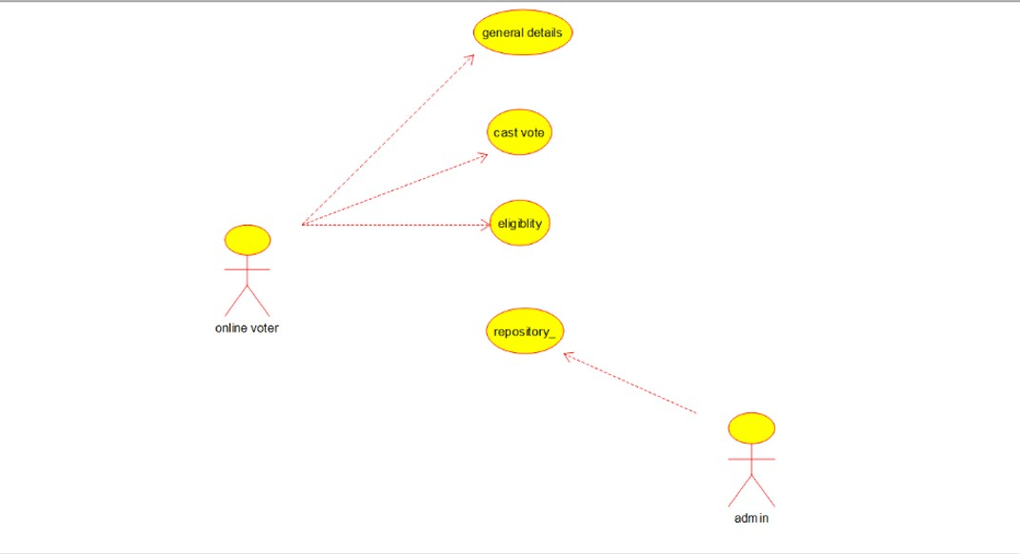

# CLASS DIAGRAM:

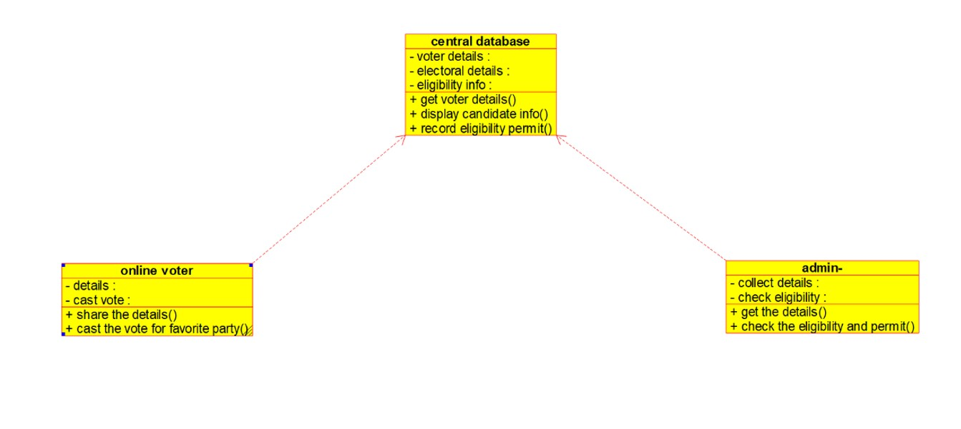

# ACTIVITY DIAGRAM:

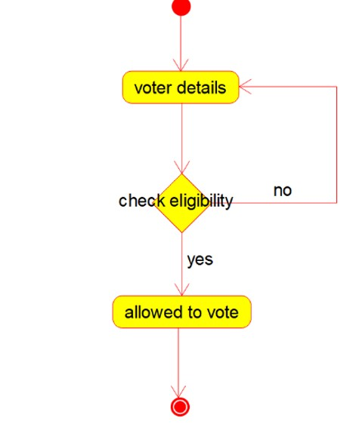

# SEQUENCE DIAGRAM:

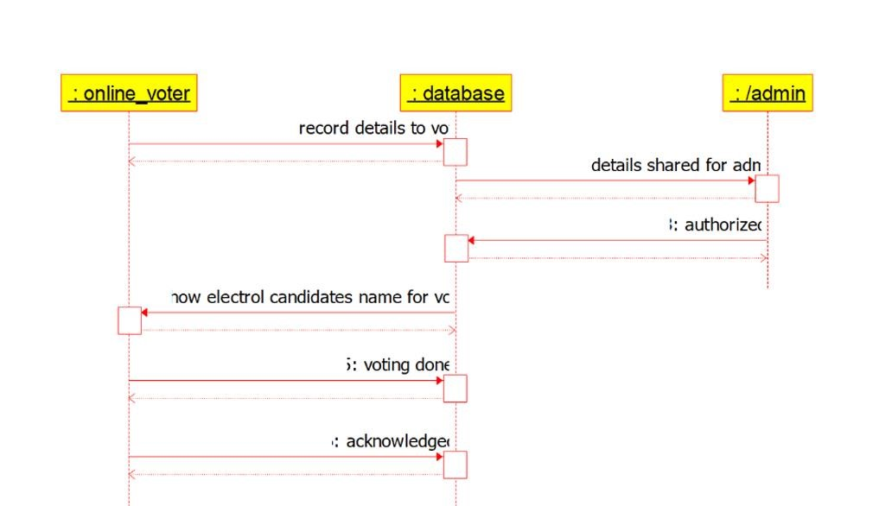

# COLLOBORATION DIAGRAM:

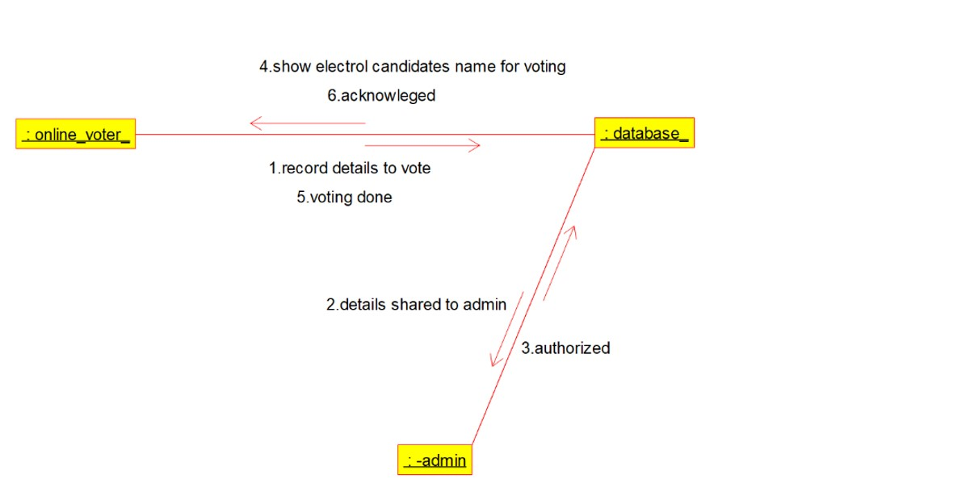

# STATE CHART DIAGRAM:

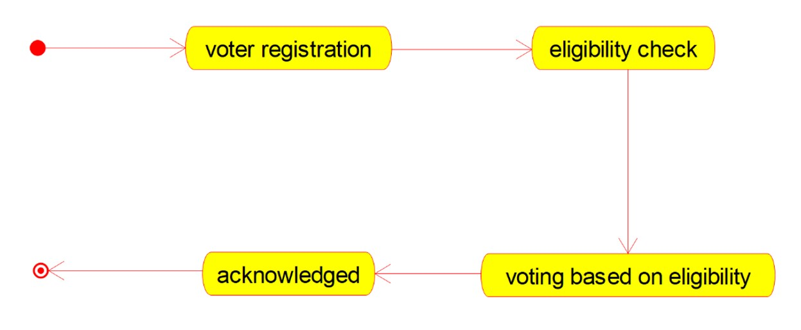

# COMPONENT DIAGRAM:

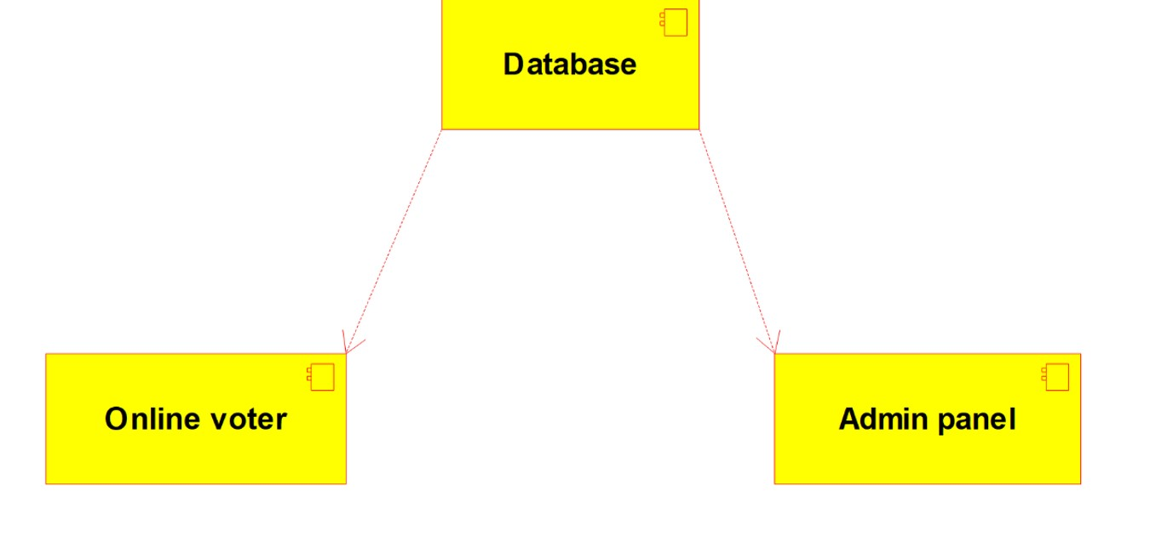

# DEPLOYMENT DIAGRAM:

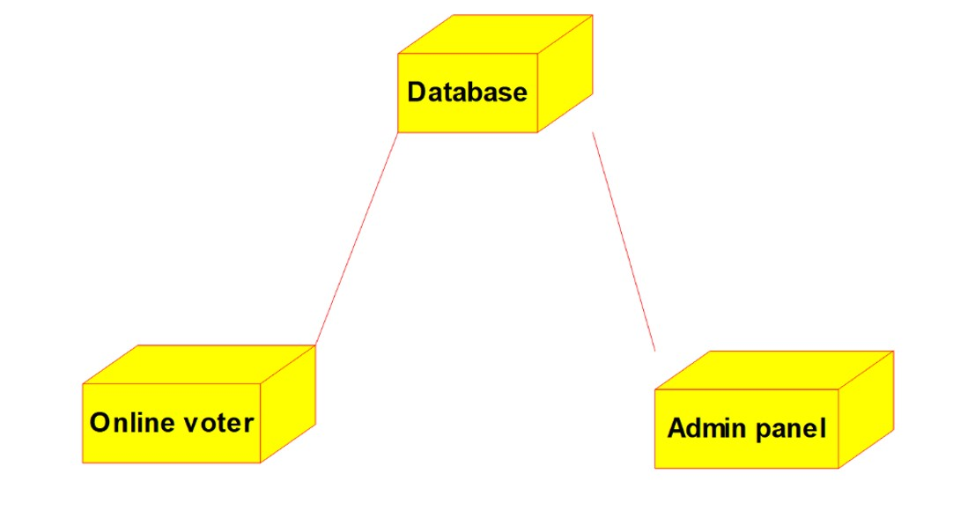

# **CODE:**

CENTRAL DATABASE:

/**

* Class central_database

*/

public class central_database {

//

// Fields

//

private void voter_details; private void electoral_details; private void eligibility_info;

//

// Constructors

//

public central_database () { };

//

// Methods

//

//

// Accessor methods

//

/**

* Set the value of voter_details
* @param newVar the new value of voter_details

*/

private void setVoter_details (void newVar) { voter_details = newVar;

}

/**

* Get the value of voter_details
* @return the value of voter_details

*/

private void getVoter_details () { return voter_details;

}

/**

* Set the value of electoral_details
* @param newVar the new value of electoral_details

*/

private void setElectoral_details (void newVar) { electoral_details = newVar;

}

/**

* Get the value of electoral_details
* @return the value of electoral_details

*/

private void getElectoral_details () { return electoral_details;

}

/**

* Set the value of eligibility_info
* @param newVar the new value of eligibility_info

*/

private void setEligibility_info (void newVar) { eligibility_info = newVar;

}

/**

* Get the value of eligibility_info
* @return the value of eligibility_info

*/

private void getEligibility_info () { return eligibility_info;

}

//

// Other methods

//

/**

*/

public void get_voter_details()

{

}

/**

*/

public void display_candidate_info()

{

}

/**

*/

public void record_eligibility_permit()

{

}

ONLINE VOTER:

/**

* Class online_voter

*/ public class online_voter {

//

// Fields

//

private void details; private void cast_vote;

//

// Constructors

//

public online_voter () { };

//

// Methods

//

//

// Accessor methods

//

/**

* Set the value of details
* @param newVar the new value of details

*/

private void setDetails (void newVar) { details = newVar;

}

/**

* Get the value of details
* @return the value of details

*/ private void getDetails () { return details;

}

/**

* Set the value of cast_vote
* @param newVar the new value of cast_vote

*/

private void setCast_vote (void newVar) { cast_vote = newVar;

}

/**

* Get the value of cast_vote
* @return the value of cast_vote

*/

private void getCast_vote () { return cast_vote;

}

//

// Other methods

//

/**

*/

public void share_the_details()

{

}

/**

*/

public void cast_the_vote_for_favorite_party()

{

}

}

ADMIN:

/**

* Class admin_

*/

public class admin_ {

//

// Fields

//

private void collect_details; private void check_eligibility;

//

// Constructors

//

public admin_ () { };

//

// Methods

//

//

// Accessor methods

//

/**

* Set the value of collect_details
* @param newVar the new value of collect_details

*/

private void setCollect_details (void newVar) { collect_details = newVar;

}

/**

* Get the value of collect_details
* @return the value of collect_details

*/

private void getCollect_details () { return collect_details;

}

/**

* Set the value of check_eligibility
* @param newVar the new value of check_eligibility

*/

private void setCheck_eligibility (void newVar) { check_eligibility = newVar;

}

/**

* Get the value of check_eligibility
* @return the value of check_eligibility

*/

private void getCheck_eligibility () { return check_eligibility;

}

//

// Other methods

//

/**

*/

public void get_the_details()

{

}

/**

*/

public void check_the_eligibility_and_permit()

{

}

}